- 导入包,并添加配置类，详细见部分代码。
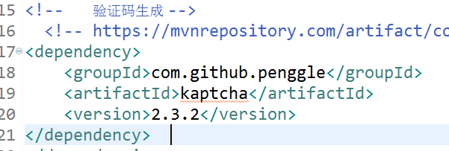
- 页面代码
<div>
<!-- <img alt="这是图片" src="/img/001.png"/> -->
<img alt="验证码" onclick = "this.src='/person/defaultKaptcha?d='+new Date()*1" src="/person/defaultKaptcha" />
</div>
- 对应的controller层
@Autowired
DefaultKaptcha defaultKaptcha;

//下面为验证码的生成
@RequestMapping("/defaultKaptcha")
public void defaultKaptcha(HttpServletRequest httpServletRequest,HttpServletResponse httpServletResponse) throws Exception{
byte[] captchaChallengeAsJpeg = null;
ByteArrayOutputStream jpegOutputStream = new ByteArrayOutputStream();
try {
//生产验证码字符串并保存到session中
String createText = defaultKaptcha.createText();
httpServletRequest.getSession().setAttribute("vrifyCode", createText);
//使用生产的验证码字符串返回一个BufferedImage对象并转为byte写入到byte数组中
BufferedImage challenge = defaultKaptcha.createImage(createText);
ImageIO.write(challenge, "jpg", jpegOutputStream);
} catch (IllegalArgumentException e) {
httpServletResponse.sendError(HttpServletResponse.SC_NOT_FOUND);
return;
}

//定义response输出类型为image/jpeg类型，使用response输出流输出图片的byte数组
captchaChallengeAsJpeg = jpegOutputStream.toByteArray();
httpServletResponse.setHeader("Cache-Control", "no-store");
httpServletResponse.setHeader("Pragma", "no-cache");
httpServletResponse.setDateHeader("Expires", 0);
httpServletResponse.setContentType("image/jpeg");
ServletOutputStream responseOutputStream =
httpServletResponse.getOutputStream();
responseOutputStream.write(captchaChallengeAsJpeg);
responseOutputStream.flush();
responseOutputStream.close();
}

//下面为验证码的判断
String parameter = request.getParameter("user");
String captchaId = (String) request.getSession().getAttribute("vrifyCode");

System.out.println("Session vrifyCode "+captchaId);

