Q1

There are 13 features in the dataset, corresponding to the 13 columns in matrix X. X has 506 rows, which means there are 506 target data points, represented by array y. The target points stand for the house prices in Boston.

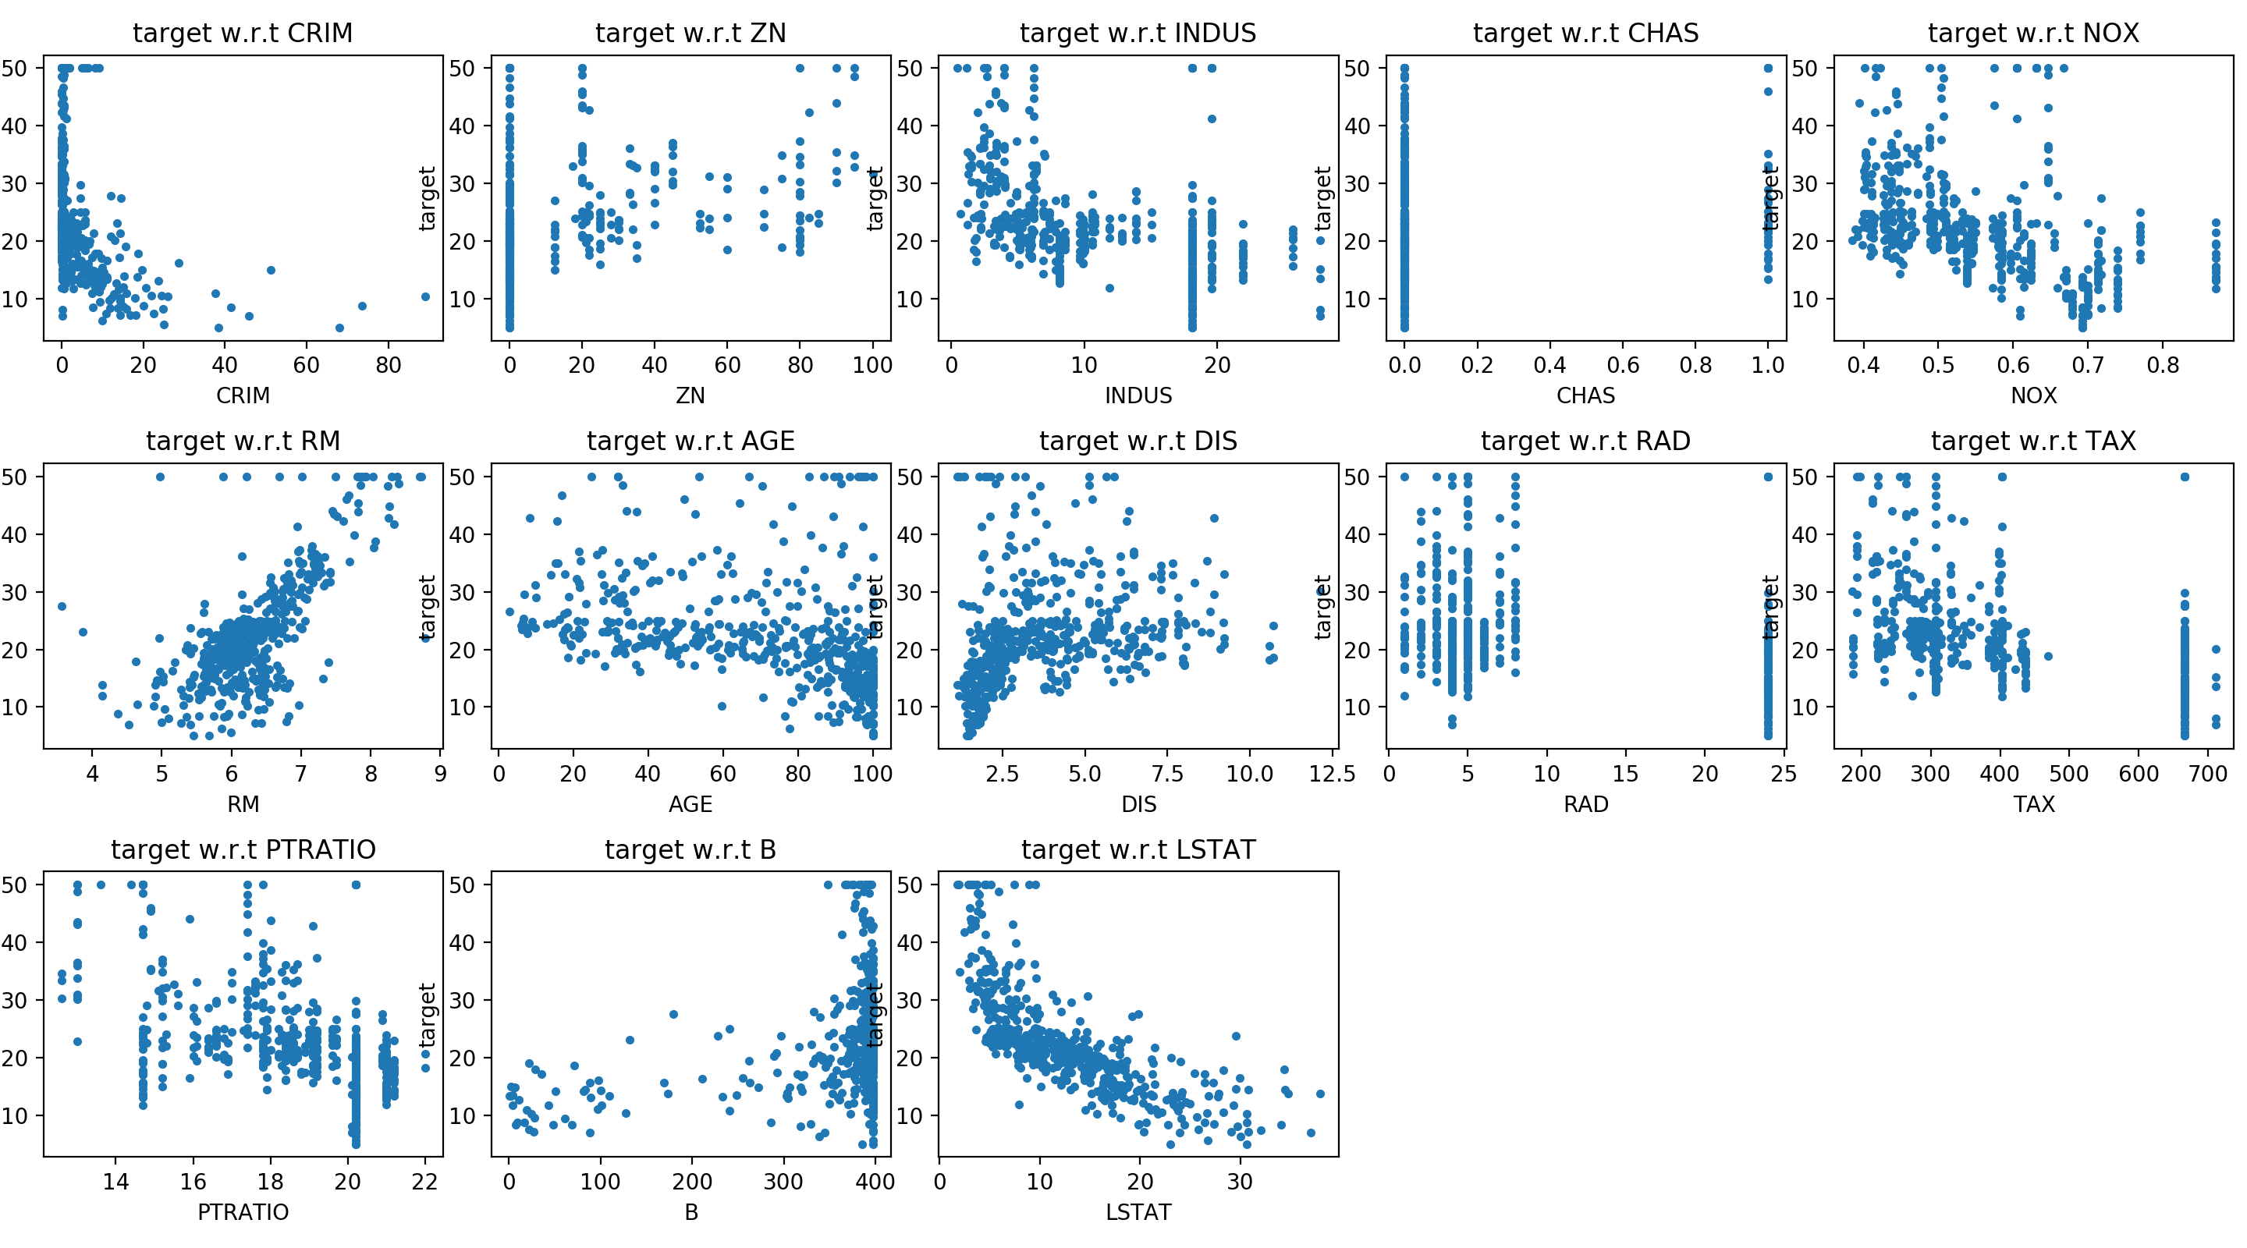

The weight of each features (including bias) is shown below:

|  |  |
| --- | --- |
| Bias | 23.5727509446 |
| CRIM | -0.122575206824 |
| ZN | 0.0303988629728 |
| INDUS | 0.0217561213734 |
| CHAS | 2.79208018512 |
| NOX | -15.2358481187 |
| RM | 5.26010409425 |
| AGE | -0.0106641921922 |
| DIS | -1.27070375914 |
| RAD | 0.264409416784 |
| TAX | -0.0115069817816 |
| PTRATIO | -0.918125669879 |
| B | 0.0102685908138 |
| LSTAT | -0.391421685711 |

‘INDUS’ has a positive weight but close to zero, which means that it is positively correlated to the house price. However, in some cases with different random seed, it has a negative weight but still close to zero. Intuitively, the reason of this sign may be that although larger proportion of non-retail business acre may cause some inconvenience of shopping, it may be better choice for people who need to live near to their work place.

Mean squared error: 34.3223041482

Mean absolute error: 3.80364904969

Huber loss: 336.511983064

MSE is not robust to outliers, so MAE and the combination, Huber loss, are necessary to value.

The most significant feature should be ‘RM’, which has the most observable trend in the grid.

Q2

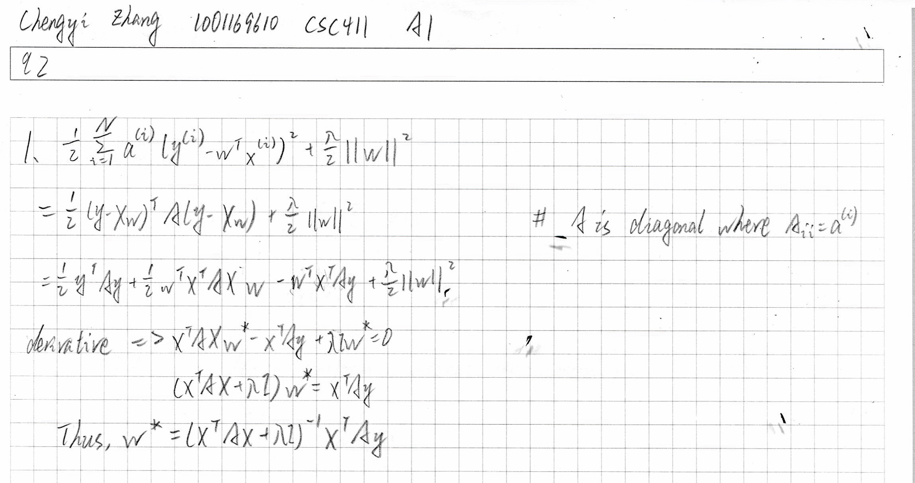

3. 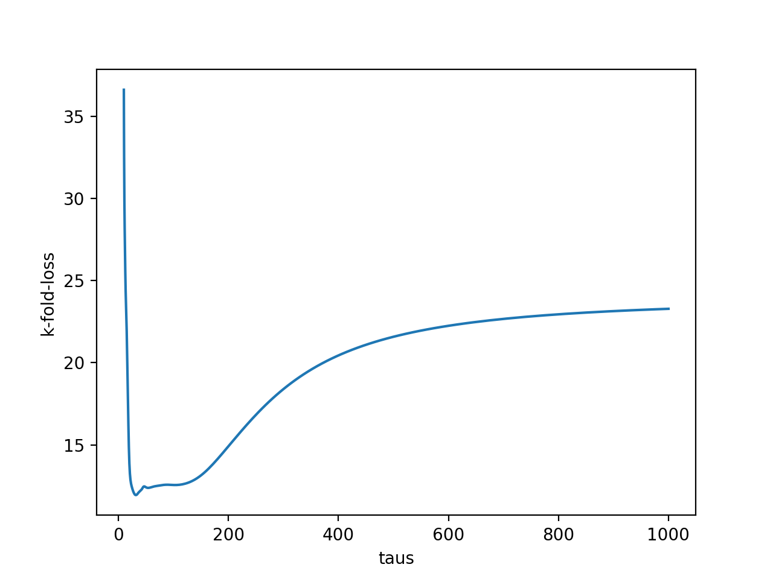

4. When tau approaches infinity, the loss tends to converge. When tau approaches 0, the loss approaches infinity. The min loss for taus in [10, 1000] is 11.9415251864.

Q3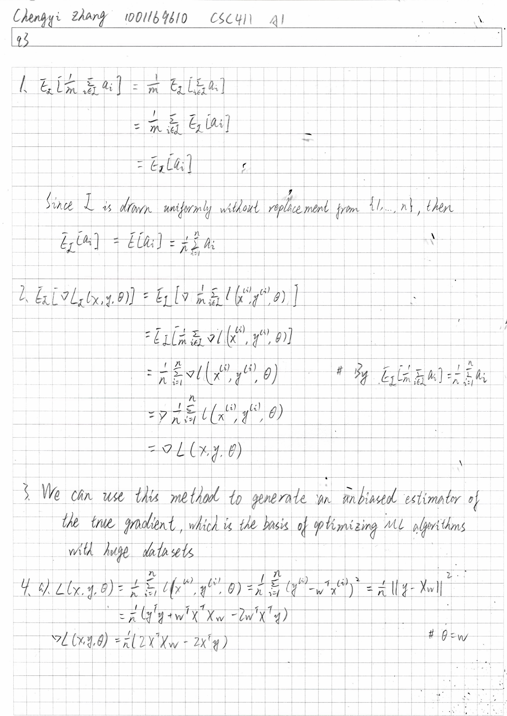

5.

cosine similarity: 0.9999991318930902

squared distance: 770.14454296346992

In this case, cosine similarity is more meaningful, because this metric shows that two vectors are ‘in the same direction’. On the other hand, though two vectors are located far from each other, this metric cannot express the difference of weights (ratios of elements) in two vectors.

6.

