

UNIVERSITI TUNKU ABDUL RAHMAN

FACULTY OF INFORMATION COMMUNICATION AND TECHNOLOGY (FICT)

January 2024 TRIMESTER
UCCB1104/ UCCG1104/ UCCT1104
INTRODUCTION TO BUSINESS PROGRAMMING

GROUP NAME: The Three Musketeers
STUDENT DETAILS:
NAME | STUDENT ID | PROGRAMME
Cheng Zheng De | 2207492 | IB
Chew Yan Yu | 2206970 | IB
Kan Lap Hoe | 2300123 | IB

MARKING SCHEME:
ASPECT | MARKS ALLOCATED | MARKS OBTAINED
Customized Reports with proper documentation style | 15
Coding (Given Tasks) | 15
Extra work (Add more functionality, reports, etc.) | 7
Application of Advanced Level of Concepts | 8
Individual Work | 5
MARKS: | 50
TOTAL MARKS: | 15
  - Introduction
Done by (Cheng Zheng De, 2207492) on 29/04/2024
In today's healthcare landscape, hospitals face numerous challenges in managing their operations efficiently while delivering high-quality patient care. Manual processes, paper-based documentation, and disparate systems often lead to inefficiencies, errors, and delays in service delivery. To address these challenges, there is a critical need for a comprehensive Hospital Management System (HMS) that improving these administrative tasks, enhances patient care, and improves overall operational efficiency.

Problem Statements
- Develop a comprehensive Hospital Management System for UTAR Hospital in Kampar, Perak, facilitating the creation of patient accounts, management of medical records, prescription details, total payments, and tracking patient illness records.

Objectives
- To improve administrative processes: Implementing automated workflows for patient registration, appointment scheduling, medical record management, reporting to improve efficiency and reduce errors.

- To enhance patient care: Providing healthcare providers with easy access to patient information, patient medical history, and communication channels to deliver personalized care and improve patient outcomes.

  - Screenshot Main Menu
Done by (Cheng Zheng De, 2207492) on 29/04/2024
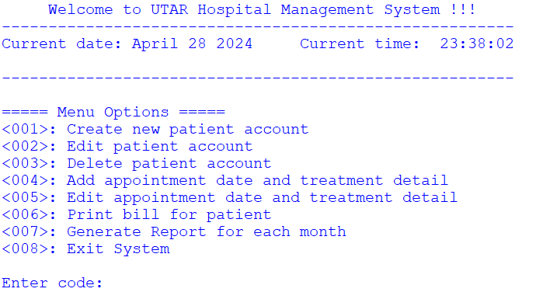
Figure 1.2.1

Create new patient account <001>, Edit patient account <002>, Delete patient account <003>, Add appointment date and treatment detail <004>, Edit appointment date and treatment detail <005>, Print bill for patient <006>, Generate report for each month <007>, and Exit system <008> are among the options available on the main interface of the UTAR Hospital Management System. Our main menu is depicted in Figure 1.2.1.

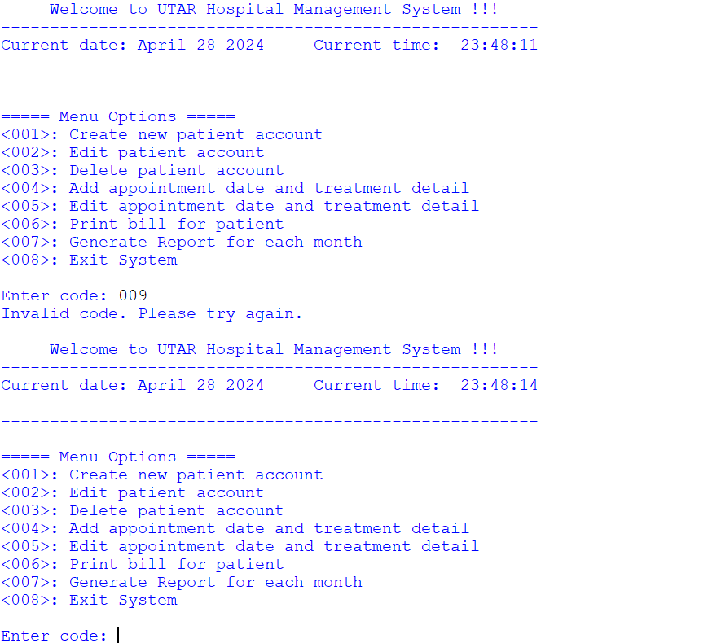
Figure 1.2.2
As can be seen in Figure 1.2.2, when an invalid key is entered. It shows an error message saying “Invalid code. Please try again.”. To continue, the user can key in the valid key to try again.

  - Create new patient account
Done by (Kan Lap Hoe, 2300123) on 29/04/2024
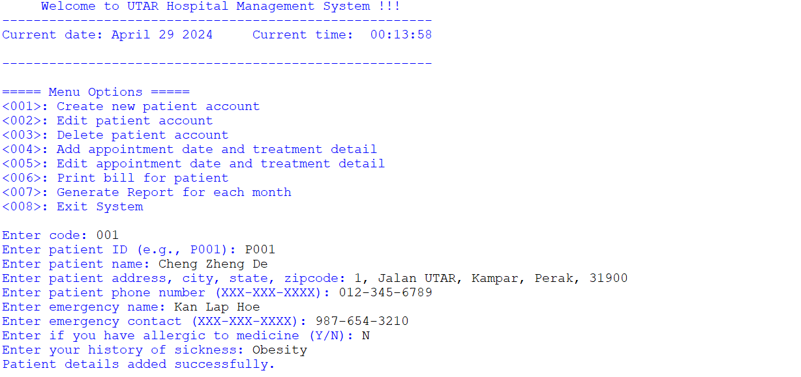
Figure 1.3.1

To create a new patient account, the user can access the <001> menu by entering 001, as shown in Figure 1.3.1. Once the user has navigated to the <001> menu, they can successfully add and append data to the excel file by keying in all the fields and providing the answers in the correct format.

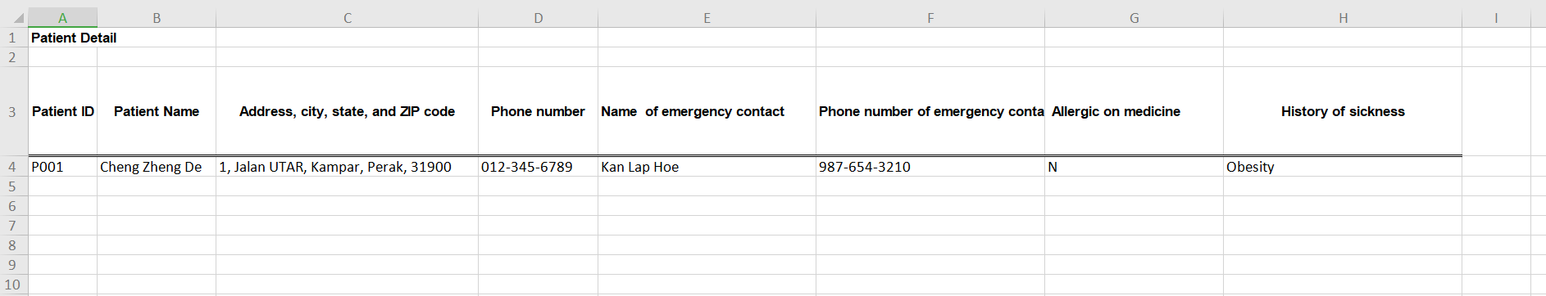
Figure 1.3.2

The data that has been appended and added to the relevant column is shown in Figure 1.3.2.

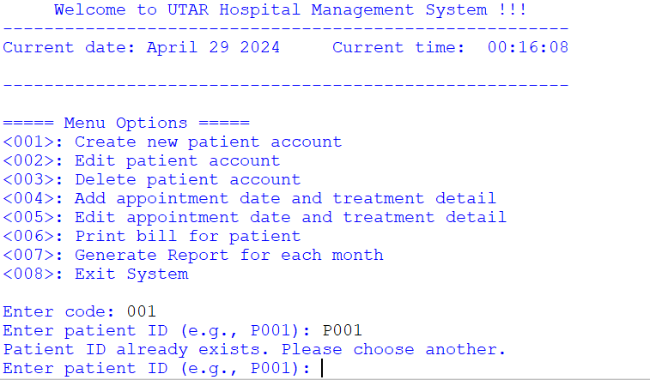
Figure 1.3.3

In Figure 1.3.3, should the user select a patient ID that already exists, the Excel file will not contain the value and instead display the result “Patient ID already exists. Please choose another.”

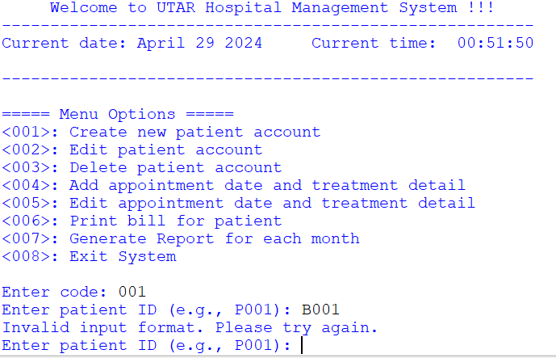
Figure 1.3.4

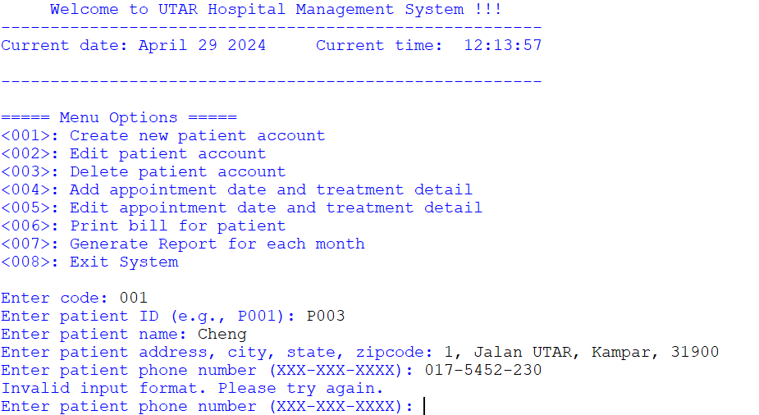
Figure 1.3.5
In Figure 1.3.4 and Figure 1.3.5, should the user provide a patient ID or phone number that is in the wrong format, the Excel file will not contain the value and instead display the result “Invalid input format. Please try again.”

If the user wants to proceed with creating a new patient account, they have to provide the data in the right format.

  - Edit patient Account
Done by (Kan Lap Hoe, 2300123) on 29/04/2024
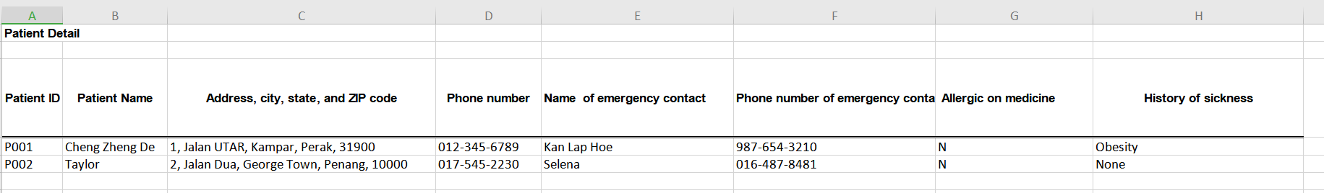
Figure 1.4.1

Figure 1.4.1 shows all the unedited data in the MasterList of the Excel file

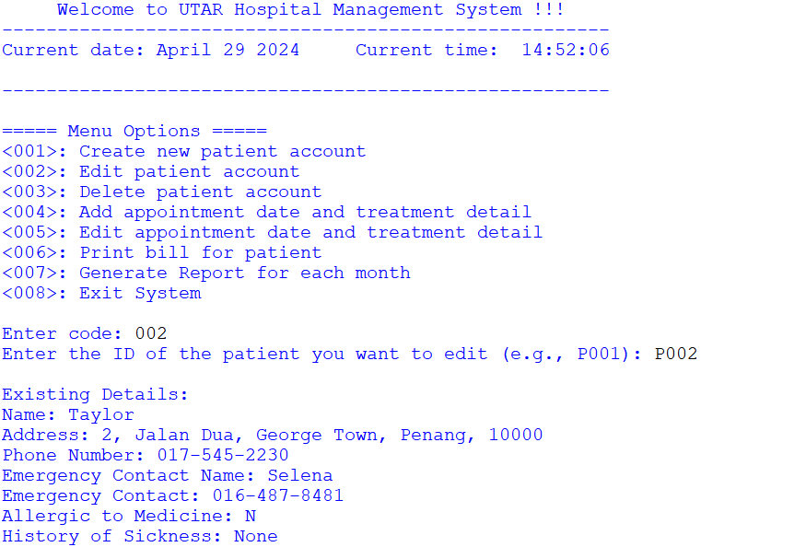
Figure 1.4.2

To edit a patient account, the user can access the <002> menu by entering 002, as shown in Figure 1.4.2. Once the user has navigated to the <002> menu, the user is prompted to input the patient ID that they want to edit. The existing patient details that the user wants to edit will be shown on the IDLE console after they have entered the patient ID.
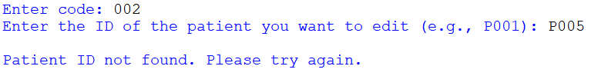
Figure 1.4.3

Figure 1.4.3 shows that if the patient ID that the user entered (even in the correct format) is not found inside the MasterList. A displayed message “Patient ID not found. Please try again.” will be displayed on the IDLE console. The user will need to access the <002> menu again if they still want to edit the existing patient details.

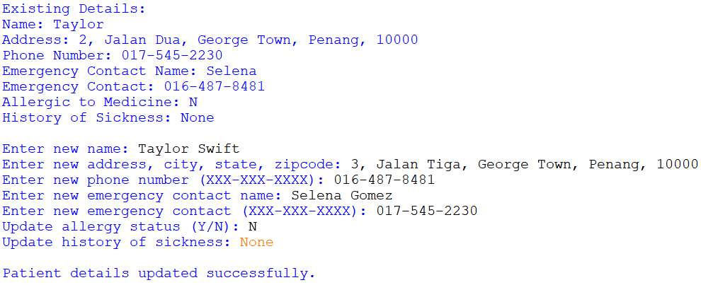
Figure 1.4.4

Figure 1.4.4 shows how the system will ask the user to provide new information after displaying the existing details, including name, address, phone number, emergency contact and name, allergy status, and medical history on the IDLE console.

Other than that, the system will display the message "Patient details updated successfully." on the IDLE console, indicating that the existing details have been replaced in the MasterList with the updated version once the user provides all the required information in the correct format.
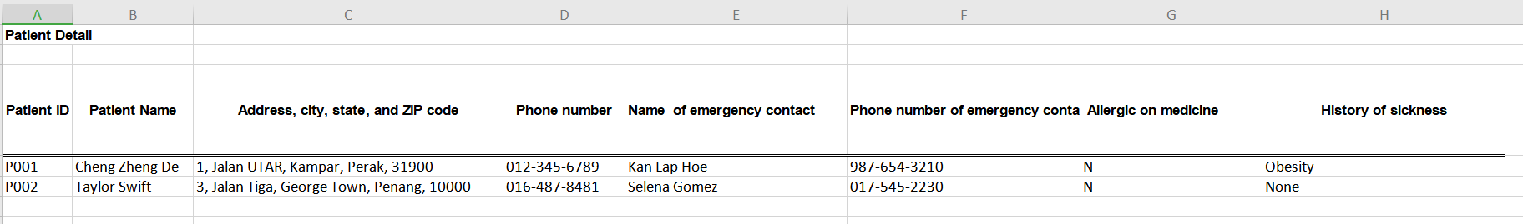
Figure 1.4.5
Figure 1.4.5 shows the current edited data in the MasterList of the Excel File

  - Delete Patient Account
Done by (Chew Yan Yu, 2206970) on 29/04/2024
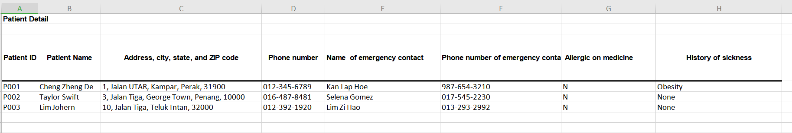
Figure 1.5.1

Figure 1.5.1 shows all the data that are currently in the MasterList of the Excel file

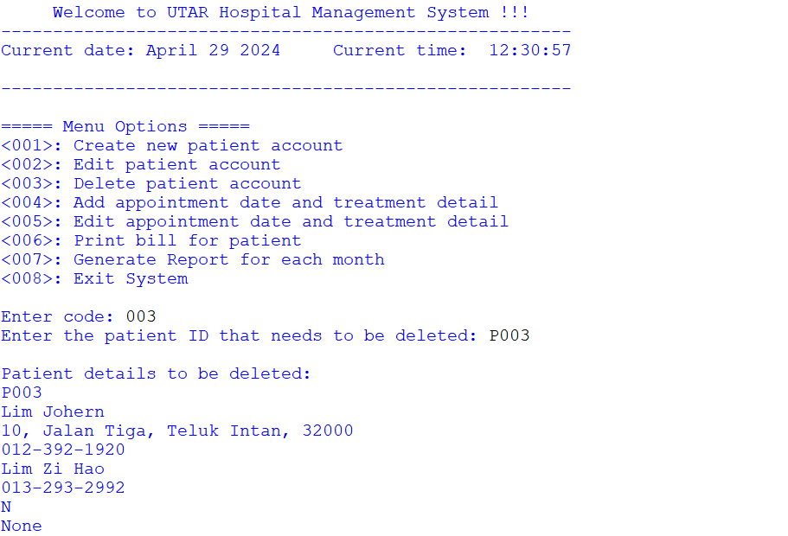
Figure 1.5.2

To delete a patient account, the user can access the <003> menu by entering 003, as shown in Figure 1.5.2. The user is prompted to input the patient ID they want to delete after navigating to the <003> menu. The patient details that the user wants to remove will be shown on the IDLE console after they have entered the patient ID.

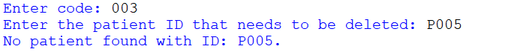
Figure 1.5.3

Figure 1.5.3 shows that if the patient ID that the user entered (even in the correct format) is not found inside the MasterList. A displayed message “No patient found with ID that needs to be deleted: P_ _ _” will be displayed on the IDLE console. The user will need to access the <003> menu again if they still want to delete the existing patient details.

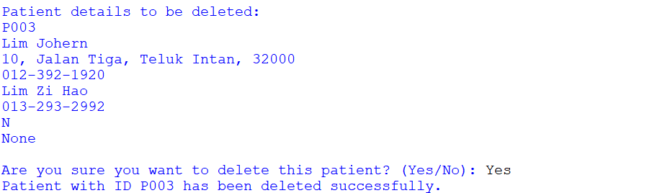
Figure 1.5.4

In Figure 1.5.4, the system will prompt the user to confirm whether they truly wish to remove the patient details from the excel file after displaying the patient details on the IDLE console. If the user chooses ‘Yes’, the patient ID will be successfully removed.

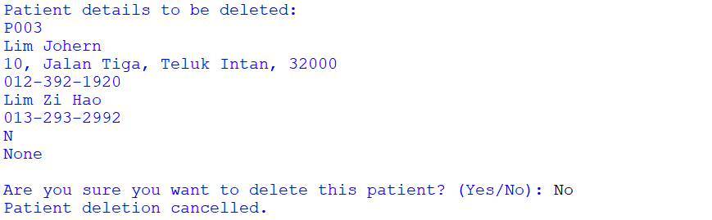
Figure 1.5.5
If the user chooses ‘No’, the patient ID will not be deleted off the Excel file as shown in Figure 1.5.5.


Figure 1.5.6

Figure 1.5.6 shows the patient details from the patient ID (P003) has been deleted off the Excel file after the user chooses ‘Yes’.

  - Add appointment date and treatment detail
Done by (Kan Lap Hoe, 2300123) on 29/04/2024
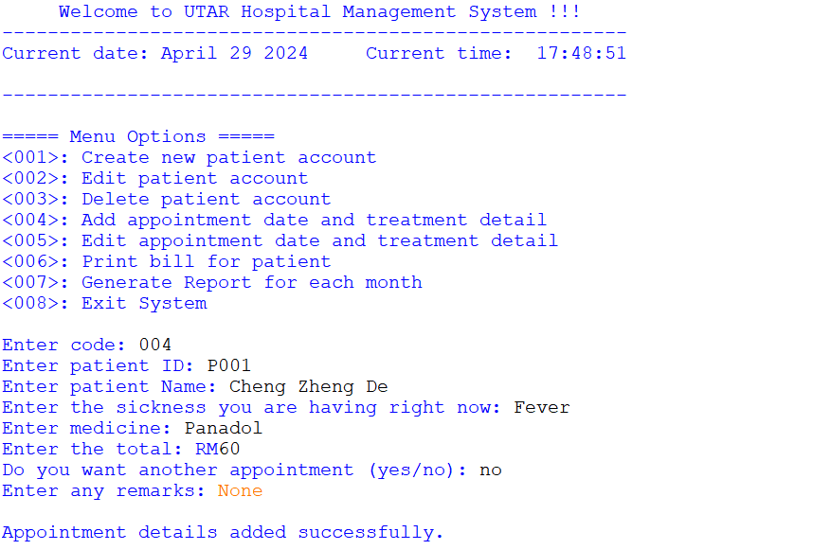
Figure 1.6.1
To add appointment date and treatment detail, the user can access the <004> menu by entering 004, as shown in Figure 1.6.1. Once the user has navigated to the <004> menu, they can successfully add and append the data to the excel file by keying in all the fields and providing the answers in the correct format.
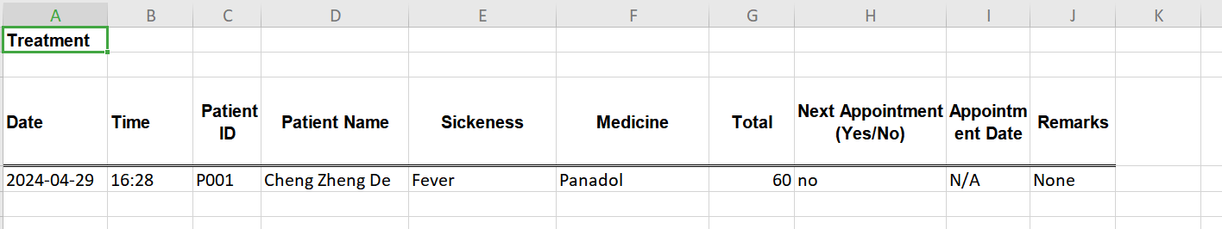
Figure 1.6.2
The data that has been appended and added to the relevant column is shown in Figure 1.6.2 and if the user did not decide to make another appointment, the ‘Appointment Date’ column will automatically be appended with “N/A”.

(Please note that the Date and Time on Figure 1.6.2 are following the system Date and Time and are automatically appended into their respective columns)

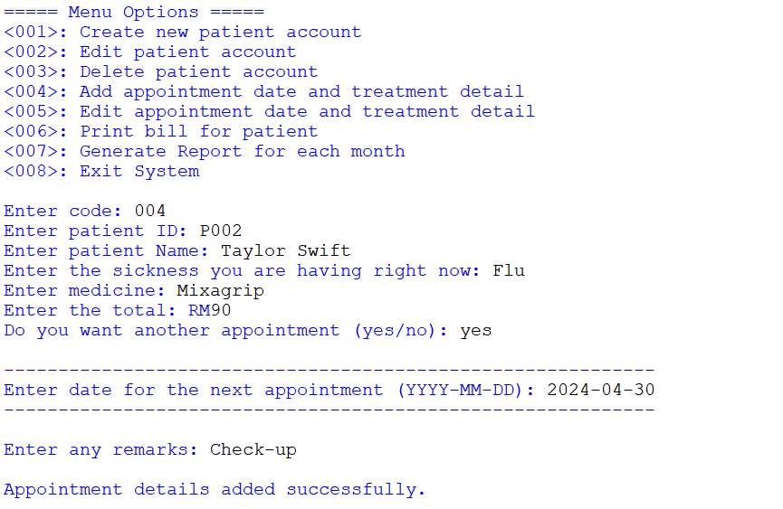
Figure 1.6.3

Figure 1.6.3 shows that if the user choose to have another appointment for check-up purposes and so on, they are prompted to enter the next date appointment in the correct format.

Other than that, the message “Appointment details added successfully.” will be displayed at the end of the line after the user has key in all the field in the correct format.

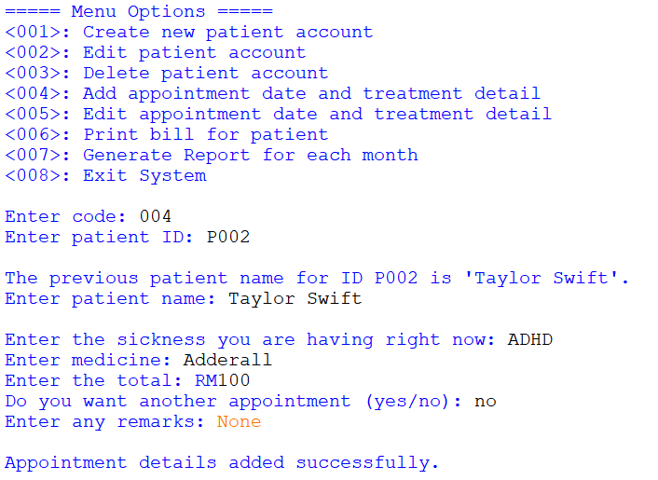
Figure 1.6.4
In Figure 1.6.4, if the patient ID has already been registered under the Treatment_Detail worksheet in the Excel file, it will display the message “The previous patient name for ID (patient_id) is (patient_name).” This is to remind the user that the following patient has this ID, and the user should provide the name based on the suggested name.

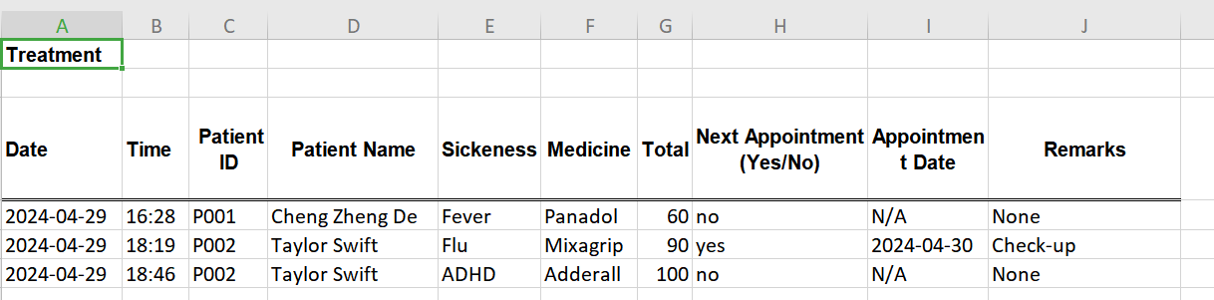
Figure 1.6.5

The following data in Figure 1.6.4 has been appended and added to the relevant column is shown in Figure 1.6.5.

  - Edit appointment date and treatment detail
Done by (Cheng Zheng De, 2207492) on 29/04/2024

Figure 1.7.1

Figure 1.7.1 shows all the unedited data in the Treatment_Detail worksheet

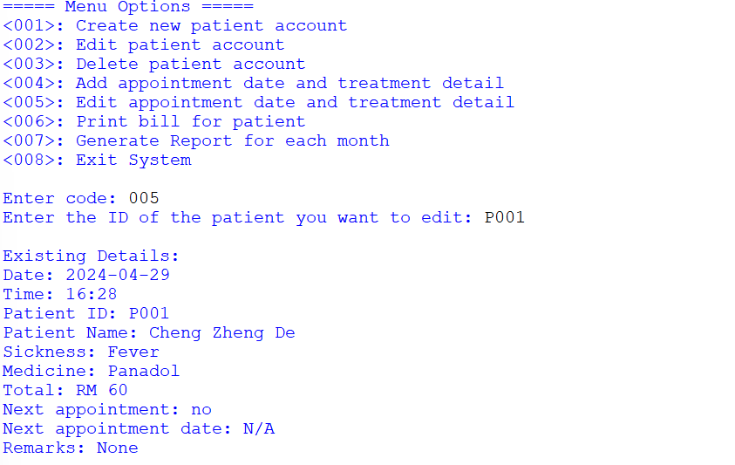
Figure 1.7.2

To edit appointment date and treatment detail, the user can access the <005> menu by entering 005, as shown in Figure 1.7.2. Once the user has navigated to the <005> menu, the user is prompted to input the patient ID that they want to edit. The existing treatment details that the user wants to edit will be shown on the IDLE console after they have entered the patient ID.

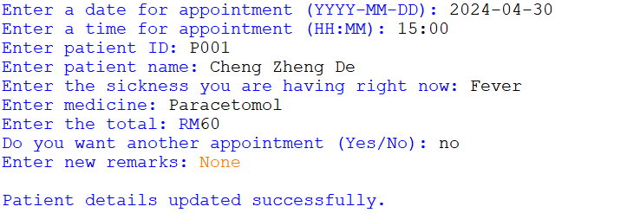
Figure 1.7.3
In Figure 1.7.3, the system will display the message "Patient details updated successfully." on the IDLE console, indicating that the existing details have been replaced in the Treatment_Details with the updated version once the user provides all the required information in the correct format.

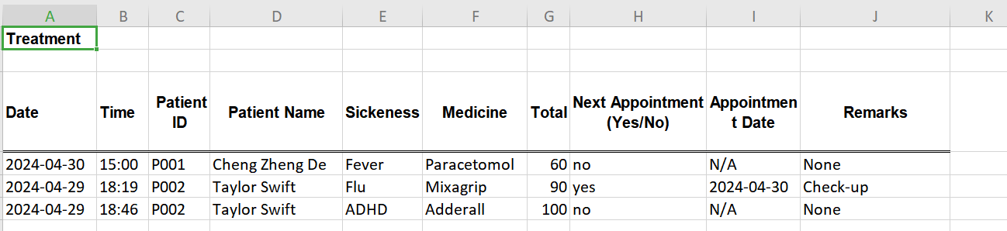
Figure 1.7.4

Figure 1.7.4 shows all the current edited data in the Treatment_Detail of the Excel File

  - Print bill for patient
Done by (Chew Yan Yu, 2206970) on 29/04/2024
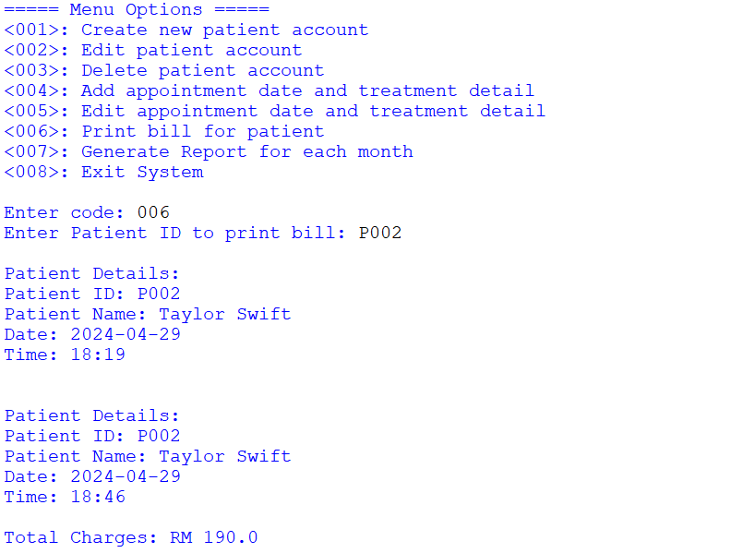
Figure 1.8.1
To print bill for patient, the user can access the <006> menu by entering 006, as shown in Figure 1.8.1. Once the user has navigated to the <006> menu, the user is prompted to input the patient ID that they want to print.

All the transactions details that involved the patient ID will be printed out on IDLE console.

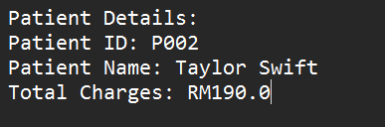
Figure 1.8.2

All the transactions involving the patient ID will also be written inside the text file as in Figure 1.8.2. The bill will also act as a receipt and will include the patient ID, name and also their total charges of the treatment in the hospital.

  - Generate Report for each month
Done by (Chew Yan Yu, 2206970) on 29/04/2024
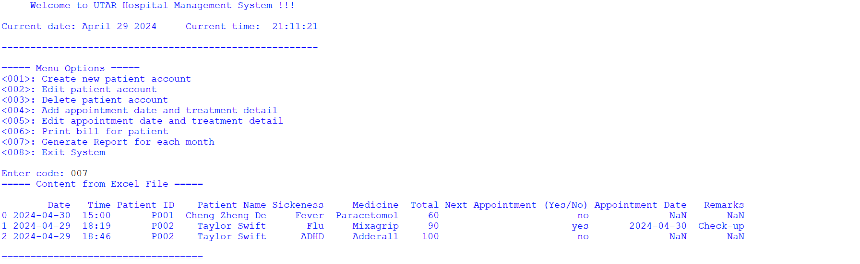
Figure 1.9.1

To generate report for each month, the user can access the <007> menu by entering 007, as shown in Figure 1.9.1. Once the user has navigated to the <007> menu, it will print the content of the Treatment_Detail worksheet from the excel file on the IDLE console.

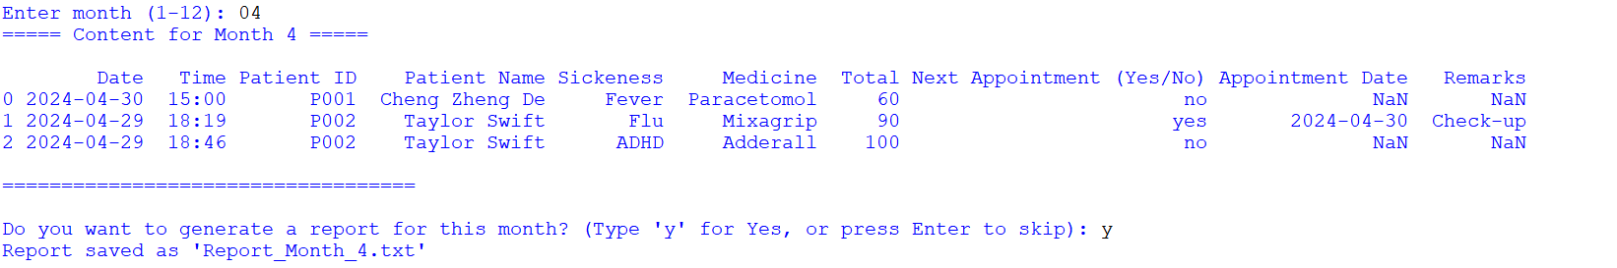
Figure 1.9.2

In Figure 1.9.2, the system will prompt the user to enter a month that they would like to print on the IDLE console.

Other than that, the system will then prompt the user whether they want to generate a report for the month that the user provides in Figure 1.9.2. If the user type ‘y’, a report is saved as a text file in the computer.

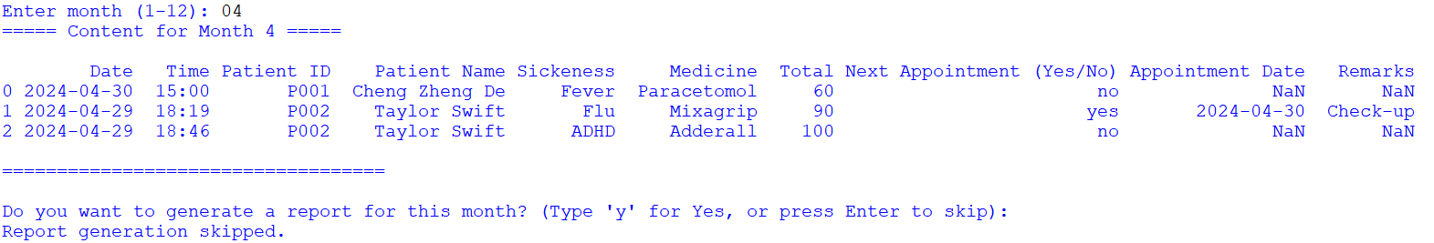
Figure 1.9.3
On the other way round, if the user press Enter to skip, a message “Report generation skipped.” will be displayed on the IDLE console as shown in Figure 1.9.3.

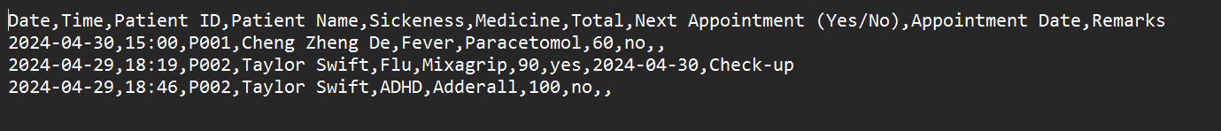
Figure 1.9.4
Figure 1.9.4 is the report that was generated from Figure 1.9.2 if the user typed ‘y’ when the system prompted the user whether they wanted to generate the report in a text file for that specific month

  - Exiting the system
Done by (Cheng Zheng De, 2207492) on 29/04/2024
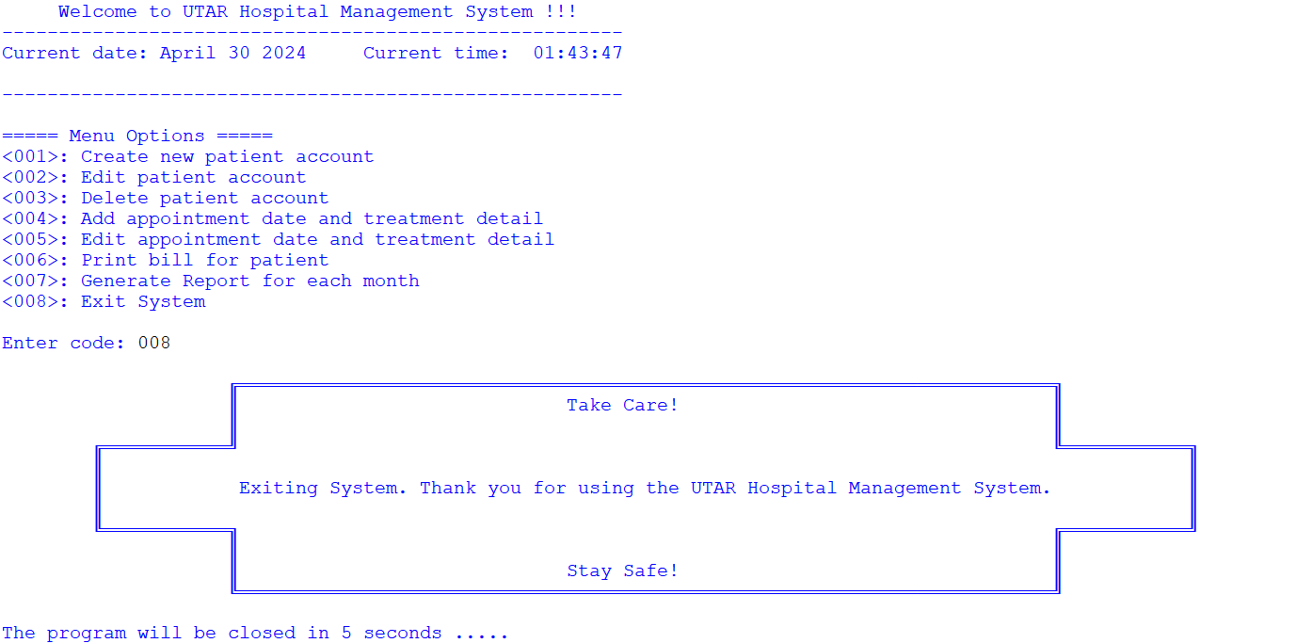
Figure 1.10.1

To exit the system, the user can access the <008> menu by entering 008, as shown in Figure 1.10.1. Once the user has navigated to the <008> menu, it will print out the thank you message and end the program in 5 seconds.

2.0 Coding with comments
2.0.1 Main program
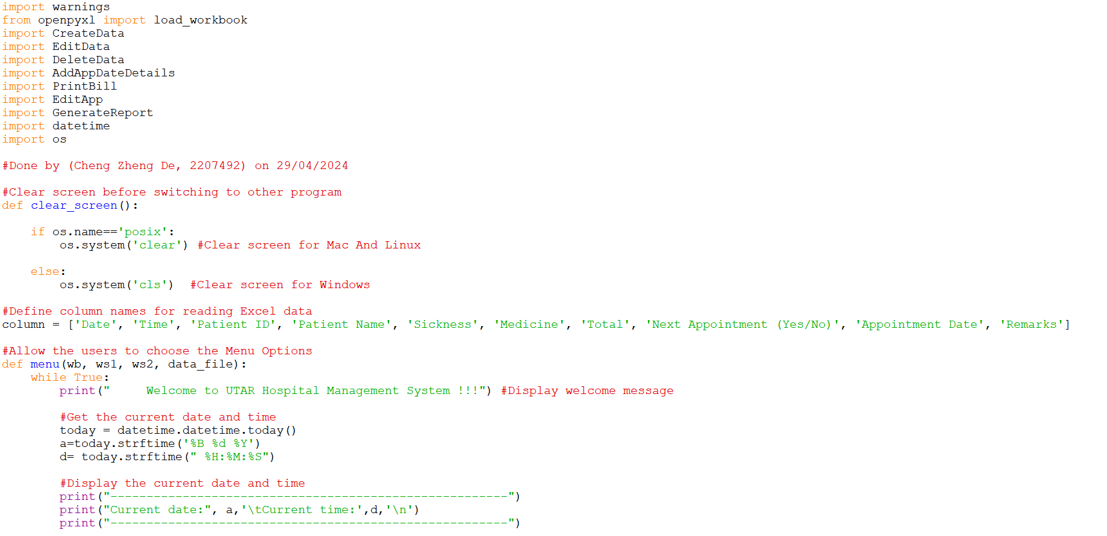
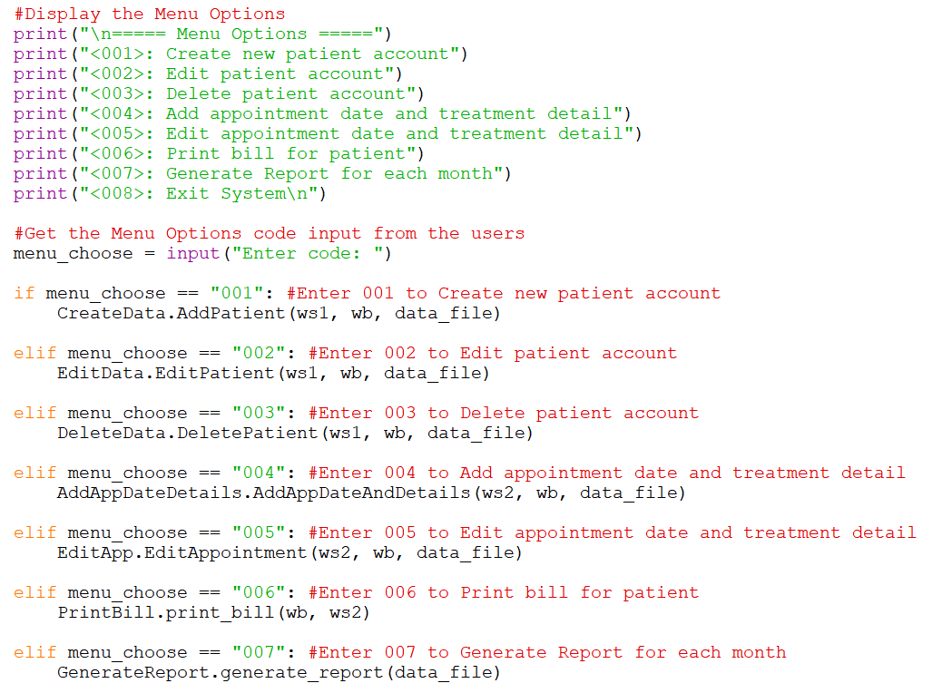

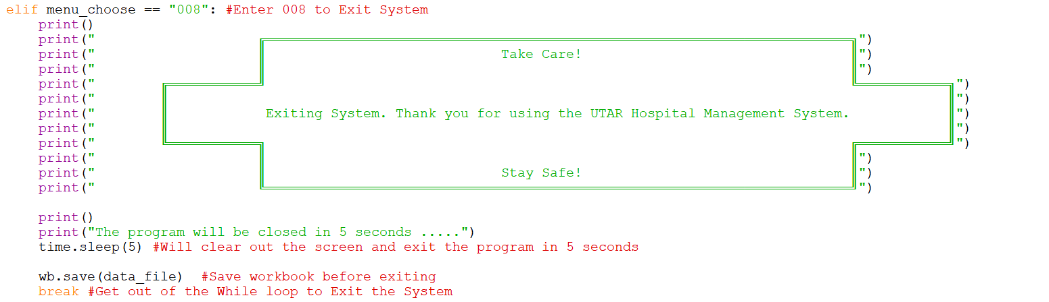
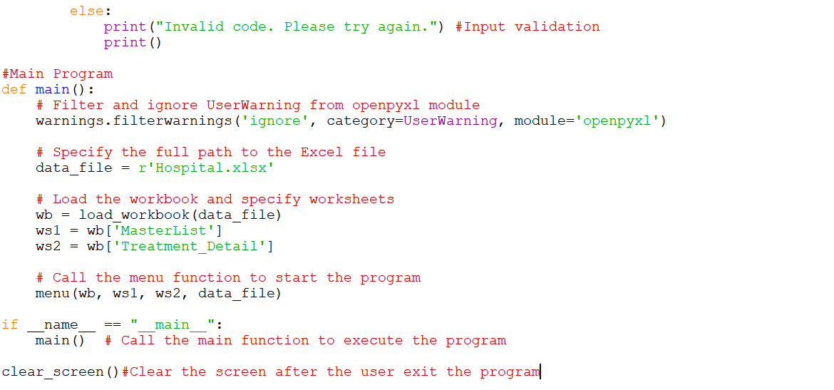
2.0.2 Create new patient account
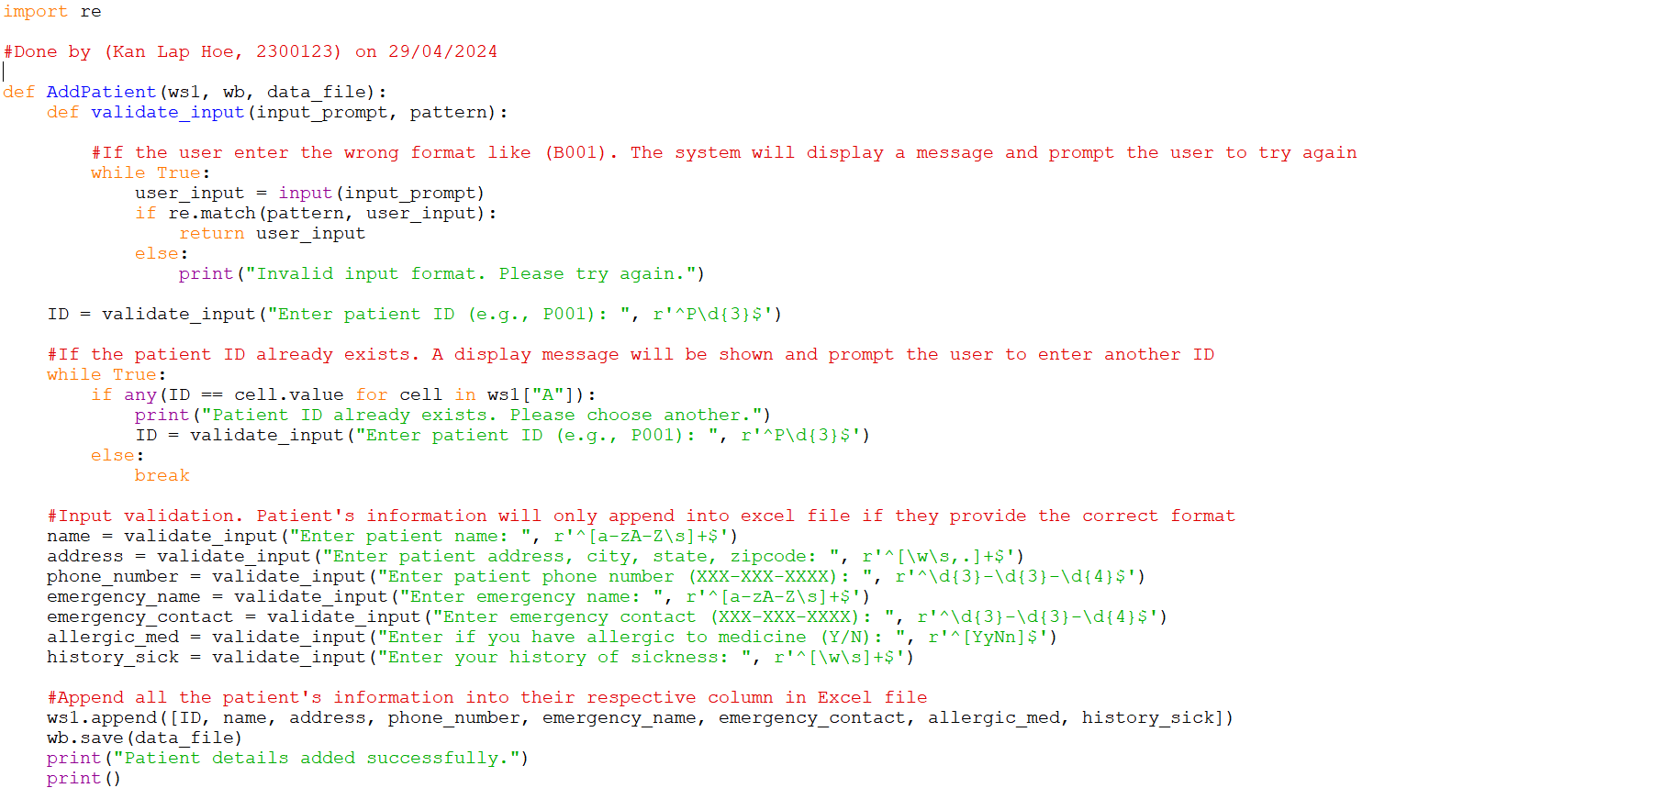

2.0.3 Edit patient account
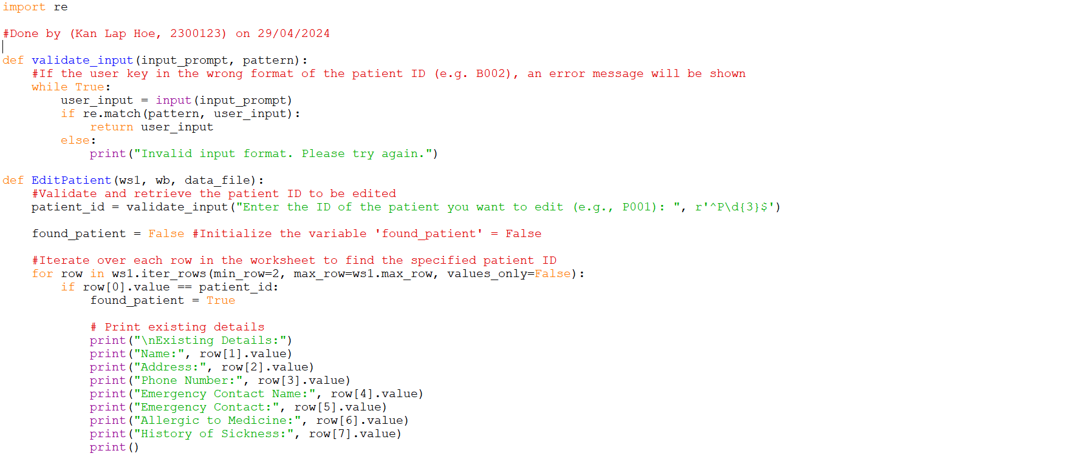
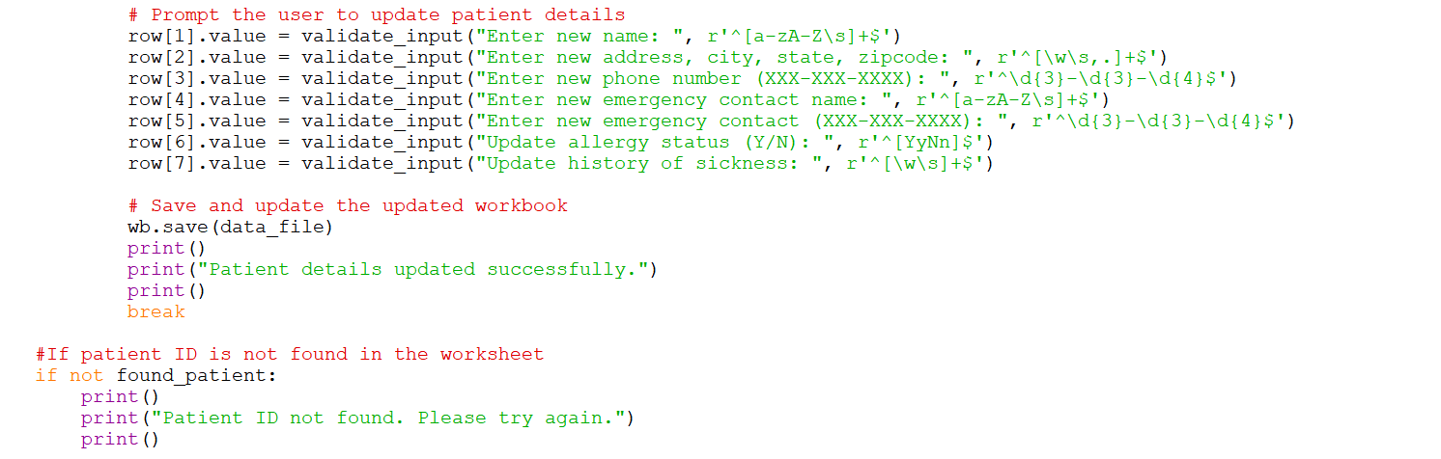

2.0.4 Delete patient account
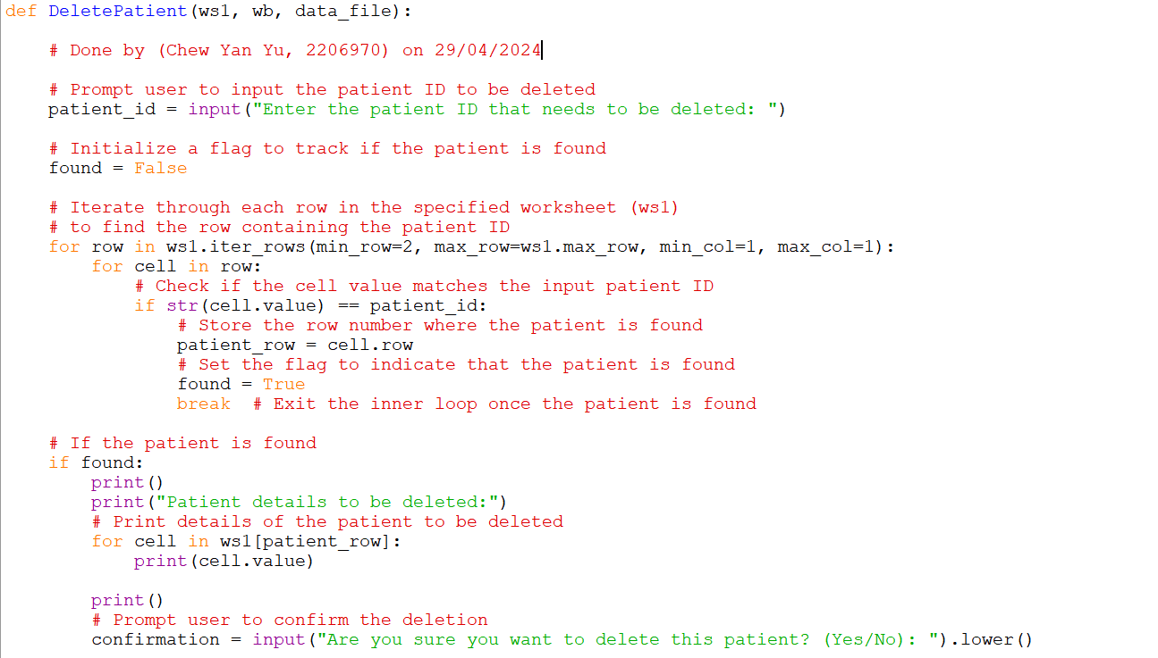
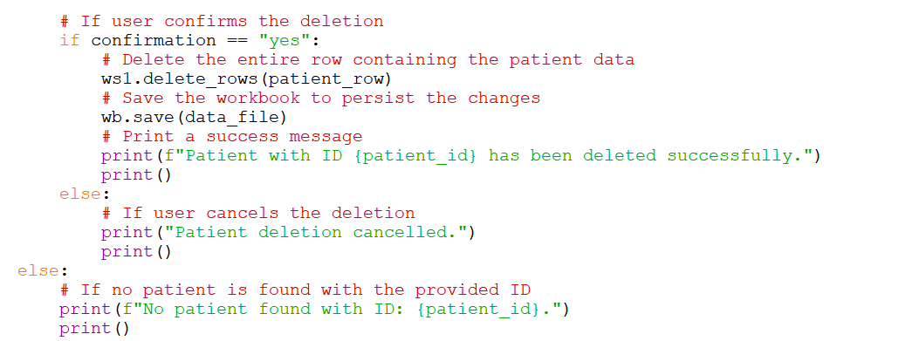
2.0.5 Add appointment date and treatment detail
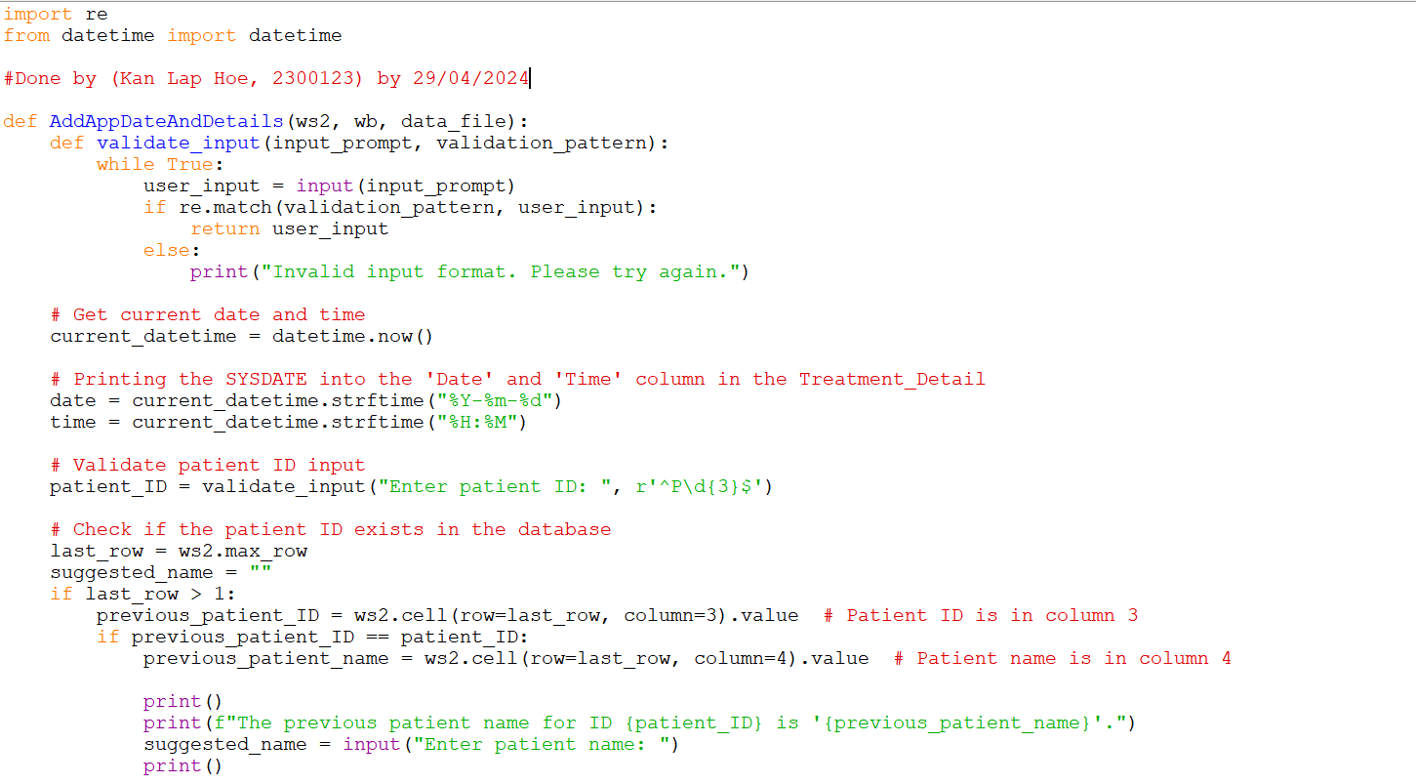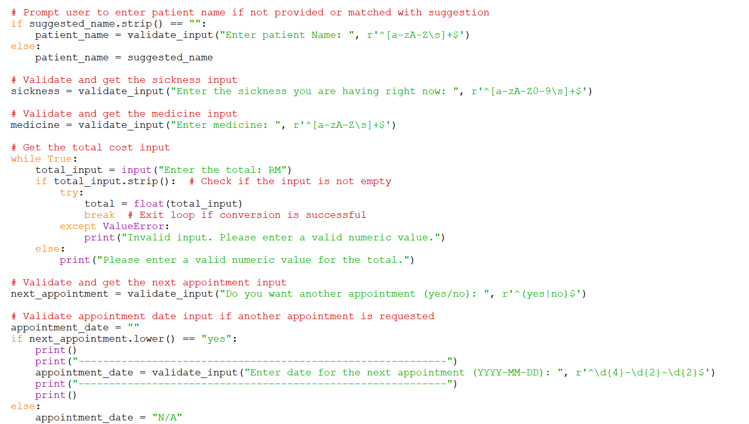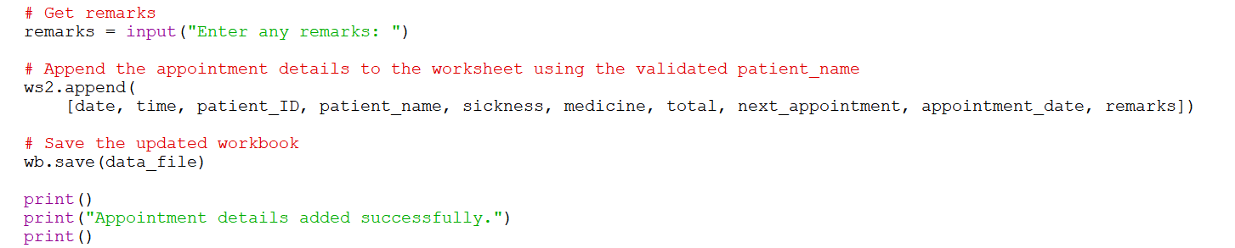

2.0.6 Edit appointment date and treatment detail
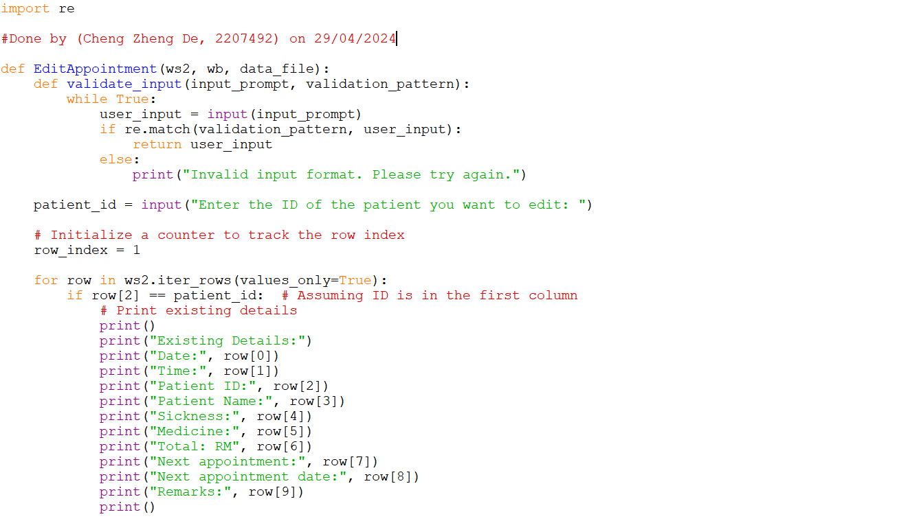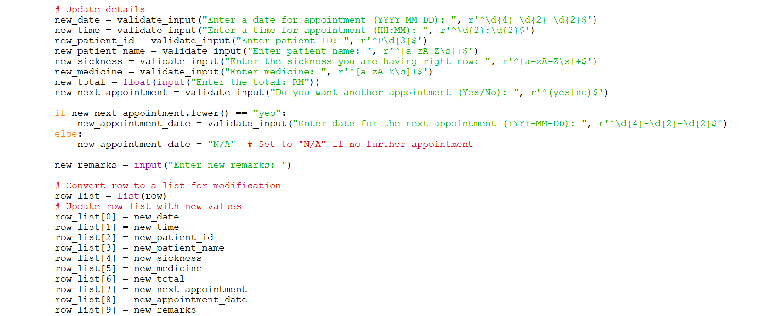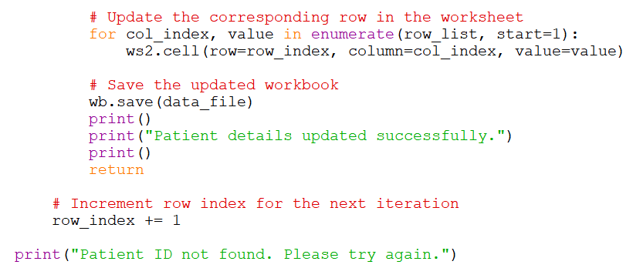
2.0.7 Print bill for patient
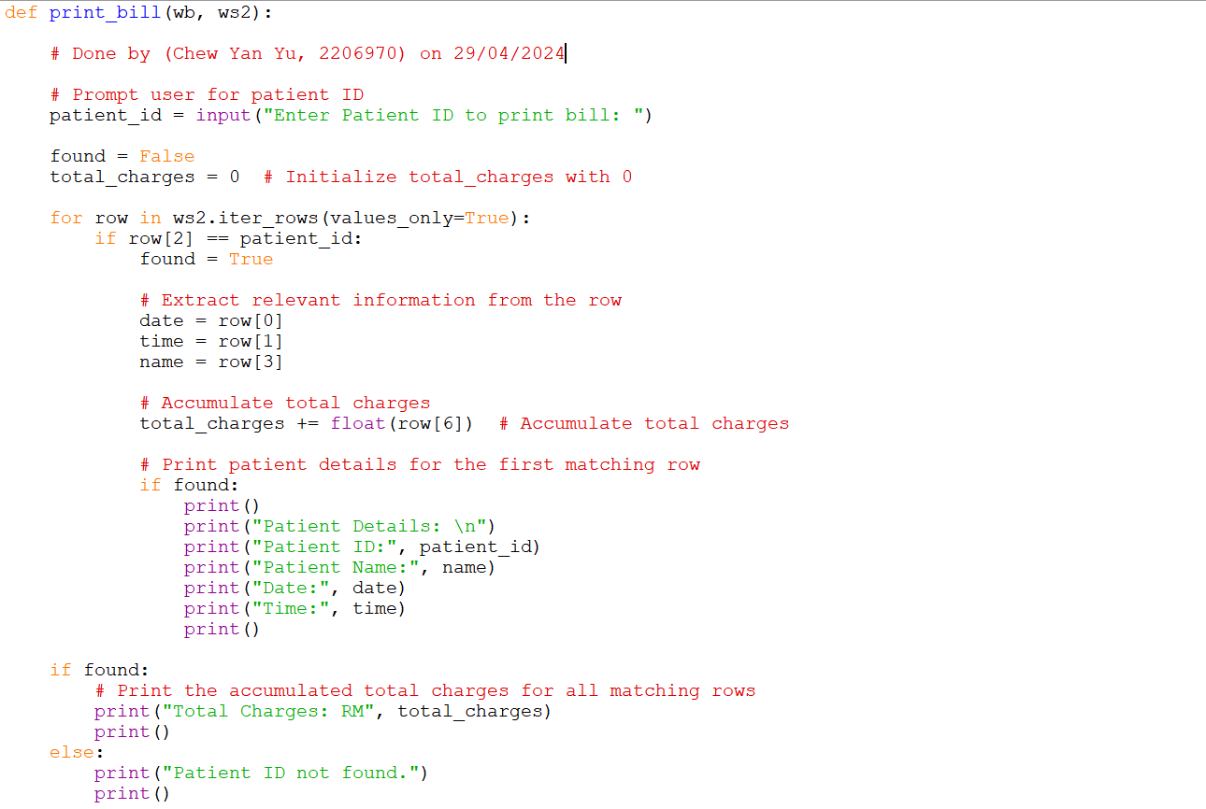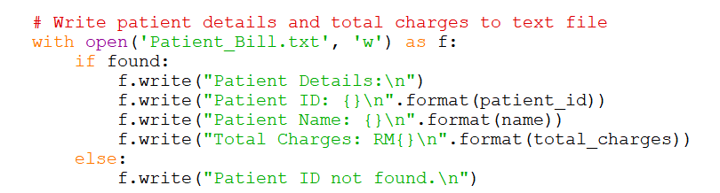

2.0.8 Generate Report for each month
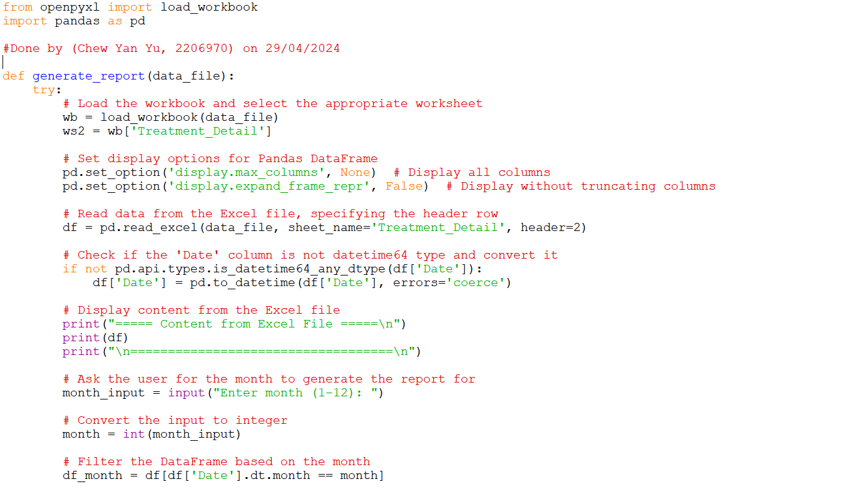
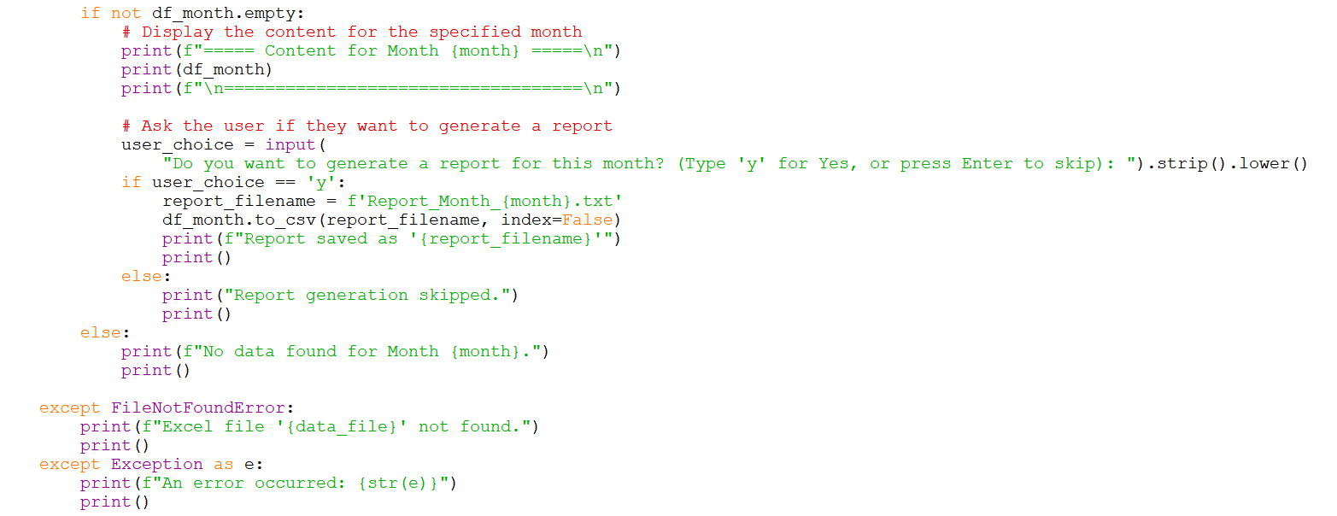

3.0 Extra Work
3.1 Import datetime
Done by (Cheng Zheng De, 2207492) on 29/04/2024
Figure 3.1.1 (same as part of Figure 2.0.1)
Import datetime as shown in Figure 3.1.1 is needed to carry out the below datetime function.
On the main menu page, it will show the current month ,year, date and time automatically.

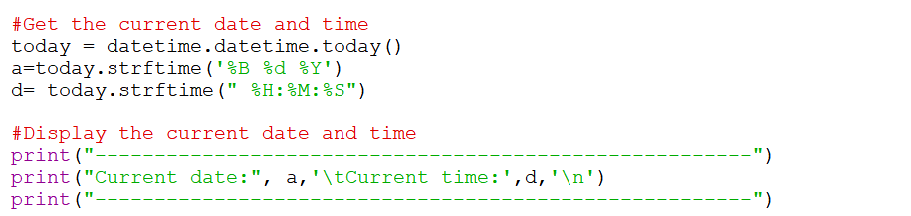
Figure 3.1.2 (same as part of Figure 2.0.1)
a = today.strftime('%B %d %Y'):
In this line, the strftime method is used to format the today datetime object as a string.

%B: This is a format code for the full month name (e.g., "April").
%d: This is a format code for the day of the month (e.g., "29" for the 29th day).
%Y: This is a format code for the year with century as a decimal number (e.g., "2024").

Therefore, the variable ‘a’ will contain a string that represents the current date in the format "Month/Day/Year", like "April 29 2024".

d = today.strftime(" %H:%M:%S")
This line uses the strftime method again to format the time part of the today datetime object.

%H: This is a format code for the hour (24-hour clock) (e.g., "22" for 10 PM).
%M: This is a format code for the minute as a zero-padded decimal number (e.g., "25" for 25 minutes past the hour).
%S: This is a format code for the second as a zero-padded decimal number (e.g., "33" for 33 seconds past the minute).

Therefore, the variable b will contain a string that represents the current time in the format "Hour:Minute:Second", like "22:25:33"

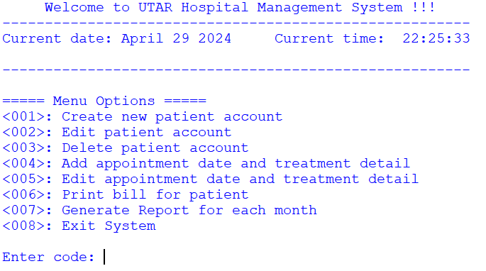
Figure 3.1.3 (same as Figure 1.2.1)
The final output with the menu option is shown in Figure 3.1.3

3.2 Import OS
Done by (Kan Lap Hoe, 2300123) on 29/04/2024
Figure 3.2.1 (same as part of Figure 2.0.1)
Import os as shown in Figure 3.2.1 is needed to carry out clear_screen function

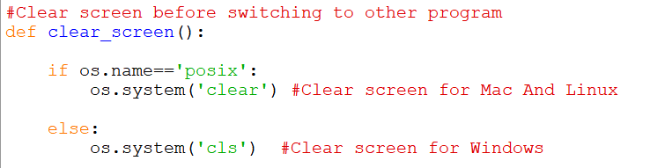
Figure 3.2.2 (same as part of Figure 2.0.1)
The clear_screen function as shown in Figure 3.2.2 is used to clear the screen to avoid user to have confusion when proceeding to a new function of a system.

3.3 Import Time and Thank You Message
Done by (Cheng Zheng De, 2207492) on 30/04/2024
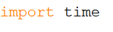
Figure 3.3.1 (same as part of Figure 2.0.1)
Import time is used in order to use the function time.sleep to pause for the specified durations in seconds, and then continue executing the subsequent code.
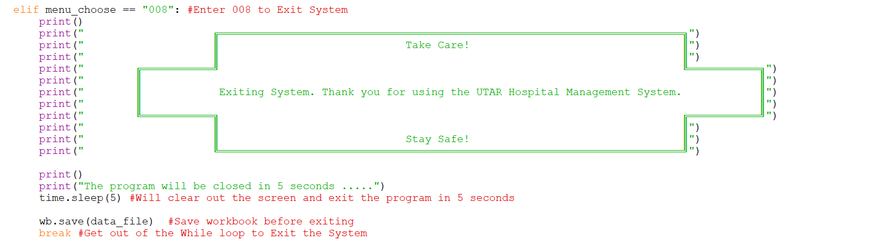
Figure 3.3.2 (same as part of Figure 2.0.1)

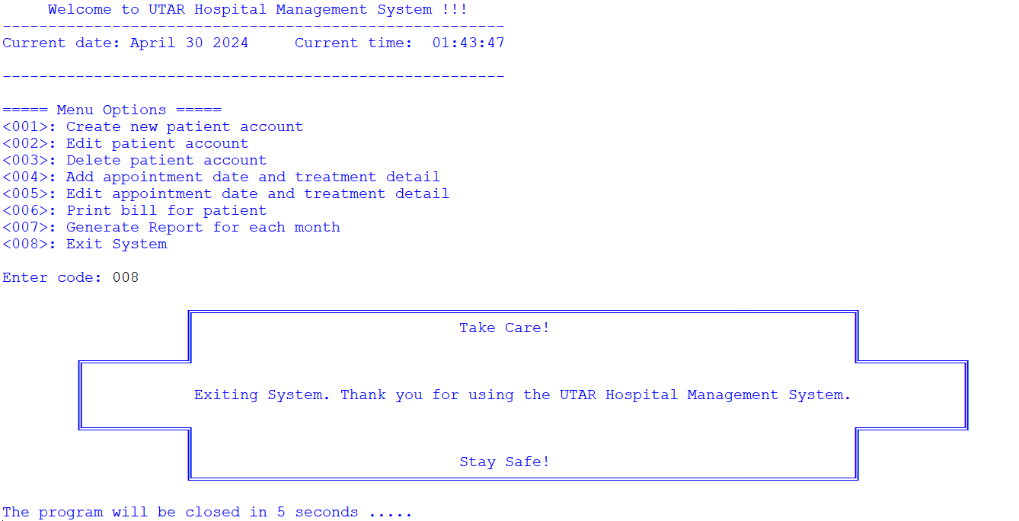
Figure 3.3.2 (same as Figure 1.10.1)
The programme will display a Thank You Message and clear off the screen in 5 seconds and exit the program.

3.4 File Creating and Writing
Done by (Chew Yan Yu, 2206970) on 29/04/2024
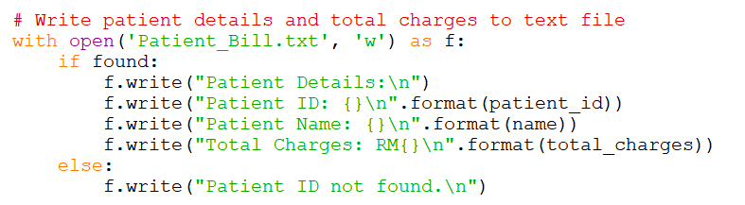
Figure 3.4.1 (same as part of Figure 2.0.7)

Figure 3.4.1 shows that this code creates or opens a file named “Patient_Bill.txt” in write mode and writes patient details (if found) or a specific message (if not found) to the file based on the ‘found’ condition, and automatically closes the file after writing. The use of formatted strings (‘format()’) allows variables to be inserted into the text written to the file.

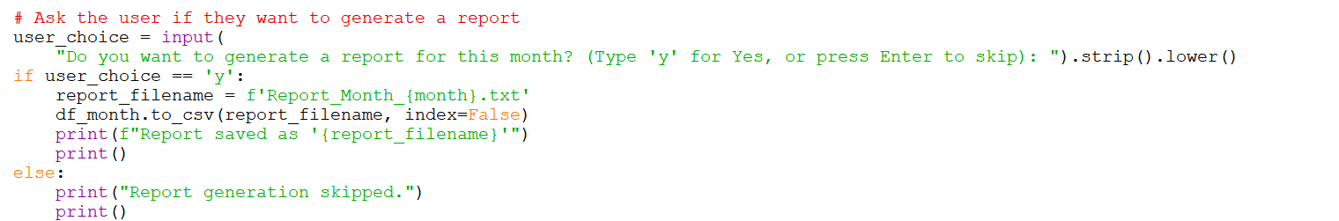
Figure 3.4.2 (same as part of Figure 2.0.8)

In Figure 3.4.2, this code efficiently handles the generation of a report in CSV format (Comma-Seperated Value) based on user input (‘user_choice’). If the user confirms (user_choice == ‘y’), a CSV file containing the filtered DataFrame (‘df_month’) is created with a file name. Upon completion, a confirmation message is displayed to inform the user of the successful report creation.

If the user opts not to generate the report, a corresponding message is printed indicating that the report generation was skipped.

4.0 Application of Advanced Level of Concepts
4.1 Functions
Done by (Cheng Zheng De, 2207492) on 29/04/2024
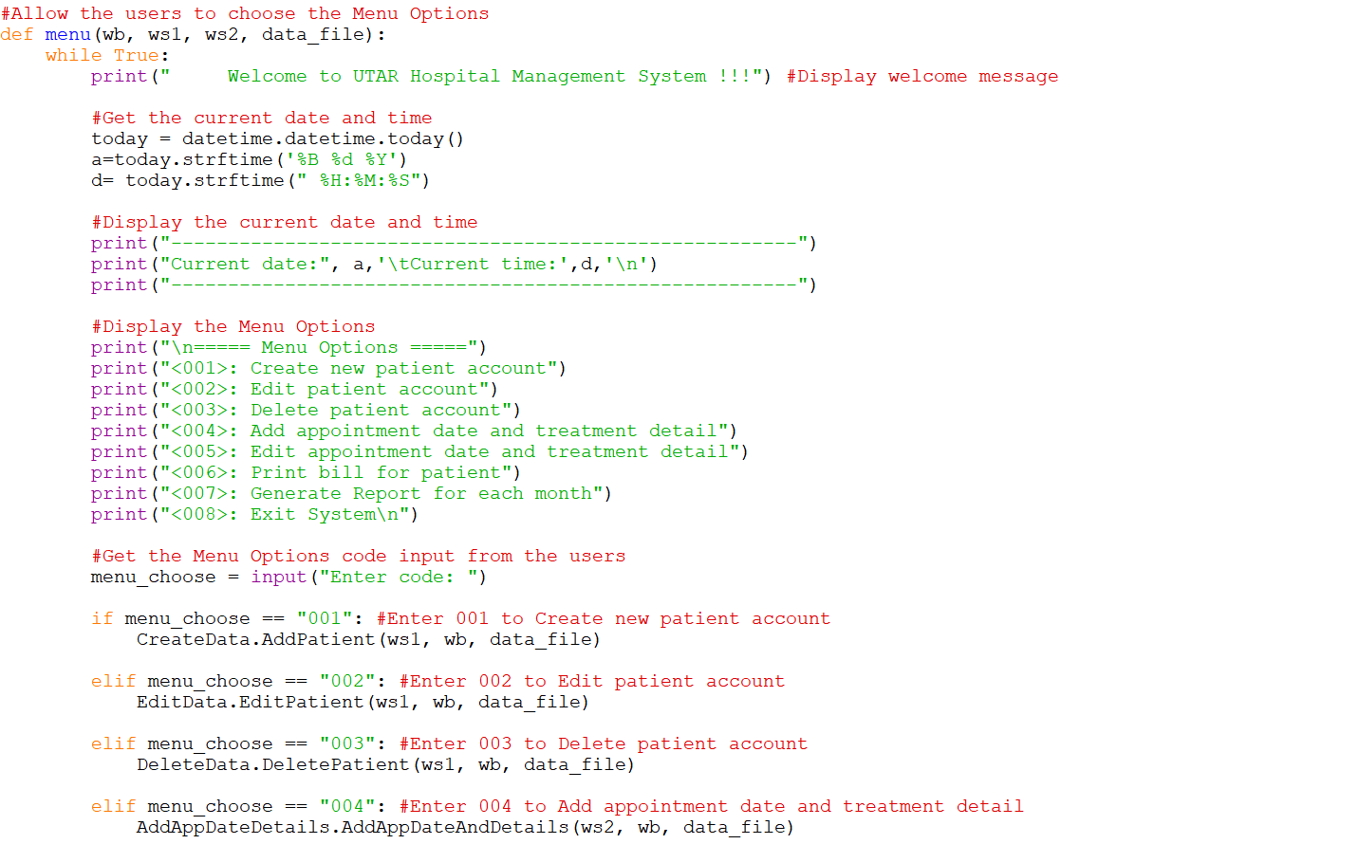
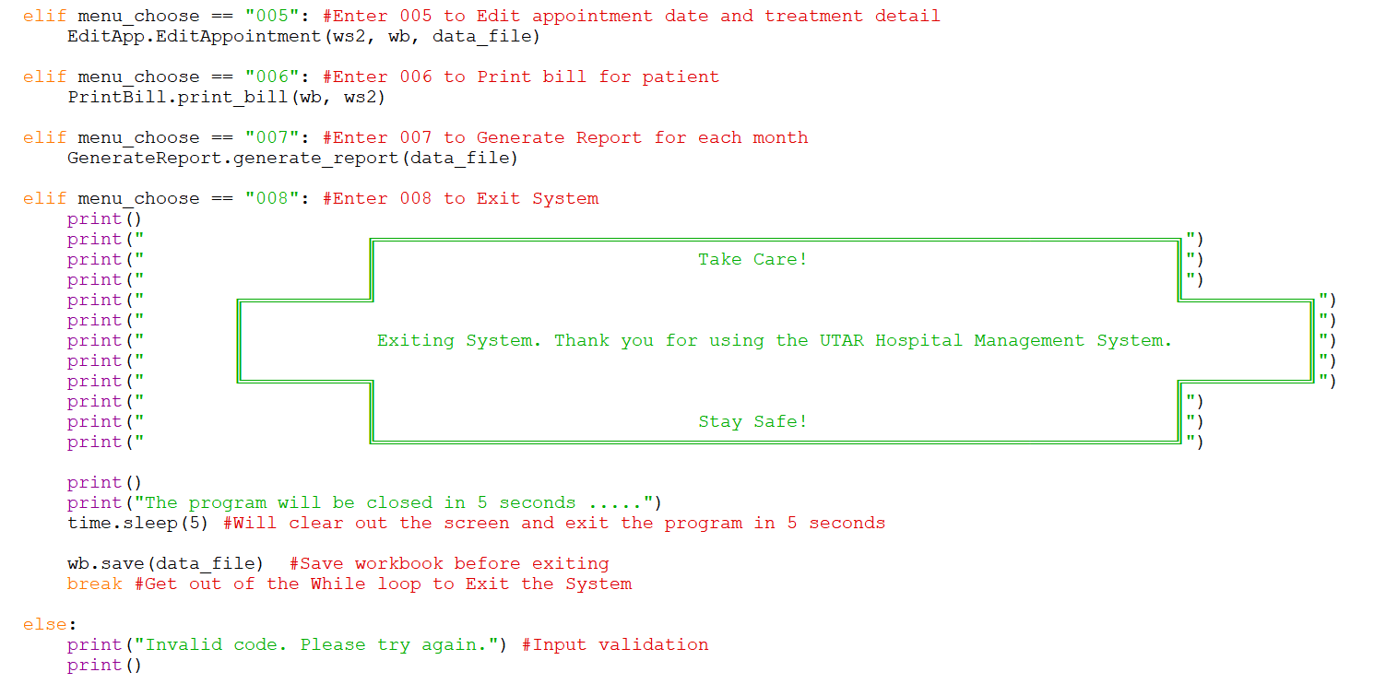
Figure 4.1.1 (same as part of Figure 2.0.1)
menu(wb, ws1, ws2, data_file)
The ‘menu ()’ function is the main user interface for the hospital management system. It presents a menu of options to the user and handles user input to execute various functionalities based on the chosen option.

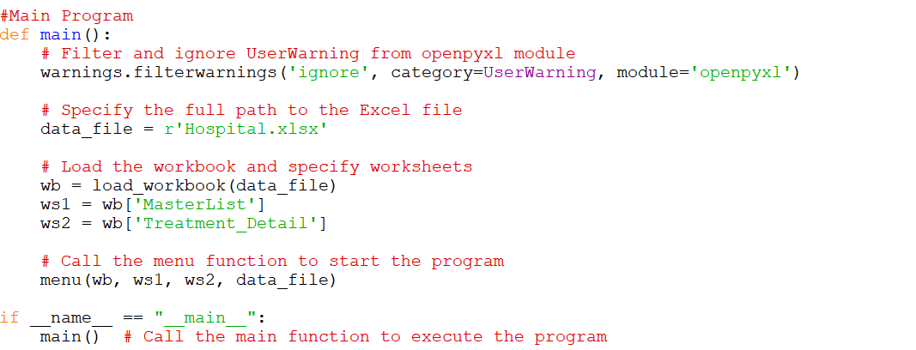
Figure 4.1.2 (same as part of Figure 2.0.1)
main()
The ‘main()’ function is the entry point of our program. It sets up the environment by filtering out specific warnings (UserWarning in this case) using ‘warnings.filterwarnings()’, loads the Excel workbook (‘Hospital.xlsx’) using ‘load_workbook()’, and then initializes the program by calling the ‘menu()’ function with the workbook (‘wb’), master list worksheet (‘ws1’), treatment detail worksheet (‘ws2’), and the data file path (‘data_file’).

1. Display Menu Options: It displays a list of available options for the user to choose from.

2. User Input and Execution: It prompts the user to enter a code corresponding to a specific action. Depending on the user's input, it calls various functions from different modules (‘CreateData’, ‘EditData’, ‘DeleteData’, ‘AddAppDateDetails’, ‘EditApp’, ‘PrintBill’, ‘GenerateReport’) to perform tasks such as adding, editing, or deleting patient data, managing appointments, printing bills, and generating reports.

3. Exiting the System: If the user chooses to exit (‘menu_choose == "008"’), it displays a customized farewell message with a decorative ASCII art and waits for a few seconds before saving the workbook and exiting the program.

This structure provides a well-organized approach to manage a hospital system through interactive menu-driven commands. The use of functions and modules keeps the code clean and maintainable, enhancing readability and scalability.

4.2 Exception handling
Done by (Chew Yan Yu, 2206970) on 29/04/2024
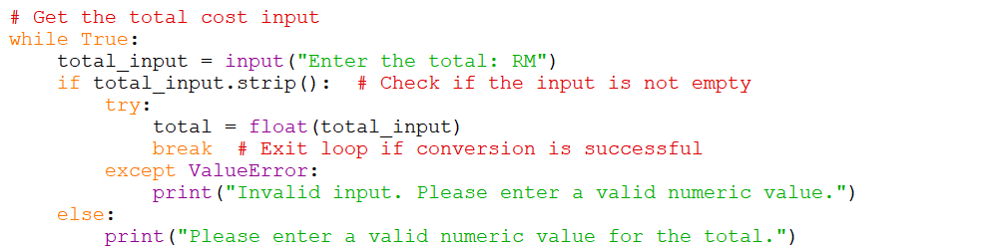
Figure 4.2.1 (same as part of Figure 2.0.5)

- The loop continues to prompt the user for input (‘total_input’).
- If the input is not empty, it attempts to convert it to a float (‘float(total_input)’).
- If the conversion is successful, the loop exits.
- If the input is empty or cannot be converted to a float, an error message is displayed, and the loop continues to prompt for input until a valid numeric value is entered.

This structure ensures that the program handles user input gracefully, providing appropriate feedback and ensuring that it does not proceed with invalid input. The loop structure allows the program to repeatedly prompt the user until a valid input is provided.



Figure 4.2.2 (same as part of Figure 2.0.8)

The code in Figure 4.2.2 uses exception handling to manage potential errors that might arise when generating a report from an Excel file using Pandas and openpyxl libraries. The ‘generate_report’ function attempts to load the specified Excel file (‘data_file’) and process data from the ‘Treatment_Detail’ worksheet.

Within the ‘try’ block, various operations are performed, such as reading the Excel data into a Pandas DataFrame, checking and converting the ‘Date’ column to datetime format if needed, and filtering the DataFrame based on a user-provided month.

If any operation encounters an error, specific exceptions (‘FileNotFoundError’ and ‘Exception’) are caught to handle different error scenarios. For instance, if the Excel file is not found (‘FileNotFoundError’), the program displays a corresponding message.

Similarly, if any other unexpected error occurs (‘Exception’), a generic error message with details about the encountered exception is printed for troubleshooting. This approach ensures that the program can gracefully handle errors and provide informative feedback to users.

4.3 Input Validation
Done by (Kan Lap Hoe, 2300123) on 29/04/2024
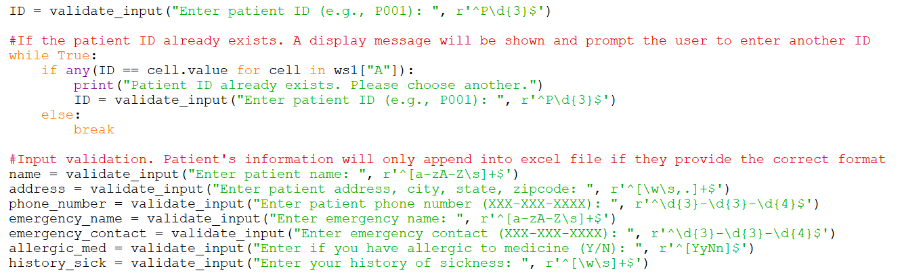
Figure 4.3.1 (same as part of Figure 2.0.2)
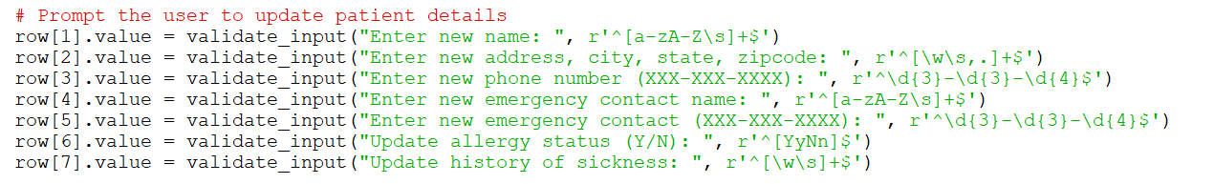
Figure 4.3.2 (same as part of Figure 2.0.3)

- ‘validate_input’ Function:

This code likely uses a function called `validate_input` to prompt the user for input and validate that input against a specified regular expression pattern.

- Variables and Prompts:

Each line is assigning a variable based on the output of the `validate_input` function.

- name = validate_input("Enter patient name: ", r'^[a-zA-Z\s]+$'):

This line prompts the user to enter a patient's name. The input will be validated against the regular expression `r'^[a-zA-Z\s]+$'`, which allows only alphabetic characters (both uppercase and lowercase) and spaces.

- address = validate_input("Enter patient address, city, state, zipcode: ", r'^[\w\s,.]+$'):

This line prompts the user to enter an address (including city, state, and zipcode). The input will be validated against the regular expression `r'^[\w\s,.]+$'`, which allows alphanumeric characters (`\w`), spaces (`\s`), commas, and periods.

- phone_number = validate_input("Enter patient phone number (XXX-XXX-XXXX): ", r'^\d{3}-\d{3}-\d{4}$'):

This line prompts the user to enter a phone number in the format `XXX-XXX-XXXX`. The input will be validated against the regular expression `r'^\d{3}-\d{3}-\d{4}$'`, which ensures the input matches this specific phone number format.

- emergency_name = validate_input("Enter emergency name: ", r'^[a-zA-Z\s]+$'):

This line prompts the user to enter the name of an emergency contact. The input will be validated using the same pattern as the patient's name (`r'^[a-zA-Z\s]+$'`).

- emergency_contact = validate_input("Enter emergency contact (XXX-XXX-XXXX): ", r'^\d{3}-\d{3}-\d{4}$'):

This line prompts the user to enter the phone number of an emergency contact. Similar to the patient's phone number, the input must match the `XXX-XXX-XXXX` format.

- allergic_med = validate_input("Enter if you have allergic to medicine (Y/N): ", r'^[YyNn]$'):

This line prompts the user to specify whether they have allergies to medicine, accepting only 'Y', 'y', 'N', or 'n' as valid inputs.

- history_sick = validate_input("Enter your history of sickness: ", r'^[\w\s]+$'):

Finally, this line prompts the user to enter their history of sickness. The input is validated against the pattern `r'^[\w\s]+$'`, which allows alphanumeric characters and spaces.

By using regular expressions for input validation, this code helps ensure that the collected data is consistent and correctly formatted, reducing the risk of errors in subsequent processing or storage of the information.

5.0 Conclusion
Done by (Cheng Zheng De, 2207492) on 29/04/2024
By addressing the challenges faced by hospitals in managing their operations effectively, the proposed Hospital Management System (HMS) aims to revolutionize healthcare administration, enhance patient care, and improve the overall efficiency and sustainability of hospital operations.

Benefits includes:
- Enhanced Efficiency: By streamlining information flow and automating repetitive procedures, medical professionals can increase operational efficiency and concentrate on providing high-quality patient care.

- Improved Patient Experience: Patients are more satisfied and loyal when they have quick access to healthcare resources, personalised services, and streamlined processes.

