### Java for Smart Phone Mini B Assignment 3

Name: Cheng Zhang Email:cheng.zhang@sv.cmu.edu ID:chengzh1

1. Test Environment

My project is mainly tested by emulator with the following configuration:

* 1. Device: Nexus S (4.0’’, 480*800:hdpi)
  2. Target: (Android 4.2 – API Level 17)

1. UI of the Marketing app:

The Main Activity is a brief introduction of the a vocal artist, it includes some basic information about the vocal artist. When you click the office website and social network website, it links to the related website.

When you click the song1 and song2 button, you will go to the songs activity and listen 2 sample songs. When you click the video1 and video2, you will go to the videos activity and can watch 2 sample videos.

When you click the send email button, you will go to mailinglist activity and can fill in a form to send email. (Note: in mailinglist activity, I use intent of ACTION_SEND to call an app, but as in my emulator, no app could response this intent, so it could not actually send an email, I do not know if there is another good way to do it. )

When you click the wall paper button, you go to the livewallpaperservice, here a use a wall paper service to show a set of live wall paper.

All these figures are displayed as following:

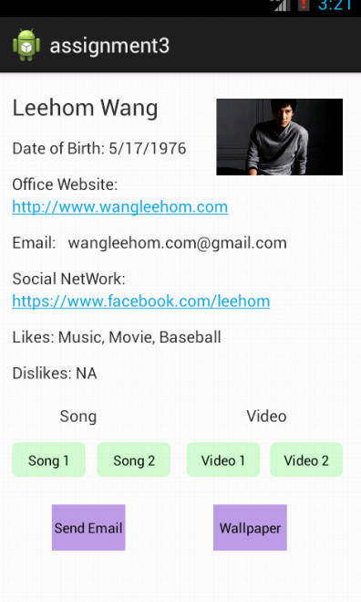

Figure1 Main Activity

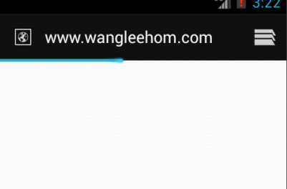

Figure2 Link to office website

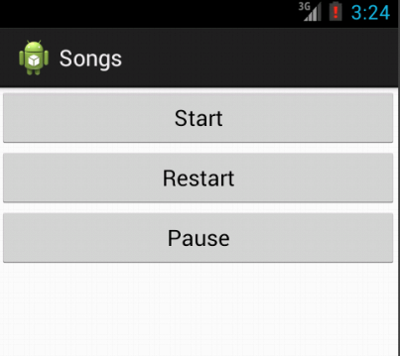

Figure3 songs activity



Figure4 videos activity

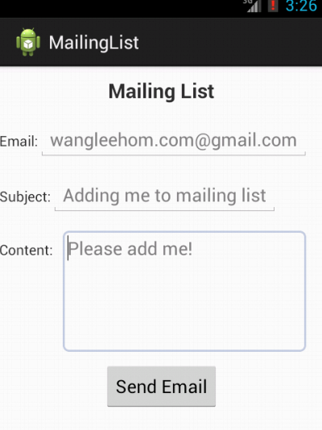

Figure5 Mailinglist Activity



Figure6 LiveWallpaper