### Java for Smart Phone Mini B Assignment 2

Name: Cheng Zhang Email:cheng.zhang@sv.cmu.edu ID:chengzh1

1. Test Environment

My project is mainly tested by emulator with the following configuration:

* 1. Device: Nexus 4 (4.7’’, 768*1280:xhdpi)
  2. Target: (Android 4.3 – API Level 18)

It is also tested in emulated device with different screen size.

1. UI of the Mortgage Calculoator:
   1. For regular size:

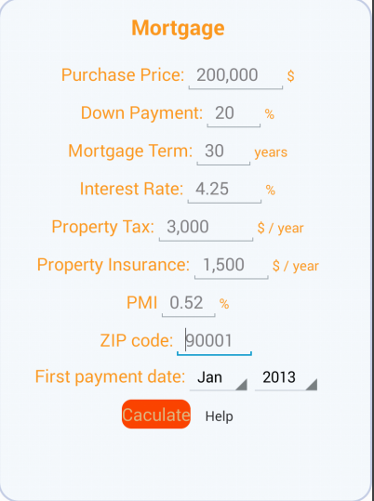

* 1. For small screen

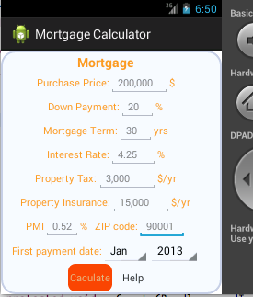

* 1. For large screen

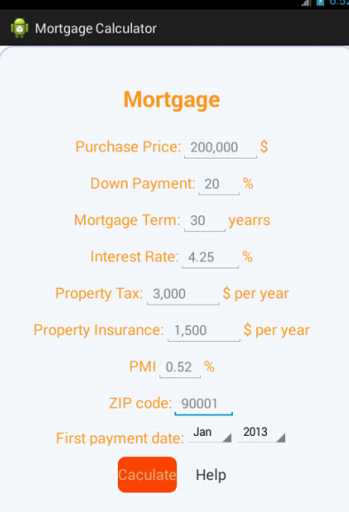

* 1. For xlarge screen

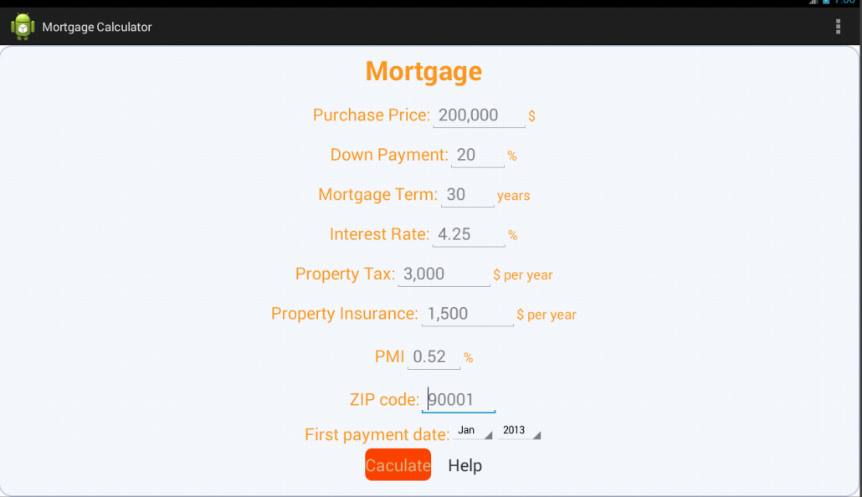

1. Function of the Calculator:
   1. All the editText part can input only number, and the editText in “Interest Rate” can input decimal number.
   2. editText in PMI as the default value of 0.52 and cannot input
   3. Hint is added to each of editText to suggest what should be input.
   4. In the “First payment date” row, spinner is used to select month and year.
   5. When click the help link, a dialog will display the needed information, just as the following picture:

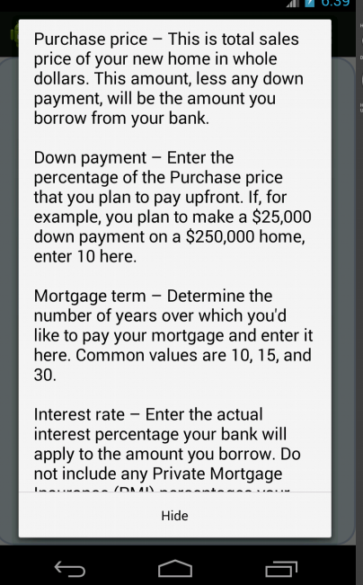

* 1. The Calculator use sqLite to save the calculation result and will read it to show the result. The database looks like the following picture:

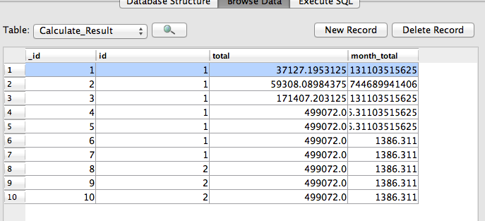

1. Result of the Calculation

Like the following picture, month payment, total payment and pay off date will show on another page:

