$$\min_{P,\tilde{P},L,E}{{\left\|P\right\|}_{*}+λf\left(\tilde{P},L\right)+ν{\left\|E\right\|}_{1}}+α{\left\|L-PL\right\|}_{F}^{2}, s.t. X=L+E, {\tilde{P}}^{T}\tilde{P}=I,P^{T}=P$$

$$\min_{P,\tilde{P},L,E}{{\left\|P\right\|}_{*}+λf\left(\tilde{P},L\right)+ν{\left\|E\right\|}_{1}}+α{\left\|L-PL\right\|}_{F}^{2}+tr\left(Y^{T}\left(X-L-E\right)\right)+\frac{μ}{2}{\left\|X-L-E\right\|}_{F}^{2}, s.t. {\tilde{P}}^{T}\tilde{P}=I,P^{T}=P, L=J$$

$$\min_{P,\tilde{P},L,E,J}{{\left\|P\right\|}_{*}+λf\left(\tilde{P},J\right)+ν{\left\|E\right\|}_{1}}+α{\left\|L-PL\right\|}_{F}^{2}+tr\left(Y_{1}^{T}\left(X-L-E\right)\right)+tr(Y_{2}^{T}\left(L-J\right))+\frac{μ}{2}{(\left\|X-L-E\right\|}_{F}^{2}+{\left\|L-J\right\|}_{F}^{2}), s.t. {\tilde{P}}^{T}\tilde{P}=I,P^{T}=P$$

**Update $P,L$**

$$\min_{P,L}{{\left\|P\right\|}_{*}}+α{\left\|L-PL\right\|}_{F}^{2}+tr\left(Y_{1}^{T}\left(X-L-E\right)\right)+tr(Y_{2}^{T}\left(L-J\right))+\frac{μ}{2}{(\left\|X-L-E\right\|}_{F}^{2}+{\left\|L-J\right\|}_{F}^{2}), s.t. P^{T}=P$$

$$\min_{P,L}{{\left\|P\right\|}_{*}}+α{\left\|L-PL\right\|}_{F}^{2}+μ({\left\|L-(J+X-E+\frac{Y_{1}-Y_{2}}{μ})/2 \right\|}_{F}^{2}), s.t. P^{T}=P$$

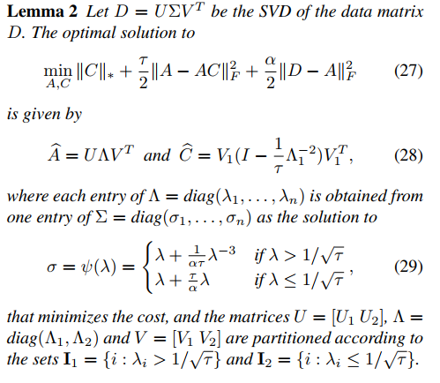It has closed-form solution, similar to the following

$$\min_{L,P}{{\left\|P\right\|}_{*}+\frac{τ}{2}\left\|L-PL\right\|+\frac{α}{2}{\left\|L-D\right\|}_{F}^{2}} s.t. P^{T}=P$$

$$τ=2α\left(input to function\right), α=2μ,$$

$$P=U_{1}P_{τ}\left(Λ\right)U_{1}^{T}, L=UΛV^{T},$$

$$D=(J+X-E+\frac{Y_{1}-Y_{2}}{μ})/2=UΣV^{T},Λ={\tilde{P}}_{α,τ}\left(Σ\right)$$

$$P_{τ}\left(x\right)=1-\frac{1}{τx^{2}}, if x>\frac{1}{\sqrt{τ}};or 0;t=\frac{α+τ}{ατ}$$

$${\tilde{P}}_{α,τ}\left(σ\right)=σ,if σ>{\tilde{σ}}_{*}=\sqrt{t+\sqrt{t/α}}; or\frac{1}{tτ}σ$$

$$U_{1}=U_{I_{1}}, I_{1}=\{i∈λ_{i}>1/\frac{1}{\sqrt{τ}}\}$$

**Update $J$,**

$$\min_{J}{λf\left(\tilde{P},J\right)+}tr\left(Y_{2}^{T}\left(L-J\right)\right)+\frac{μ}{2}{\left\|L-J\right\|}_{F}^{2})$$

$$fisher\left(\tilde{P},J\right)={\left\|{\tilde{P}}^{T}J(I-H_{1})\right\|}_{F}^{2}-{\left\|{\tilde{P}}^{T}J\left(H_{1}-H_{2}\right)\right\|}_{F}^{2}+1.1{\left\|{\tilde{P}}^{T}J\right\|}_{F}^{2}$$

$${argmin_{P} λ(\left\|{\tilde{P}}^{T}J(I-H_{1})\right\|}_{F}^{2}-{\left\|{\tilde{P}}^{T}J\left(H_{1}-H_{2}\right)\right\|}_{F}^{2}+1.1{\left\|{\tilde{P}}^{T}J\right\|}_{F}^{2})+\frac{μ}{2}{\left\|L-J+Y_{2}/μ\right\|}_{F}^{2}$$

Take derivative and it is

-> $tr\left(XX^{T}\right)=tr(X^{T}X)={\left\|X\right\|}_{F}^{2}$

-> $∇tr\left(AXBX^{T}C\right)= A^{T}C^{T}XB^{T}+CAXB$

$$λ\left(2{\tilde{P}\tilde{P}}^{T}J{\left(I-H_{1}\right)}^{2}-2{\tilde{P}\tilde{P}}^{T}J{\left(H_{1}-H_{2}\right)}^{2}+2.2\tilde{P}{\tilde{P}}^{T}J\right)+μ\left(J-L-Y_{2}/μ\right)=0$$

$${\tilde{P}\tilde{P}}^{T}J({\left(I-H_{1}\right)}^{2}-{\left(H_{1}-H_{2}\right)}^{2}+1.1I_{n×n})+\frac{μ}{2λ}\left(J-L-Y_{2}/μ\right)=0$$

-> $A={\left(I-H_{1}\right)}^{2}-{\left(H_{1}-H_{2}\right)}^{2}+1.1I_{n×n}$

$${\tilde{P}\tilde{P}}^{T}JA+\frac{μ}{2λ}\left(J-L-Y_{2}/μ\right)=0$$

$${\tilde{P}\tilde{P}}^{T}JA+\frac{μ}{2λ}J=\frac{μ}{2λ}\left(L+\frac{Y_{2}}{μ}\right)$$

$${\tilde{P}\tilde{P}}^{T}J+J\frac{μ}{2λ}A^{-1}=\frac{μ}{2λ}\left(L+\frac{Y_{2}}{μ}\right)A^{-1}$$

Sylvester solver

If $λ=0$, updating $J$ will not exist

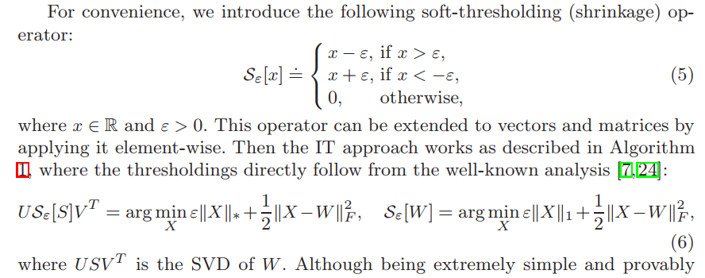**Update $E$,**

$$\min_{E}{ν{\left\|E\right\|}_{1}}+tr\left(Y_{1}^{T}\left(X-L-E\right)\right)+\frac{μ}{2}{\left\|X-L-E\right\|}_{F}^{2}$$

$$\min_{E}{ν{\left\|E\right\|}_{1}}+\frac{μ}{2}{\left\|X-L-E+\frac{Y_{1}}{μ}\right\|}_{F}^{2}$$

$$W=X-L+Y_{1}/μ$$

$$ε=ν/μ$$

If $ν=0$

$$E=E_{0}=0$$

**Update $\tilde{P}$**

$$\min_{\tilde{P}}{λf\left(\tilde{P},J\right)}, s.t. {\tilde{P}}^{T}\tilde{P}=I$$

$$\underset{\tilde{P}}{minλ(}{{\left\|{\tilde{P}}^{T}J(I-H_{1})\right\|}_{F}^{2}-{\left\|{\tilde{P}}^{T}J\left(H_{1}-H_{2}\right)\right\|}_{F}^{2}+1.1{\left\|{\tilde{P}}^{T}J\right\|}_{F}^{2}} ), s.t. {\tilde{P}}^{T}\tilde{P}=I$$

$$\min_{\tilde{P}}{λ({\left\|{\tilde{P}}^{T}J\left(I-H_{1}\right)\right\|}_{F}^{2}-{\left\|{\tilde{P}}^{T}J\left(H_{1}-H_{2}\right)\right\|}_{F}^{2}+1.1{\left\|{\tilde{P}}^{T}J\right\|}_{F}^{2}})+β ({\tilde{P}}^{T}\tilde{P}-I)$$

Take derivative

$$λ\left(J{\left(I-H_{1}\right)}^{2}J^{T}-J{\left(H_{1}-H_{2}\right)}^{2}J^{T}+1.1JJ^{T}\right)\tilde{P}=-β\tilde{P}$$

$$\tilde{P} are the smallest nonzero eigenvectors of$$

$$λ\left(J{\left(I-H_{1}\right)}^{2}J^{T}-J{\left(H_{1}-H_{2}\right)}^{2}J^{T}+1.1JJ^{T}\right)$$

If $λ=0$

$$\tilde{P}={\tilde{P}}_{0}=I$$

**Update $Y_{1}$,**

$$Y_{1} = Y_{1} +μ(X - L- E)$$

**Update $Y_{2}$,**

$$Y_{2} = Y_{2} +μ(L-J)$$

**Update $μ$,**

$$μ=ρμ$$