**Comparison of CNN vs. ML models for EEG-based Schizophrenia Detection**

**Introduction**

This project aims to develop a CNN model capable of analyzing electroencephalography (EEG) data to detect potential schizophrenia. Utilizing datasets comprising EEG recordings from both control subjects and patients with schizophrenia, the model will hopefully learn to identify patterns associated with the disorder, particularly focusing on the suppression of the N100 component, a feature observed in control subjects but not in patients with schizophrenia.

**Group Members**

* Chenhao Lu
* Nada Saaidia

**Objectives**

* **Model Development**: To train a hierarchical CNN model proposed in the paper<https://www.mdpi.com/2079-9292/10/24/3183>using EEG data on categorizing regular vs. schizophrenic subjects. The HCNN works by assigning a weight to every image before training, and updating the weights after training every sub-network based on the classification results. The updated weights are then used to train the next sub-network.
* **Comparison with ML classifiers**: Since the EEG data are not images, the CNN model may not be the optimal solution for EEG-based schizophrenia detection. Therefore, we hope to compare its performance against some of the traditional machine learning classifiers.

**Datasets**

The project will use two datasets available on Kaggle:

* [Button Tone SZ Dataset](https://www.kaggle.com/datasets/broach/button-tone-sz/)
* [ButtonToneSZ2 Dataset](https://www.kaggle.com/datasets/broach/buttontonesz2)

These datasets include EEG data from 32 controls and 49 patients with schizophrenia.

**Methodology**

1. **Preprocessing**: The EEG data has 74 columns, with the first 4 being subject ID, trial ID, condition number, and sample ID. The remaining columns correspond to the 70 different EEG features. For each of the 81 subjects, we only kept the trials with 9216 samples in order to keep the data shapes consistent, and that gave us 7092 trials. We then reduced the total number of samples by averaging every 64 rows, resulting in a final dimensionality of 7092 x 144 x 70 where 144 = 9216 / 64. Finally, we used a min-max scaler to normalize the features. The labels were one-hot encoded and the data was split using a 75/25 split into training and test sets.
2. **Model** **Building**: We tested 2 CNN models and 2 ML classifiers for this project. The first CNN is a simple CNN with 3 convolutional layers, two fully-connected layers, and the leaky ReLU activation function. The second CNN is the HCNN from the paper above. We built it using a combination of MobileNetV1, EfficientNetB0, and ResNet-50. The SVM is a support vector machine with the default settings, and the MLP is a neural network with 3 hidden layers of sizes 32, 32, 16.
3. **Model Training**
   * The 3-layer CNN was trained for 100 epochs using the binary cross entropy loss, SGD, and a learning rate of 0.02.
   * The HCNN was trained for 30 epochs using SGD, a learning rate of 0.02, and a weighted combination of CCE loss and triplet loss with the weight ɑ = 0.25.
   * When training the ML classifiers, we flattened the data first so that each sample could be represented by a vector, and then applied PCA to reduce the dimensionality of our data matrix.

**Results & Discussion**

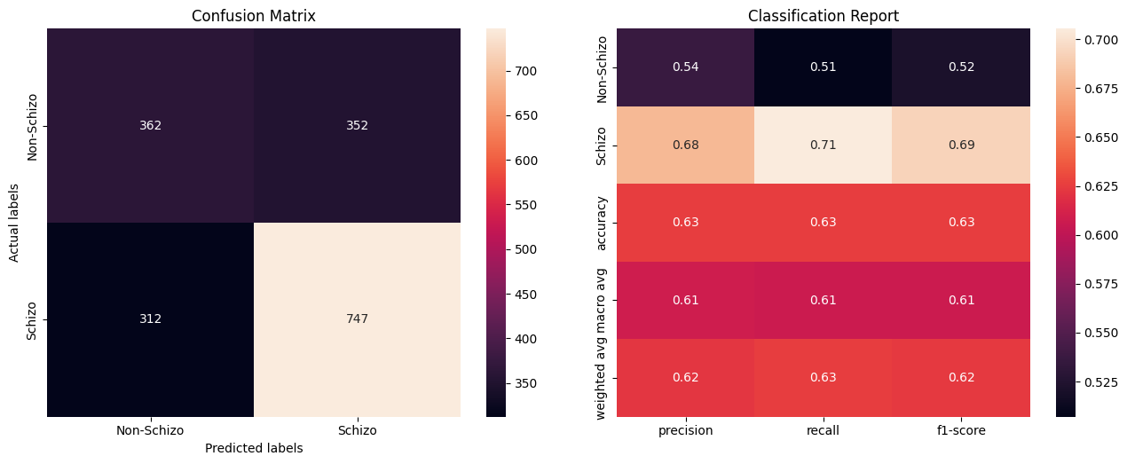

Fig 1. Confusion matrix and classification report of the 3-layer CNN

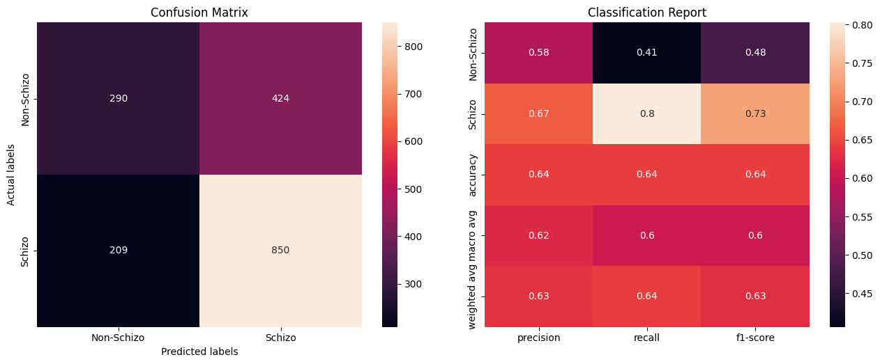

Fig 2. Confusion matrix and classification report of the HCNN

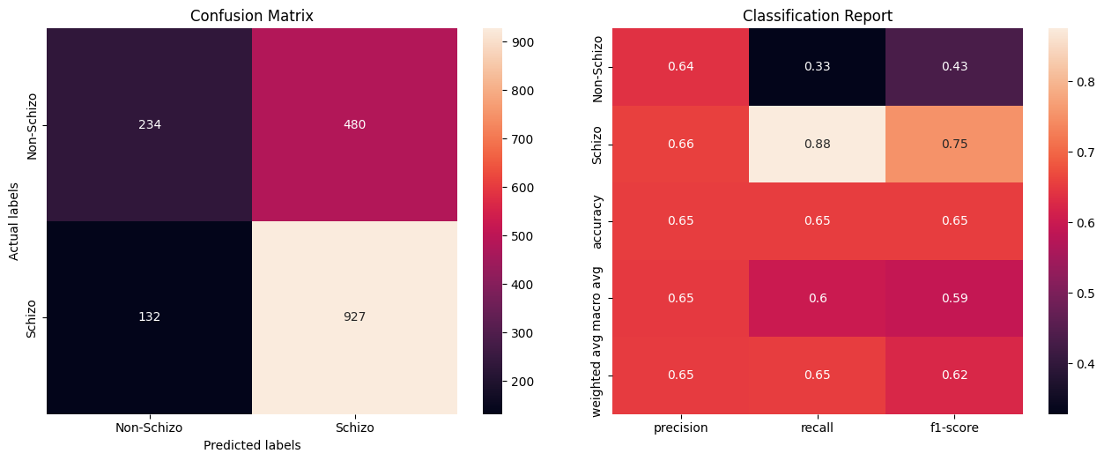

Fig 3. Confusion matrix and classification report of the SVM

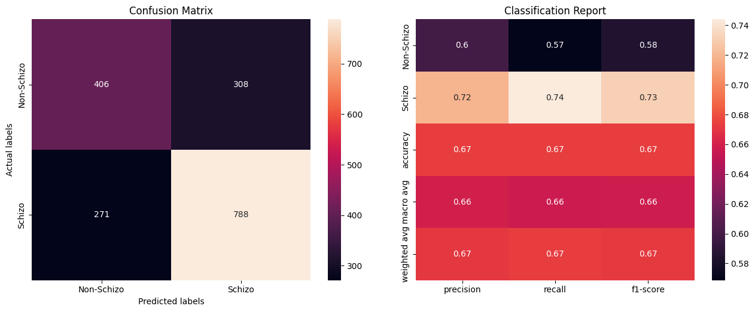

Fig 4. Confusion matrix and classification report of the MLP

Figures 1-4 above correspond to the confusion matrix and classification report of the four classifiers we tested. The accuracies on the 1773 test samples are 62.54%, 64.29%, 65.48%, and 67.34% respectively for the CNN, HCNN, SVM, and MLP. Overall, the MLP achieved the highest accuracy and a balance between the two classes. It only captured 74% of the true positives, but also managed to find 57% of the true negatives, which is at least 16% higher than the SVM and the HCNN. If we look at the schizophrenia class specifically, the SVM achieved the highest recall of 0.88, meaning that 88% of schizophrenic EEG samples can be captured by the model. However, it did this at the compromise of the non-schizophrenia class where it only achieved a recall of 0.33. In other words, the model predicted a majority (1407) of the 1773 test samples as schizophrenia. Similarly, the HCNN also has the same issue where a large gap exists between the recall of the two classes. But if we need to perform this task in a real-world setting, we may even prioritize the two less-balanced models because the consequence of false negatives can be very costly.

The results matched our expectations for this project. Since a CNN learns by preserving spatial information within small local windows, it is possible that it doesn’t work very well for the data we have. Even though the data is in 2D, it is still tabular data and spatial information within local windows do not tell much, if at all, about the feature relationships. It’s more meaningful to look at each row individually rather than sliding a convolutional filter across the rows, which is why the MLP proved to be the most effective overall in this case.