Hadnout PySP
PySP: (Pyomo Stochastic Programming), where parameters are allowed to be uncertain.
The underlying algorithm in pysp is based on Progressive Hedging, which decomposes the problem into sub-problem, one for each scenario.

The sequence of activities is typically the following:
- 建立deterministic model
- Develop base-case data for the deterministic model
- Test, verify and validate the deterministic model
- Model the stochastic processes
- Develop a way to generate scenarios (in the form of a tree if there are more than two stages)
- Create the data files need to describe the stochastics
- Use PySP to solve stochastic problem

如果以 file creation流程來看，分為4步：
- 建立abstract model for deterministic problem (ReferenceModel.py)
- 給定此model的資料(ReferenceModel.dat)
- 給定隨機的資料(ScenarioStructure.dat)
- 指定Scenario data

Farmer’s problem
- 農夫要在他的500 acres農地上種植wheat, corn與sugar beets三種作物，且必須在冬天之前做出決定。
- Wheat種植成本$150/acre, corn種植成本為$230/acre, sugar beets種植成本為$260/acre為了cattle feed，至少必須有 200 tons (T) of wheat與240 T of corn. 這些農產品可用種植或是向wholesaler購買。
- 如果農產品的量超出需求時，則將農產品賣出。Wheat賣出價為$170/T, corn賣出價$150/T。但是若是量wholesaler購買時，上述兩產品為(wheat:$238/T, corn: $210/T)。
- Sugar beet賣出價為$36/T, 但European Commission有限制sugar beet的產量，若超過產量時，sugar beet的賣出價只有$10/T，而農夫的產量限制為6000T.
- 根據經驗，農夫知道他的農地wheat產量為2.5T/acre, corn產量為3T/acre, sugar beet產量為20T/acre.

以下為模型的決策參數：
- x1: 農地種稙wheat的面積(acre)
- x2: 農地種稙corn的面積(acre)
- x3: 農地種稙sugar beet的面積(acre)
- w1: wheat賣出量(ton)
- y1: wheat買進量(ton)
- w2: corn賣出量(ton)
- y2: corn買進量(ton)
- w3: sugar beet賣出量(ton) (at higher price)
- w4: sugar beet 賣出量(ton) (at lower price)
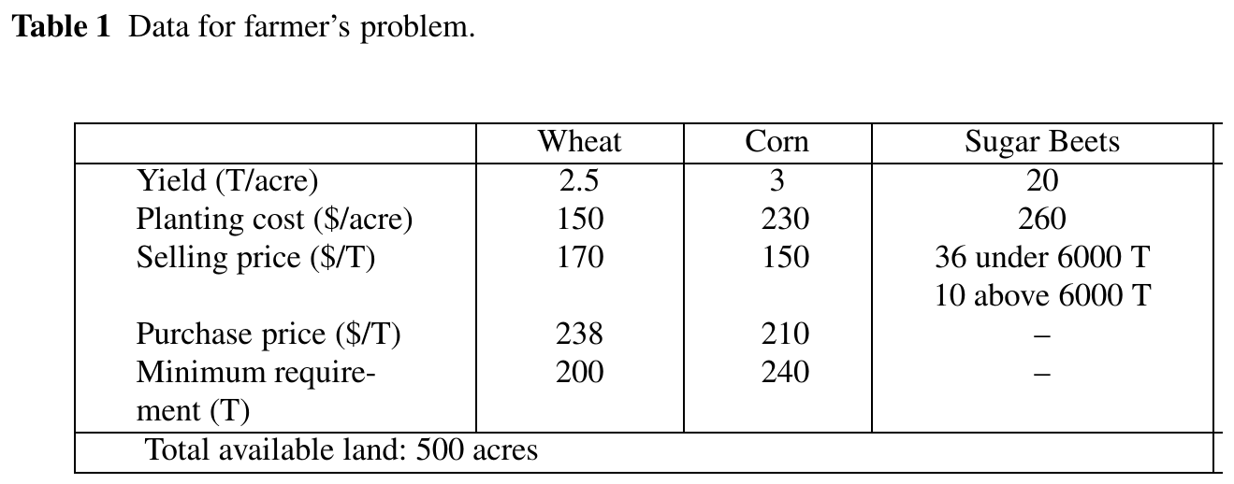

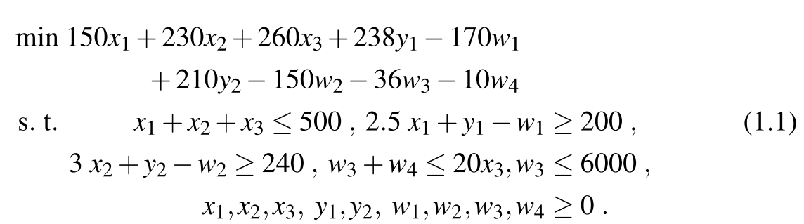

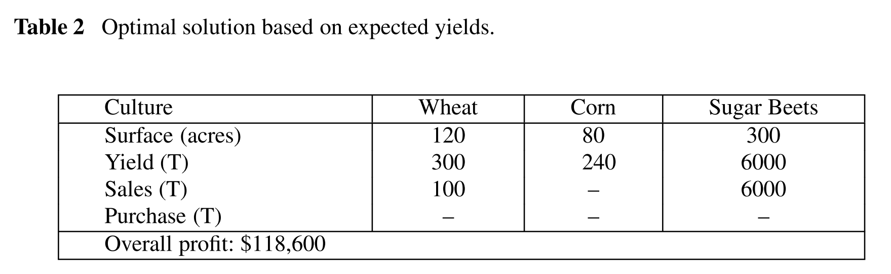

ReferenceModel.py
# Farmer: rent out version has a singleton root node var
# note: this will minimize
from coopr.pyomo import *

# Model
model = AbstractModel()

# Parameters
model.CROPS = Set() #三種作物(WHEAT CORN SUGAR_BEETS)
model.TOTAL_ACREAGE = Param(within=PositiveReals) #農場面積(500)

#只有SUGAR BEETS有價格quota ( WHEAT 100000 CORN 100000 SUGAR_BEETS 6000 )
model.PriceQuota = Param(model.CROPS, within=PositiveReals)

#賣出價格(未超出 Quota限制時)WHEAT 170 CORN 150 SUGAR_BEETS 36 ;
model.SubQuotaSellingPrice = Param(model.CROPS, within=PositiveReals)

def super_quota_selling_price_validate (model, value, i):
return model.SubQuotaSellingPrice[i] >= model.SuperQuotaSellingPrice[i]

#賣出價格(超出Quota限制時) WHEAT 0 CORN 0 SUGAR_BEETS 10 ;
model.SuperQuotaSellingPrice = Param(model.CROPS, validate=super_quota_selling_price_validate)

#種植面積下限( WHEAT 200 CORN 240 SUGAR_BEETS 0 ;)
model.CattleFeedRequirement = Param(model.CROPS, within=NonNegativeReals)

#買進價格 (WHEAT 238 CORN 210 SUGAR_BEETS 100000 );
model.PurchasePrice = Param(model.CROPS, within=PositiveReals)

#種植成本(單位面積)WHEAT 150 CORN 230 SUGAR_BEETS 260 ;
model.PlantingCostPerAcre = Param(model.CROPS, within=PositiveReals)

#單位面積產量 WHEAT 3.0 CORN 3.6 SUGAR_BEETS 24
model.Yield = Param(model.CROPS, within=NonNegativeReals)

# Variables 每種作物種植量(x1, x2, x3) in 1 st stage
model.DevotedAcreage = Var(model.CROPS, bounds=(0.0, model.TOTAL_ACREAGE))

# Variables未超過quota時，每種作物賣出量 (w1, w2, w3)
model.QuantitySubQuotaSold = Var(model.CROPS, bounds=(0.0, None))

# Variables超過quota時，每種作物賣出量 (none, none, w4)
model.QuantitySuperQuotaSold = Var(model.CROPS, bounds=(0.0, None))

# Variables每種作物買進量 (y1, y2, none)
model.QuantityPurchased = Var(model.CROPS, bounds=(0.0, None))

model.FirstStageCost = Var()
model.SecondStageCost = Var()

# Constraints, 總種植面積不可超過農場面積 (x1+x2+x3 <=500)
def ConstrainTotalAcreage_rule(model):
return summation(model.DevotedAcreage) <= model.TOTAL_ACREAGE
model.ConstrainTotalAcreage = Constraint(rule=ConstrainTotalAcreage_rule)

# Constraints, 每一種作物總量必須大於下限
# (單位面積產量 * 種稙面積 + 買進數量 - 低於quota賣出數量 - 高於quota賣出數量 >= # 作物數量下限)
def EnforceCattleFeedRequirement_rule(model, i):
return model.CattleFeedRequirement[i] <= (model.Yield[i] * model.DevotedAcreage[i]) +
model.QuantityPurchased[i] - model.QuantitySubQuotaSold[i] -
model.QuantitySuperQuotaSold[i]
model.EnforceCattleFeedRequirement = Constraint(model.CROPS)

# Constraints, 賣出作物的數量，不可大於總產量
def LimitAmountSold_rule(model, i):
return model.QuantitySubQuotaSold[i] + model.QuantitySuperQuotaSold[i] - (model.Yield[i] * model.DevotedAcreage[i]) <= 0.0
model.LimitAmountSold = Constraint(model.CROPS)
# Constraints, 賣出作物的數量，不可大於總產量

# Constraints, quota的範圍限制
def EnforceQuotas_rule(model, i):
return (0.0, model.QuantitySubQuotaSold[i], model.PriceQuota[i])
model.EnforceQuotas = Constraint(model.CROPS)

# Stage-specific cost computations
def ComputeFirstStageCost_rule(model):
return model.FirstStageCost - summation(model.PlantingCostPerAcre, model.DevotedAcreage) == 0.0
model.ComputeFirstStageCost = Constraint()

def ComputeSecondStageCost_rule(model):
expr = summation(model.PurchasePrice, model.QuantityPurchased)
expr -= summation(model.SubQuotaSellingPrice, model.QuantitySubQuotaSold)
expr -= summation(model.SuperQuotaSellingPrice, model.QuantitySuperQuotaSold)
return (model.SecondStageCost - expr) == 0.0
model.ComputeSecondStageCost = Constraint()

# PySP Auto-generated Objective
# minimize: sum of StageCostVariables
# A active scenario objective equivalent to that generated by PySP is
# included here for informational purposes.
def total_cost_rule(model):
return model.FirstStageCost + model.SecondStageCost
model.Total_Cost_Objective = Objective(rule=total_cost_rule, sense=minimize)

ReferenceModel.dat
set CROPS := WHEAT CORN SUGAR_BEETS ;
param TOTAL_ACREAGE := 500 ;

# no quotas on wheat or corn
param PriceQuota :=
WHEAT 100000 CORN 100000 SUGAR_BEETS 6000 ;

param SubQuotaSellingPrice :=
WHEAT 170 CORN 150 SUGAR_BEETS 36 ;

param SuperQuotaSellingPrice :=
WHEAT 0 CORN 0 SUGAR_BEETS 10 ;

param CattleFeedRequirement :=
WHEAT 200 CORN 240 SUGAR_BEETS 0 ;

# can't purchase beets (no need, as cattle don't eat them)
param PurchasePrice :=
WHEAT 238 CORN 210 SUGAR_BEETS 100000 ;

param PlantingCostPerAcre :=
WHEAT 150 CORN 230 SUGAR_BEETS 260 ;

param Yield := WHEAT 3.0 CORN 3.6 SUGAR_BEETS 24 ;

在上述模型中，我們只考慮單位產量(yield)的不確定性(higher or lower)。
假設：
- 1/3的機率yield為平均值(2.5, 3, 20)。
- 1/3的機率yield會於平均值(2, 2.4, 16)。
- 1/3的機率yield高於平均值(3, 3.6, 24)。
上述每一種情形稱為一個scenario，全部scenario所形成的集合稱scenario tree。
所以此scenario tree有一個root node，三個leaf node。

- First stage: 在root node必須決定每種作物的種植面積(x1, x2, x3)，此時無法得知每種作物的單位產量(yield)。
- Second stage：剩餘的決策變數(w1, y1, w2, y2, w3, w4)為2nd stage，因為這些變數都是depend on scenario realized。

ScenarioStructure.dat
建立scenario tree的架構
# IMPORTANT - THE STAGES ARE ASSUMED TO BE IN TIME-ORDER.
#設定stages的名稱(自取)，前後順序不可調換
set Stages := FirstStage SecondStage ;

#設定Node name(自取)
set Nodes := RootNode
BelowAverageNode
AverageNode
AboveAverageNode ;

#描述stage與 node關係(用前面兩個定義的名稱建立關係)
param NodeStage := RootNode FirstStage
BelowAverageNode SecondStage
AverageNode SecondStage
AboveAverageNode SecondStage ;

#(required for node which has childen)建立arcs, 只有root有children
set Children[RootNode] := BelowAverageNode
AverageNode
AboveAverageNode ;

#node發生的機率
param ConditionalProbability := RootNode 1.0
BelowAverageNode 0.33333333
AverageNode 0.33333334
AboveAverageNode 0.33333333 ;
#Scenario name(自取)
set Scenarios := BelowAverageScenario
AverageScenario
AboveAverageScenario ;

#Scenario leaf node，將scenario對應到tree leaf(1-1 mapping)
param ScenarioLeafNode :=
BelowAverageScenario BelowAverageNode
AverageScenario AverageNode
AboveAverageScenario AboveAverageNode ;

#stagewise variable(defined in ReferenceModel.py) [*]表示all index
set StageVariables[FirstStage] := DevotedAcreage[*] ;
set StageVariables[SecondStage] := QuantitySubQuotaSold[*]
QuantitySuperQuotaSold[*]
QuantityPurchased[*] ;
#For reporting purposes, stagecost variable that will be assigned the cost associated with each stage.
param StageCostVariable := FirstStage FirstStageCost
SecondStage SecondStageCost ;

Scenario parameters:
給定RefernceModel.py與ScenarioStructure.dat後，只需要再給定不同scenario下的參數即可求解。
PySP支援兩種方法：
- Scenario-based (default)
- Node-based

Scenario-based
在此種設定參數方法中，所有的參數都是放在一個.dat檔案中(with the root name that is the name of the scenario)。
所以檔案名AverageScenario.dat就是AverageScenario的參數檔案。
而BelowAverageScenario.dat與AboveAverageScenario分別對應到各自的scenario。

以下為AverageScenario.dat的內容：
set CROPS := WHEAT CORN SUGAR_BEETS ;
param TOTAL_ACREAGE := 500 ;
# no quotas on wheat or corn
param PriceQuota := WHEAT 100000 CORN 100000 SUGAR_BEETS 6000 ;
param SubQuotaSellingPrice := WHEAT 170 CORN 150 SUGAR_BEETS 36 ;
param SuperQuotaSellingPrice := WHEAT 0 CORN 0 SUGAR_BEETS 10 ;
param CattleFeedRequirement := WHEAT 200 CORN 240 SUGAR_BEETS 0 ;

# can't purchase beets (no real need, as cattle don't eat them)
param PurchasePrice := WHEAT 238 CORN 210 SUGAR_BEETS 100000 ;
param PlantingCostPerAcre := WHEAT 150 CORN 230 SUGAR_BEETS 260 ;
param Yield := WHEAT 2.5 CORN 3 SUGAR_BEETS 20 ;

以下為AboveAverageScenario.dat的內容：
# above mean scenario
set CROPS := WHEAT CORN SUGAR_BEETS ;
param TOTAL_ACREAGE := 500 ;
# no quotas on wheat or corn
param PriceQuota := WHEAT 100000 CORN 100000 SUGAR_BEETS 6000 ;
param SubQuotaSellingPrice := WHEAT 170 CORN 150 SUGAR_BEETS 36 ;
param SuperQuotaSellingPrice := WHEAT 0 CORN 0 SUGAR_BEETS 10 ;
param CattleFeedRequirement := WHEAT 200 CORN 240 SUGAR_BEETS 0 ;

# can't purchase beets (no real need, as cattle don't eat them)
param PurchasePrice := WHEAT 238 CORN 210 SUGAR_BEETS 100000 ;
param PlantingCostPerAcre := WHEAT 150 CORN 230 SUGAR_BEETS 260 ;
param Yield := WHEAT 3.0 CORN 3.6 SUGAR_BEETS 24 ;

以下為BelowAverageScenario.dat的內容：
# below-mean scenario

set CROPS := WHEAT CORN SUGAR_BEETS ;
param TOTAL_ACREAGE := 500 ;
# no quotas on wheat or corn
param PriceQuota := WHEAT 100000 CORN 100000 SUGAR_BEETS 6000 ;
param SubQuotaSellingPrice := WHEAT 170 CORN 150 SUGAR_BEETS 36 ;
param SuperQuotaSellingPrice := WHEAT 0 CORN 0 SUGAR_BEETS 10 ;
param CattleFeedRequirement := WHEAT 200 CORN 240 SUGAR_BEETS 0 ;

# can't purchase beets (no real need, as cattle don't eat them)
param PurchasePrice := WHEAT 238 CORN 210 SUGAR_BEETS 100000 ;
param PlantingCostPerAcre := WHEAT 150 CORN 230 SUGAR_BEETS 260 ;
param Yield := WHEAT 2.0 CORN 2.4 SUGAR_BEETS 16 ;

Node-based
如果要使用此方式建模，在ScenarioStructure.dat中必須含下行：
param ScenarioBasedData := False ;

Scenario-based必須將所有的參數都描述出來，很浪費時間，而node-based可只描述變動部份。
首先檔案RootNode.dat和ReferenceModel.dat相同，除了yield的部份。
而 BelowAverageNode.dat, AverageNode.dat, and AboveAverageNode.dat只有含yield的部份。

RootNode.dat
set CROPS := WHEAT CORN SUGAR_BEETS ;
param TOTAL_ACREAGE := 500 ;
# no quotas on wheat or corn
param PriceQuota := WHEAT 100000 CORN 100000 SUGAR_BEETS 6000 ;
param SubQuotaSellingPrice := WHEAT 170 CORN 150 SUGAR_BEETS 36 ;
param SuperQuotaSellingPrice := WHEAT 0 CORN 0 SUGAR_BEETS 10 ;
param CattleFeedRequirement := WHEAT 200 CORN 240 SUGAR_BEETS 0 ;
# can't purchase beets (no real need, as cattle don't eat them)
param PurchasePrice := WHEAT 238 CORN 210 SUGAR_BEETS 100000 ;
param PlantingCostPerAcre := WHEAT 150 CORN 230 SUGAR_BEETS 260 ;

AverageNode.dat
param Yield := WHEAT 2.5 CORN 3 SUGAR_BEETS 20 ;

AboveAverageNode.dat
param Yield := WHEAT 3.0 CORN 3.6 SUGAR_BEETS 24 ;

BelowAverageNode.dat
param Yield := WHEAT 2.0 CORN 2.4 SUGAR_BEETS 16 ;

Find solution for model

Runef (extensive form)
runef -m models -i nodedata --solver=cplex --solve

Runph (progressive hedging)
runph -m models -i nodedata

注意這邊得到的答案並非對三個scenario各別算出答案後再加總，而是先把不同的scenario參數求出後，加權得到recourse value後，再和first stage加總去算出最佳值。

兩種方法所得到的答案不相同
Extensive form solution:
----------------------------------------------------
Tree Nodes:

Name=AboveAverageNode
Stage=SecondStage
Parent=RootNode
Variables:
QuantitySubQuotaSold[CORN]=48.0
QuantitySubQuotaSold[SUGAR_BEETS]=6000.0
QuantitySubQuotaSold[WHEAT]=310.0

Name=AverageNode
Stage=SecondStage
Parent=RootNode
Variables:
QuantitySubQuotaSold[SUGAR_BEETS]=5000.0
QuantitySubQuotaSold[WHEAT]=225.0

Name=BelowAverageNode
Stage=SecondStage
Parent=RootNode
Variables:
QuantitySubQuotaSold[SUGAR_BEETS]=4000.0
QuantitySubQuotaSold[WHEAT]=140.0
QuantityPurchased[CORN]=48.0

Name=RootNode
Stage=FirstStage
Parent=None
Variables:
DevotedAcreage[CORN]=80.0
DevotedAcreage[SUGAR_BEETS]=250.0
DevotedAcreage[WHEAT]=170.0

Solution(ph):
Variable=DevotedAcreage
Index: [CORN] (Scenarios: BelowAverageScenario AverageScenario AboveAverageScenario )
Values: 79.9844 80.0000 79.9768 Max-Min= 0.0232 Avg= 79.9871
Index: [SUGAR_BEETS] (Scenarios: BelowAverageScenario AverageScenario AboveAverageScenario )
Values: 249.9848 249.9770 250.0000 Max-Min=0.0230 Avg= 249.9873
Index: [WHEAT] (Scenarios: BelowAverageScenario AverageScenario AboveAverageScenario )
Values: 170.0308 170.0230 170.0232 Max-Min=0.0078 Avg= 170.0256

Cost Variable=FirstStageCost
Tree Node=RootNode (Scenarios: BelowAverageScenario AverageScenario AboveAverageScenario )
Values: 108897.0836 108897.4725 108898.1476 Max-Min=1.0640 Avg= 108897.5679

Reference model
Reference model(ReferenceModel.py)是做為single scenario建模使用。
Ref model不含任何隨機的元素，然而objective中必含有不同scenario所得出的結果。

Scenario tree
A PySP scenario tree speciﬁcation supplies all information concerning the time stages, the mapping of decision variables to time stages, how various scenarios are temporally related to one another (i.e., scenario tree nodes and their inter-relationships), and the probabilities of various scenarios.

As discussed below, the scenario tree does not directly specify uncertain parameter values; rather, it speciﬁes references to data ﬁles containing such data.
問題：如何自行建立scenario後，以變數的方式傳入model中求解?

