house prices

1. 认识数据
2. traindata shape：（1640，81）
3. train_data.describe()

|  |  |  |  |  |  |
| --- | --- | --- | --- | --- | --- |
|  | Id | MSSubClass | LotFrontage | LotArea | OverallQual |
| count | 1460.000000 | 1460.000000 | 1201.000000 | 1460.000000 | 1460.000000 |
| mean | 730.500000 | 56.897260 | 70.049958 | 10516.828082 | 6.099315 |
| std | 421.610009 | 42.300571 | 24.284752 | 9981.264932 | 1.382997 |
| min | 1.000000 | 20.000000 | 21.000000 | 1300.000000 | 1.000000 |
| 25% | 365.750000 | 20.000000 | 59.000000 | 7553.500000 | 5.000000 |
| 50% | 730.500000 | 50.000000 | 69.000000 | 9478.500000 | 6.000000 |
| 75% | 1095.250000 | 70.000000 | 80.000000 | 11601.500000 | 7.000000 |
| max | 1460.000000 | 190.000000 | 313.000000 | 215245.000000 | 10.000000 |

|  |  |  |  |  |  |
| --- | --- | --- | --- | --- | --- |
|  | OverallCond | YearBuilt | YearRemodAdd | MasVnrArea | BsmtFinSF1 |
| count | 1460.000000 | 1460.000000 | 1460.000000 | 1452.000000 | 1460.000000 |
| mean | 5.575342 | 1971.267808 | 1984.865753 | 103.685262 | 443.639726 |
| std | 1.112799 | 30.202904 | 20.645407 | 181.066207 | 456.098091 |
| min | 1.000000 | 1872.000000 | 1950.000000 | 0.000000 | 0.000000 |
| 25% | 5.000000 | 1954.000000 | 1967.000000 | 0.000000 | 0.000000 |
| 50% | 5.000000 | 1973.000000 | 1994.000000 | 0.000000 | 383.500000 |
| 75% | 6.000000 | 2000.000000 | 2004.000000 | 166.000000 | 712.250000 |
| max | 9.000000 | 2010.000000 | 2010.000000 | 1600.000000 | 5644.000000 |

|  |  |  |  |  |  |
| --- | --- | --- | --- | --- | --- |
|  | BsmtFinSF2 | BsmtUnfSF | TotalBsmtSF | 1stFlrSF | 2ndFlrSF |
| count | 1460.000000 | 1460.000000 | 1460.000000 | 1460.000000 | 1460.000000 |
| mean | 46.549315 | 567.240411 | 1057.429452 | 1162.626712 | 346.992466 |
| std | 161.319273 | 441.866955 | 438.705324 | 386.587738 | 436.528436 |
| min | 0.000000 | 0.000000 | 0.000000 | 334.000000 | 0.000000 |
| 25% | 0.000000 | 223.000000 | 795.750000 | 882.000000 | 0.000000 |
| 50% | 0.000000 | 477.500000 | 991.500000 | 1087.000000 | 0.000000 |
| 75% | 0.000000 | 808.000000 | 1298.250000 | 1391.250000 | 728.000000 |
| max | 1474.000000 | 2336.000000 | 6110.000000 | 4692.000000 | 2065.000000 |

|  |  |  |  |  |  |
| --- | --- | --- | --- | --- | --- |
|  | LowQualFinSF | GrLivArea | BsmtFullBath | BsmtHalfBath | FullBath |
| count | 1460.000000 | 1460.000000 | 1460.000000 | 1460.000000 | 1460.000000 |
| mean | 5.844521 | 1515.463699 | 0.425342 | 0.057534 | 1.565068 |
| std | 48.623081 | 525.480383 | 0.518911 | 0.238753 | 0.550916 |
| min | 0.000000 | 334.000000 | 0.000000 | 0.000000 | 0.000000 |
| 25% | 0.000000 | 1129.500000 | 0.000000 | 0.000000 | 1.000000 |
| 50% | 0.000000 | 1464.000000 | 0.000000 | 0.000000 | 2.000000 |
| 75% | 0.000000 | 1776.750000 | 1.000000 | 0.000000 | 2.000000 |
| max | 572.000000 | 5642.000000 | 3.000000 | 2.000000 | 3.000000 |

|  |  |  |  |  |  |
| --- | --- | --- | --- | --- | --- |
|  | HalfBath | BedroomAbvGr | KitchenAbvGr | TotRmsAbvGrd | Fireplaces |
| count | 1460.000000 | 1460.000000 | 1460.000000 | 1460.000000 | 1460.000000 |
| mean | 0.382877 | 2.866438 | 1.046575 | 6.517808 | 0.613014 |
| std | 0.502885 | 0.815778 | 0.220338 | 1.625393 | 0.644666 |
| min | 0.000000 | 0.000000 | 0.000000 | 2.000000 | 0.000000 |
| 25% | 0.000000 | 2.000000 | 1.000000 | 5.000000 | 0.000000 |
| 50% | 0.000000 | 3.000000 | 1.000000 | 6.000000 | 1.000000 |
| 75% | 1.000000 | 3.000000 | 1.000000 | 7.000000 | 1.000000 |
| max | 2.000000 | 8.000000 | 3.000000 | 14.000000 | 3.000000 |

|  |  |  |  |  |  |
| --- | --- | --- | --- | --- | --- |
|  | GarageYrBlt | GarageCars | GarageArea | WoodDeckSF | OpenPorchSF |
| count | 1379.000000 | 1460.000000 | 1460.000000 | 1460.000000 | 1460.000000 |
| mean | 1978.506164 | 1.767123 | 472.980137 | 94.244521 | 46.660274 |
| std | 24.689725 | 0.747315 | 213.804841 | 125.338794 | 66.256028 |
| min | 1900.000000 | 0.000000 | 0.000000 | 0.000000 | 0.000000 |
| 25% | 1961.000000 | 1.000000 | 334.500000 | 0.000000 | 0.000000 |
| 50% | 1980.000000 | 2.000000 | 480.000000 | 0.000000 | 25.000000 |
| 75% | 2002.000000 | 2.000000 | 576.000000 | 168.000000 | 68.000000 |
| max | 2010.000000 | 4.000000 | 1418.000000 | 857.000000 | 547.000000 |

|  |  |  |  |  |  |
| --- | --- | --- | --- | --- | --- |
|  | EnclosedPorch | 3SsnPorch | ScreenPorch | PoolArea | MiscVal |
| count | 1460.000000 | 1460.000000 | 1460.000000 | 1460.000000 | 1460.000000 |
| mean | 21.954110 | 3.409589 | 15.060959 | 2.758904 | 43.489041 |
| std | 61.119149 | 29.317331 | 55.757415 | 40.177307 | 496.123024 |
| min | 0.000000 | 0.000000 | 0.000000 | 0.000000 | 0.000000 |
| 25% | 0.000000 | 0.000000 | 0.000000 | 0.000000 | 0.000000 |
| 50% | 0.000000 | 0.000000 | 0.000000 | 0.000000 | 0.000000 |
| 75% | 0.000000 | 0.000000 | 0.000000 | 0.000000 | 0.000000 |
| max | 552.000000 | 508.000000 | 480.000000 | 738.000000 | 15500.000000 |

|  |  |  |  |
| --- | --- | --- | --- |
|  | MoSold | YrSold | SalePrice |
| count | 1460.000000 | 1460.000000 | 1460.000000 |
| mean | 6.321918 | 2007.815753 | 180921.195890 |
| std | 2.703626 | 1.328095 | 79442.502883 |
| min | 1.000000 | 2006.000000 | 34900.000000 |
| 25% | 5.000000 | 2007.000000 | 129975.000000 |
| 50% | 6.000000 | 2008.000000 | 163000.000000 |
| 75% | 8.000000 | 2009.000000 | 214000.000000 |
| max | 12.000000 | 2010.000000 | 755000.000000 |

1. 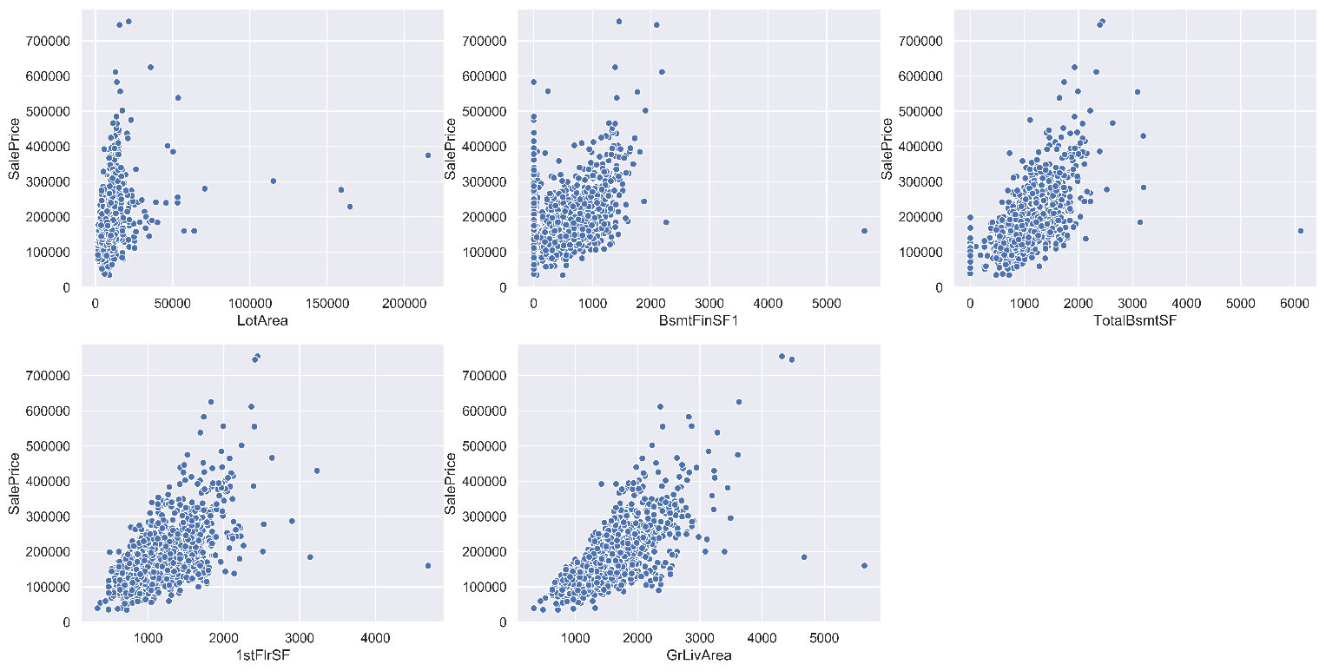对数值型字段画图分析异常值

挑选了一些较有规律的散点图，第一张规律不明显，暂时放在这里，其余几张均有明显异常值，最后一张右下角两个座位异常值剔除，然后重新画图

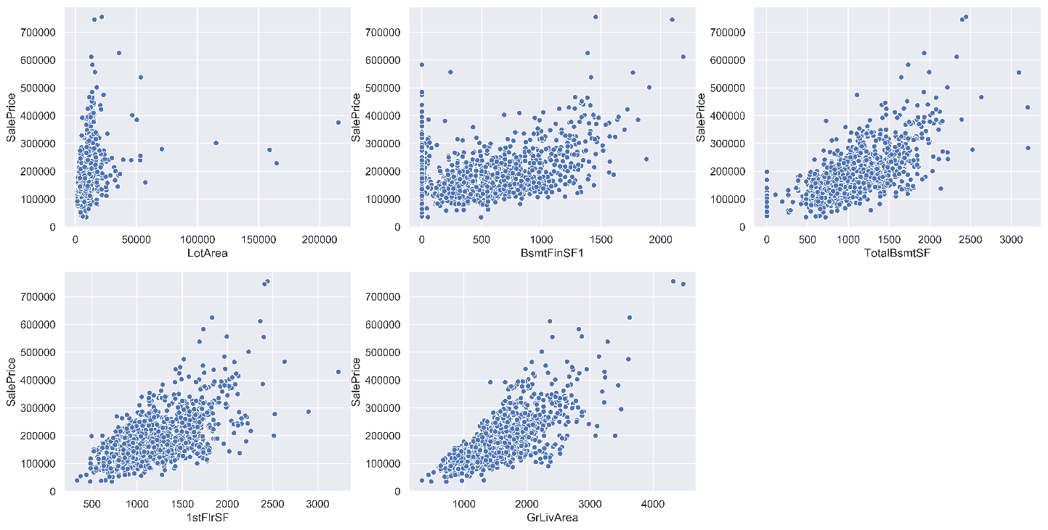剔除第五张图的异常值后，第二三四张的异常值也去掉了，第一张图规律不明显，暂不理会

1. traindata.isnull.sum() 处理缺失值

PoolQC 1452 游泳池质量­——无游泳池——None填充

MiscFeature 1404 其他类别未涵盖的杂项功能——无——None填充

Alley 1367 小巷通道的类型——无小巷通道——None填充

Fence 1177 篱笆质量——无篱笆——None填充

FireplaceQu 690 壁炉质量——无壁炉——None填充

LotFrontage 259 房产临街距离（线性英尺）——根据其他因素填充

GarageCond 81 车库条件——无车库——None填充

GarageType 81 车库位置——无车库——None填充

GarageYrBlt 81 车库建成年份——无车库——None填充

GarageFinish 81 车库的内部装饰——无车库——None填充

GarageQual 81 车库质量——无车库——None填充

BsmtExposure 38 地下室墙采光——无地下室——None填充

BsmtFinType2 38 地下室1评级——无地下室——None填充

BsmtFinType1 37 地下室2评级——无地下室——None填充

BsmtCond 37 地下室的一般条件——无地下室——None填充

BsmtQual 37 地下室高度——无地下室——None填充

MasVnrArea 8 砖石贴面面积——无贴面——0填充

MasVnrType 8 砖石贴面类型——无贴面——None填充

Electrical 1 电力系统——缺失值——众数填充

1. 特征工程
2. testdata: (1459, 80) testdata也存在缺失值，有些字段在traindata没有缺失值但在testdata有缺失值，在traindata中有缺失值的按traindata的缺失值补充方法进行补充，没有的根据情况进行补充

定性数据转换，降维，模型选择，预测

<https://www.kaggle.com/xirudieyi/house-prices>

<https://zhuanlan.zhihu.com/p/34904202>

<https://www.kaggle.com/massquantity/all-you-need-is-pca-lb-0-11421-top-4>