1. **内核配置**

使用am335x_evm_defconfig作为默认配置：

|  |
| --- |
| make ARCH=arm CROSS_COMPILE=arm-linux-gnueabihf- O=am335x am335x_evm_defconfig  make ARCH=arm CROSS_COMPILE=arm-linux-gnueabihf- O=am335x menuconfig |

* 1. 增加devtmpfs支持

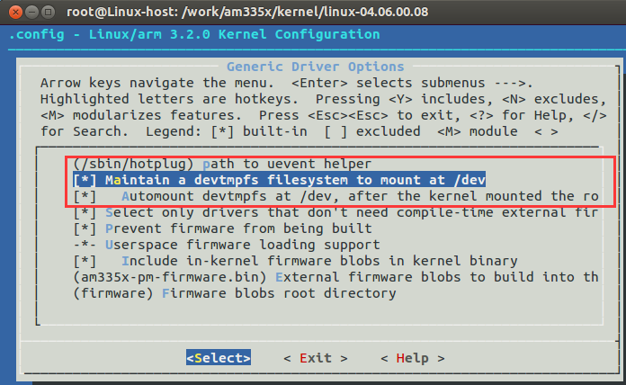

* 1. 去除LCD支持

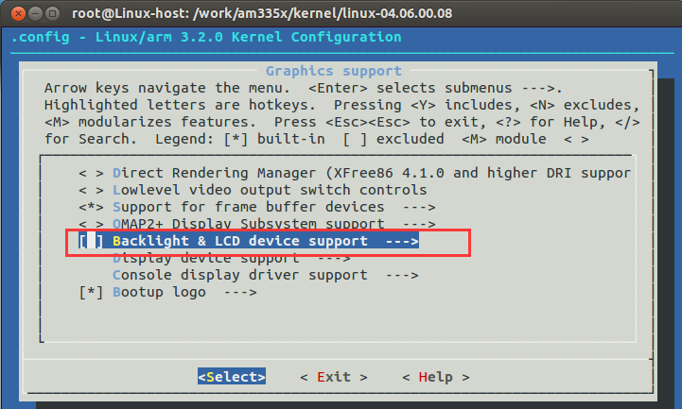

* 1. 去除Nand和OneNAND设备驱动

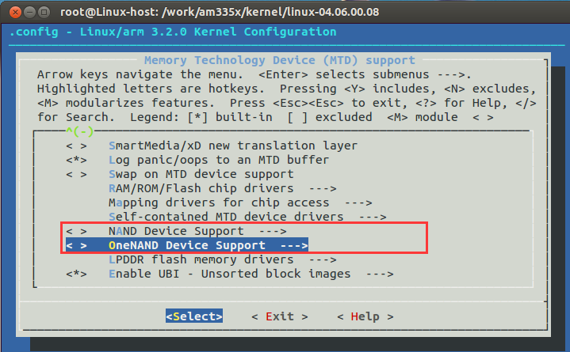

* 1. 去除video for Linux

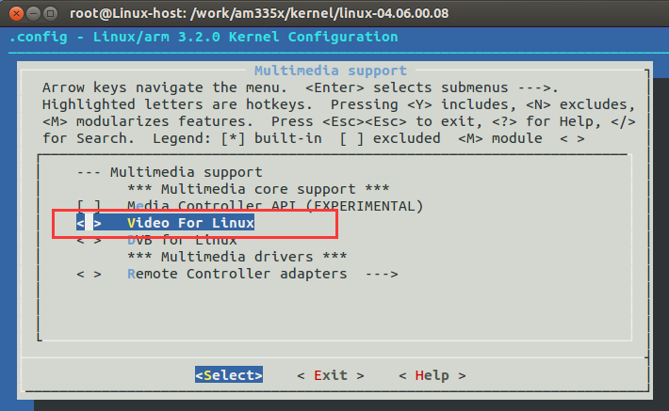

* 1. D

1. **代码修改**
   1. 修改 IIC 读取EEPROM 信息，红色部分为修改部分

|  |
| --- |
| static void am335x_evm_setup(struct memory_accessor *mem_acc, void *context)  {  int ret;  char tmp[10];  /* 1st get the MAC address from EEPROM */  ret = mem_acc->read(mem_acc, (char *)&am335x_mac_addr,  EEPROM_MAC_ADDRESS_OFFSET, sizeof(am335x_mac_addr));  #**if 1**  **strcpy(config.name,"IRTK2");**  **strcpy(config.opt,"SKU#01");**  **// if (!strncmp("SKU#01", config.opt, 6))**  **if (!strncmp("SKU#01", config.opt, 6))**  **setup_general_purpose_evm();**  **else**  **goto out;**  **#else**  if (ret != sizeof(am335x_mac_addr)) {  pr_warning("AM335X: EVM Config read fail: %d\n", ret);  return;  }  ………………省略………………  **#endif**  return;  out:  ………………省略………………  machine_halt();  } |

* 1. 修改SD卡CD引脚

[board-am335xevm.c]

|  |
| --- |
| static struct pinmux_config mmc0_cd_only_pin_mux[] = {  // {"spi0_cs1.gpio0_6", OMAP_MUX_MODE7 | AM33XX_PIN_INPUT_PULLUP},  {**"mii1_rxd0.gpio2_21"**, OMAP_MUX_MODE7 | AM33XX_PIN_INPUT_PULLUP},  {NULL, 0},  }; |

* 1. 修改emmc支持
     1. 修改emmc引脚 [board-am335xevm.c]

|  |
| --- |
| static void mmc1_emmc_init(int evm_id, int profile){  setup_pin_mux(mmc1_common_pin_mux);  setup_pin_mux(mmc1_dat4_7_pin_mux);  **am335x_mmc[1].mmc = 2;**  am335x_mmc[1].name = "emmc";  **am335x_mmc[1].caps = MMC_CAP_8_BIT_DATA;**  **am335x_mmc[1].nonremovable = true;** /* Nonremovable e.g. eMMC */  am335x_mmc[1].gpio_cd = -EINVAL;  am335x_mmc[1].gpio_wp = -EINVAL;  am335x_mmc[1].ocr_mask = MMC_VDD_32_33 | MMC_VDD_33_34; /* 3V3 */  pr_info("Configure emmc Enable pin...\n");  /* mmc will be initialized when mmc0_init is called */  return;  } |
|  |

* + 1. **支持eMMC-v5.0**

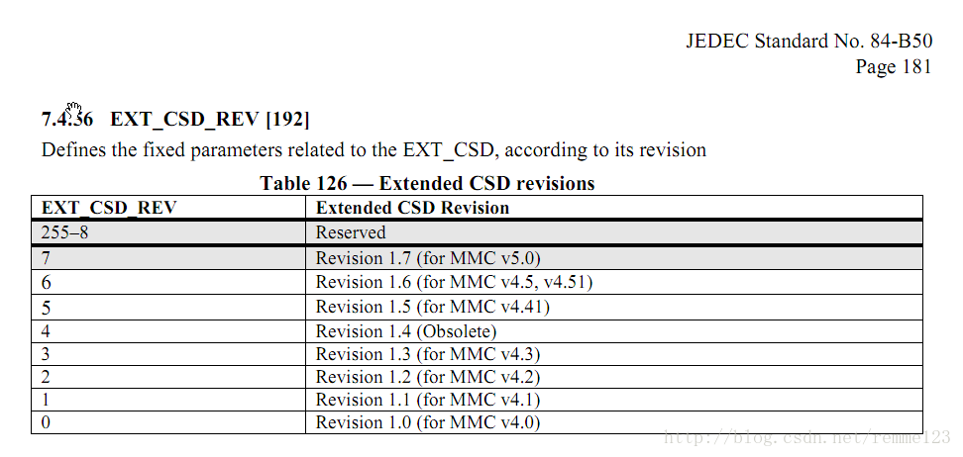

|  |
| --- |
| static int mmc_read_ext_csd(struct mmc_card *card, u8 *ext_csd)  {  ………………省略………………  #if 1  **if (card->ext_csd.rev > 7) {**  pr_err("%s: unrecognised EXT_CSD revision %d\n",  mmc_hostname(card->host), card->ext_csd.rev);  err = -EINVAL;  goto out;  }  #else  if (card->ext_csd.rev > 6) {  pr_err("%s: unrecognised EXT_CSD revision %d\n",  mmc_hostname(card->host), card->ext_csd.rev);  err = -EINVAL;  goto out;  }  #endif  ………………省略………………  } |

* + 1. 修改板子初始化

|  |
| --- |
| /* General Purpose EVM */  static struct evm_dev_cfg gen_purp_evm_dev_cfg[] = {  ………………省略………………  **{mmc1_emmc_init,DEV_ON_BASEBOARD, PROFILE_ALL},//这里要放在mmc0前**  {mmc0_init, DEV_ON_BASEBOARD, (PROFILE_ALL & ~PROFILE_5)},  ………………省略………………  } |

1. **支持声卡修改记录**

**static void __init am335x_evm_i2c_init(void)**

**static struct i2c_board_info __initdata am335x_i2c0_boardinfo[] = {**

**修改：sound/soc/codecs/kconfig和Makefile**

**Kconfig:**

**config SND_SOC_WM8960**

**tristate "iRTK2 WM8960 CODEC"**

**depends on I2C**

**Makefile:**