Uboot2011 代码分析：

正确uboot输出

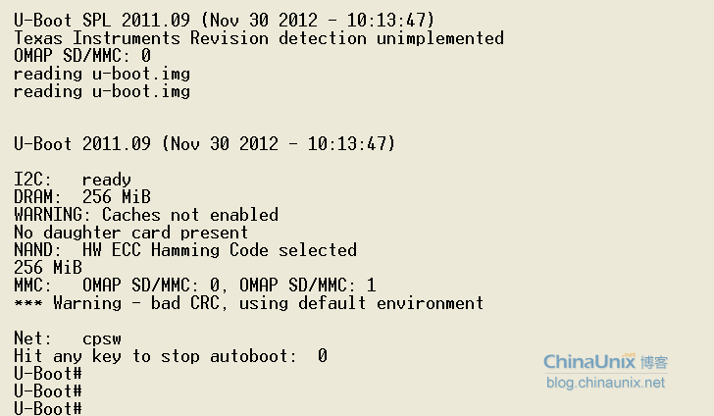

Mmc_initialize(bd_t *bis)[Mmc.c中]🡪Board_mmc_init🡪Omap_mmc_init(int dev_index) “OMAP SD/MMC: 0”

Jump_to_image_no_args🡪Spl_mmc_load_image🡪Mmc_load_image_fat[omap-common]🡪File_fat_read🡪“reading u-boot.img”

Init_func_i2c🡪 “I2C: ready”

自己输出

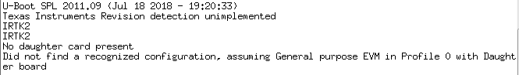

Step1:Cpu_init_crit[start.s]🡪Lowlevel_init.S🡪s_init(void) 🡪void preloader_console_init(void) “Texas Instruments …..”

Step2:board_init_f 🡪relocate_code(CONFIG_SPL_STACK, &gdata, CONFIG_SPL_TEXT_BASE);

其中gdata 🡪 static gd_t gdata __attribute__ ((section(".data")));

Step3:在RAM中执行：

Board_init_r[start.s]🡪board_init(void) 🡪void detect_daughter_board(void) “No daughter card present”

board_init(void) 🡪 “Did not find a recognized configuration,”

board_init

->configure_evm_pin_mux

->static struct evm_pin_mux *am335x_evm_pin_mux[] (配置引脚)

cpu_init_crit

|🡪lowlevel_init

| |🡪s_init

| | |🡪l2_cache_enable(); //可以不初始化

| | |🡪Disable WDT //关闭看门狗

| | |🡪pll_init(); //PLL和时钟设置

| | | |🡪mpu_pll_config(MPUPLL_M_500); //mpu时钟初始化

| | | |🡪per_clocks_enable //初始化外围模块时钟,MMC0,MMC1

| | |🡪rtc32k_enable(); //使能RTC

| | |🡪enable_uart0_pin_mux(); //串口引脚等配置

| | |🡪init_timer(); //初始化定时器

| | |🡪preloader_console_init(); //初始化串口

| | |🡪i2c_init //初始化IIC

| | |🡪if (read_eeprom()) //读取EEPROM板子信息，**需修改代码，修改的代**| | | //**码在附录中**

| | | **可剪裁:**enable_gpio0_7_pin_mux(); //EVM SK 1.2A及更高版本使用gpio0_7

| | | //启用DDR3。

| | | gpio_request(GPIO_DDR_VTT_EN, "ddr_vtt_en");

| | | gpio_direction_output(GPIO_DDR_VTT_EN, 1);

| | |🡪config_am335x_ddrx //初始化DDR2,3

| | | |🡪enable_ddr3_clocks(); //初始化DDR3时钟

| | | |🡪set IO control registers //设置IO控制寄存器

| | | | writel(DDR3_IOCTRL_VALUE, DDR_CMD0_IOCTRL);

| | | | writel(DDR3_IOCTRL_VALUE, DDR_CMD1_IOCTRL);

| | | |🡪config_emif_ddr3(); //不知道干啥的

**SPL编译时使用的board_init_r**

board_init_r

|🡪mem_malloc_init

|🡪timer_init();

|🡪i2c_init(CONFIG_SYS_I2C_SPEED, CONFIG_SYS_I2C_SLAVE);

|🡪void **spl_board_init**(void)[evm.c]

| |🡪board_init(); //板载初始化，初始化复用引脚

| | |🡪enable_i2c0_pin_mux(); //初始化IIC

| | |🡪read_eeprom()

| | | /\***读取开发板EEPROM，移植需修改，根据读到的信息， 判断板卡型号**

| | | **GP_BOARD、IA_BOARD、IPP_BOARD（板卡有两部分组成）**

| | |  **BONE_BOARD、SK_BOARD （板卡单独一个整体 ）*/**

|||🡪detect_daughter_board(); //判断是否有子板

| | |🡪static struct am335x_baseboard_id __attribute__((section (".data"))) **header**;

| | |/*根据**header.config**和**header.name**配置 board_id,profile,

| | |daughter_board_connected给下面的configure_evm_pin_mux初始化复用引脚

| | |🡪**configure_evm_pin_mux**

| | | 🡪set_evm_pin_mux(am335x_evm_pin_mux[dghtr_brd_id], profile,

| | | daughter_board_flag);

| | | //其中am335x_evm_pin_mux是初始化引脚的具体，修改引脚可在这里

| | |🡪gpmc_init(); //用于初始化**SDRAM和SRAM**，**IRTK2有问题需修改，** | | | **公司使用的DDR3是GPMC接口？**

| |🡪PMIC //电源管理，使用到了IIC0，**这里有问题，需检查**

| | //**IRTK2的PMIC管理芯片与EVM基本一致**

| | //**PMIC_INT1_GPIO:** EVM接GPMC_CLK/IRTK2接GPMC_CSn0

| | //

| |🡪mpu_pll_config(MPUPLL_M_720); //**这里有问题，需检查**

|🡪boot_device = omap_boot_device();

| 🡪return (u32) (boot_params.omap_bootdevice);

|🡪switch (boot_device) { //选择加载image的方式，有MMC,NAND,SPI等

| |🡪 #ifdef CONFIG_SPL_MMC_SUPPORT //如果定义了MMC支持

| | |🡪spl_mmc_load_image(); //加载image

| | |🡪mmc_initialize(); //mmc初始化**,经过测试这里卡住**

| | |🡪find_mmc_device(0); //寻找MMC，**可能需修改0**

| | |🡪err = mmc_init(mmc); //mmc初始化

| | |🡪boot_mode = omap_boot_mode();

| | | |🡪u32 omap_bootmode = MMCSD_MODE_FAT; // MMCSD_MODE_FAT==2;

| | | |🡪mmc_load_image_fat(mmc); //加载fat格式

| | | | |🡪struct image_header *header;

| | | | | header = (struct image_header *)(**CONFIG_SYS_TEXT_BASE** -

| | | | | **sizeof(struct image_header)**);

| | | | | //其中 #define **CONFIG_SYS_TEXT_BASE** **0x80100000**

|🡪switch (spl_image.os)

| |🡪jump_to_image_no_args(); **//uboot的入口地址**

| | |🡪image_entry_noargs_t image_entry =

| | | (image_entry_noargs_t) **spl_image.entry_point**;

| | | **//跳转到entry_point执行，这个u-boot.img头部信息提供。**

**enable_IRTK2_mmc1_pin_mux(); //init irtk2 mmc1 pin**

**Uboot编译时使用的board_init_r**

UBOOT 环境参数 CONFIG_EXTRA_ENV_SETTINGS

Uboot 中使用

原来为：mmc_root=/dev/mmcblk0p2 rw

mmc_root_fs_type=ext3 rootwait

修改为：mmc_root=/dev/ram rw

mmc_root_fs_type=cramfs

mach-types.h

**gd_t ：global_data 数据结构的定义，位于：/arch/arm/include/asm/global_data.h**

**bd_t ：bd_info 数据结构的定义，位于：/arch/arm/include/asm/u-boot.h 中。**

**#define DECLARE_GLOBAL_DATA_PTR register volatile gd_t *gd asm ("r8")**

**DECLARE_GLOBAL_DATA_PTR 宏定义在系统初始化过程中会被频繁调用**

其的作用是，声明gd这么一个全局的指针，这个指针指向gd_t结构体类型，并且这个gd指针是保存在ARM的r8这个寄存器里面的。

gb_t 结构体中某些元素的值是来自于 uboot.img's header，这个header的数据保存在内存的0x807FFFCO，大小为 64字节

**Uboot编译时使用的board_init_r**

|🡪board_init_r [arch/arm/lib/board.c]

| |🡪enable_caches();

| |🡪board_init();

| |🡪#ifdef CONFIG_SERIAL_MULTI

| | serial_initialize(); //未进入

| |🡪mem_malloc_init

| |🡪#if !defined(CONFIG_SYS_NO_FLASH)

| | flash_init();

| |🡪#if defined(CONFIG_CMD_NAND)

| | nand_init();

| |🡪#ifdef CONFIG_GENERIC_MMC

| | mmc_initialize(bd);

| |🡪env_relocate(); //初始化环境变量

| |🡪stdio_init(); //获取设备列表

| |🡪jumptable_init(); //gd->jt

| |🡪console_init_r(); //控制台完全初始化

| |🡪interrupt_init(); //异常中断初始化

| |🡪enable_interrupts(); //使能异常中断

| |🡪eth_initialize(gd->bd);    //初始化以太网 /net/eth.c文件中

| |🡪main_loop(); //进入uboot主循环

| | |🡪#ifndef CONFIG_SYS_HUSH_PARSER

| | | static char lastcommand[CONFIG_SYS_CBSIZE] = { 0, }; //定义一个字符数组来存

| | | //储所有读取到的命令

| | |🡪u_boot_hush_start

| | |🡪hush_init_var

| | |🡪run_command

| | |🡪len = readline (CONFIG_SYS_PROMPT); //读取串口信息

Uboot命令处理过程分析：

命令的结构以及定义：

#define U_BOOT_CMD(name,maxargs,rep,cmd,usage,help) \

U_BOOT_CMD_COMPLETE(name,maxargs,rep,cmd,usage,help,NULL)

#define U_BOOT_CMD_COMPLETE(name,maxargs,rep,cmd,usage,help,comp) \

cmd_tbl_t __u_boot_cmd_##name Struct_Section = \

U_BOOT_CMD_MKENT_COMPLETE(name,maxargs,rep,cmd,usage,help,comp)

#define U_BOOT_CMD_MKENT(name,maxargs,rep,cmd,usage,help) \

U_BOOT_CMD_MKENT_COMPLETE(name,maxargs,rep,cmd,usage,help,NULL)

#define U_BOOT_CMD_MKENT_COMPLETE(name,maxargs,rep,cmd,usage,help,comp) \

{#name, maxargs, rep, cmd, usage, _CMD_HELP(help) _CMD_COMPLETE(comp)}

根据以上定义可以分析出：

**#define** U_BOOT_CMD(name,maxargs,rep,cmd,usage,help) \

**cmd_tbl_t** __u_boot_cmd_##name **Struct_Section** =\

{#name, maxargs, rep, cmd, usage, _CMD_HELP(help) _CMD_COMPLETE(comp)}

1.**cmd_tbl_t**是命令格式的数据结构，其定义如下所示、

|  |
| --- |
| struct cmd_tbl_s {  char *name; /* Command Name */  int maxargs; /* maximum number of arguments */  int repeatable; /* autorepeat allowed? */  /* Implementation function */  int (*cmd)(struct cmd_tbl_s *, int, int, char * const []);  char *usage; /* Usage message (short) */  #ifdef CONFIG_SYS_LONGHELP  char *help; /* Help message (long) */  #endif  #ifdef CONFIG_AUTO_COMPLETE  /* do auto completion on the arguments */  int (*complete)(int argc, char * const argv[], char last_char, int maxv, char *cmdv[]);  #endif  }; |

2. ##name是指直接用U_BOOT_CMD里面的name参数替换，#name表示将U_BOOT_CMD里面的name参数加上双引号（“”），然后替换

3. **Struct_Section**是个宏定义，定义在common/command.h

#define struct_section __attribute__((unused,section(".u_boot_cmd")))

它表示将该处的内容放入u_boot_cmd段（具体u_boot_cmd段的信息可以参看u-boot.lds连接文件）

|  |
| --- |
| 例如，定义了如下命令 U_BOOT_CMD(command,1,0,fun,”short help”,”long help”)  cmd_tbl_t __u_boot_cmd_command \  __attribute__((unused.section(".u_boot_cmd")))={"command",1,0,fun,"short help‘,"long help"’} |

二、处理控制台输入命令

UBOOT 环境参数 CONFIG_EXTRA_ENV_SETTINGS

Uboot主要命令在 cmd_nvedit.c中

在s5pc210_ubivers.h中定义：

#define CONFIG_ENV_IS_IN_MMC 1

#define CONFIG_SYS_MMC_ENV_DEV 0

#define CONFIG_ENV_SIZE 4096

#define CONFIG_ENV_OFFSET ((32 - 4) << 10)/* 32KiB - 4KiB */

#define CONFIG_ENV_OFFSET (6 * 64 * 1024)

#define CONFIG_ENV_SIZE (8 * 1024)

#define CONFIG_ENV_IS_IN_MMC

#define CONFIG_SYS_MMC_ENV_DEV 0

（BOOTLOADER）AM335x bootloader 分3部分： 1st stage：RBL （ROM） 2st stage：SPL （内部RAM：0x402f0400） 3st stage：U-Boot （一般外部DDR） 注：SPL的代码包含在U-Boot中，在编译U-Boot时会自动编译。

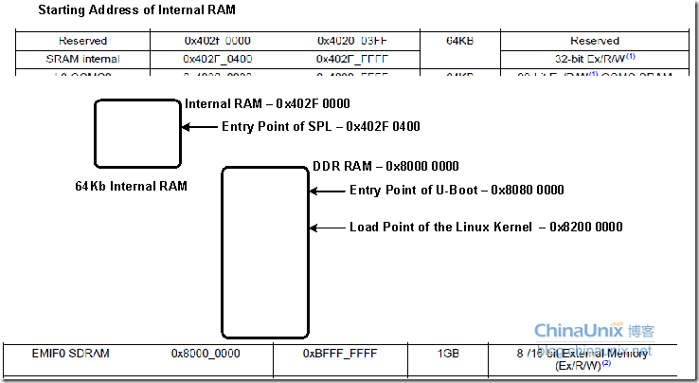

声卡：

|🡪evm_hw_params

| |🡪machine_is_am335xevm() set sysclk

| |🡪snd_soc_dai_set_fmt(codec_dai, AUDIO_FORMAT); //entry wm8960_set_dai_fmt

| |🡪 snd_soc_dai_set_fmt(cpu_dai, AUDIO_FORMAT); //entry davinci_mcasp_set_dai_fmt

| |🡪snd_soc_dai_set_sysclk(codec_dai, 0, sysclk, SND_SOC_CLOCK_OUT); **//error**

soc_pcm_hw_params[soc-pcm.c]

static struct snd_soc_dai_ops wm8960_dai_ops = {

.hw_params = wm8960_hw_params,

.digital_mute = wm8960_mute,

.set_fmt = wm8960_set_dai_fmt,

**.set_clkdiv = wm8960_set_dai_clkdiv,**

**.set_pll = wm8960_set_dai_pll,**

};

static struct snd_soc_dai_ops wm8962_dai_ops = {

.hw_params = wm8962_hw_params,

.set_sysclk = wm8962_set_dai_sysclk,

.set_fmt = wm8962_set_dai_fmt,

.digital_mute = wm8962_mute,

};

static struct snd_soc_dai_ops aic3x_dai_ops = {

.hw_params = aic3x_hw_params,

.digital_mute = aic3x_mute,

.set_sysclk = aic3x_set_dai_sysclk,

.set_fmt = aic3x_set_dai_fmt,

};

static struct snd_soc_dai_driver wm8960_dai = { [wm8960.c]

static struct snd_soc_dai_driver davinci_mcasp_dai[] [davinci-mcasp.c]

输出信息：

[ 7.781463] soc_pcm_hw_params

[ 7.784393] snd_soc_dai_set_fmt

[ 7.797546] snd_soc_dai_set_fmt

[ 7.801116] entry davinci_mcasp_set_dai_fmt

[ 7.805572] entry dai->driver && dai->driver->ops->set_sysclk

[ 7.805572]

[ 7.813568] entry davinci_mcasp_hw_params

[ 7.818054] exit davinci_mcasp_hw_params

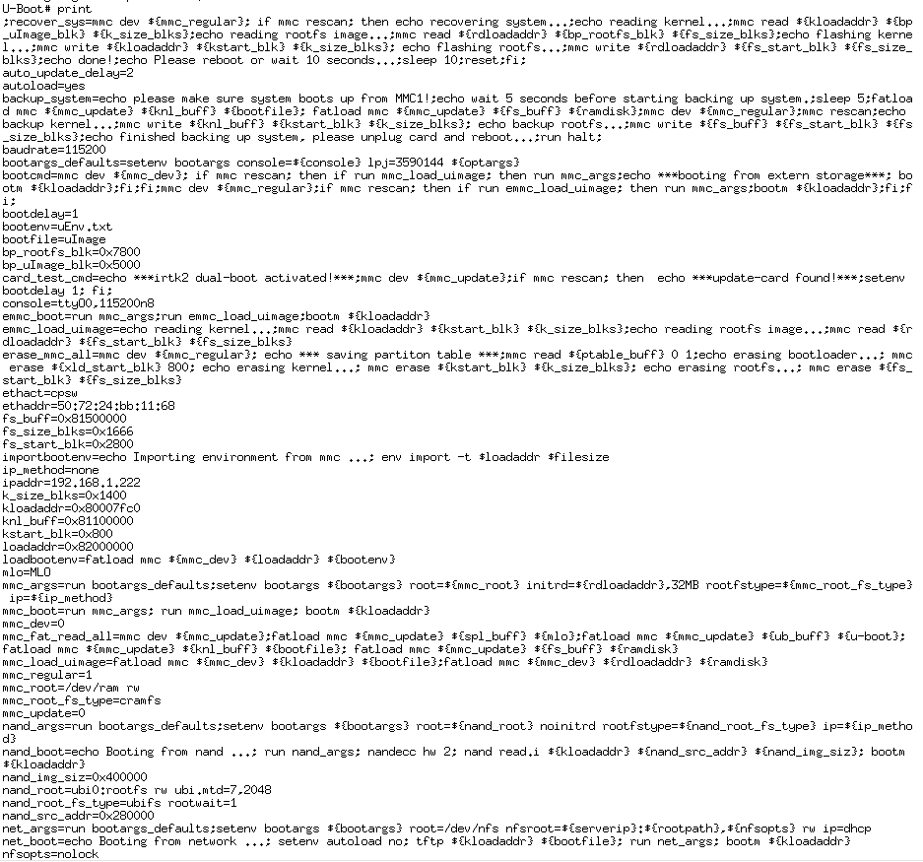

由以上代码可以得知：

**配置时定义了NAND支持**

/* NAND support */

#ifdef CONFIG_NAND

**#define BOOT_DEVICE_MMC1 8**

**#define BOOT_DEVICE_MMC2 9 /* eMMC or daughter card */**

**/*mmc引脚配置*/**

static struct module_pin_mux mmc1_pin_mux[] = {

{OFFSET(gpmc_ad3), (MODE(1) | RXACTIVE | PULLUP_EN)}, /* MMC1_DAT3 */

{OFFSET(gpmc_ad2), (MODE(1) | RXACTIVE | PULLUP_EN)}, /* MMC1_DAT2 */

{OFFSET(gpmc_ad1), (MODE(1) | RXACTIVE | PULLUP_EN)}, /* MMC1_DAT1 */

{OFFSET(gpmc_ad0), (MODE(1) | RXACTIVE | PULLUP_EN)}, /* MMC1_DAT0 */

{OFFSET(gpmc_csn1), (MODE(2) | RXACTIVE | PULLUP_EN)}, /* MMC1_CLK */

{OFFSET(gpmc_csn2), (MODE(2) | RXACTIVE | PULLUP_EN)}, /* MMC1_CMD */

{OFFSET(gpmc_csn0), (MODE(7) | RXACTIVE | PULLUP_EN)}, /* MMC1_WP */

{OFFSET(gpmc_advn_ale), (MODE(7) | RXACTIVE | PULLUP_EN)}, /* MMC1_CD */

{-1},

};

**Strncmp 若str1与str2的前n个字符相同，则返回0**

#ifndef __ASSEMBLY__

struct omap_boot_parameters {

char *boot_message;

unsigned int mem_boot_descriptor;

unsigned char omap_bootdevice;

unsigned char reset_reason;

unsigned char ch_flags;

};

#endif

/*

* This is used to verify if the configuration header

* was executed by rom code prior to control of transfer

* to the bootloader. SPL is responsible for saving and

* passing the boot_params pointer to the u-boot.

*/

struct omap_boot_parameters **boot_params** __attribute__ ((section(".data")));

/*

* store the boot params passed from rom code or saved

* and passed by SPL

*/

cmp r0, #0

beq 1f

ldr r1, =**boot_params**

str r0, [r1]

emmc中启动：

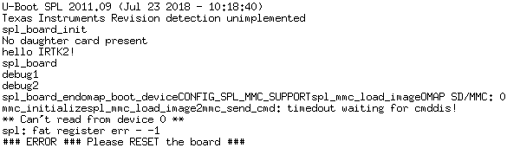

Emmc 为8bit连接方式

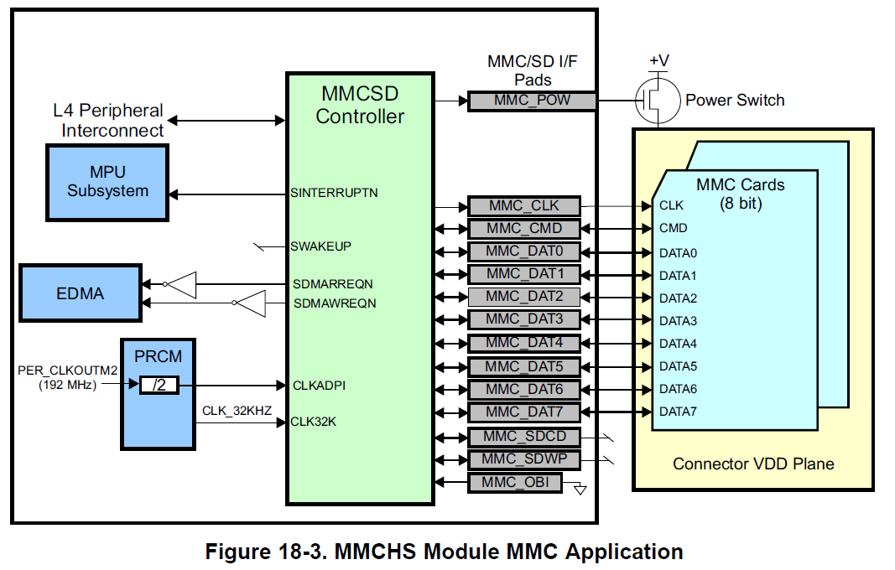

WiFi配置：

UART 串口代码分析笔记：

Serial.c --->配置DMA

am335x_evm_init

omap_serial_init

|🡪Omap_serial_init(void) //入口函数

| |🡪omap_serial_board_init(NULL) //轮询所有uart,并配置基本属性

| | |🡪list_for_each_entry(uart, &uart_list, node) // uart_list怎么来的？

| | | |🡪omap_serial_init_port

| | | | |🡪omap_serial_init_port(&bdata, NULL); //用于初始化串口 *info->NULL

| | | | |   /*配置所有属性，DMD等

*不要混合调用omap_serial_init_port（）和omap_serial_init（），

  *只使用两者中的一个。*/

| | | | |🡪

Mmc代码分析： 需要分为spl 和uboot两段？？？

|🡪Mmc_initialize //mmc初始化，uboot段

| |🡪 board_mmc_init(bis)

| | |🡪omap_mmc_init[omap_hsmmc.c] //uboot初始化时使用

| | | | mmc->send_cmd = mmc_send_cmd[omap_hsmmc.c] //发送命令函数

| | | | mmc->set_ios = mmc_set_ios; //

| | | | **mmc->init = mmc_init_setup;**

| |

|🡪mmc_init_setup[omap_hsmmc.c] // struct mmc类型的结构体指针, 记录了mmc的

| //一些信息，以及函数指针所指向的函数

| hsmmc_t *mmc_base = (hsmmc_t *)**mmc->priv**; //mmc->priv =

| // (hsmmc_t *)OMAP_HSMMC1_BASE; 0x 48060100

| // (hsmmc_t *)OMAP_HSMMC2_BASE; 0x 481D8100

| |🡪mmc_board_init[omap_hsmmc.c] //好像没有做初始化？

| |🡪

**增加mmc调试信息：#ifdef CONFIG_MMC_TRACE**

**设置sysclkd寄存器的**

**当前uboot中使用save保存环境变量，是写调用nand的写入，需修改为mmc的写入函数。**

mmc_startup ---> mmc_set_bus_width(mmc, 8);

emmc调试：

uboot不配置mmc0,mmc1不配置mux情况一样？

|🡪mmc_init

| |🡪mmc->has_init //判断mmc是否已经初始化

| |🡪mmc->init(mmc) // 也就是进入了**mmc_init_setup**[omap_hsmmc.c]

| |🡪mmc_set_bus_width(mmc, 1); // 设置mmc数据宽度

| | mmc->bus_width = width;

| | mmc_set_ios(mmc); // mmc_set_ios

| |🡪mmc_set_clock(mmc, 1); // 设置时钟,该函数设置时钟在

| | //omap_mmc_init中设置的最大时钟和最小时钟相关,mmc1可能有问题？？？？

| |🡪mmc_go_idle(mmc);

| |🡪 err = mmc_send_if_cond(mmc); //测试是否是SD_VERSION_2，

| | //mmc0为SD_VERSION_2

| | //**mmc1不是SD_VERSION_2的卡**

| |🡪err = sd_send_op_cond(mmc); //尝试获取SD卡的运行状况

| | |🡪mmc_send_cmd(mmc, &cmd, NULL); //发送到cmd55命令，检测是否正确

| |🡪if (err == TIMEOUT) {

| | |🡪mmc_send_op_cond (mmc); //如果不是SD卡运行条件，使用mmc卡检测

| | | |🡪mmc_send_cmd(mmc, &cmd, NULL); //发送cmd1命令，emmc在这里发送

| | | | //**整机错误**

| | | |

| | if (err)

| | printf("Card did not respond to voltage select!\n");} // **mmc1输出该信息，修改**

| |🡪mmc_startup //mmc 初始化

| | |🡪mmc_send_cmd[MMC_CMD_ALL_SEND_CID] //发送**CMD2**,获取设备**CID**号

| | |🡪mmc_send_cmd[SD_CMD_SEND_RELATIVE_ADDR] //发送CMD3,设置相对地址，

| | | //进入Standby状态

| | |🡪 mmc_send_cmd[MMC_CMD_SEND_CSD] //发送**cmd9**,

| | |🡪mmc_send_status(mmc, timeout); //等待准备状态

| | | |🡪MMC_CMD_SEND_STATUS //发送**CMD13**

| | |🡪 freq = fbase[(cmd.response[0] & 0x7)]; //设置频率

| | | mult = multipliers[((cmd.response[0] >> 3) & 0xf)];

| | | mmc->tran_speed = freq * mult;

| | | mmc->read_bl_len = 1 << ((cmd.response[1] >> 16) & 0xf);

| | | mmc->write_bl_len = 1 << ((cmd.response[3] >> 22) & 0xf);

| | |🡪if (!IS_SD(mmc) && (mmc->version >= MMC_VERSION_4)) //进入该函数

| | | |🡪 mmc_send_ext_csd //发送CMD8,

| | |🡪 mmc->card_caps |= MMC_MODE_4BIT; //变为4线？

| | |🡪 mmc_change_freq //mmc改变频率

| | | |🡪mmc_send_ext_csd

其中CMD8

Cmd_mmc.c 🡪"mmc%d(part %d) is current device\n"

在擦写emmc时发生错误，如下所示：

|  |
| --- |
| U-Boot# mmc erase 1 1  MMC erase: dev # 1, block # 1, count 1 ... CMD_SEND:35  ARG 0x00000001  FLAG 0  mmc_send_cmd: timedout waiting for cmddis!  MMC_RSP_R1,5,6,7 0x00000000  mmc erase failed  0 blocks erase: ERROR |

公司输出：

公司打印的输出为：mmc1(part 0) is current device

|  |
| --- |
| U-Boot# mmc erase 1 1  MMC erase: dev # 1, block # 1, count 1 ... 1 blocks erase: OK |

Mmcinfo 公司输出

|  |
| --- |
| SD卡  Device: OMAP SD/MMC  Manufacturer ID: 9c  OEM: 534f  Name: USD00  Tran Speed: 25000000  Rd Block Len: 512  SD version 2.0  High Capacity: Yes  Capacity: 7.4 GiB  Bus Width: 4-bit  emmc:  Device: OMAP SD/MMC  Manufacturer ID: 11  OEM: 100  Name: 008G7  Tran Speed: 25000000  Rd Block Len: 512  MMC version 4.0  High Capacity: Yes  Capacity: 7.3 GiB  Bus Width: 4-bit |

自己调试输出

|  |
| --- |
| SD卡  Device: OMAP SD/MMC  Manufacturer ID: 9c  OEM: 534f  Name: USD00  Tran Speed: 25000000  Rd Block Len: 512  SD version 2.0  High Capacity: Yes  Capacity: 7.4 GiB  Bus Width: 4-bit  emmc:  Device: OMAP SD/MMC  Manufacturer ID: 3c  OEM: 3c00  Name: Tran Speed: 0  Rd Block Len: 1  MMC version 1.2  High Capacity: Yes  Capacity: 1 KiB  Bus Width: 8-bit |

|🡪mmc_send_cmd

| |🡪printf("%s: timedout waiting for cmddis!\n", __func__);

mmc命令分析

|🡪do_mmcops

| |🡪if (strcmp(argv[1], "rescan") == 0) //如果输入的是重新扫描

| | |🡪mmc_init(mmc) //重新初始化

| |🡪if (strncmp(argv[1], "part", 4) == 0) //如果是part0部分

| | |🡪mmc_init(mmc);

| | |🡪mmc_dev = mmc_get_dev(curr_device);

| | |🡪print_part(mmc_dev);

**移植uboot2011笔记**

**SPL代码修改：**

**Step1:**

cpu_init_crit[start.S]

|🡪lowlevel_init

| |🡪s_init

| | |🡪if (read_eeprom())

**int read_eeprom(void)**

|  |
| --- |
| int read_eeprom(void)  {  **#if 1**  **strcpy(header.name,"IRTK2");**  **//printf("IRTK2\n");**  **#else**  /* Check if baseboard eeprom is available */  if (i2c_probe(I2C_BASE_BOARD_ADDR)) {  printf("Could not probe the EEPROM; something fundamentally "  "wrong on the I2C bus.\n");  return 1;  }  /* read the eeprom using i2c */  if (i2c_read(I2C_BASE_BOARD_ADDR, 0, 2, (uchar *)&header,  sizeof(header))) {  printf("Could not read the EEPROM; something fundamentally"  " wrong on the I2C bus.\n");  return 1;  }  if (header.magic != 0xEE3355AA) {  /* read the eeprom using i2c again, but use only a 1 byte address */  if (i2c_read(I2C_BASE_BOARD_ADDR, 0, 1, (uchar *)&header,  sizeof(header))) {  printf("Could not read the EEPROM; something fundamentally"  " wrong on the I2C bus.\n");  return 1;  }  if (header.magic != 0xEE3355AA) {  printf("Incorrect magic number in EEPROM\n");  return 1;  }  }  **#endif**  return 0;  } |

**Step2:**

if (!strncmp("A335X_SK", header.name, 8) || !strncmp("IRTK2", header.name, 5)) {

is_ddr3 = 1;

/*

* EVM SK 1.2A and later use gpio0_7 to enable DDR3.

* This is safe enough to do on older revs.

*/

enable_gpio0_7_pin_mux();

gpio_request(GPIO_DDR_VTT_EN, "ddr_vtt_en");

gpio_direction_output(GPIO_DDR_VTT_EN, 1);

}

if (!strncmp("SKU#01", header.config, 6)) {

board_id = GP_BOARD;

detect_daughter_board_profile();

} else if (!strncmp("SKU#02", header.config, 6)) {

board_id = IA_BOARD;

detect_daughter_board_profile();

} else if (!strncmp("SKU#03", header.config, 6)) {

board_id = IPP_BOARD;

} else if (!strncmp("A335BONE", header.name, 8)) {

board_id = BONE_BOARD;

profile = 1; /* profile 0 is internally considered as 1 */

daughter_board_connected = 0;

} else if (!strncmp("A335X_SK", header.name, 8) **|| !strncmp("IRTK2", header.name, 5)** ) {

board_id = SK_BOARD;

profile = 1; /* profile 0 is internally considered as 1 */

daughter_board_connected = 0;

} else {

printf("Did not find a recognized configuration, "

"assuming General purpose EVM in Profile 0 with "

"Daughter board\n");

board_id = GP_BOARD;

profile = 1; /* profile 0 is internally considered as 1 */

daughter_board_connected = 1;

}

Am335x_evm.h

#define PHYS_DRAM_1_SIZE 0x8000000 /* 128 MiB */

支持uboot环境变量save到mmc中命令：

|  |
| --- |
| 在am335x_evm中删除SPI和 NAND相关支持  修改  #ifndef CONFIG_SPI_BOOT  **#define CONFIG_MMC_ENV**  #endif  添加以下代码:  #if defined(**CONFIG_MMC_ENV**)  #undef CONFIG_ENV_IS_NOWHERE  #define CONFIG_ENV_IS_IN_MMC 1  #define CONFIG_SYS_MMC_ENV_DEV 0  #define CONFIG_ENV_SIZE 4096  #define CONFIG_ENV_OFFSET ((32 - 4) << 10)/* 32KiB - 4KiB */  #endif/* MMC support */ |

修改uboot环境变量，需注意：一旦在uboot中使用save命令，那么之后uboot都是启动save在内存中的环境变量，**修改uboot源码的环境变量就不会被读取，源码具体待分析。**

|  |
| --- |
| #define CONFIG_BOOTCOMMAND \  "mmc dev ${mmc_dev};" \  "if mmc rescan; then " \  "if run mmc_load_uimage; then "\  "run mmc_args;"\  "echo ***booting from extern storage***;"\  "bootm ${kloadaddr};" \  "fi;"\  "fi;"\  "mmc dev ${mmc_regular};"\  "if mmc rescan; then "\  "if run emmc_load_uimage; then "\  "run mmc_args;"\  "bootm ${kloadaddr};"\  "fi;"\  "fi;"\  展开：setenv bootargs root=/dev/ram rw initrd=0x81600000,32MB rootfstype=cramfs ip=none console=ttyO0,115200  set bootargs noinitrd root=/dev/nfs nfsroot=192.168.10.169:/work/rootfs/fs_mini ip=192.168.10.17:192.168.10.169:192.168.10.1:255.255.255.0::usb0:off init=/linuxrc console=ttyO0 |

公司的uboot：bootcmd

bootcmd=mmc dev ${mmc_dev}; if mmc rescan; then if run mmc_load_uimage; then run mmc_args;echo ***booting from extern storage***; bootm ${kloadaddr};fi;fi;mmc dev ${mmc_regular};if mmc rescan; then if run emmc_load_uimage; then run mmc_args;bootm ${kloadaddr};fi;fi;

xld_size_blks=0xc8

xld_start_blk=0x100

kstart_blk=0x800

k_size_blks=0x1400

fs_size_blks=0x1666

fs_start_blk=0x2800

ub_buff=0x81060000

ub_size_blks=0x200

ub_start_blk=0x300

/*擦除emmc全部内容*/

erase_mmc_all=mmc dev ${mmc_regular}; echo *** saving partiton table ***;mmc read ${ptable_buff} 0 1;echo erasing bootloader...; mmc erase ${xld_start_blk} 800; echo erasing kernel...; mmc erase ${kstart_blk} ${k_size_blks}; echo erasing rootfs...; mmc erase ${fs_start_blk} ${fs_size_blks}

/*读取全部内容到内存中*/

mmc_fat_read_all=mmc dev ${mmc_update};fatload mmc ${mmc_update} ${spl_buff} ${mlo};fatload mmc ${mmc_update} ${ub_buff} ${u-boot}; fatload mmc ${mmc_update} ${knl_buff} ${bootfile}; fatload mmc ${mmc_update} ${fs_buff} ${ramdisk}

/*写入内容到emmc中*/

update_all=mmc dev ${mmc_regular};echo flashing bootloader...;mmc write ${spl_buff} ${xld_start_blk} ${xld_size_blks};mmc write ${ub_buff} ${ub_start_blk} ${ub_size_blks};echo flashing kernel...;mmc write ${knl_buff} ${kstart_blk} ${k_size_blks}; echo flashing rootfs...;mmc write ${fs_buff} ${fs_start_blk} ${fs_size_blks};echo *** recovering partition table ***;mmc write ${ptable_buff} 0 1;

/*更新系统，先擦除全部，在读取到内存中，最后写入*/

update_sys=echo entering update mode...;mmc dev ${mmc_update}; if mmc rescan; then echo found SD/MMC in slot(1), enter upgrade mode.;if run erase_mmc_all; then run mmc_fat_read_all;run update_all;echo update system sucessfully!;echo Please reboot and unplug the card...;run halt;fi;fi;

内核代码分析

板载初始化定义[board-am335xevm.c]

static struct omap2_hsmmc_info am335x_mmc[] __initdata = {

在最上层的板级初始化文件（board-am335xevm.c）中会定义一个这样的结构体数组，确定所要初始化的引脚复用寄存器，交由omap_mux_init_signals(partition, board_mux);使用。例如：

/*内核初始化*/

static struct omap_board_mux board_mux[] __initdata = {

修改mmc1引脚：

static void mmc1_init(int evm_id, int profile)