由于OpenCV Android版，需要先装OpenCV Manager，对用户相当不友善，并且泄及大量的代码重写。所以就采用JNI接口，从JAVA调用C来处理。

1.环境搭建

1.1 Android开发环境搭建，相当简单。网上有大量的文章，我就不详细写。

我用的是

jdk-8u25-windows-i586.exe

adt-bundle-windows-x86-20131030.zip

1.2 Android+JNI+OpenCV环境搭建

1.先下载并解压好

android-ndk-r10d-windows-x86.exe

OpenCV-3.1.0-android-sdk.zip

接着新建个Android项目

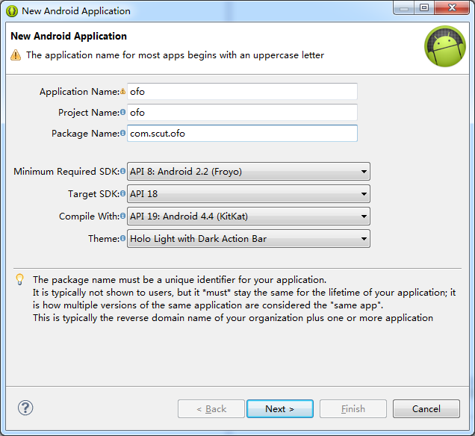

2.建好后，什么都不要操作，就要立即转成C++ Project，否则后面是选不到(太坑了！)

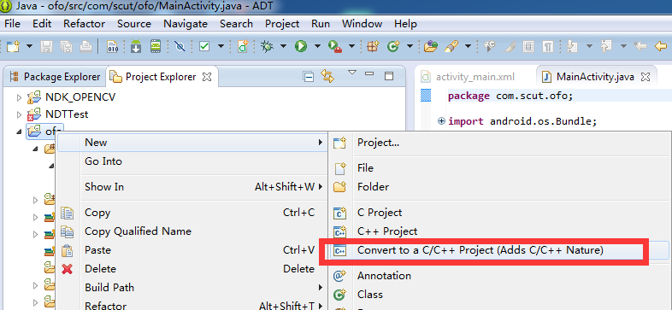

2.1见到这个可以转换时，就成功了10%

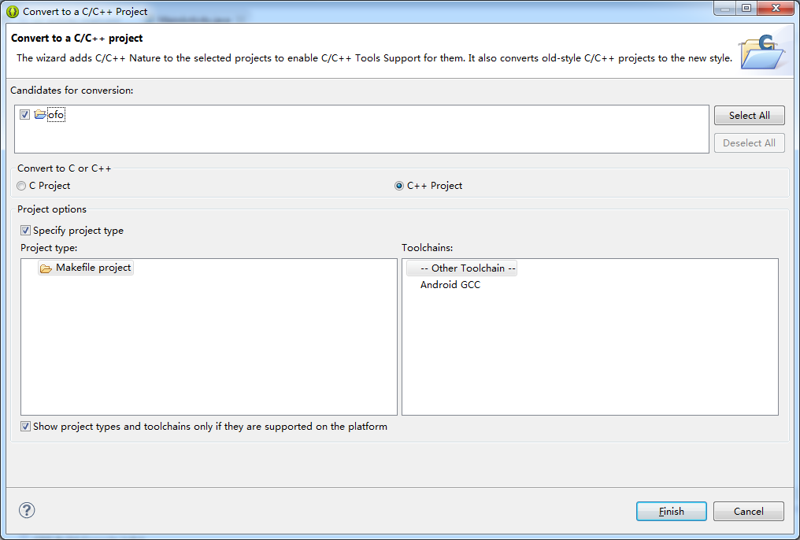

3.接下来在**windows环境变量**中设置NDK路径

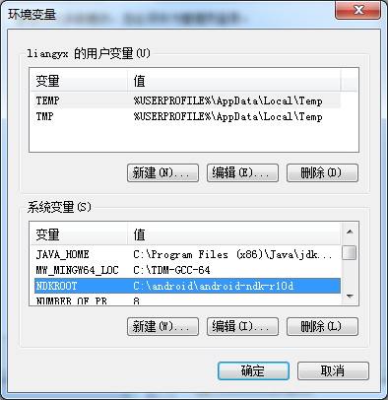

4.1 回到eclipse，在项目属性中设好NDK相关信息

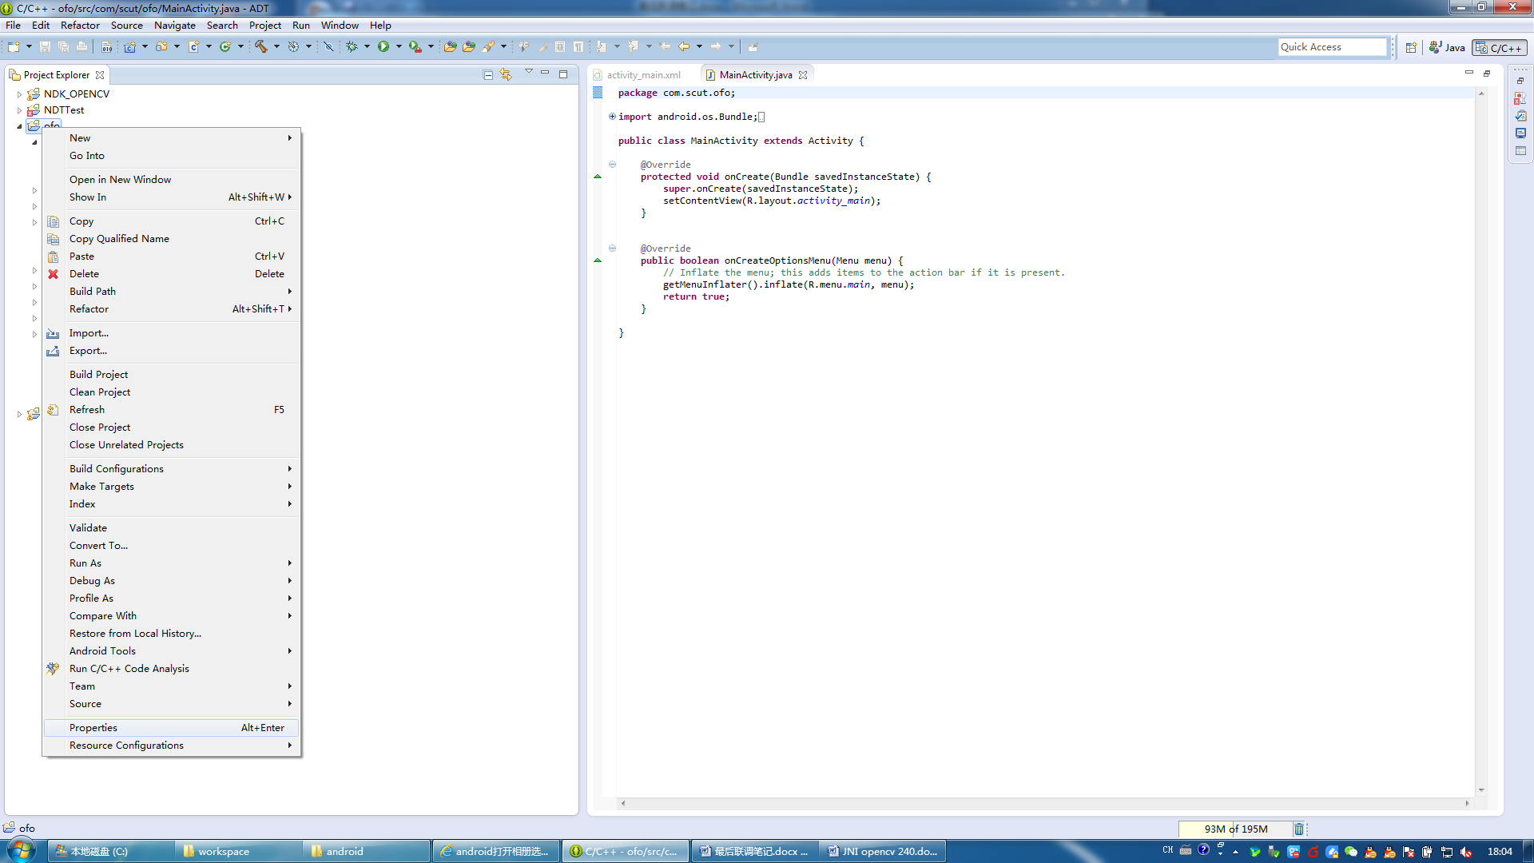

4.2然后在C/C++ Build中的Builder Settings中

将Use default build command：去勾

将Build command设为

|  |
| --- |
| ${NDKROOT}/ndk-build.cmd |

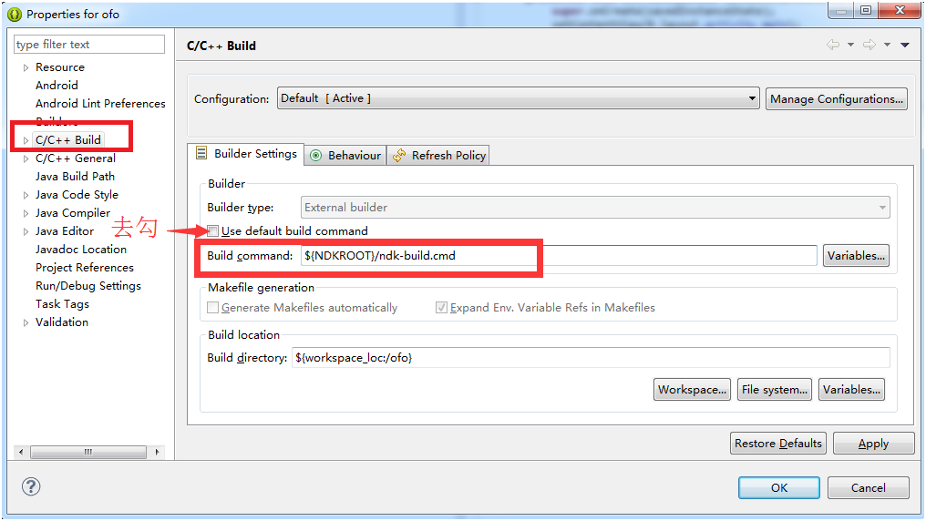

4.3 在Behaviour中

Build on resource save (Auto build)：勾上

Build (Incremental build)：勾上

Clean：去勾

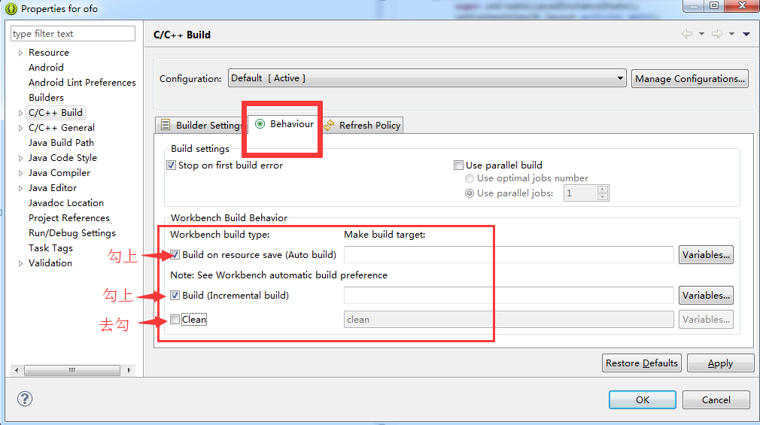

4.4 接着在C/C++ General→Paths and Symbols→GNU C++中设好

${NDKROOT}/platforms/android-9/arch-arm/usr/include

${NDKROOT}/sources/cxx-stl/gnu-libstdc++/4.6/include

${NDKROOT}/sources/cxx-stl/gnu-libstdc++/4.6/libs/armeabi-v7a/include

${ProjDirPath}/opencv310sdk/native/jni/include

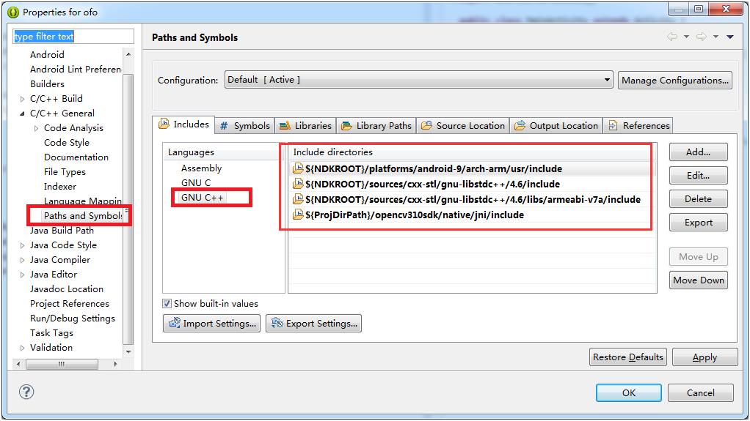

5.1 建一个JAVA文件，用于JAVA通过JNI交互

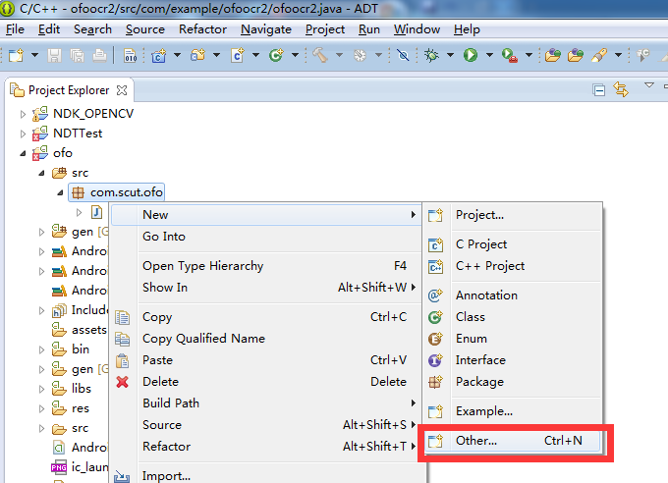

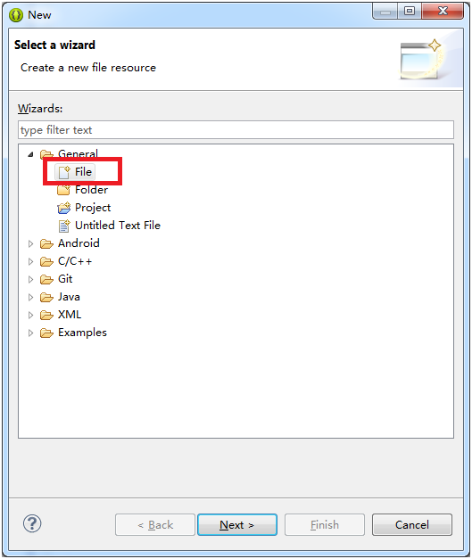

ofo.java

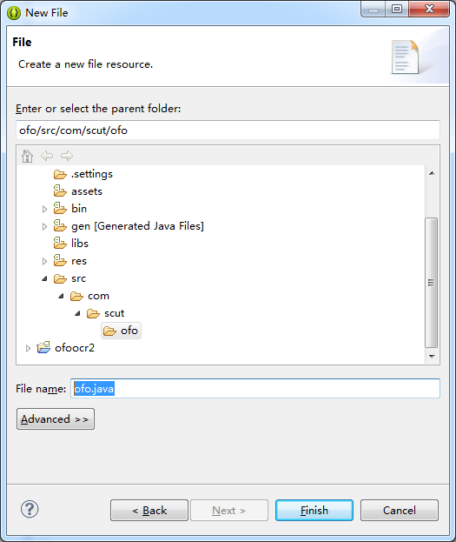

5.2 检查目录结构是否像这样

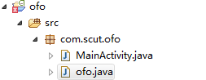

5.3 在ofo.java中输入交换的内容代码

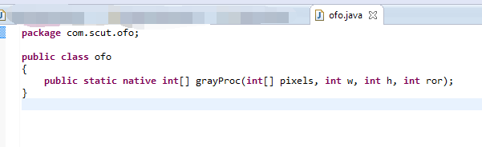

|  |
| --- |
| **package** com.scut.ofo;  **public** **class** ofo  {  **public** **static** **native** **int**[] grayProc(**int**[] pixels, **int** w, **int** h, **int** ror);  } |

6.1 .在命令行中生成.h文件

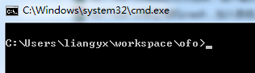

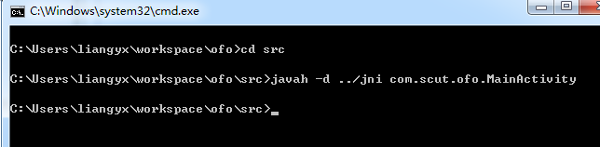

|  |
| --- |
| cd src  javah -d ../jni com.scut.ofo.MainActivity |

6.2在eclipse.exe中刷新一下，看看是否己经在项目中

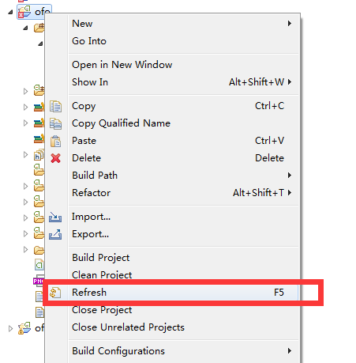

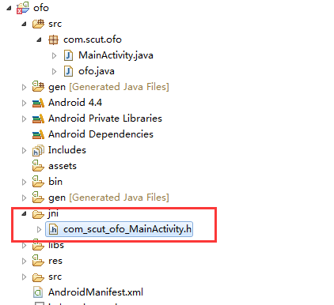

7.将OpenCV 3.1放进项目中

7.1先解压

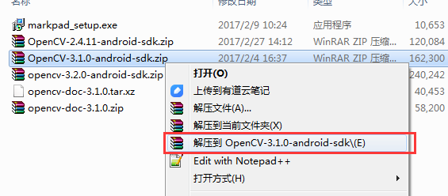

7.2将OpenCV-android-sdk/sdk目录重命名为opencv310sdk

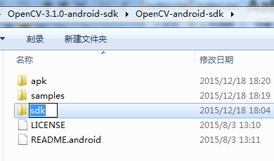

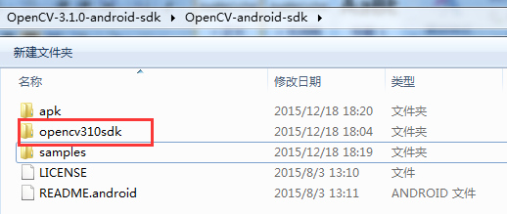

7.3然后拖进eclipse项目中

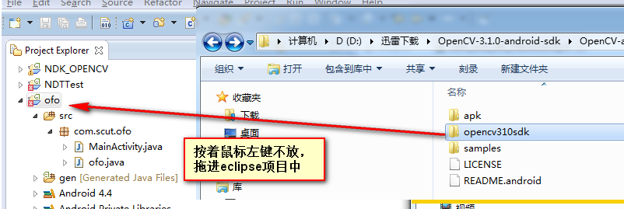

7.4这时会问你导入到项目，选Copy files and folders

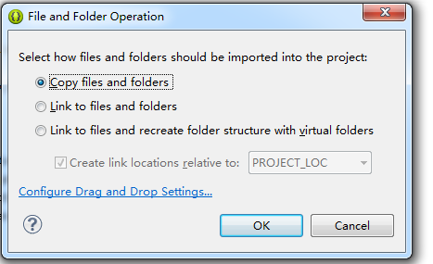

这样Android+JNI+OpenCV环境就准备好了。

接下来验证

将一张正方形旋转的ofo照片放进res/drawable-hdpi目录中

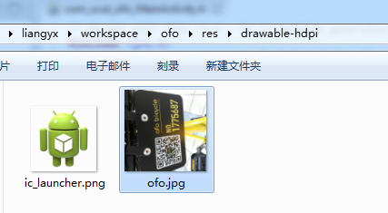

刷新一下

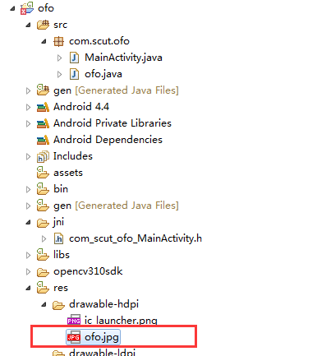

接着就帖代码

ofo.cpp，要注意文件名要与整个项目名一致，以免出现奇怪问题，并且JNIEXPORT要对着刚才生成的.h文件来写

|  |
| --- |
| ofo.cpp |
| **#include** <jni.h>  **#include** <com_scut_ofo_MainActivity.h> //请改成自己的  **#include** <opencv2/opencv.hpp>  **#include** <opencv2/core/core.hpp>  **#include** <opencv2/highgui/highgui.hpp>  **#include** <opencv2/ml/ml.hpp>  **#include** <string>  **#include** <vector>  **#include** <sstream>  **#include** <android/log.h>  **using** **namespace** cv;  **using** **namespace** std;  //JNImain  **extern** "C" {  JNIEXPORT jintArray JNICALL **Java_com_scut_ofo_ofo_grayProc** (JNIEnv* env, jclass obj, jintArray buf, jint w, jint h,jint ror) //这行要根据生成出来的.h文件来写  {  jint *cbuf;  cbuf = env->GetIntArrayElements(buf,JNI_FALSE);  **if**(cbuf == NULL){  **return** 0;  }  Mat imgData(h, w, CV_8UC4, (**unsigned** **char**\*)cbuf);  Mat lastImg;  imgData.copyTo(lastImg);  //s1-02:rotate  cv::Mat rotateImg;  //先设置中心点  cv::Mat M = cv::getRotationMatrix2D(Point2f(lastImg.cols/2,lastImg.rows/2),ror,1);  //再用warpAffine旋转  cv::warpAffine(lastImg,rotateImg,M,rotateImg.size());  rotateImg.copyTo(lastImg);  cv::imwrite("/sdcard/ofo_ocr/temp.jpg",lastImg);  **return** 0;  }  } |

Android.mk，include的路径要写对。并且modules要on，否则生成不了库

|  |
| --- |
| Android.mk |
| LOCAL_PATH := $(call my-dir)  include $(CLEAR_VARS)  OPENCV_CAMERA_MODULES:=on  OPENCV_INSTALL_MODULES:=on  OPENCV_LIB_TYPE:=SHARED  include opencv310sdk\native\jni\OpenCV.mk  LOCAL_MODULE := ofo  LOCAL_SRC_FILES := ofo.cpp  LOCAL_LDLIBS := -llog  include $(BUILD_SHARED_LIBRARY) |

Application.mk，要注意默认的架构是all，而all的话opencv3.1编译不通过，要改成armeabi-v7a才通过。

|  |
| --- |
| Application.mk |
| APP_STL := gnustl_static  APP_CPPFLAGS := -frtti -fexceptions  APP_ABI := armeabi-v7a |

AndroidManifest.xml要开启相机、写入sdcard权限

|  |
| --- |
| AndroidManifest.xml |
| <?xml version=*"1.0"* encoding=*"utf-8"*?>  <manifest xmlns:android=*"http://schemas.android.com/apk/res/android"*  package=*"com.scut.ofo"*  android:versionCode=*"1"*  android:versionName=*"1.0"* >  <uses-sdk  android:minSdkVersion=*"8"*  android:targetSdkVersion=*"18"* />  <application  android:allowBackup=*"true"*  android:icon=*"@drawable/ic_launcher"*  android:label=*"@string/app_name"*  android:theme=*"@style/AppTheme"* >  <activity  android:name=*"com.scut.ofo.MainActivity"*  android:label=*"@string/app_name"* >  <intent-filter>  <action android:name=*"android.intent.action.MAIN"* />  <category android:name=*"android.intent.category.LAUNCHER"* />  </intent-filter>  </activity>  </application>  <uses-permission android:name=*"android.permission.CAMERA"* />  <uses-permission android:name=*"android.permission.FLASHLIGHT"* />  <uses-permission android:name=*"android.permission.WRITE_EXTERNAL_STORAGE"* />  <uses-feature android:name=*"android.hardware.camera"* />  <uses-feature android:name=*"android.hardware.camera.autofocus"* />    </manifest> |

|  |
| --- |
| activity_main.xml |
| <RelativeLayout xmlns:android=*"http://schemas.android.com/apk/res/android"*  xmlns:tools=*"http://schemas.android.com/tools"*  android:layout_width=*"match_parent"*  android:layout_height=*"match_parent"*  android:paddingBottom=*"@dimen/activity_vertical_margin"*  android:paddingLeft=*"@dimen/activity_horizontal_margin"*  android:paddingRight=*"@dimen/activity_horizontal_margin"*  android:paddingTop=*"@dimen/activity_vertical_margin"*  tools:context=*".MainActivity"* >  <Button  android:id=*"@+id/btn_gray_process"*  android:layout_width=*"fill_parent"*  android:layout_height=*"wrap_content"*  android:text=*"识别7位ofo车牌"* />  <ImageView  android:id=*"@+id/image_view"*  android:layout_width=*"wrap_content"*  android:layout_height=*"wrap_content"*  android:layout_alignLeft=*"@+id/btn_gray_process"*  android:layout_below=*"@+id/btn_gray_process"* />    <TextView  android:id=*"@+id/text_view"*  android:layout_width=*"wrap_content"*  android:layout_height=*"wrap_content"*  android:layout_below=*"@+id/image_view"* />  </RelativeLayout> |

|  |
| --- |
| MainActivity.java |
| **package** com.scut.ofo;  **import** java.io.File;  **import** java.io.FileInputStream;  **import** java.io.IOException;  **import** android.os.Bundle;  **import** android.app.Activity;  **import** android.graphics.Bitmap;  **import** android.graphics.Bitmap.Config;  **import** android.graphics.BitmapFactory;  **import** android.util.Log;  **import** android.view.Menu;  **import** android.view.View;  **import** android.view.View.OnClickListener;  **import** android.widget.Button;  **import** android.widget.ImageView;  **import** android.widget.TextView;  **public** **class** MainActivity **extends** Activity **implements** OnClickListener{    **private** **static** String TAG = "ofoocr";  **private** Button btnProc;  **private** ImageView imageview;  **private** Bitmap bmp;  **private** TextView tv;    //OpenCV类库加载并初始化成功后的回调函数，在此我们不进行任何操作  **static** {  Log.i(TAG, "TryloadLibrary");  System.loadLibrary("ofo");  Log.i(TAG, "loadLibrary");  }      @Override  **protected** **void** onCreate(Bundle savedInstanceState) {  **super**.onCreate(savedInstanceState);  setContentView(R.layout.activity_main);    imageview = (ImageView) findViewById(R.id.image_view);  bmp = BitmapFactory.decodeResource(getResources(), R.drawable.ofo);  imageview.setImageBitmap(bmp);    tv = (TextView) findViewById(R.id.text_view);    btnProc = (Button) findViewById(R.id.btn_gray_process);  btnProc.setOnClickListener(**new** Button.OnClickListener()  {  @Override  **public** **void** onClick(View arg0) {  // **TODO** Auto-generated method stub    **int** w = bmp.getWidth();  **int** h = bmp.getHeight();    //bmp --> rgb_pixels_data  **int**[] pixels = **new** **int**[w*h];  bmp.getPixels(pixels, 0, w, 0, 0, w, h);    //rgb_pixels_data --> gray_pixels_data  ofo.grayProc(pixels, w, h,270);  //找了很久资源都找不到Mat转jintarray，只能用文件交互法  String filepatha = "/sdcard/ofo_ocr/temp.jpg";  File file = **new** File(filepatha);  **if** (file.exists()) {  Bitmap bm = BitmapFactory.decodeFile(filepatha);  imageview.setImageBitmap(bm);  }  Log.i(TAG, "setImageBitmap");    }  });  }  @Override  **public** **boolean** onCreateOptionsMenu(Menu menu) {  // Inflate the menu; this adds items to the action bar if it is present.  getMenuInflater().inflate(R.menu.main, menu);  **return** **true**;  }  @Override  **public** **void** onClick(View arg0) {  // **TODO** Auto-generated method stub    }    } |

最终的目录架构大致是这样

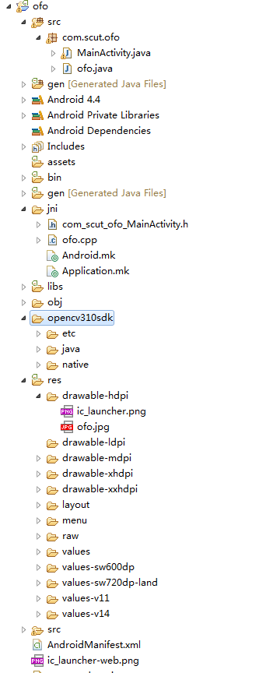

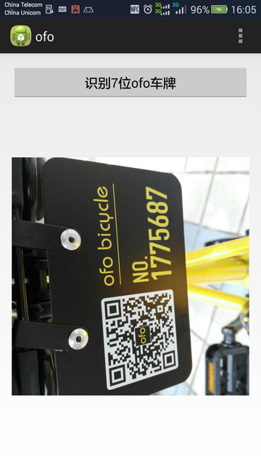

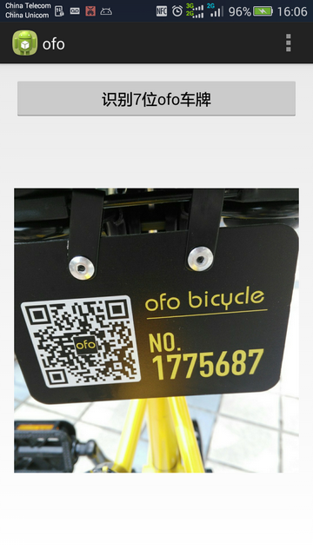

**注意Android版OpenCV在SVM阶段，要将Feature为0的值重新赋值为0.01，否则预测的值会全部相同。**

|  |
| --- |
| ofo.cpp |
| //s2-07 计算feature2  **for** (**int** i=0; i<7; i++)  {  cv::MatIterator_<cv::Vec3b> it = croppedCharListImg[i].begin<cv::Vec3b>();  **int** arrayNum = 0;  **for**(**int** j=0; j<72; j=j+8)  {  **for** (**int** k=0; k<32; k=k+8)  {  **int** countBW = 0;  **for** (**int** lj=0; lj<8; lj++)  {  **for**(**int** lk=0; lk<8; lk++)  {  **if** ((imgArray[i][j+lj][k+lk]) == 1)  {  countBW++;  }  }  }  feature2Extract[i][arrayNum] = countBW;  arrayNum++;  }  }  }  //输出至log方便观察 (奇怪是每个数都比Qt算出来的少1)  **for** (**int** i=0; i<7; i++)  {  **for** (**int** j=0; j<32/8*72/8; j++)  {  **if**(feature2Extract[i][j] == 0)  {  feature2Extract[i][j] = 0.01; //关键！！！所有为0的均赋值为0.01，否则预测计的值会全部相同  }  }  }  cv::imwrite("/sdcard/ofo_ocr/temp.jpg",lastImg);  } |

接下来的步骤就相当简单，加个摄像头、做些优化就可以。