环境搭建文档：<https://github.com/NetEaseGame/ATX>

**（1）Windows atx 安装——连接Android**

第一步：安装python ，配置环境变量

第二步：

cmd中输入：[python -m pip install --upgrade pip](https://github.com/NetEaseGame/ATX) 安装pip

cmd中输入：[pip install -i https://pypi.doubanio.com/simple/ --upgrade --pre atx](https://github.com/NetEaseGame/ATX) 安装atx

cmd中输入：[pip install -i https://pypi.doubanio.com/simple/ opencv_contrib_python](https://github.com/NetEaseGame/ATX)

安装opencv_contrib库

第三步：adb 环境变量（android sdk）

ANDROID_HOME：D:\android-sdk-windows\sdk

path:%ANDROID_HOME%\platform-tools;%ANDROID_HOME%\tools

第四步：pip install --pre --upgrade weditor 安装weditor

该工具用于查看ui层次结构

第五步：weditor及附属库安装

cmd中输入：git clone https://github.com/openatx/uiautomator2

cmd中输入：cd uiautomator2

cmd中输入：pip install -e .

cmd中输入：python -m uiautomator2 init（需连接手机，安装报错时可以试着运行python -m uiautomator2 clear-cache命令清除缓存重新下载）（多尝试几次，安装失败的情况有很多）

Atx使用教程：

1. adb shell /data/local/tmp/atx-agent -d
2. cmd中输入：python -m weditor （浏览器最好用谷歌或者火狐）如下图：

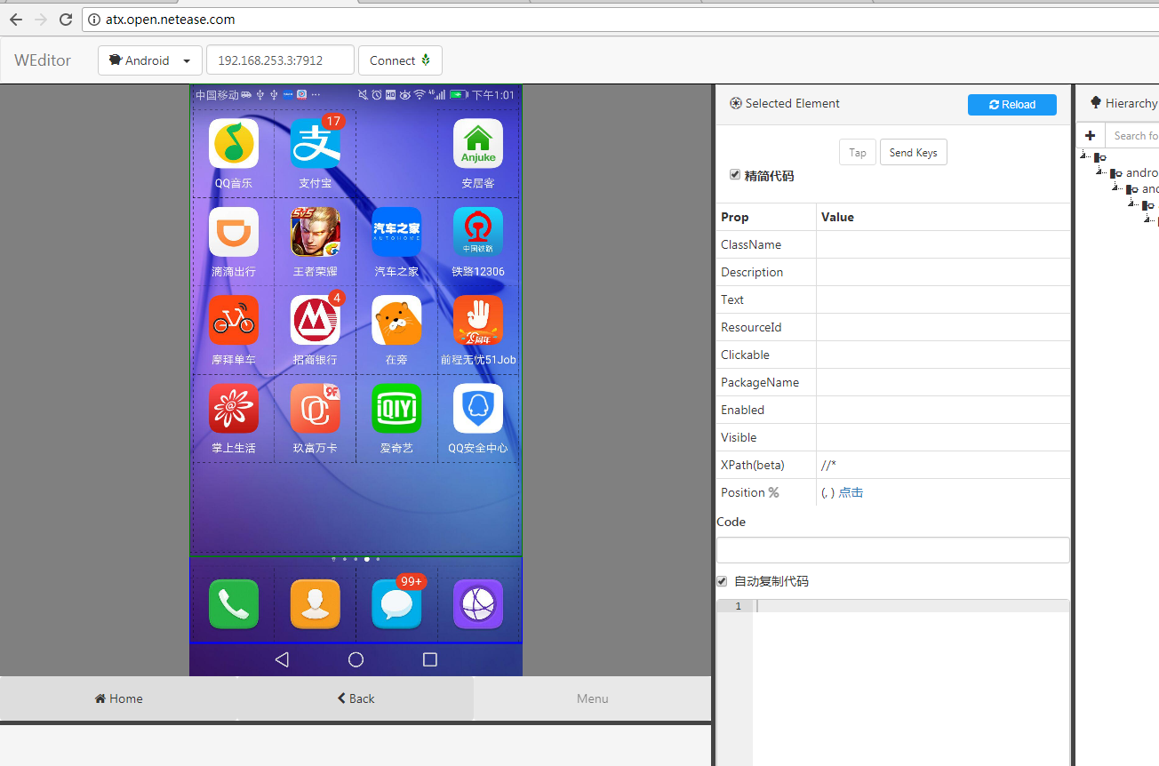

1. 代码如下：

**例子1：**

**import** uiautomator2 **as** ut2

package_namesaler = **'winretailsaler.net.winchannel.wincrm'**

d = ut2.context(192.168.253.3:7912)

d.app_start(package_namesaler)

**if** d(resourceId=**"android:id/up"**).exists:  
 d(resourceId=**"android:id/up"**).click()  
**else**:  
 **pass**

**例子2：**

**def** dealerManagesalers(self,salername,ip):  
 self.d(resourceId=**"winretaildealer.net.winchannel.wincrm:id/component_maintab_tab_textview"**, text=**u"门店管理"**).click()  
 **while True**:  
 **if** self.d(text=**u"搜索"**).exists:  
 self.d(text=**u"搜索"**).set_text(salername)  
 **break  
 else**:  
 **break** salertype = self.d(resourceId=**"winretaildealer.net.winchannel.wincrm:id/tv_dealer_type"**).info[**u"text"**]  
 print (salertype)  
 print(type(salertype))  
 self.d(resourceId=**"winretaildealer.net.winchannel.wincrm:id/list_jiantou"**).click()  
 print(self.d(resourceId=**"winretaildealer.net.winchannel.wincrm:id/dealer_type"**).info[**u"text"**])  
 **assert** salertype **in** (self.d(resourceId=**"winretaildealer.net.winchannel.wincrm:id/dealer_type"**).info[**u"text"**])  
 self.d(resourceId=**"winretaildealer.net.winchannel.wincrm:id/dealer_type"**).click()  
 c = self.d(resourceId=**"winretaildealer.net.winchannel.wincrm:id/name"**, text=**u"AB店"**).info[**u"text"**]  
 self.d(resourceId=**"winretaildealer.net.winchannel.wincrm:id/name"**, text=**u"AB店"**).click()  
 print(c)

1. **atx安装-Mac IOS**
2. sudo easy_install pip

2、安装webdriver：（selenium）

<http://blog.csdn.net/heybob/article/details/52922645>

3、sudo pip install --upgrade --pre atx

4、sudo pip install opencv_contrib_python

5、<https://testerhome.com/topics/7861>

<https://testerhome.com/topics/7220>

<http://blog.csdn.net/m0_37615390/article/details/60581058>

1. sudo pip install --pre --upgrade weditor

iproxy 8100 8100

http://localhost:8100/status

http://localhost:8100/inspector

1. sudo pip install -U --pre atx-webide

python -m weditor

1. <https://github.com/openatx/atx-webide>

python -m atxweb

<https://testerhome.com/topics/7204>