

**IDDS**

**I**GETS (International Geodynamics and Earth Tide Service) **D**ata **D**ownload **S**oftware

**User Manual**



Date: April 16, 2025

Contents

1 Preface 1

1.1 Background Introduction 1

1.2 Introduction to IDDS 1

1.3 Data Introduction 1

2 Function Introduction 2

2.1 Login 2

2.1.1 Preparation 2

2.1.2 Login Verification 2

2.2 Data Download 3

2.2.1 Setting Time Range 3

2.2.2 Station Selection 4

2.2.3 URL Selection 6

2.2.4 File Type Selection 7

2.2.5 File Storage 7

2.2.6 File Download 7

3 Common Issues 8

3.1 Login Issues 8

3.2 Download Issues 8

4 Operation Process 9

# **1 Preface**

## **1.1 Background Introduction**

Changes in the gravity field serve as the most direct and fundamental physical indicators of variations in Earth's internal material density and dynamic behavior under diverse environmental conditions. Advances in gravity observation technology, particularly the advent of the Superconducting Gravimeter (SG), have elevated measurement precision from millimeters to micrometers, and even nanometers. Between 1997 and 2015, the Global Geodynamics Project (GGP) voluntarily integrated SG data to establish a global network of superconducting gravimeters. Since 2015, the International Geodynamics and Earth Tide Service (IGETS) has taken over GGP’s efforts, continuing to provide global data services.

## **1.2 Introduction to IDDS**

IDDS (IGETS Data Download Software) is a specialized software tool designed for downloading data from the IGETS database. It supports both FTP (File Transfer Protocol) and SFTP (Secure File Transfer Protocol) protocols and offers robust features such as interactive maps, detailed station information (including latitude, longitude, data types, and time ranges), and station search capabilities. By streamlining the data retrieval process, IDDS enhances user efficiency and delivers a seamless and effective data acquisition experience.

## **1.3 Data Introduction**

The IGETS database provides three primary data products: Level 1, Level 2, and Level 3.

1. **Level 1**

Raw gravity and local atmospheric pressure records sampled at 1 or 2 seconds, in addition to the same records decimated at 1-minute samples.

1. **Level 2**

Gravity and atmospheric pressure data corrected for instrumental perturbations, ready for tidal analysis. This product is derived from the previous datasets, and is computed by UPF (University of French Polynesia) and EOST (Ecole et Observatoire des Sciences de la Terre).

1. **Level 3**

Gravity residuals after particular geophysical corrections (including solid Earth tides, polar motion, tidal and non-tidal loading effects). This product is also derived from the previous dataset and is computed by one or several Analysis Centers.

# **2 Function Introduction**

## **2.1 Login**

### **2.1.1 Preparation**

Users with an existing IGETS database account can proceed directly to login. For those without an account, registration is required at the following URL:

<https://isdc.gfz.de/igets-data-base/registration-for-data-users/>

The registration interface is illustrated in Fig. 2.1.

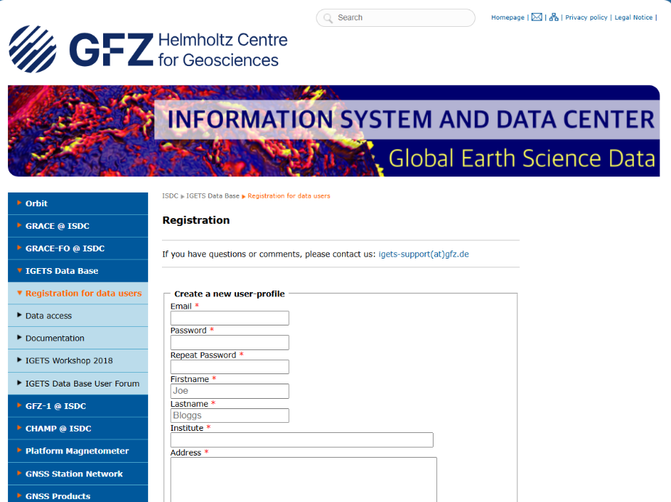

**Fig. 2.1** Account registration interface

### **2.1.2 Login Verification**

To mitigate occasional remote server connection issues, IDDS incorporates a pre-login verification mechanism. The login interface is depicted in Fig. 2.2. The software provides real-time pop-up alerts for incorrect account credentials or connection failures.

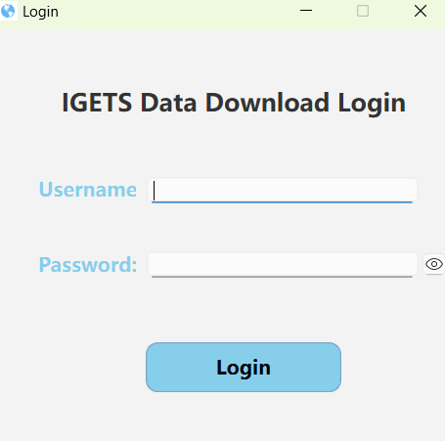

**Fig. 2.2** Login interface

## **2.2 Data Download**

### **2.2.1 Setting Time Range**

Upon successful login, users can select their desired data product for download, as shown in Fig. 2.3.

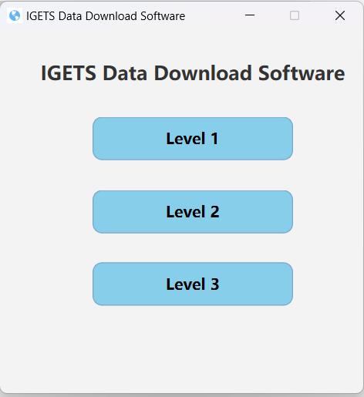

**Fig. 2.3** IDDS Main Interface

For example, selecting "Level 2" reveals an interface (Fig. 2.4) featuring six key functional modules: Time Range, Station Selection, URL Selection, File Type Selection, File Output, and Data Download.

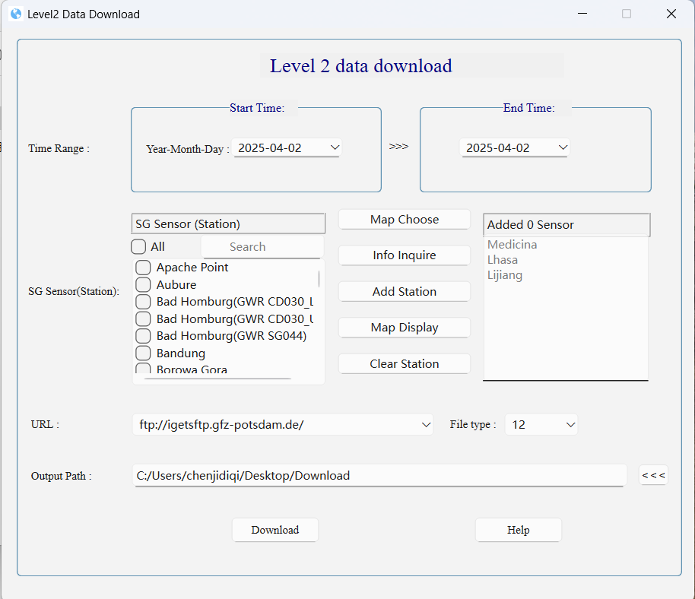

**Fig. 2.4** Level 2 Main Interface

**Time Range**: This module uses a calendar-based selection tool. Since GGP files are organized by year and month, the "day" component of the date is arbitrary and can be chosen freely, as shown in Fig. 2.5.

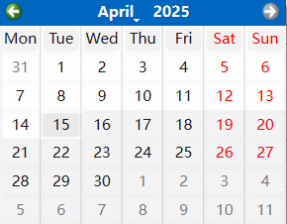

**Fig. 2.5** Time Range Selection

### **2.2.2 Station Selection**

IDDS offers three methods for selecting stations:

1. **Information Inquire Selection**:

Displays station details such as latitude, longitude, instrument type, instrument number, and available time ranges for Level 1, Level 2, and Level 3 data (Fig. 2.6).

1. **Visual Map Choose**:

Provides options for 2D maps and 3D globes (Fig. 2.7 and Fig. 2.8).

1. **Station Search and Add Station**:

This is achieved by searching for stations and manually adding stations (Fig. 2.9).

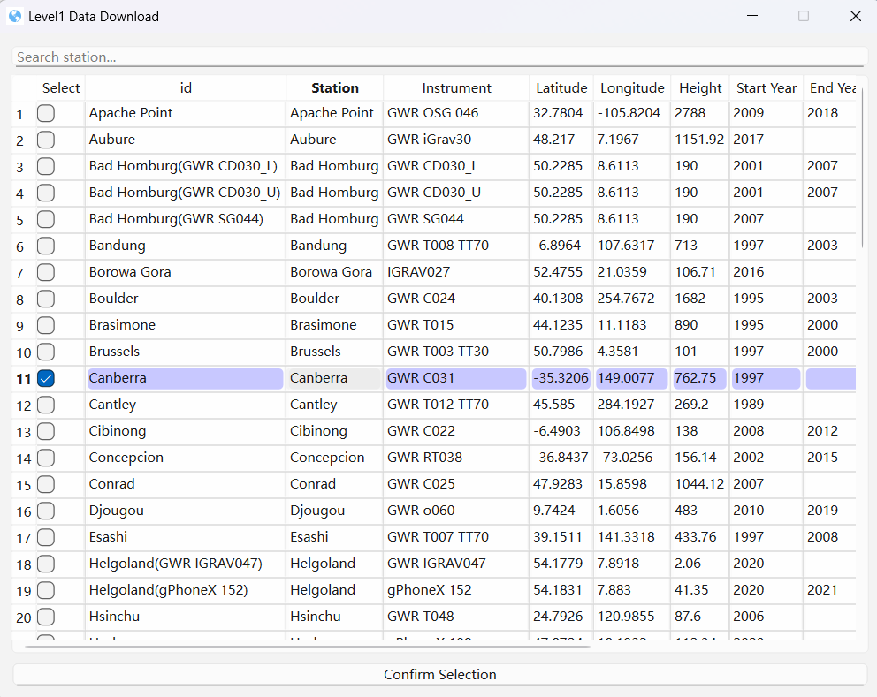

**Fig. 2.6** Information Inquire Interface

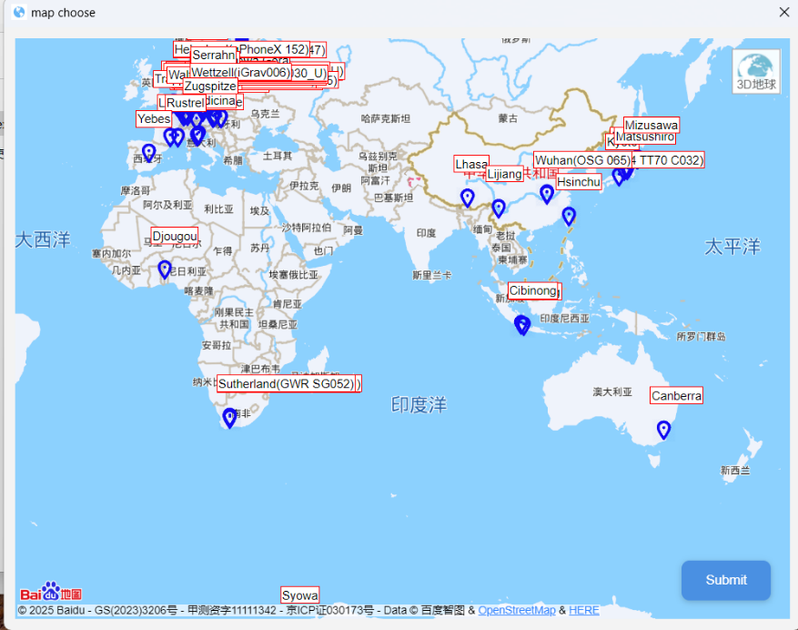

**Fig. 2.7** Map Choose Interface(2D)

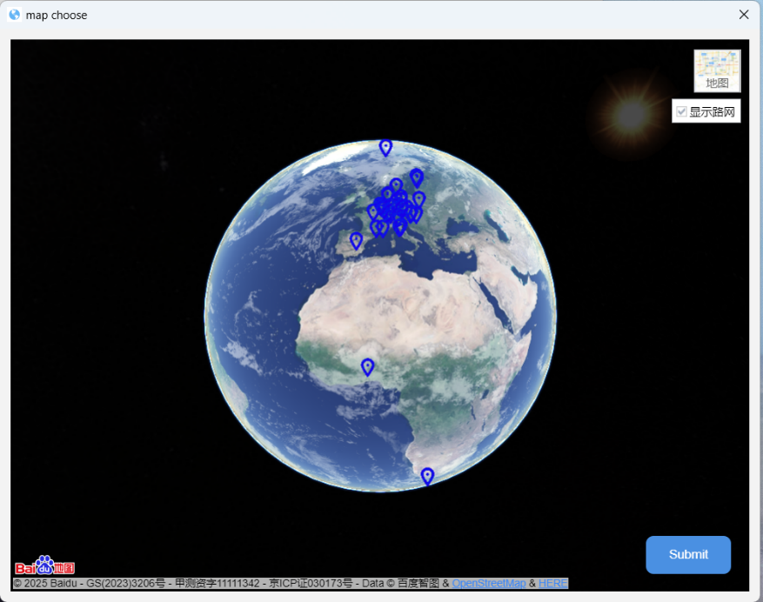

**Fig. 2.8** Map Choose Interface(3D)

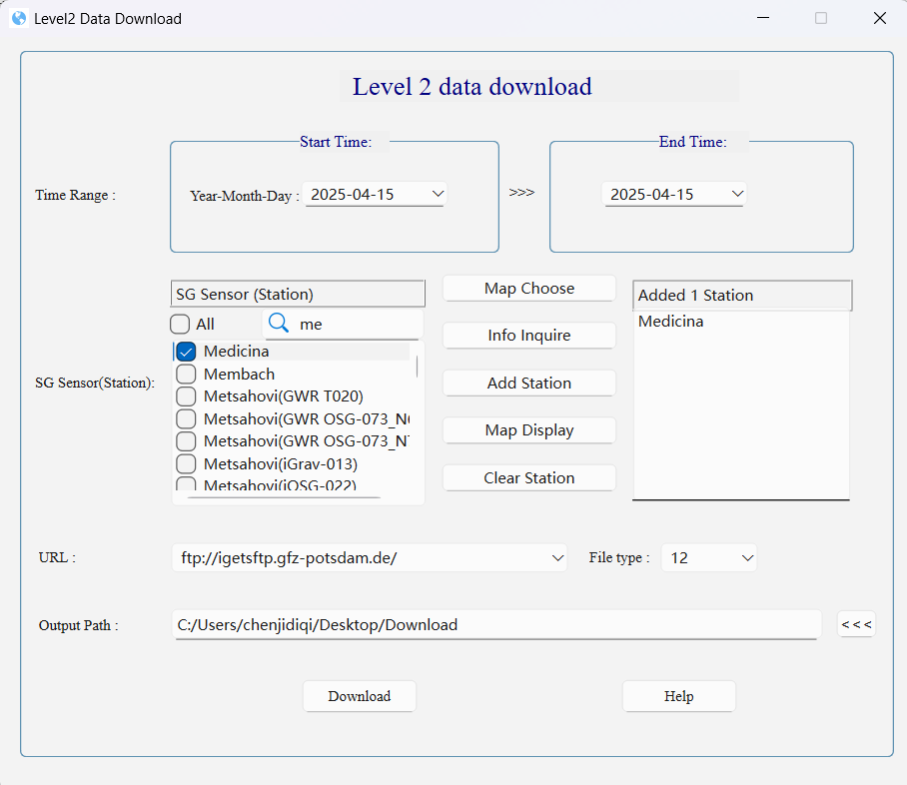

**Fig. 2.9** Station Search and Add Station

### **2.2.3 URL Selection**

The software supports two protocols: FTP and SFTP.

FTP, an unencrypted file transfer protocol vulnerable to interception, will be discontinued on May 1, 2025.

SFTP, built on the SSH (Secure Shell) security protocol, ensures encrypted transmission and is recommended for its enhanced security.

### **2.2.4 File Type Selection**

The primary file types for IGETS data products are listed in Table 1. Currently, IDDS supports the following downloads:

1. **Level 1**: ”00” files only.
2. **Level 2**: “21”, ”22”,”32” files only.
3. **Level 3**: “r2” files only.

**Table 1.** IGETS ProductFile Types

|  |  |  |  |
| --- | --- | --- | --- |
| IGETS Product | File Type | Sampling Interval | Description |
| Level 1 | 00 | 1 sec or min | Raw gravity and pressure |
| Level 1 | 01 | 1 sec or min | Corrected for synthetic tides, gaps filled, spikes and earthquakes. |
| Level 1 | 02 | 1 sec or min | Based on 01 file, with corrections for significant offsets. |
| Level 2 | 21 | 1 min | Gaps filled with synthetic signals, spikes and earthquakes corrected by UPF. |
| Level 2 | 22 | 1 min | Based on 21 file, with offset corrections by UPF. |
| Level 2 | 32 | 1 min | Based on 21 file, with offset corrections by EOST. |
| Level 3 | r1 | 1 h | Tidal and atmospheric effects removed by station administrators; non-tidal effects unprocessed. |
| Level 3 | r2 | 1 h | Tidal and atmospheric effects removed by EOST ;non-tidal effects unprocessed. |

### **2.2.5 File Storage**

The default download location is the "Download" folder on the user’s desktop. Users may also specify a custom path.

### **2.2.6 File Download**

After configuring the time range, stations, URL, file type, and storage path, users can initiate the download. The interface (Fig. 2.10) includes a progress bar, current task details, and download duration. Note that pausing downloads is not supported.

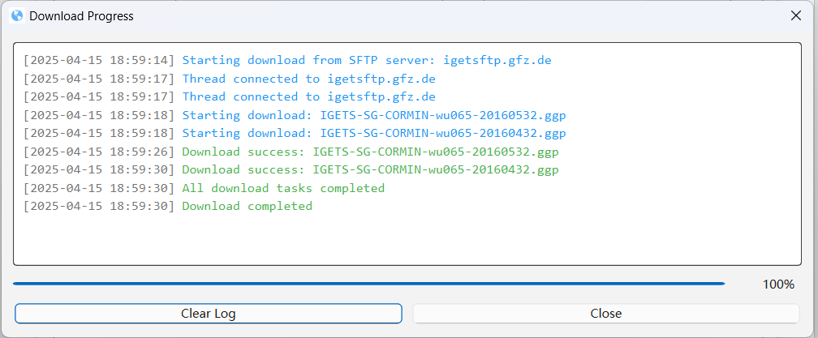

**Fig. 2.10** Download Progress Interface

# **3 Common Issues**

## **3.1 Login Issues**

When registering, the "@" symbol in email addresses is replaced with "_*at_*". For example, an account registered as "[609648766@qq.com](mailto:609648766@qq.com)" must be entered as "609648766_at_qq.com" during login.

## **3.2 Download Issues**

If the download is interrupted, subsequent attempts may trigger a port conflict, as shown in Fig. 3.1.

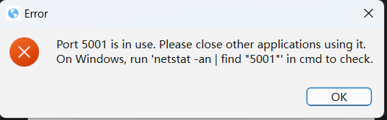

**Fig. 3.1** Download Issues

**Solution**（Fig. 3.2）：

1. Press “Win+R”，input “cmd” and enter to open the Command Prompt.
2. input ‘netstat -ano| findstr “5001” ’to check port usage.
3. input ‘taskkill/pid [PID] -f’ to terminate the process (replace [PID] with process ID).

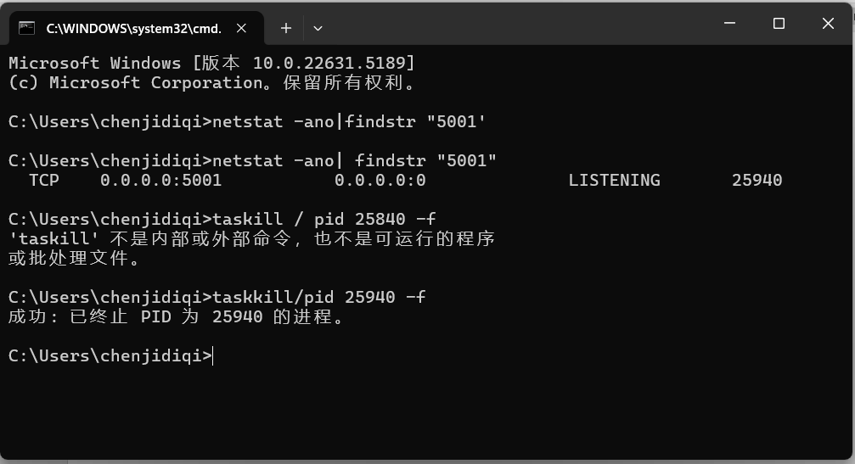

**Fig. 3.2** Resolving Download Issues example

# **4 Operation Process**

The workflow for using IDDS is as follows:

1. Login Verification
2. Product Selection
3. Station Selection
4. Setting Time Range
5. URL Selection
6. File Type Selection
7. Setting Output Path
8. Data Download

This process is visualized in the flowchart below.(Fig. 4.1)

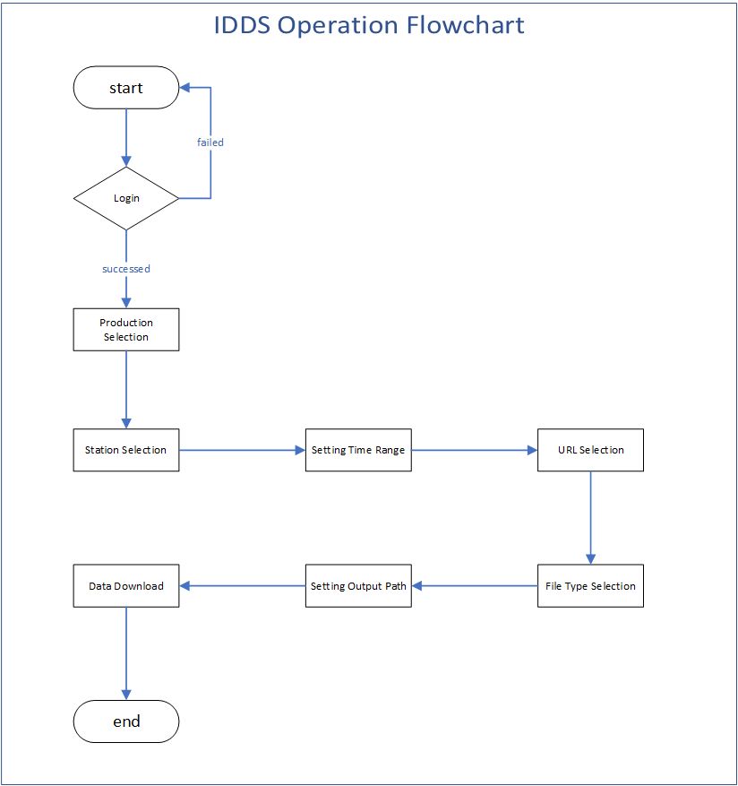

**Fig. 4.1** IDDS Operation Flowchart