Logstash采集日志

一、实验环境
192.168.31.146 CentOS Linux release 7.5.1804 (Core)
二、实验目的
logstash采集系统日志和nginx日志
参考文档：https://www.elastic.co/guide/en/logstash/6.2/config-examples.html //官方参考
三、实验步骤
1、配置例子
采集系统日志

input {
file {
path => "/var/log/messages"
type => "systemlog"
start_position => "beginning"
stat_interval => "3"
}
file {
path => "/var/log/secure"
type => "securelog"
start_position => "beginning"
stat_interval => "3"
}
}

output {
if [type] == "systemlog" {
elasticsearch {
hosts => ["localhost:9200"]
index => "system_log_%{+YYYY.MM.dd}"
}
}
if [type] == "securelog" {
elasticsearch {
hosts => ["localhost:9200"]
index => "secure_log_%{+YYYY.MM.dd}"
}
}
}

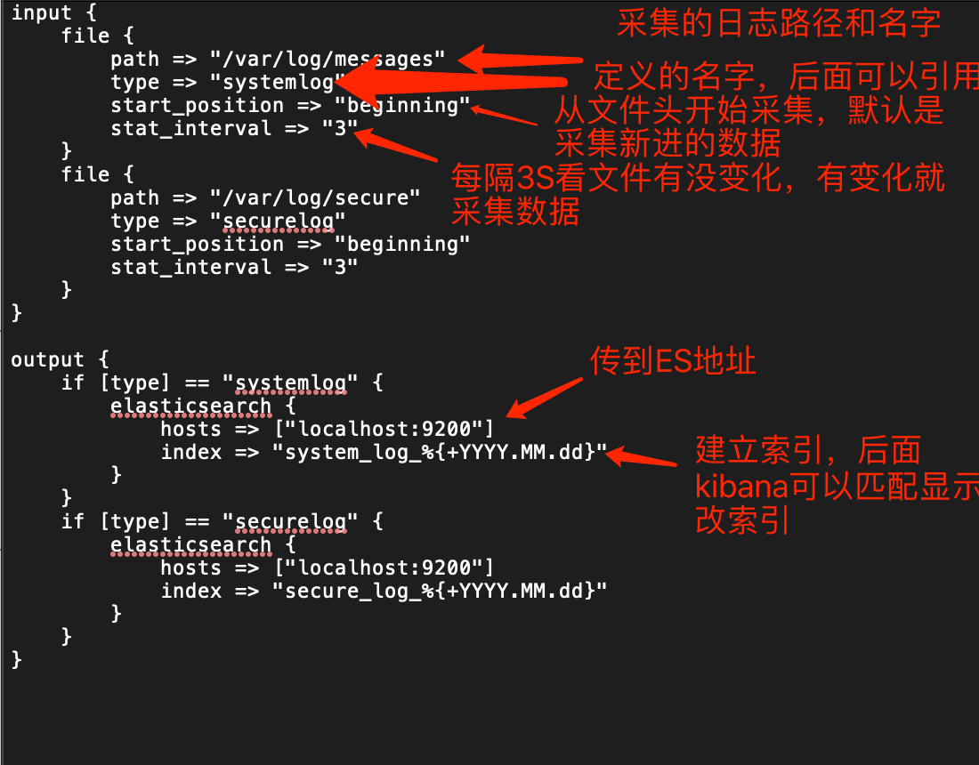

采集nginx日志
input {
file {
path => "/usr/local/nginx/logs/access.log"
}
}
output {
elasticsearch {
hosts => ["localhost:9200"]
index => "nginxlog-%{+YYYY.MM.dd}"
}
stdout { codec => rubydebug }
}

其中 stdout { codec => rubydebug }会将抓到的数据显示在终端

2、启动logstash
#cd /usr/share/logstash
#./bin/logstash -f example/nginx.conf -t //做语法检查
#启动logstash
#./bin/logstash -f example/nginx.conf

提醒： 启动方式 1）、nohup+ &方式启动 2）screen方式启动 3）systemd方式启动 4）supervisord方式启动 5）脚本方式启动
不能同时一台机器开多个logstash

