TECHNICAL PORTFOLIO REPORT
Energy Management Strategy for a
Grid-connected PV-BESS System
Constraint-based Sizing, Multi-day Validation, and Price-aware Grid Precharging
FINAL PROTOTYPE
340 kWh / 70 kW BESS | 100 kW grid-import limit | 20%–90% SOC range
Prepared by Chen Jin
BEng Electrical Engineering, The Hong Kong Polytechnic University
MATLAB / Simulink Engineering Portfolio Project | August 2026
Project objective
Demonstrate the ability to translate a power-and-energy requirement into an executable, verifiable and explainable engineering solution.

1. Technical Summary
This project develops and validates a rule-based energy management system for a grid-connected photovoltaic and battery energy storage system. The supervisory model was implemented in MATLAB/Simulink with a 15-minute timestep and explicitly enforced a 100 kW grid-import limit, a 20%–90% battery SOC range, and battery power and energy constraints. An initial 200 kWh / 50 kW design reduced the nominal peak import from 140 kW to 100 kW, but adverse-scenario testing showed that it was energy-limited. A worst-case capacity sweep identified 310 kWh as the minimum tested feasible capacity and 340 kWh / 70 kW as the first tested design providing at least five percentage points of SOC margin. State-aware precharging then achieved 14/14 compliant days in a continuous multi-day sequence with zero SOC-handover and power-balance error. The model also passed five engineering exception tests with the expected compliant or constraint-limited outcomes. Finally, an enhanced price-aware strategy using Shandong day-ahead prices and deadline SOC recovery retained reliability and terminal-energy comparability on all 90 observed price days while reducing modeled grid-import energy cost by 10.805%.
140 → 100 kW  preliminary peak reduction | 340 kWh / 70 kW  final simulated BESS design | 14 / 14 days  state-aware grid compliance
26.10%  minimum SOC in final 14-day test | 5 / 5 tests  engineering validation outcomes | 10.805%  modeled import-energy cost reduction

CLAIM BOUNDARY
The price result is a controlled sensitivity study using one repeated representative load/PV day. It is not a historical site reconstruction, guaranteed saving, ROI or payback calculation.

2. Requirements Traceability
The design process began by converting an application requirement—limit grid import while preserving battery readiness—into measurable constraints and test gates.
Engineering requirement | Design response | Verification metric
Grid import ≤100 kW | Peak-shaving discharge rule | Peak power; exceedance energy
SOC between 20% and 90% | SOC-dependent saturation | Minimum and maximum SOC
Battery power ≤70 kW | Charge/discharge power limiter | Maximum |Pbatt|
Continuous energy state | Final SOC handed to next day | SOC handover error
Adverse-condition operation | Sunny/cloudy and normal/high-load cases | Scenario compliance
Multi-day readiness | State-aware precharge and recovery | Compliant days; terminal SOC
Low-price charging | Daily P25 price gate | Import-energy cost
Fair strategy comparison | Terminal-energy comparability gate | Final-SOC difference ≤0.5 point
Physical consistency | Explicit power balance | Maximum balance error

3. System Boundary and Model Specification
The model represents supervisory energy scheduling rather than converter-level electromagnetic dynamics. Load, PV, forecast/state flags and day-ahead price signals are processed into net-load, battery and grid-power commands at 900-second intervals.
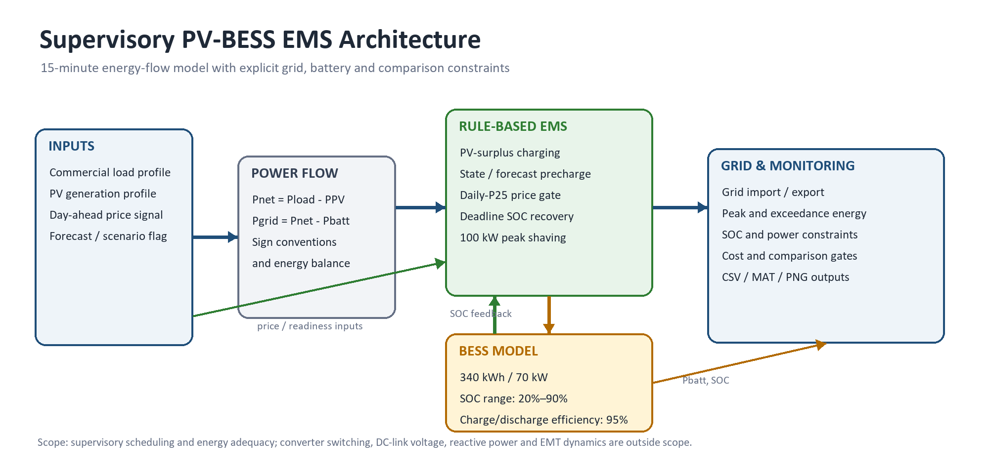
Figure 1. Supervisory PV-BESS EMS architecture and information flow.

3.1 Power-flow equations and sign conventions
Pnet = Pload − PPV
Pgrid = Pnet − Pbatt
Signal condition | Engineering meaning
Pbatt > 0 | Battery discharging
Pbatt < 0 | Battery charging
Pgrid > 0 | Grid import
Pgrid < 0 | Grid export

3.2 Final design parameters
Parameter | Value / implementation
Simulation step | 900 s (15 min)
Grid-import limit | 100 kW
Final BESS design | 340 kWh / 70 kW
SOC operating range | 20%–90%
Charge/discharge efficiency | 95% / 95%, fixed
Precharge target | 90% SOC
Low-price threshold | Daily P25 economic clearing price
Deadline recovery | 13:00–17:00 guardrail

4. Final Rule-based EMS Strategy
The controller was deliberately kept interpretable. Reliability constraints are evaluated before accepting an economic dispatch action, and every command is saturated by SOC, energy, power-rating and grid-headroom limits.
- Calculate net load from the commercial load and PV profiles.
- Charge the battery from PV surplus while SOC remains below 90%.
- Discharge when net demand would push grid import above 100 kW.
- Use available grid headroom to precharge when forecast and state preparation indicate insufficient stored energy.
- In price-aware mode, prioritize charging during intervals below the daily P25 day-ahead price threshold.
- From 13:00 to 17:00, apply deadline SOC recovery when the low-price opportunity alone cannot restore the required pre-peak energy state.
- Record comparison-validity gates: grid reliability, terminal-SOC equivalence, SOC integration, battery-power rating and power balance.
ENGINEERING RATIONALE
Economic timing is accepted only after reliability and comparison validity are preserved. This prevents a lower-cost result from being credited simply because one strategy ends the day with less stored energy.

5. Nominal Prototype Performance
The preliminary 200 kWh / 50 kW prototype established functional feasibility under a sunny, normal-load day. It reduced the baseline peak from 140 kW to the 100 kW grid limit.
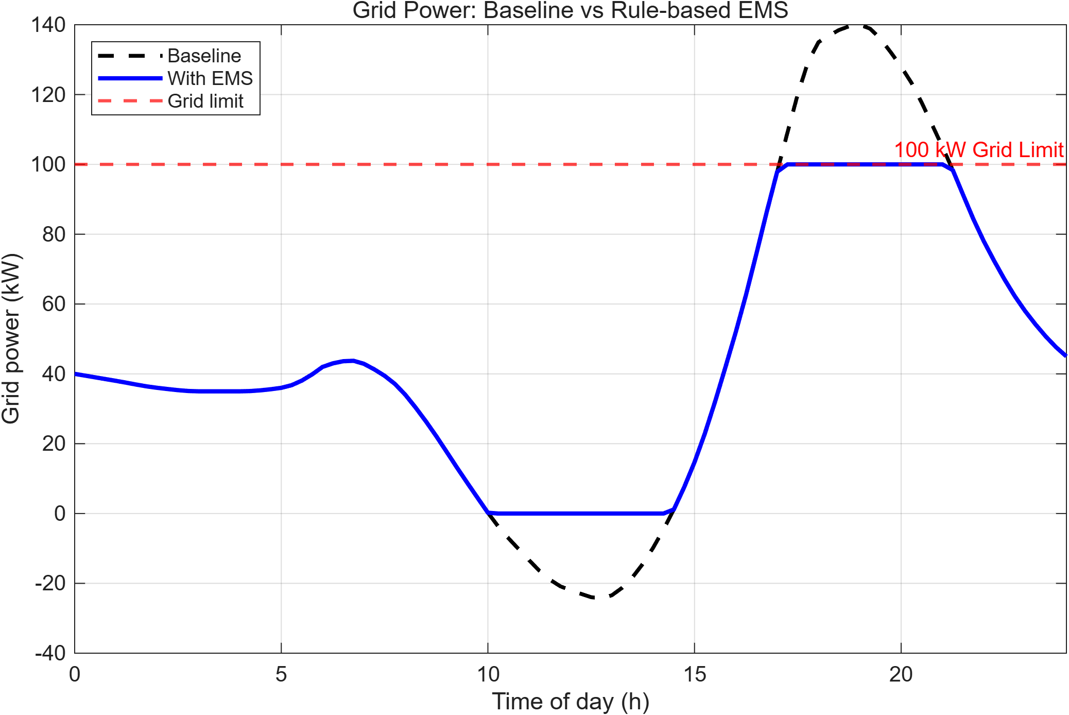
Figure 2. Preliminary 200 kWh / 50 kW prototype: baseline and EMS grid-power profiles.
KPI | Baseline | With EMS
Peak grid import | 140.0 kW | 100.0 kW
Daily grid import | 1168.0 kWh | 1057.7 kWh
PV self-consumption | 92.1% | 100.0%
Battery / model checks | — | 179.1 kWh throughput; SOC 24.7%–82.7%; balance error 0 kW

DESIGN LESSON
Nominal success was not treated as proof of adequate BESS sizing; high-load and cloudy cases were tested next.

6. Adverse-scenario Sizing and Engineering Selection
Scenario testing separated power adequacy from energy adequacy. A 70 kW converter rating exceeded the estimated 61 kW peak discharge requirement, yet the 300 kWh design still failed the cloudy/high-load case. The dominant constraint was therefore usable energy capacity.
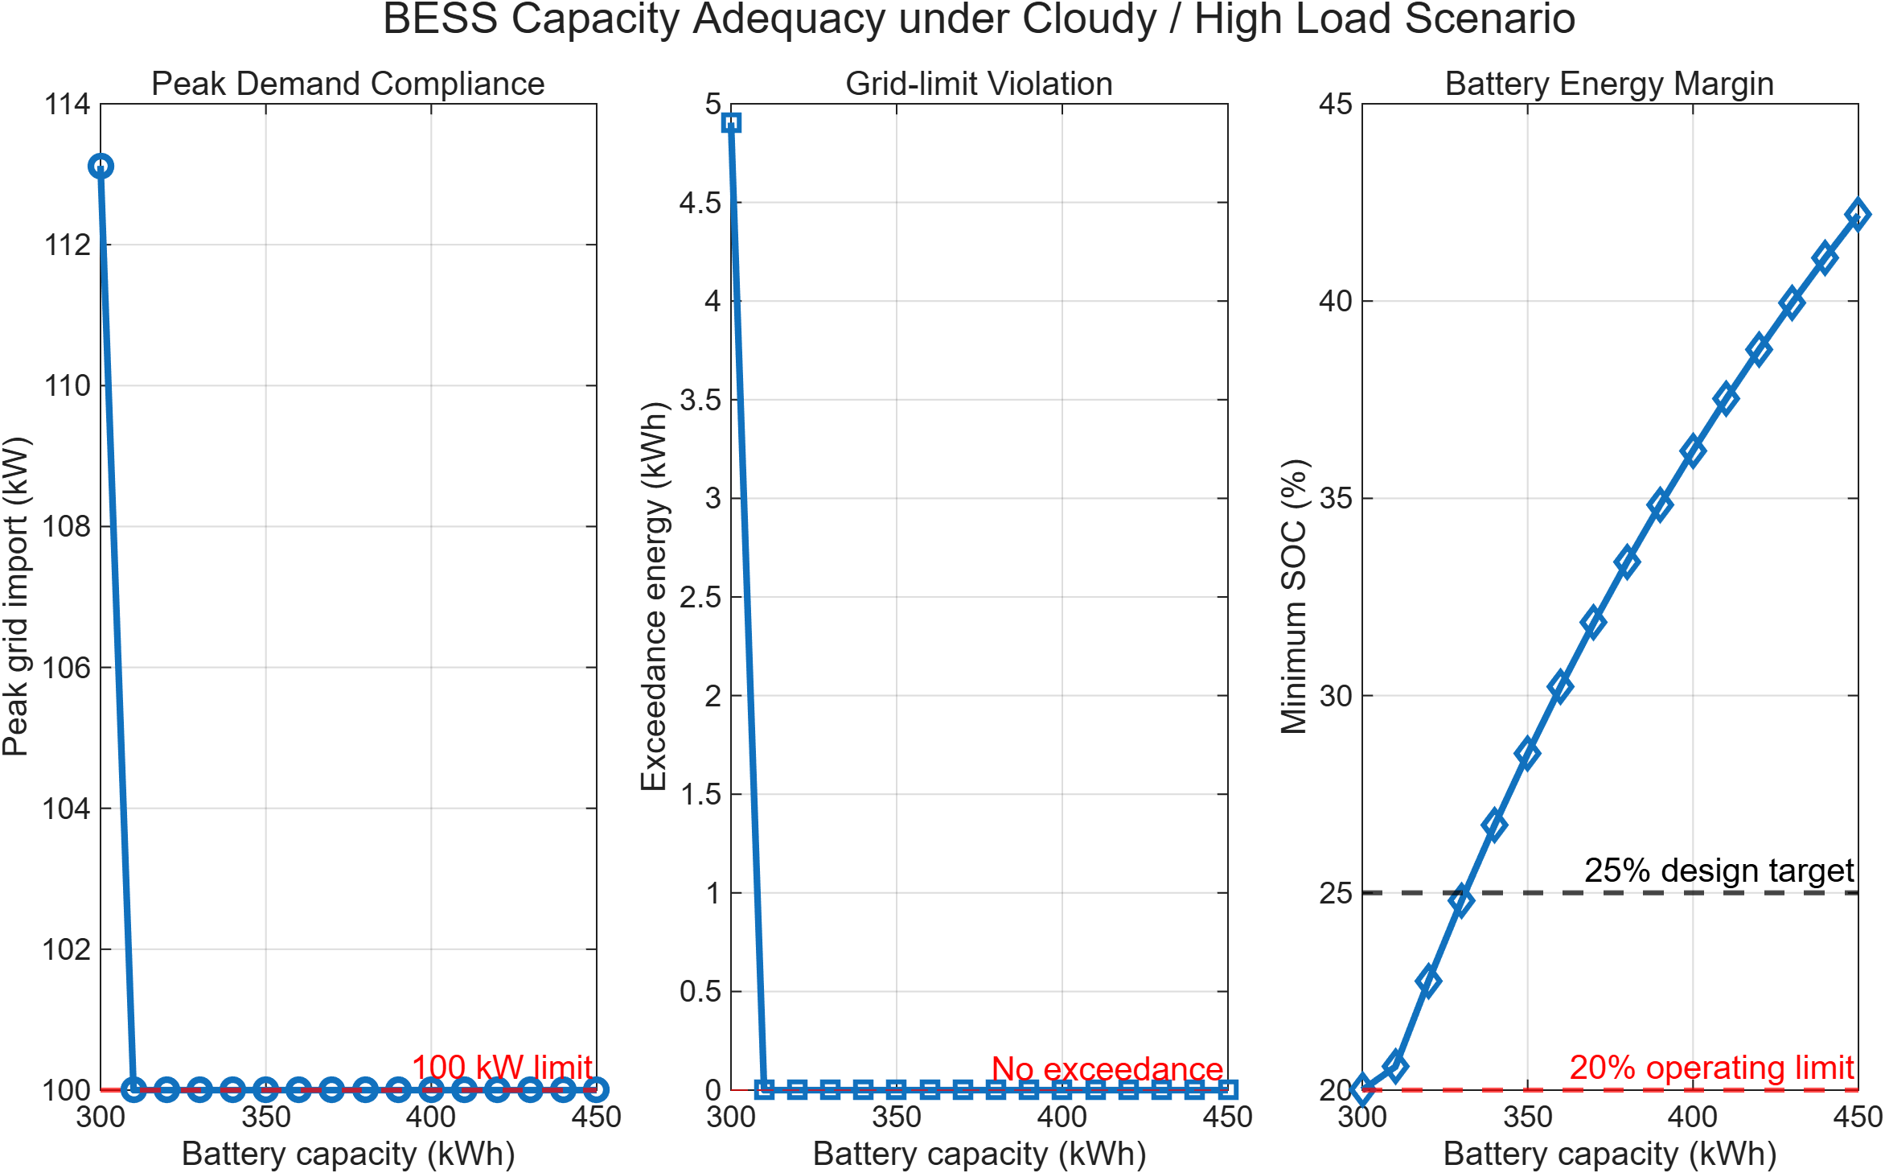
Figure 3. Worst-case capacity sweep at a fixed 70 kW BESS power rating.
Configuration | Case | Peak grid | Min SOC | Decision
200 kWh / 50 kW | High-load cases | 147.2 kW | 20.0% | Failed: power and energy constrained
300 kWh / 70 kW | Cloudy / high load | 113.12 kW | 20.0% | Failed: 4.9046 kWh exceedance
310 kWh / 70 kW | Cloudy / high load | 100.0 kW | 20.593% | First tested feasible point; negligible margin
340 kWh / 70 kW | Cloudy / high load | 100.0 kW | 26.717% | Selected: first tested point above 25% target

SELECTED DESIGN
340 kWh / 70 kW is the first tested configuration satisfying both the 100 kW grid limit and a five-percentage-point SOC operating margin in the defined worst case. The recommendation is profile- and assumption-specific and must be mapped to supplier product ratings before deployment.

7. Multi-day SOC Continuity and Controller Upgrade
The first sequential study demonstrated exact SOC handover but exposed a readiness failure when precharging was disabled on a day that began with insufficient energy. Failure diagnosis led to a state-aware schedule that considered both the upcoming scenario and the inherited SOC.
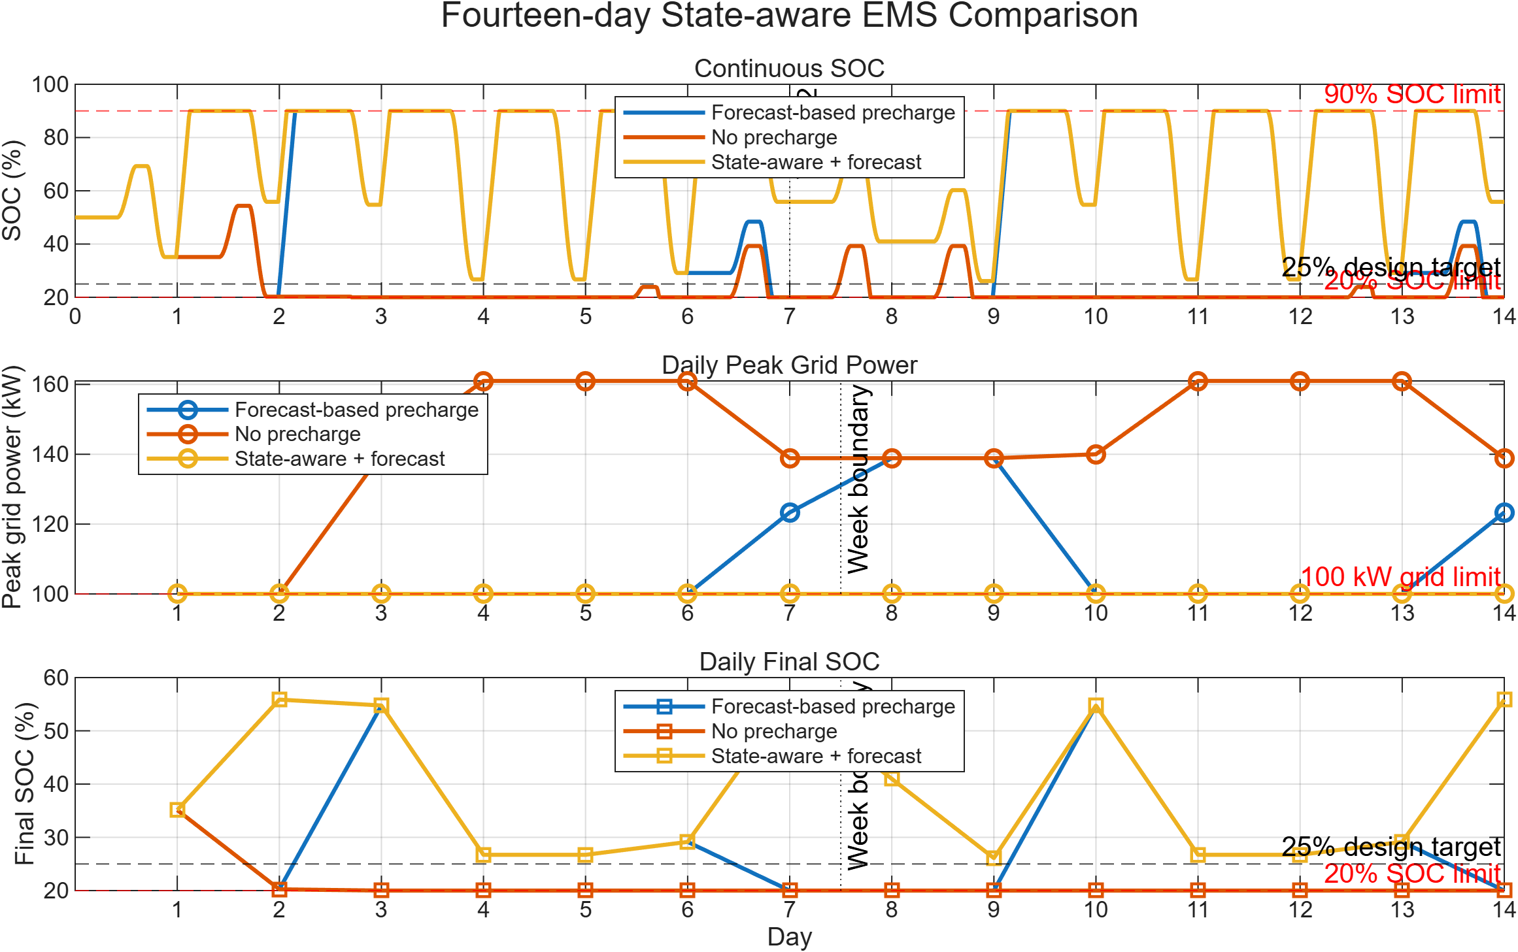
Figure 4. Final 14-day comparison of no-precharge, forecast-only and state-aware strategies.
Strategy | Compliant days | Max grid | Exceedance | Min SOC
No precharge | 2 / 14 | 161.00 kW | 1604.84 kWh | 20.000%
Forecast-based precharge | 10 / 14 | 138.86 kW | 133.24 kWh | 20.000%
State-aware + forecast | 14 / 14 | 100.00 kW | 0 kWh | 26.101%

CONTINUITY CHECKS
The final state-aware strategy finished both weeks at 55.867% SOC, with zero inter-day handover error and zero maximum power-balance error.

8. Engineering Validation and Expected Failure Behaviour
A validation test passes when the simulated outcome matches the expected physical behavior. Fault cases are therefore allowed to exceed the grid limit when the defined BESS constraints make compliance impossible; the controller must fail predictably without violating SOC, power-rating or balance constraints.
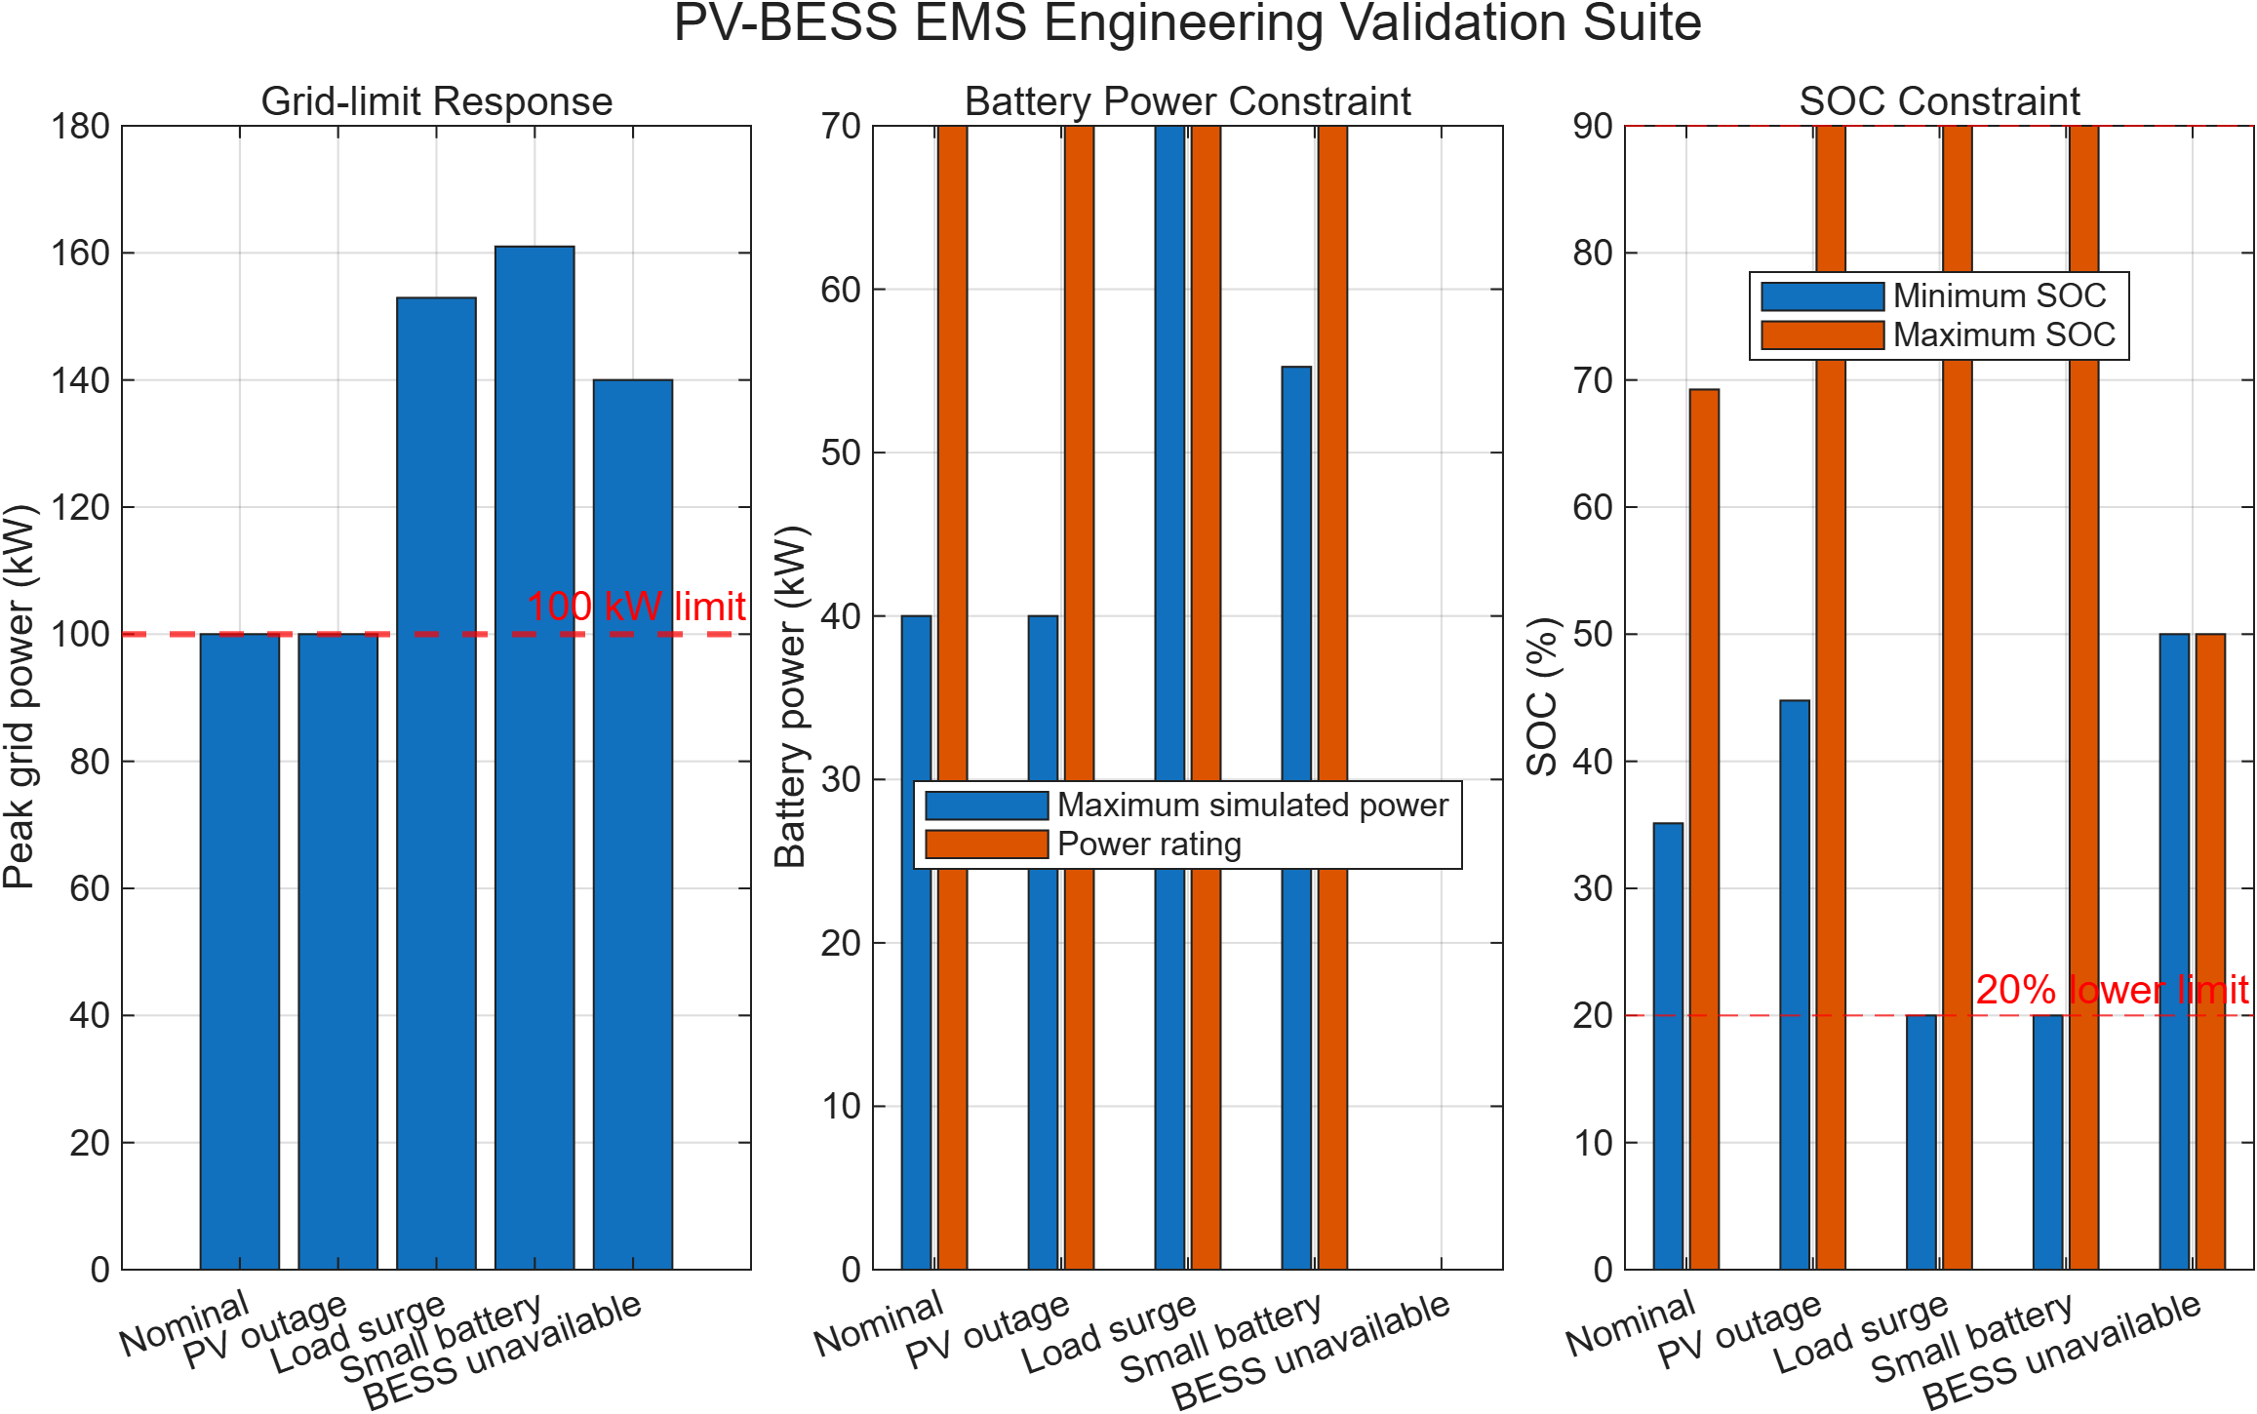
Figure 5. Validation suite covering nominal operation and four abnormal conditions.
Test | Expected behavior | Actual | Peak grid | Verdict
Nominal operation | Compliant | Compliant | 100.00 kW | PASS
Complete PV outage | Compliant | Compliant | 100.00 kW | PASS
Load surge | Power-limited failure | Non-compliant | 152.92 kW | PASS
Undersized battery | Energy-limited failure | Non-compliant | 161.00 kW | PASS
BESS unavailable | Grid follows net load | Non-compliant | 140.00 kW | PASS

VALIDATION VERDICT
5/5 scenario outcomes matched expectation; 5/5 SOC checks, 5/5 power-rating checks and 5/5 power-balance checks passed.

9. Price-aware Charging Sensitivity
The final extension tested whether charging could be shifted toward low-price intervals without sacrificing readiness. The daily P25 price gate was supplemented by a 13:00–17:00 deadline recovery rule so that economic timing did not create a lower terminal energy state.
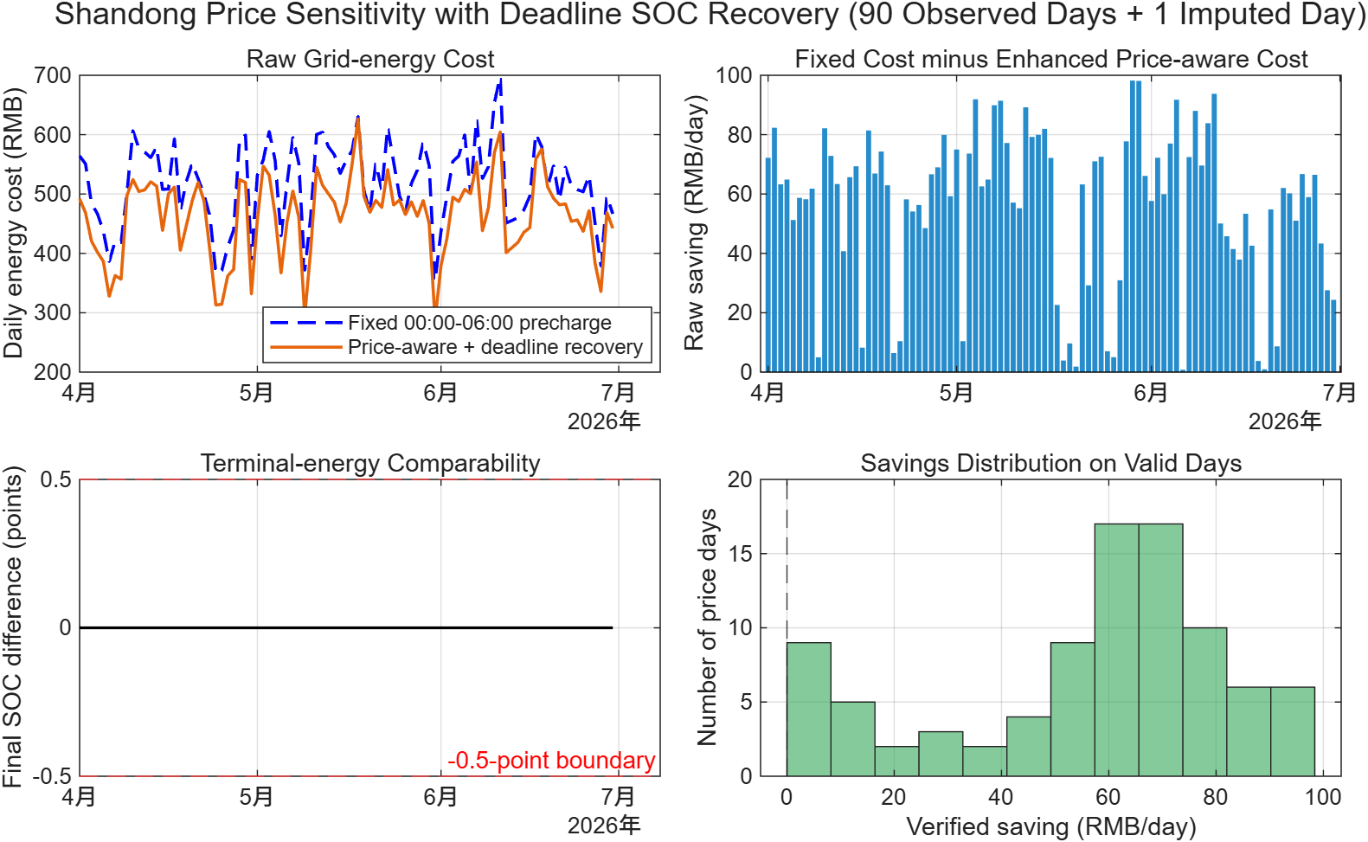
Figure 6. Controlled Shandong day-ahead price sensitivity with deadline SOC recovery.
Scope | Price days | Comparable | Cost reduction | Mean saving | Median saving
Observed price days | 90 | 90 | 10.805% | 56.053 RMB/day | 62.754 RMB/day
Including imputed day | 91 | 91 | 10.797% | 55.940 RMB/day | 62.581 RMB/day

Observed-day statistic | Value
P05 / P25 / P75 / P95 modeled saving | 3.910 / 42.595 / 73.605 / 91.757 RMB/day
Minimum / maximum modeled saving | 0.819 / 98.215 RMB/day
Positive modeled saving days | 90 / 90
Scenario-set aggregate | 5044.8 RMB (not a historical quarterly saving)

ECONOMIC INTERPRETATION
Each of the 90 observed price curves was applied to the same representative sunny/normal load and PV profile. Energy cost includes grid imports only, assumes zero export compensation, and assumes commercial access to the stated Shandong day-ahead economic clearing price.

10. Limitations and Claim Boundaries
• The 15-minute model resolves supervisory energy dispatch, not converter switching, DC-link voltage, reactive power or electromagnetic transients.
• Load and PV profiles are representative rather than synchronized measured histories from a specific site.
• Battery charge and discharge efficiencies are fixed at 95%; temperature, nonlinear internal resistance, ageing and degradation are not modeled.
• The price study changes only the price signal while repeating one physical day; it is a controlled sensitivity study rather than historical operation.
• The main price statistics exclude the fully imputed 2026-06-13 price day.
• The commercial customer is assumed to buy at the Shandong day-ahead clearing price; retail contract terms, network charges, taxes and settlement rules are outside scope.
• Export compensation is zero. Demand charges, CAPEX, EPC, HVAC, fire protection, O&M, warranty, replacement and financing costs are omitted.
• The 340 kWh / 70 kW recommendation applies to the tested profiles and assumptions; it is not a universal site design or a direct supplier specification.
• The study supports technical feasibility and comparative controller behavior. It does not establish a unique ROI, payback period or guaranteed saving.

11. Recommended Engineering Extensions
1. Replace the representative load/PV inputs with synchronized measured site profiles and repeat the sizing and multi-day validation workflow.
2. Add tariff, demand-charge and export-compensation sensitivity after obtaining an applicable commercial contract.
3. Map the 340 kWh / 70 kW requirement to available supplier products, installation derating, fire/HVAC constraints and protection interfaces.
4. Build a separate second-scale event model for cloud transients or DC-link response if a power-electronics-focused portfolio is required.
5. Introduce SOC/C-rate-dependent efficiency only when traceable battery parameters are available.

12. Conclusion
The project demonstrates that effective PV-BESS engineering requires more than a nominal dispatch rule. BESS power and energy ratings, adverse operating scenarios, SOC continuity, recovery capability, economic timing and comparison validity must be treated as linked design constraints. The final 340 kWh / 70 kW prototype translated these requirements into a controller that was executable, testable and explainable. Its principal contribution is therefore not an advanced optimization algorithm, but a traceable engineering workflow from requirement definition through failure diagnosis, sizing, controller revision and independent validation.
PORTFOLIO MESSAGE
I understand power and energy system constraints, and I can translate an energy problem into a practical technical solution.

