Orb1000 | ransac | Ransac_pro | 结果
1 |  |  | 失败
2
3
4
5
6 | 59.73ms | 51.85ms | 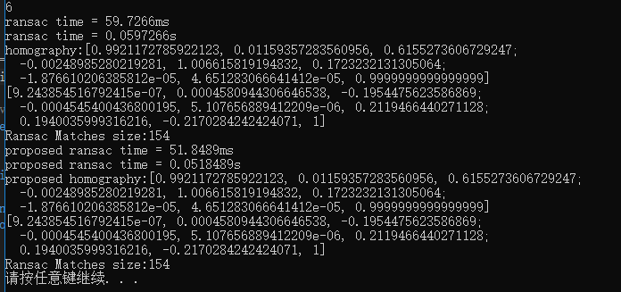
bank | 55.97ms | 52.95ms | 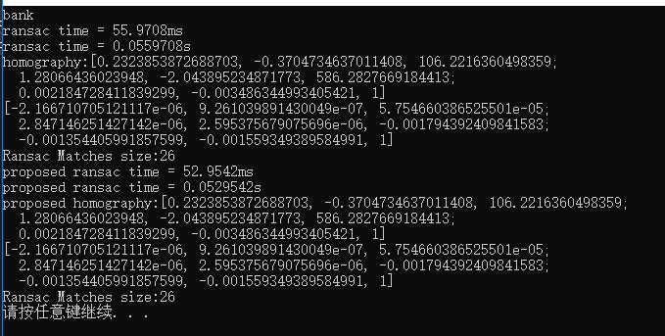
boat | 5.36ms | 4.46ms | 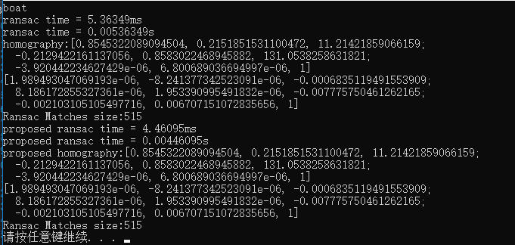
graf
leuven | 4.15ms | 3.83ms | 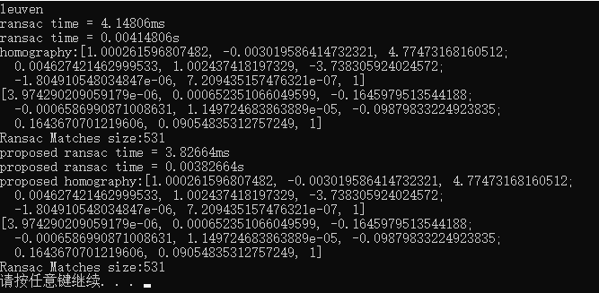
notredame12 | 56.85ms | 53.17ms | 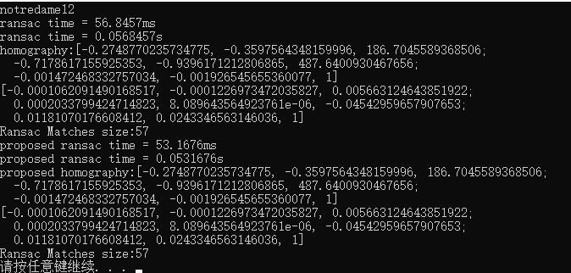  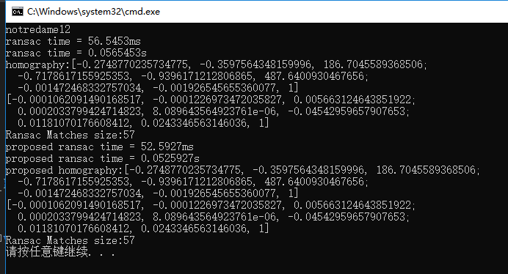
notredame15 | 57.20ms | 54.43ms | 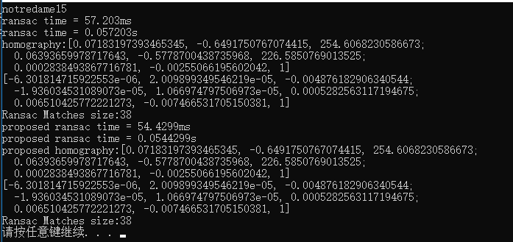
trevi02 | 59.47ms | 52.75ms | 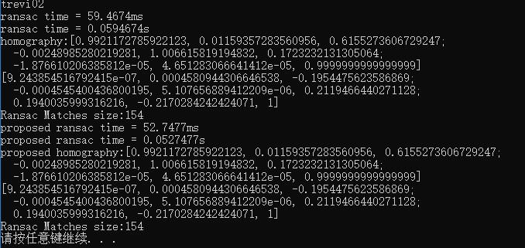
ubc
wall
Adam | 56.85ms | 52.26ms | 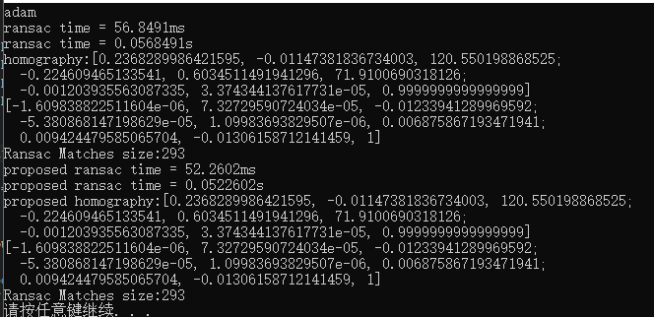  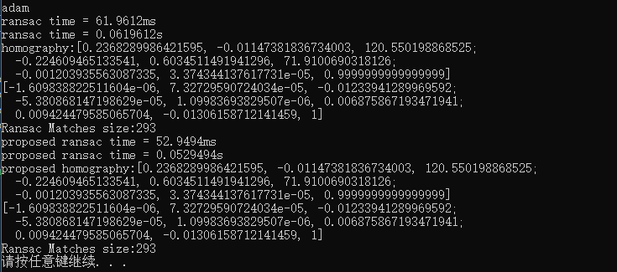

Orb3000 | Ransac | Ransac_pro
bank | 76.92ms | 53.00ms | 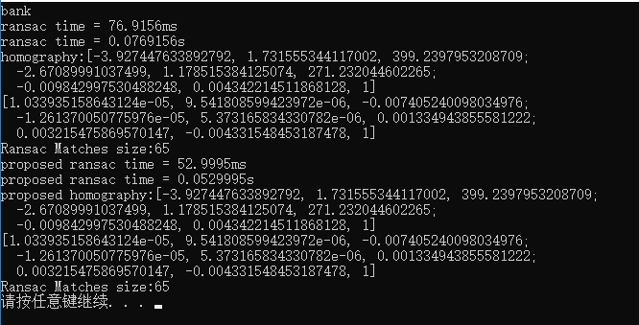
boat | 11.96ms | 7.93ms | 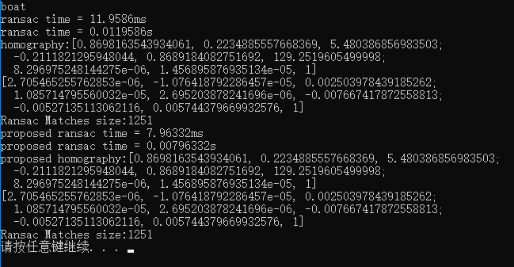
graf
leuven | 6.16ms | 4.42ms | 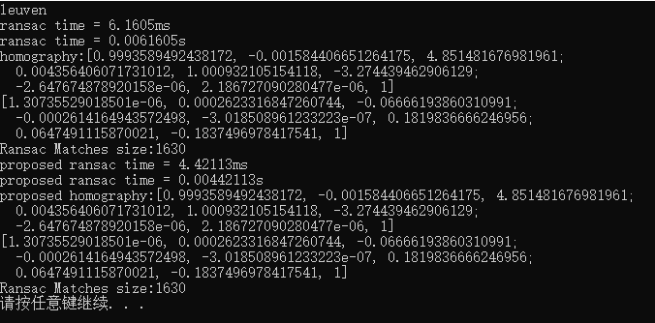
notredame12 | 82.90ms | 55.16ms | 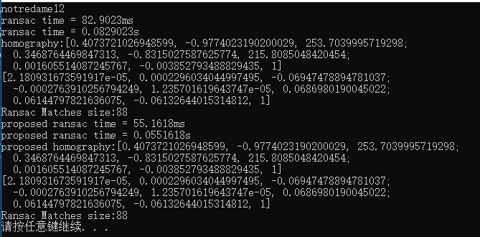
notredame15 | 78.17ms | 55.32ms | 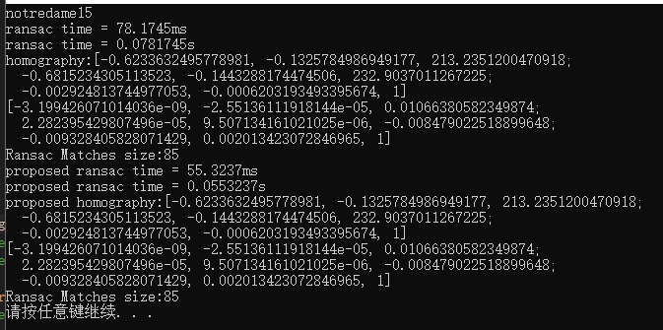
trevi02 | 75.74ms | 52.91ms | 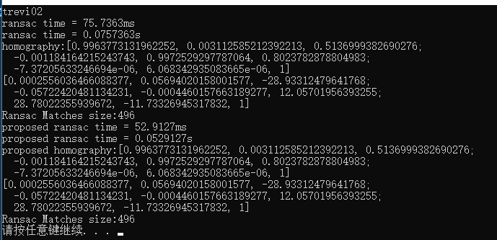  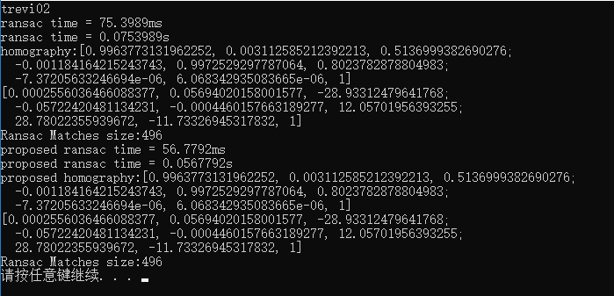
Adam | 45.88ms | 42.11ms | 