The Entity-Relationship Model-Toward a Unified View of Data

找到了ER diagram提出的原论文。感觉论文很清楚的讲述了ER diagram实现了什么层级的信息的记录，和建立ER diagram应该怎么思考：（1）先明确我们自己是否理解实体之间的关系，把这样的理解表示出来 （2）将这种表示进行结构化表示，使用数据来表现entity和relationships （3）考虑access-path- independent的data structure （4）考虑access-path-dependent的data structure。文中主要使用一个例子解释了整个过程，便于理解，在这个过程中，清晰的解释了entity、relationship、attribute是什么，以及什么是weak entity relation，什么是regular entity relation。

1. An entity is a thing, and entities can be divided into difference entity sets, the entities in the same set have common properties. (when we organized the entity sets as a form, the form is a entity relation, similarly, we can have relationship relation) we can use primary key to identify an entity.   
2. Some entity sets can be subset of another

3.relationship is a tuple of different entities, and each entity can have its own role. The set of all the relationships is a relationship set. Relationship is identified by the engaged entities

4.we can see attribute as a kind of function, mapping entities values to value set

5.entity or a relationship can be seen as the tuple, in which is the attribute-value pair

6.there are two ways to identify entity. In one case, we may use the entity’s own information, it is called regular entity relation. In another, except the attribute of this entity itself, we also use other entity’s information (relationship), in this case, it’s a weak entity relation

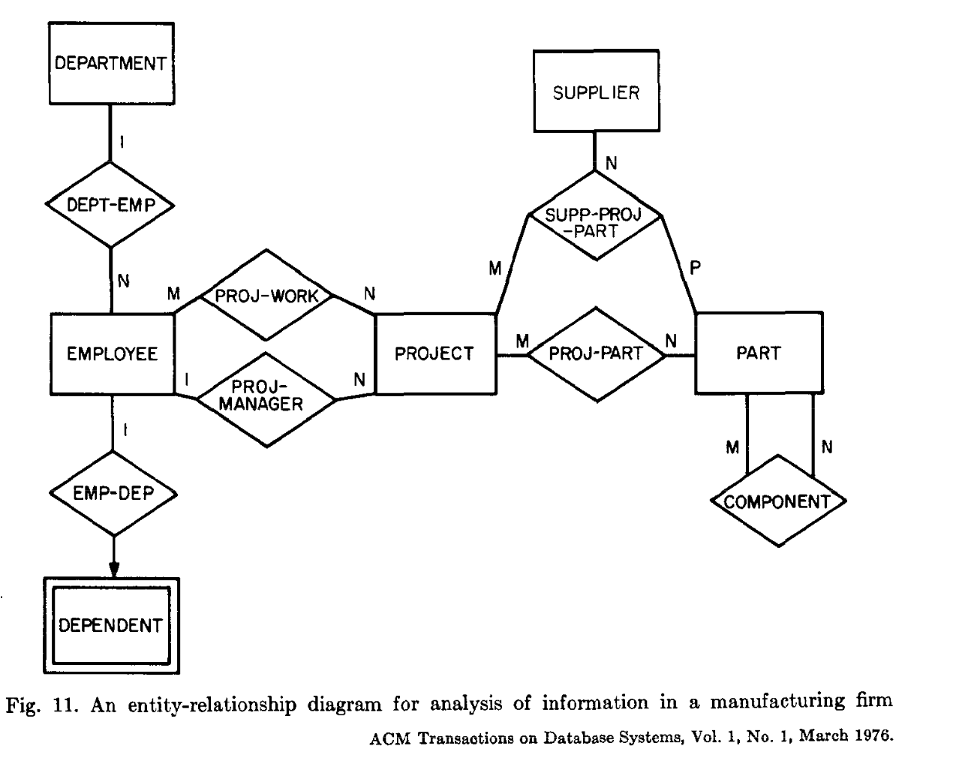

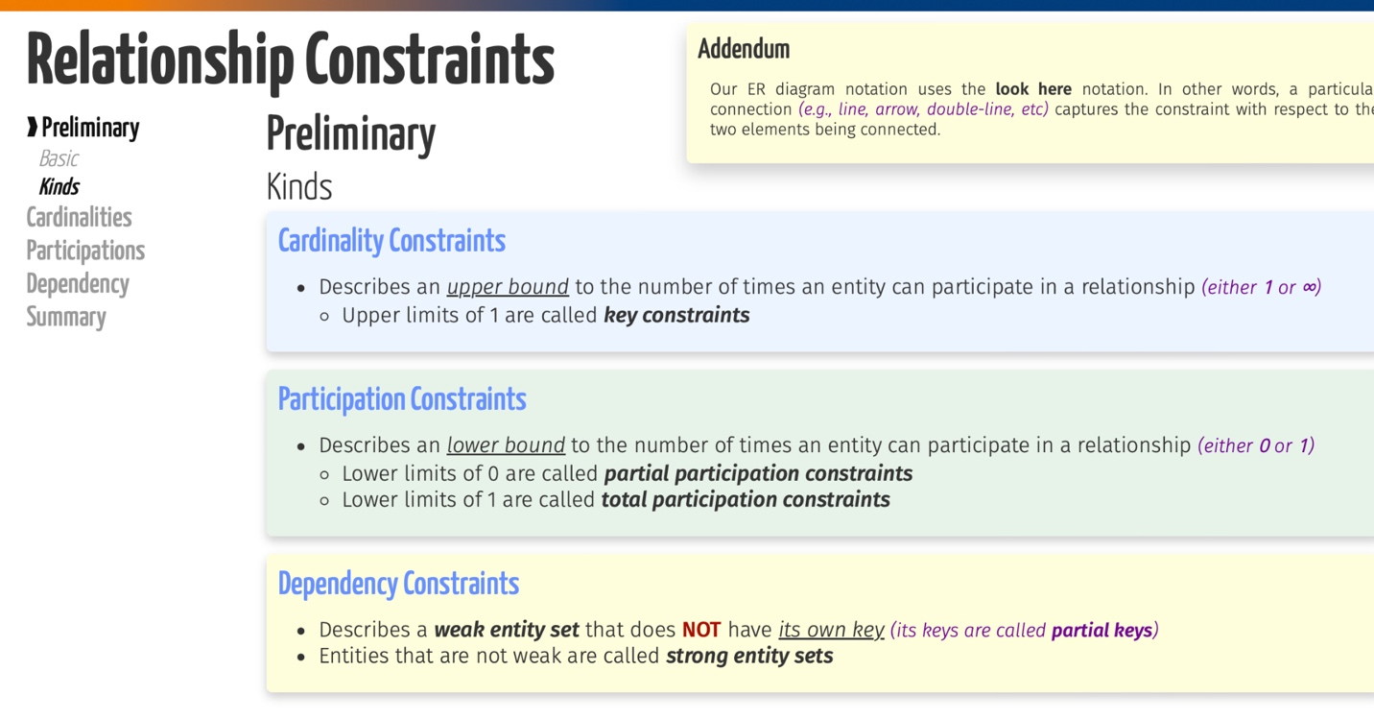

Cardinalities

(1) upper limit

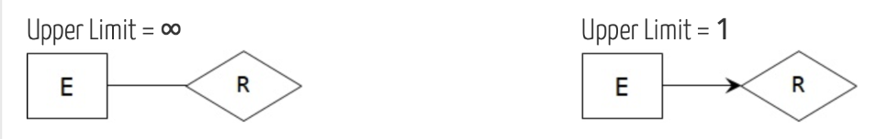

Use line with no arrow: most infinite E can be involved in R

Use line with arrow: 0/1 E can be involved in R

Participations

(2) lower bound

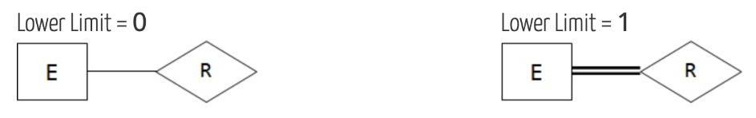

One line: E don’t have to be involved in R

Double line: There at least an E in R

Dependency

For weak entity which don’t have its own key and need other entities when search

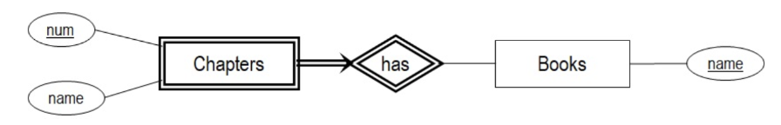

ISA  
used for the userclass and subclass

Look at the addendum, and that’s the meaning why we want to use ISA

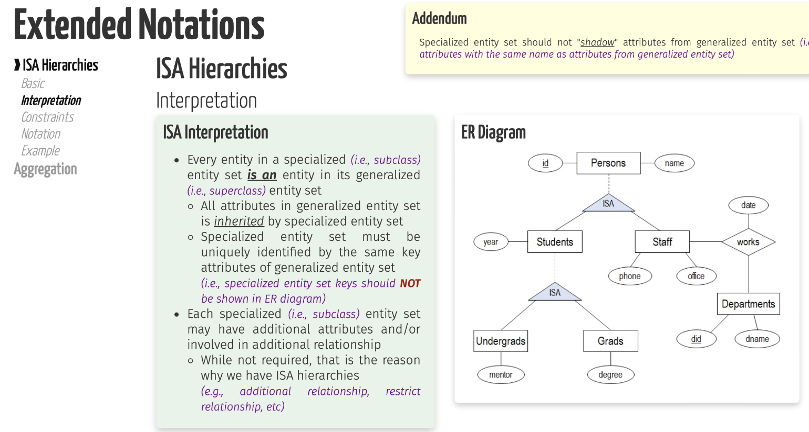

How to note:

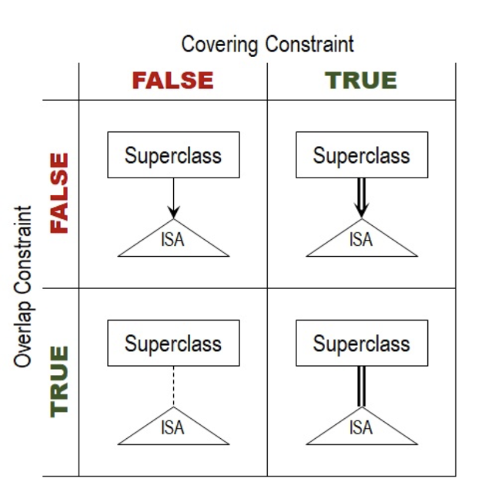

Covering means each superclass at least belong to one subclass

Overlap means, if one class can belong to one subclass and another at the same time, then, it is overlapping.