# Software Engineering

Textbook: Pro MERN Stack: Full Stack Web App Development with Mongo, Express, React, and Node by Vasan Subramanian

1. main logic is from server – internet – user device(UI), improvement on each part(hardware, internet, language logic, etc.) can makes the technology different from it used to.

2.opensource makes it possible for people to contribute and improve(combine more people’s effort to make something better) but there are also some laws

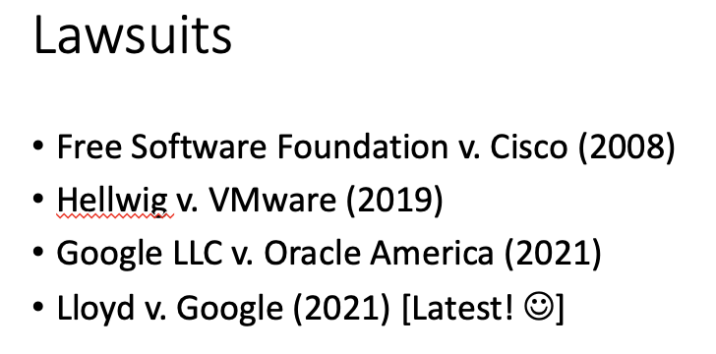 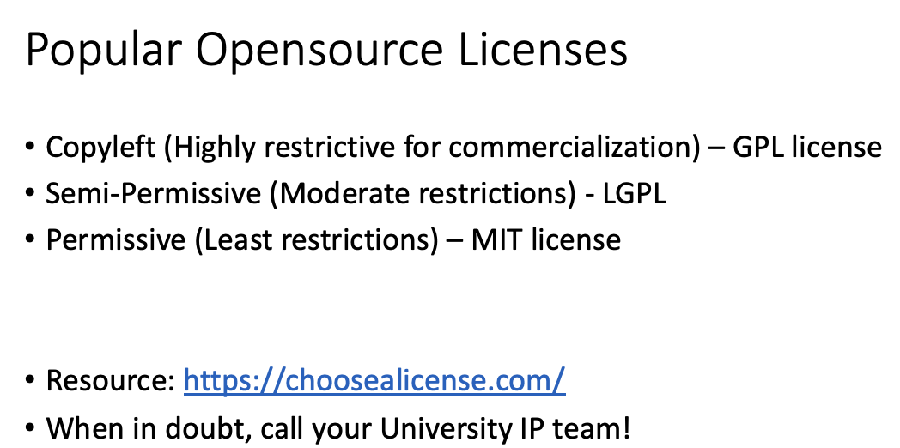 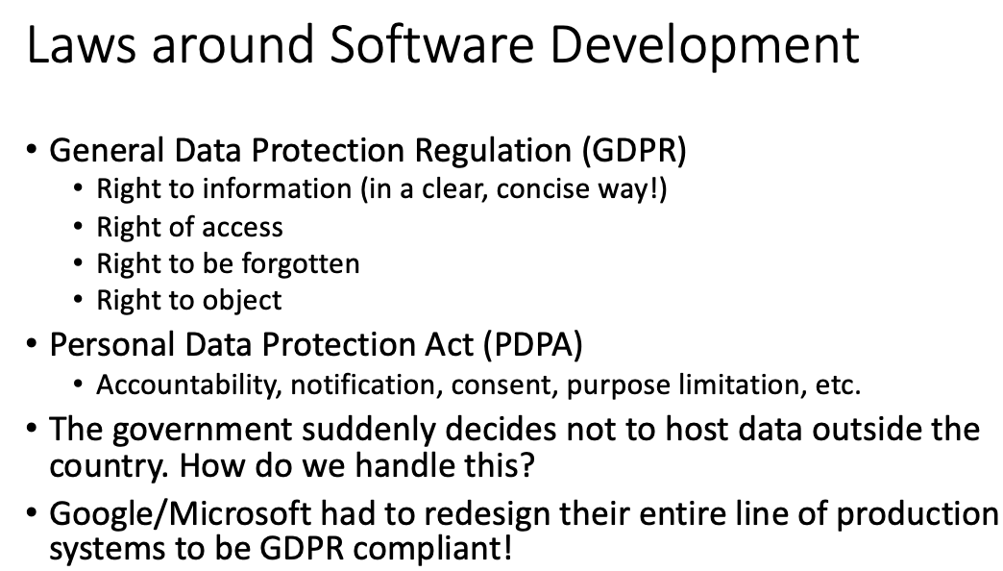

3.types of website

* 2-way: Broadcast Information
* 3-way: Broadcast Information and Collect User Data
* 4-way: Collect User Data and customize experience