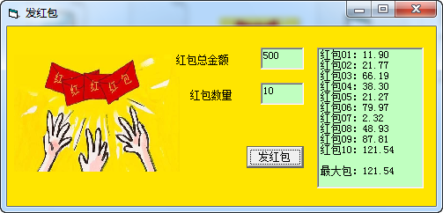   
  
程序界面设计如下：  
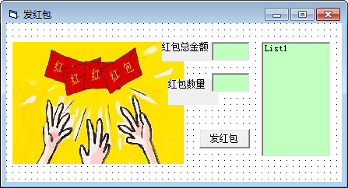

源代码如下：  
Private Sub Command1_Click()  
      Dim s As Single, x As Single, n As Integer, i As Integer  
      Dim max As Single  '存储最大红包金额  
      Randomize  
      List1.Clear  
      List1.Visible = True  
      s = Val(Text1.Text)  
      n = Val(Text2.Text)  
      max = 0  
      For i = 1 To n - 1 ' 通过循环语句产生 n-1 个红包的随机值  
       x = Int((Rnd() * s / (n - i + 0.005) * 100)) / 100  
       If x > max Then max = x  
       s = s - x  
       List1.AddItem "红包" + Format$(i, "00") + "：" + Format$(x, "0.00")  
     Next i  
     x = Int((s + 0.005) * 100) / 100 ' 产生最后一个红包  
     If x > max Then max = x  
     List1.AddItem "红包" + Format$(n, "00") + "：" + Format$(x, "0.00")  
     List1.AddItem ""  
     List1.AddItem "最大包：" + Format$(max, "0.00")  
End Sub  
  
Private Sub Form_Load()  
Form1.BackColor = &HE5FF&  
Label1.BackColor = &HE5FF&  
Label2.BackColor = &HE5FF&  
End Sub