**对象属性、事件处理过程练习**

**1．控件认识**

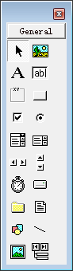

请说明左图中标注的控件的名称

7. ⑤⑥⑦
8. ⑤⑥⑦
9. ②③④⑤⑥⑦
10. ⑤⑥⑦
11. ⑤⑥⑦

2.如有以下一个窗体，设计界面如下：

Private Sub Form_Load()

Form1.Caption = "用户登陆界面"

Label1.Caption = "姓名"

Label2.Caption = "密码"

Label3.Caption = "状态信息"

Label3.Visible = False

Text1.Text = "user"

Text2.Text = ""

Command1.Caption = "确定"

Command2.Caption = "重置"

Command2.Enabled = False

End Sub

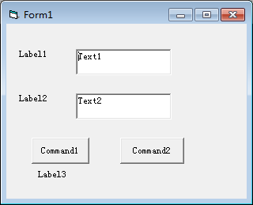

当窗体加载(代码为右图)时，此时界面会发生什么变化？用草图画一下界面的样子。

3．有如下的界面，左边的列表框为list1，右边的列表框为list2,当点击确定按钮后，list1和list2的内容会发生变化? 代码为如下:

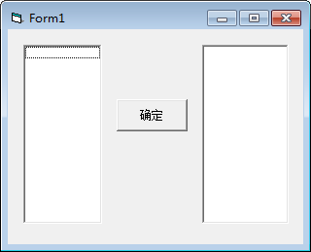

Private Sub Command1_Click()

List1.Clear

List2.Clear

For i = 1 To 10

If i Mod 2 = 0 Then

List1.AddItem Str(i)

ElseIf i Mod 3 = 0 Then

List2.AddItem Str(i)

End If

Next i

End Sub

4．界面如下图，运行窗体，点击确定按钮时，请说出列表框、文本框一和文本框的内容分别是什么信息?

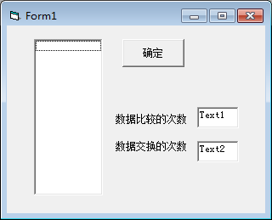

Dim a(1 To 5) As Integer

Private Sub Command1_Click()

Dim c1 As Integer, c2 As Integer

Dim t As Integer

List1.Clear

x = 0: y = 0

For i = 1 To 4

For j = 5 To i + 1 Step -1

If a(j) < a(j - 1) Then

t = a(j): a(j) = a(j - 1): a(j - 1) = t

x = x + 1

End If

y = y + 1

Next j

Next i

Label1.caption=str(x)

Label2.caption=str(y)

For i = 1 To 5

List1.AddItem Str(a(i))

Next i

End Sub

Private Sub Form_Load()

a(1) = 32: a(2) = 15: a(3) = 36: a(4) = 8: a(5) = 7

End Sub