FIT5225 Assignment 2
Pacific BioArchive
Team Report | 30 August 2026

Team Details
Private repository: https://github.com/chenjunboa/PacificBioArchive
Student name and ID | Contribution | Project elements contributed
Junbo Chen, 36970271 | 25% | Local prototype, baseline REST API, SQLite/local storage workflow, initial React UI, model/inference scaffold, Terraform skeleton, repository structure, handoff documentation, and first working local validation.
Bingyi Wang, 36668397 | 25% | AWS/GCP deployment foundation, Cognito, API Gateway, Lambda API/Worker images, S3, SQS/DLQ, DynamoDB, SNS topic, private GCP Cloud Run inference, Artifact Registry/GCS model bundle, WIF, cost and cleanup documentation.
Duo Chen, 36668222 | 25% | S3-to-SQS worker handoff, Docker-free Lambda fallback, media status processing, backend task ownership for DynamoDB/S3/SQS worker, query/index/delete requirements, and issue-based backend completion planning.
Bo Pang, 36969842 | 25% | Final UI integration, Cognito frontend flow, upload/query/manage/notification pages, DynamoDB tag and thumbnail index stabilization, cloud smoke runner, local E2E, live image/video cloud validation, evidence and report preparation.

Architecture
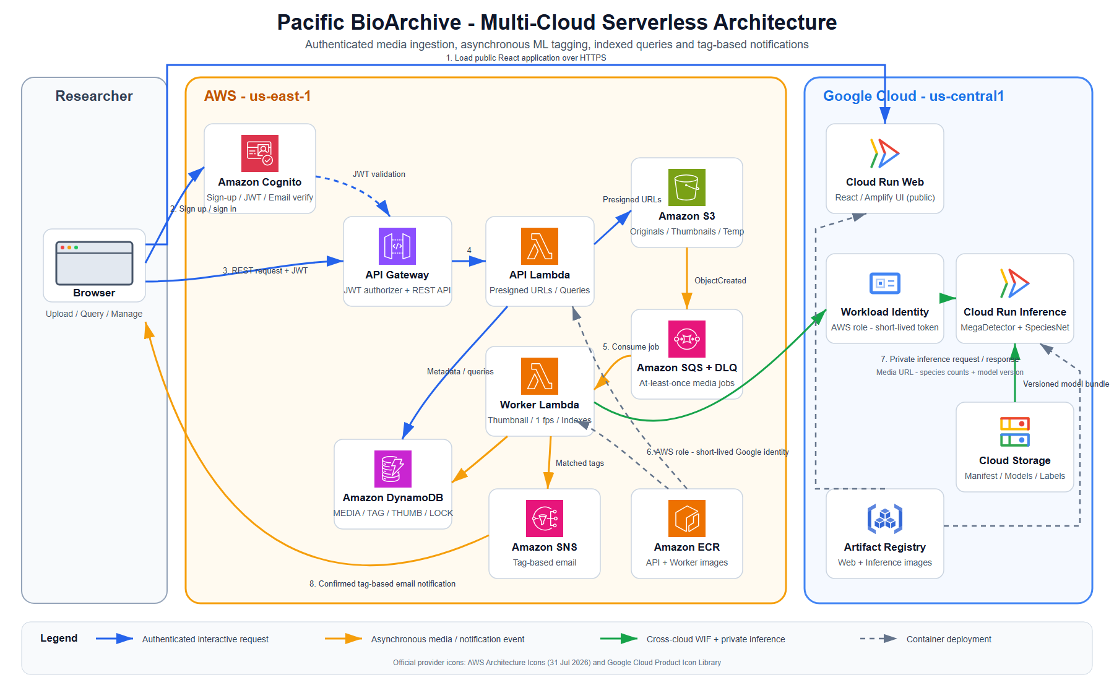
Figure 1. Pacific BioArchive deployment and processing flow. AWS and Google Cloud service symbols use the providers' official architecture icon sets; source links and retrieval dates are recorded in docs/assets/architecture/SOURCES.md.

System Overview
Pacific BioArchive is a serverless multi-cloud wildlife media archive. Authenticated users register and sign in through AWS Cognito, then upload images or short videos through the React interface. The API validates file type, size, checksum, and ownership, then stores media in private S3. S3 events enter SQS and are processed by the main Worker Lambda. The worker validates the uploaded object, creates compressed thumbnails for images, samples videos at one frame per second, invokes the private GCP inference service without a long-lived JSON key, and writes the resulting species tags, model version, file type, URLs, and indexes to DynamoDB.
The application supports the required query flows: tag/count AND search, species search, thumbnail URL reverse lookup, and temporary file query without permanent storage. Users can manually add or remove tags in bulk and delete owned media; deletion removes S3 objects and related DynamoDB rows. The UI includes sign-up, sign-in, sign-out, upload feedback, result cards, query pages, management controls, and notification subscription controls.

Validation Evidence
Local validation passed Python tests, Ruff, Terraform validation, frontend build, and Playwright E2E. The local E2E covers login, image upload, duplicate checksum rejection, all four query modes, tag editing, non-owner 403, delete cleanup, and signed-out 401.
Live cloud validation was completed on 29 August 2026 after deploying the latest main API and Worker Lambda images and disabling the fallback member3-worker trigger. Two image smoke runs passed through Cognito sign-in, deployed frontend upload, S3/SQS/Lambda/GCP inference, tag query, thumbnail reverse query, delete, 404 after deletion, sign-out, and zero DynamoDB residue. A separate 3 second MP4 smoke run passed with video/mp4, the expected alectura_lathami tag, tag query, delete, 404 after deletion, and zero DLQ messages.

User Guide
- Open the deployed Cloud Run web URL.
- Register or sign in with a verified Cognito account.
- Upload a JPG, JPEG, PNG, MP4, or MOV file. Images must be 20 MB or smaller; videos must be 100 MB or smaller and 60 seconds or shorter.
- Wait until the media reaches READY, then inspect tags, model version, original URL, and image thumbnail URL.
- Use Search to query by tag/count, species, thumbnail URL, or temporary query file.
- Use Manage to add/remove tags or delete owned media.
- Use Notifications to subscribe/unsubscribe to species tag email updates, then confirm the SNS email if demonstrating notifications.
- Sign out and confirm protected endpoints reject unauthenticated access.

Generative AI Statement
Generative AI was used selectively for architecture planning, implementation assistance, test design, debugging, documentation, and evidence organization. All submitted code and report claims must be reviewed by the responsible student. The team did not commit cloud passwords, Cognito test user passwords, email verification codes, JWTs, AWS/GCP access tokens, presigned URL query strings, Terraform state, or model weights.

References
- AWS Lambda, API Gateway, Cognito, S3, SQS, SNS, DynamoDB, and ECR documentation.
- Google Cloud Run, Cloud Storage, Artifact Registry, IAM Credentials, and Workload Identity
Federation documentation.
- AWS Architecture Icons, https://aws.amazon.com/architecture/icons/ (accessed 29 August 2026).
- Google Cloud Architecture Icons, https://cloud.google.com/icons (accessed 29 August 2026).
- FIT5225 2026 S2 Assignment 2 brief and marking rubric.

