**PMP认证申请表项目经验描述参考：**

1．PMI要求PMP认证的候选人必须是Leading and directing the project, 因此，如果候选人在某个项目中承担着辅助或只是负责某个过程组的角色，就不具备报考的资格，Application Review将不予通过。

Qualified **PMP candidates** should:

•Perform their duties under general supervision and are responsible for all aspects of the project for the life of the project 在全面的监督下，作为项目经理负责整个项目周期的所有事情

•**Lead and direct cross-functional teams** to deliver projects within the constraints of schedule, budget and scope 领导和指引跨部门合作，在限定的时间进度，预算和范围内交付项目

•Demonstrate sufficient knowledge and experience to appropriately apply a methodology to projects that have reasonably well-defined project requirements and deliverables.具备足够的项目管理知识和经验，在明确了项目的需求和交付结果的前提下，合理的将项目管理工具和方法运用到项目中。

2. 工作经验填写不少于150个英文单词，一个项目经验写不下的，可以将项目五个过程组拆开进行填写，因此，项目经验描述不要写的过于简单或者过于繁冗。

Project descriptions should consist of the following：项目文字描述应该包括如下内容

•A brief, one-sentence project objective 一句话描述项目目标

•Project deliverables summarized by process areas (Initiating, Planning, Executing, Monitoring and Controlling, and Closing – abbreviations are acceptable – IN, PL, EX, MC, and CL) 通过项目的五大过程组（起始/计划/执行/监控/收尾）展示项目的整个内容， 在描写的过程中，五大过程组可以缩写为 IN, PL, EX, MC, and CL。两句话描述你在项目中的角色和负责的主要内容

•A brief, one-sentence project outcome 一句话总结项目成果

Reference Template (refer to **PMP Exam Content Outline** )参考格式如下，在填写五大过程组的内容时，建议参考**PMP考试内容大纲**，运用项目管理的专用用语进行描述，请注意该描述单词控制在150-200之间，不能过多，也不能过少。

Job title/project objective

IN: (启动)

PL: (规划)

EX: (执行)

MC: (监控)

CL: (收尾

A brief of project outcome

中文参考

1.项目目标/名称（一句话）

2.你在项目中的角色以及你在五大过程组各负责什么内容，完成了什么

例如：张三负责一个信息系统开发项目，作为项目经理，他在启动过程组负责跟干系人沟通，在计划和执行过程组，负责项目计划的制定以及带领团队实现项目计划，在监控和收尾过程组进行绩效审查和风险处理，及时做好总结。

3.项目可交付成果

句式参考：

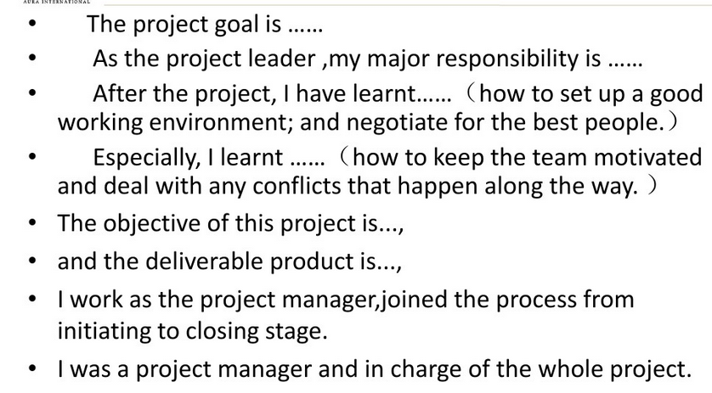

3．案例分析

案例一

Project manager, Factory relocation and integration.

**IN:** Define project scope; identify risks, constraints; obtained proj charter approval

**PL:** Create WBS, develop proj schedule,budget,change&risk management plans; Develop new factory layout; Present to key stakeholders

**EX:** Manage physical move, install & verify per proj plan,Manage communication

**MC:** Monitor IT sys and operations. Manage changes to scope, schedule, cost; Update risk register; Implement corrective actions.

**CL:** Final acceptance from customer; Review lessons learned; Archive proj docs

案例二

The goal of the project is to set up a private banking system. I’m the project manager and in charge of leading the team to carry out requirements analysis in the initiating process, making the project plans in the planning process and monitoring the risks and conflicts in the executing and monitoring process, at last I lead the team to summarize the lessons learned. After that I learned how to deal with the problem in project.

4.经验描述中的专业用词可参考 PMP Exam Content Outline，如下是总结5大过程组的关键任务（可结合自己的项目选取使用）

**Initiating the Project:** Defining the project scope and obtaining approval from stakeholders. For example: Perform project assessment; define the high-level scope of the project; perform key stakeholder analysis; identify and document high-level risks, assumptions, and constraints; develop and obtain approval for the project charter.

**Planning the Project:** Preparing the project plan and developing the work breakdown structure (WBS). For example: Assess detailed project requirements, constraints, and assumptions with stakeholders; create the work breakdown structure; develop a project schedule; develop budget, human resource management, communication, procurement, quality management, change management, and risk management plans; present the project plan to the key stakeholders; conduct a kick-off meeting.

**Executing the Project:** Performing the work necessary to achieve the stated objectives of the project. For example: Obtain and manage project resources; execute the tasks as defined in the project plan; implement the quality management plan; implement approved changes according to the change management plan; implement approved actions by following the risk management plan; maximize team performance.

**Controlling and Monitoring the Project:** Monitoring project progress, managing change and risk, and communicating project status. For example: Measure project performance using appropriate tools and techniques; manage changes to the project scope, schedule, and costs; ensure that project deliverables conform to the quality standards; update the risk register and risk response plan; assess corrective actions on the issue register; communicate project status to stakeholders.

**Closing the Project:** Finalizing all project activities, archiving documents, obtaining acceptance for deliverables, and communicating project closure. For example: Obtain final acceptance of the project deliverables; transfer the ownership of deliverables; obtain financial, legal, and administrative closure; distribute the final project report; collate lessons learned; archive project documents and materials; measure customer satisfaction.

**项目经理五大过程组：**

**启动过程组（Initiating process）可选内容**

1. **执行项目评估**
2. **定义项目的高层次范围**
3. **执行关键利益相关者分析**
4. **确定和记录高层次的风险**
5. **评估假设条件和制约因素**
6. **制定并获得批准的项目章程。**

**规划过程组（Planning process）可选内容**

1. **评估详细的项目要求**
2. **评估约束与利益相关者的假设**
3. **创建工作分解结构**
4. **制定项目进度和预算**
5. **制定人力资源管理，沟通，采购，质量管理，变更管理和风险管理计划**
6. **分析目前与该项目计划的关键利益相关者**
7. **进行一次启动会议**

**执行过程组（Executing process）可选内容**

1. **获取和管理项目资源**
2. **执行项目计划中确定的任务**
3. **实施质量管理计划**
4. **实行按变更管理计划批准的变更**
5. **落实风险管理计划获得批准的行为**
6. **最大限度的发挥团队绩效**

**监控过程组（Controlling and Monitoring process）可选内容**

1. **使用适当的工具和技术测量项目绩效**
2. **管理对项目范围、进度和成本的变更**
3. **确保项目交付符合质量标准**
4. **更新风险登记册和风险应对计划**
5. **评估在这个问题上登记的纠正措施**
6. **与利益相关者交流项目状态**

**收尾过程组（Closing process）可选内容**

1. **获取项目交付成果的验收**
2. **转让成果的所有权**
3. **进行合同和行政收尾**
4. **分发最终项目报告**
5. **整理经验教训**
6. **存档项目文件和资料**
7. **衡量客户满意度**