Knowledge Base Service in Rust — Design
Sep 29, 2026 · @Banks Jorge

What we're building
We're building an open-source, self-hosted knowledge service in Rust. It works like a library: the wiki is the collection, and an LLM acts as the librarian that files and summarizes everything that comes in. Agents search it in milliseconds, and no LLM is involved when they read.
- One way in: the wiki. Every search goes through a single entry, and that entry is the wiki. One query brings back related memories, related knowledge and entity relations together, plus further knowledge reached through those memories.
- Five ways to add knowledge. There is one insert entry point per kind of knowledge, each with its own rules. Searching stays in one place; adding is split by kind.
- The librarian keeps it current. When new content arrives, the librarian finds the related pages and updates them, instead of just adding another document. An LLM verifies every change to the wiki.
- Five kinds of knowledge. Agent experience, user decision history, vertical expertise, the business graph and user preferences. Each has its own scope and page shape.
- A graph described by its schema. For each graph space, the wiki holds one description of its schema. The nodes and edges live in Neo4j as data, so relationship questions get real edges, not summaries.
- The agent decides how to search. Following A-RAG, the agent chooses keyword or meaning-based search, what to open and what to follow. The service returns signals, not decisions.
- Isolated by tenant and user. A tenant can never see another tenant's knowledge, and user-level knowledge stays with that user.
- Identity comes from outside. The service doesn't manage accounts. The system that embeds it passes tenant and user ids in, so developers can plug it into their own stack.
- Ultra-fast reads. Reads are lookups, keyword search, graph walks and, when the agent asks, a vector search, all over data in memory, with no LLM. The target is a few milliseconds of service time and around 20 ms end to end.
- English and Chinese from day one.
- Three interfaces. There's an HTTP API to manage the knowledge, an MCP server for agents, and a streaming chat endpoint for testing.
The service returns knowledge, not answers; writing the answer is the calling agent's job. Version 1 leaves out a hosted offering, user account management, spreading one tenant across several machines, and every search entry point other than the wiki. Those other entry points come later, as experiments measured against the wiki-only design.
The thesis research built on this design is in the Research plan tab.

The core idea: a library with a librarian
The expensive thinking happens once, when content is added, so reads only have to look things up. This is the LLM wiki pattern Andrej Karpathy described in an April 2026 gist.
The pattern has three layers, and this service adds a fourth for graph data:
Layer | In this service | Who writes it
Raw sources | Task records, decision records, documents, schema definitions and preference notes; never modified | The systems that call the service, through the five insert entry points
Wiki | Markdown pages for each tenant and user, including one schema description per graph space, plus index.md (a catalog) and log.md (a history) | The librarian
Graph data | The nodes and edges of each graph space, checked against its schema | The host system; no LLM involved
Rules | One rules file per knowledge kind, covering page shape, what to merge and what to flag | Shipped with the project; tenants can override them
It also has three operations:
- Ingest. The librarian folds new content into existing pages, or creates new pages. Graph data skips the librarian and is checked by code against its schema.
- Query. Agents search through the wiki, the only entry, then open the pages, memories and graph edges it leads to, with no LLM involved.
- Lint. The librarian periodically checks for contradictions, stale claims, duplicate pages, broken links and memories that aren't anchored to anything.
How this differs from classic RAG. Classic RAG searches raw text chunks and asks an LLM to assemble an answer on every question. Here, the synthesis is already written into the pages, so a search returns an answer-shaped page instead of fragments. That's what makes a fast read path with no LLM possible. Vectors still have a place, but as one way into the wiki that the agent chooses, not as the whole method.

Five kinds of knowledge
Each kind has its own insert entry point, scope and page shape. All five are searched through the same single entry, the wiki, and come back in one of three slots: memories, knowledge or relations.
Kind | Insert entry point | Scope | Written from | Page shape | Comes back in
Agent experience | /ingest/experience | Tenant | Agent task outcomes, including problems agents hit while serving users | One playbook per task type: steps that work, pitfalls and their fixes, how often each was seen | Memories
User decision history | /ingest/decision | Tenant + user | Records of what the user decided and what happened as a result | One page per decision topic: the decision, its context, the outcome, the date | Memories, filtered to the user
Vertical expertise | /ingest/expertise | Tenant | Domain documents and manuals | Linked concept and entity pages, as in a classic wiki | Knowledge
Business graph | /ingest/graph | Tenant, one graph space each | Schema definitions, plus nodes and edges as data | One schema description per graph space; nodes and edges are data, not pages | Knowledge (the description) and relations (the edges)
Preferences | /ingest/preference | Tenant + user | Explicit statements and observed habits | One short profile page per user | Memories, filtered to the user
Problems users run into are recorded as agent experience, because they are lessons about how agents should operate. User decision history records choices and their outcomes, not problems.
Preferences are scoped per tenant, so the same person in two tenants has two separate profiles.

One way in: the wiki as the only search entry
Every read starts with one search call, and the wiki is where it enters. The upstream agent wraps the user's request into a query with meaning, and the service turns that one query into memories, knowledge and relations together. Version 1 has no other search entry on purpose: running the wiki as the only way in is the primary experiment of the thesis.
Why one entry. A single query can bring back related memories and related knowledge at once, then more knowledge reached through those memories. Separate entry points per kind would make the agent guess where the answer lives, and would lose the links between kinds.
The catch: prose can hide the graph. If the entry only ranks page text, a relationship question returns knowledge pages that happen to share its keywords, and the actual edges never appear. Knowledge pages are long and full of keywords, while relationships live in graph data that a text index barely sees. So the design keeps one entry but stops any single signal from deciding everything.
How one search runs
- Match names. Query terms are matched against every alias in the wiki's catalog, in English and Chinese, with a multi-pattern matcher. This gives the starting entities. It's exact and cheap, and prose can't outrank it.
- Search three channels in parallel.
  - Memories: experience, decisions and preferences, filtered to the user.
  - Knowledge: expertise pages and schema descriptions.
  - Relations: relation types matched in the schema descriptions, then the graph edges among the starting entities; with two or more entities, the paths between them too.
- Lift text hits to entities. Each memory or knowledge hit adds the entities it's anchored to. Even when a prose page wins the ranking, its entities still reach the graph.
- Hop from memories to knowledge. The entities anchored by the top 3 memories bring in their one-hop knowledge pages and edges. These score lower and are marked via: memory, so the hop can't drift far.
- Assemble by slot. Each channel keeps its own ranked slot in the response, with its own top_k and coverage flag.
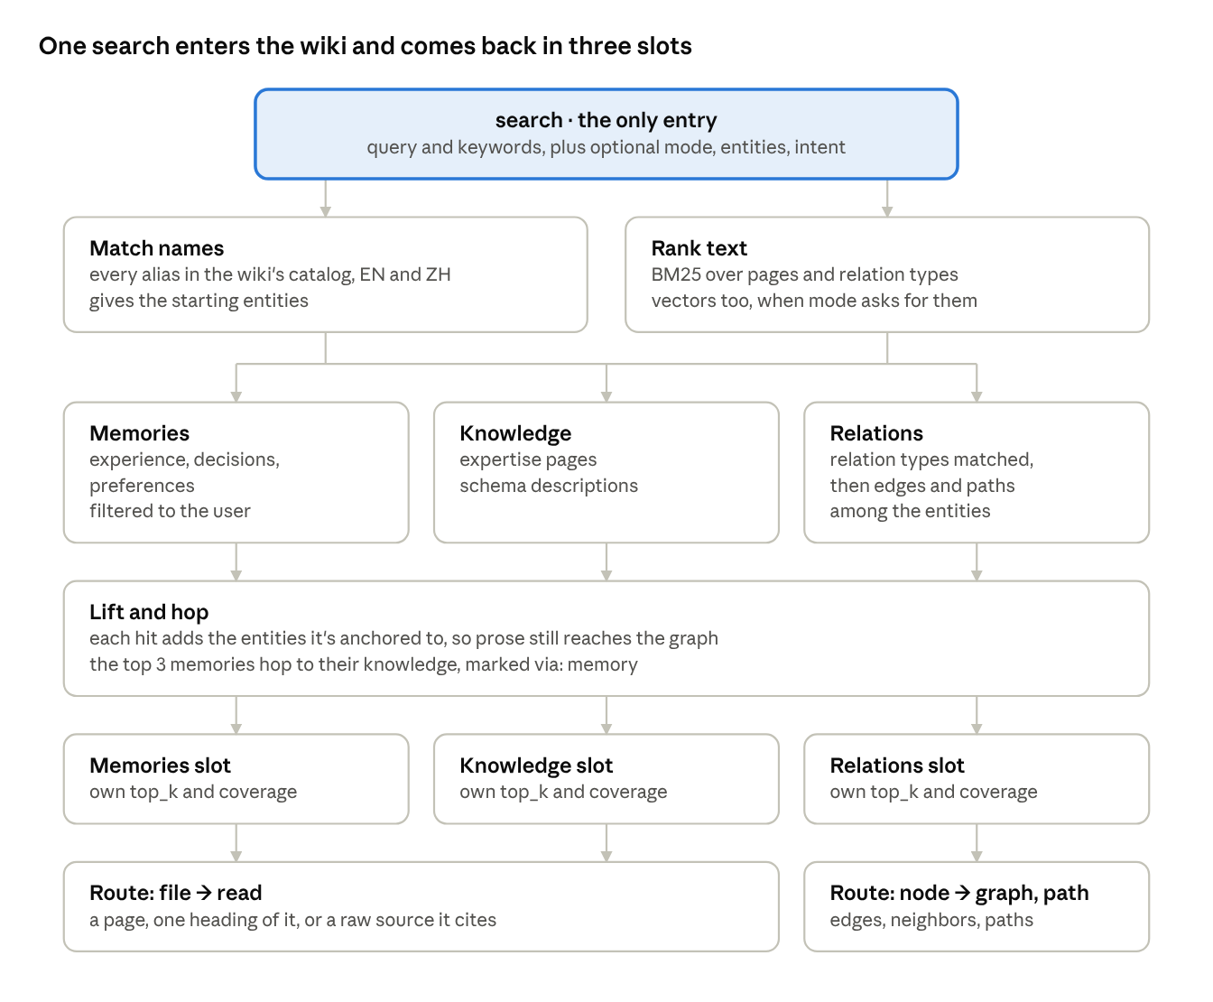
search pipeline · one entry, three channels, three slots
Names and text both lead into the three channels, so a relationship question reaches the graph even when prose shares its keywords.
Slots, not one ranked list. Scores from different channels are never compared, so prose can't crowd out the graph. A slot with nothing good stays empty rather than padded. Web search engines do the same thing: one search box, with separate blocks for news, images and maps.
Intent changes the budget, not the entry. Relationship cue words, or two or more matched entities, give the relations slot more room and turn on the path search. Cue words include "relationship", "depends on", "between", "upstream", 关系, 关联, 依赖, 上下游 and 影响. The agent can also pass entities or intent hints in the same call.
Every hit carries a route. A hit says where to go next: a Markdown file to read (a page, one heading of it, or a raw source it cites), or a node to open with graph or path. These follow-up calls only take ids that search returned, so they are steps after the entry, not other ways in.
Later entry points. Direct graph queries, search over raw chunks and per-kind search tools are left out of version 1. Once the wiki-only design is measured, they are opened one at a time and compared against it on the same test set.

The business graph: a schema description plus live data
For each graph space, the wiki holds one description of the schema and nothing about individual changes. The nodes and edges are stored in Neo4j, checked against that schema, and copied into memory so searches can walk them.
What the description holds. The node types and relation types of the space, what each one means in English and Chinese, a few aliases, and the key fields. It changes only when the schema itself changes, and the librarian verifies that change like any other wiki edit.
---
kind: graph
space: commerce
summary: Orders and the customers who place them.
nodes:
order: { en: "A customer order", zh: "客户订单", aliases: [orders, 订单], key: order_id }
customer: { en: "A buyer account", zh: "买家账户", aliases: [customers, 客户], key: customer_id }
relations:
placed_by:
from: order
to: customer
via: customer_id
en: "The customer who placed the order"
zh: "下单的客户"
aliases: [ordered by, buyer, 下单人, 所属客户]
updated: 2026-09-29
---
Relation types are searchable; edges are not summarized. Each relation type in a description becomes one entry in a small index of its own: its name, both descriptions, its aliases and the node types it connects. A space with 40 relation types has 40 entries, and they rarely change. For a question like "which customer placed order 1042" (订单1042的下单客户), "placed" or 下单 matches placed_by, the name matcher finds the order, and the graph returns the real edge. The answer always comes from the graph itself.
Graph data skips the librarian. Nodes and edges arrive through /ingest/graph. Code checks them against the schema (known types, required keys, both ends present) and writes them to Neo4j. No LLM is involved, and no page is written.
Anchors join the wiki to the graph. Memory and knowledge pages list the entities they're about in their front matter. The lift and the memory-to-knowledge hop follow these anchors, so the librarian must anchor every memory, and lint flags any memory without one.
In memory. When a tenant opens, its nodes and edges are read from Neo4j and its page anchors from the wiki, into adjacency lists in both directions built with petgraph. Searches walk that copy and never query Neo4j, so a walk takes microseconds. Walks are breadth-first, with caps on depth (3) and nodes (100).
Why a graph still fits A-RAG. A-RAG's critique of graph-based RAG, such as GraphRAG and HippoRAG2, is that those systems "rely on predefined retrieval algorithms rather than model-driven decisions." Here the graph is reached through the same agent-driven search, and the agent decides whether to follow a graph route.

Tenants, users and identity
The service never creates or authenticates end users. The host system passes tenant and user ids in, and the service enforces isolation around them.
Where the ids come from. There are two modes, chosen in config:
Mode | Tenant id | User id | Fits
API key (default) | Bound to the key; each key belongs to one tenant | The X-User-Id header, set by the calling backend | A backend or agent platform calling the service directly
JWT | A claim in a token the host signs | A claim in the same token | Setups where end-user tokens reach the service
Ids are opaque strings: the service never reads meaning into them. Header names, claim names and key lists are all set in config, so developers can adapt the service without changing code.
How isolation is enforced.
- One folder per tenant. Each tenant gets its own folder, holding its wiki files, its SQLite file and its search index.
- Safe folder names. Folder names are derived from the ids (a hash), never the raw strings, so an id like ../other can't escape its folder.
- Filters the caller can't remove. The service adds the tenant and user filters to every search, graph walk and read, and request bodies can't widen them. Anchors that lead into another user's pages are dropped before a walk starts.
- One graph database, filtered. Neo4j Community edition runs a single database, so every node and edge carries the tenant id, with an index on it, and every Cypher query the service sends filters on it.
- Separate ranking statistics. Separate indexes mean one tenant's content never shifts another tenant's search results.
- A scoped librarian. The librarian only ever sees pages from the same scope, so another tenant's content never enters a prompt.
- Clean deletion. Deleting a tenant deletes its folder and its nodes and edges in Neo4j. Deleting a user removes their decision history and preferences, with the anchors and vectors that came from them.
- Loaded on demand. A tenant's index, vectors and graph load on first use, from its files, its SQLite file and Neo4j. Busy tenants stay in memory, and idle ones cost only disk space.

Search signals: names, keywords and meaning, in English and Chinese
Inside the one entry, three signals find things: names, keywords and meaning. Names and keywords run on every search; meaning runs when the agent asks for it. The semantic work is shared by two LLMs that already exist, one at each end.
- At write time, the librarian enriches every page. It adds aliases, keywords in both languages, and the questions the page answers. Matching different phrasings is then solved once per page, not on every query.
- At read time, the calling agent writes the query. It wraps the user's request into a query with meaning, plus keywords: canonical terms, exact identifiers, and both English and Chinese forms. If a slot comes back weak, it retries with other terms or switches to meaning-based search.
The next section lists the exact tools and parameters agents use for this.
Tokenizing Chinese. Chinese has no spaces between words, so a plain tokenizer finds almost nothing. Each text field is therefore indexed twice, and searches use both versions, with whole words weighted higher. Aliases, node names and domain terms from the wiki are added to jieba's dictionary, so it doesn't split them wrongly:
Version | How the text is split | Why
Words | jieba segmentation for Chinese (via tantivy-jieba), English words lowercased | Precise matches on whole words
Bigrams | Overlapping 2-character pieces of Chinese text, English words as-is | Catches domain terms that jieba's dictionary splits wrongly
The name matcher. Every alias, title and node name in the tenant's wiki goes into an Aho-Corasick automaton, rebuilt when pages change. It finds all known names in a query in one pass, in either language, in microseconds. Aliases come from page front matter and schema descriptions, so the wiki's catalog is the matcher's only source.
Meaning, when the agent asks for it. Vectors are part of version 1, but only as a mode the agent chooses. Following A-RAG, the service doesn't decide when to use them. It returns coverage per slot and the keywords that matched nothing, and the agent decides whether to retry with mode: semantic. In A-RAG's ablation, removing semantic search hurt most on the hardest multi-hop benchmark. Vectors help most with:
- cross-language questions, such as an English query over Chinese pages, without the agent translating its keywords
- "have we seen something like this?" searches over experience and decision memories, where the wording rarely matches but the situation does
- relation types asked about in words no alias covers, such as "who bought this" for placed_by
Only wiki content is embedded: page sections, memory pages and relation-type descriptions, never raw sources. The embeddings are computed at write time with a small multilingual model, such as multilingual-e5-small through fastembed, and stored in the tenant's SQLite file (see "Storage layout"). e5 models expect a query: prefix on queries and passage: on stored text; leaving them off quietly hurts results.
The only read-time cost is embedding the query, roughly 5–15 ms on a CPU, to be confirmed by the benchmark. The vector search itself is brute force in memory: about 100,000 vectors take a few milliseconds, and an in-process index such as usearch is added only if one tenant nears a million. For callers that don't decide well, such as weaker models or code, mode: auto tries keywords first and falls back to meaning when coverage is weak.
The test set. Before any tuning, collect 30–50 real questions per knowledge kind. Tag each with the page, memory or edge that answers it and the slot it should come back in. Include relationship questions whose keywords also appear in knowledge pages, and questions that need a memory plus the knowledge it leads to. Every change to search is measured against this set.

Retrieval for agents: open parameters, A-RAG style
The service doesn't run a fixed retrieval pipeline. It exposes one entry, search, and three follow-ups, and leaves their parameters open, so the calling agent decides how to search, what to open, which connections to follow, and when it has enough.
This follows A-RAG (Du et al., February 2026). The paper gives the model keyword search, semantic search and full-text reading as separate tools. It found that this beat fixed pipelines and graph-based RAG, while retrieving a similar or smaller number of tokens.
One entry, three follow-ups
Tool | Role | Returns | Open parameters
search | The only entry | Memories, knowledge and relations in separate slots; each hit has a summary, matching lines and a route, never full text | query, keywords, mode, entities, intent, slots, hop, session
graph | Follow-up | The nodes and pages around a node, with typed edges | node, depth, direction, relations, max_nodes, session
path | Follow-up | The shortest chain of relations between two nodes | from, to, relations, session
read | Follow-up | A whole page, one heading of it, or a raw source it cites | ids, heading, with_links, session
search also replaces the old get_context warm start, since one call already returns the user's preferences, related memories, knowledge and relations. The follow-ups take the ids that search returns; they are never a way to start.
Parameters the agent controls
Parameter | Meaning | Default
query | The request, wrapped by the agent into a sentence with meaning | required
keywords | Short terms of 1–3 words: names, identifiers, and both English and Chinese forms | taken from query
mode | keyword, semantic, both, or auto (keywords first, meaning when coverage is weak) | keyword
entities | Names the agent already knows are involved | none
intent | A hint such as relation, procedure or history, which shifts the slot budget | inferred from cue words
slots | Hits per slot, such as {memories: 3, knowledge: 3, relations: 5} | those values, maximum 20 each
hop | Follow the top memories to the knowledge they're anchored to | on
depth, direction, relations, max_nodes | How far a graph walk goes, which way, along which relation types, and how many nodes it returns | 1 (maximum 3), both ways, all types, 25 (maximum 100)
heading | Read only one heading of a page | whole page
with_links | Also return the summaries of pages linked from the one being read | false
session | An id for the agent's current task, used by the read tracker | none
Tenant and user are never parameters; they always come from the credentials.
How keyword ranking works inside a channel
- Exact routing. A name found by the name matcher pins its page, node or relation type to the top of its slot.
- Ranking. BM25 runs over wiki pages. Title and aliases count most, then summary and keywords, then body text. Multi-word keywords get a phrase-match boost, longer and more specific keywords weigh more, and identifiers such as order_status also match exactly.
- Snippets. Each hit returns its summary, the lines that contain the keywords, its anchors and the sources it cites.
- Coverage. Each slot is marked strong or weak from its best score and its number of matches.
- Feedback. Each hit lists the keywords it matched, and the response lists the keywords that matched nothing, so the agent knows what to rephrase or whether to switch mode.
A-RAG matches keywords by scanning the text at query time. We keep an index instead, because it stays fast as tenants grow.
Here is an example search, a question that needs a memory, knowledge and a relation at once:
POST /search
{ "query": "which customer placed order 1042, and how do we give them a partial refund after shipment?",
"keywords": ["order 1042", "partial refund", "部分退款"],
"mode": "keyword" }
200 OK
{ "entities": ["commerce:order/1042"],
"intent": "relation",
"memories": { "coverage": "strong", "hits": [
{ "page": "experience/refund-handling", "match": "alias",
"matched_keywords": ["partial refund", "部分退款"],
"summary": "Check shipment status first; partial refunds after shipment need a manual ledger entry.",
"about": ["commerce:order", "expertise/refund-regulations"],
"route": { "read": "experience/refund-handling", "heading": "Pitfalls" }, "read": false },
{ "page": "users/u_7b21e0d4/decisions/refund-policy", "summary": "...",
"about": ["commerce:order"],
"route": { "read": "users/u_7b21e0d4/decisions/refund-policy" }, "read": false } ] },
"knowledge": { "coverage": "strong", "hits": [
{ "page": "expertise/refund-regulations", "summary": "...", "via": "memory",
"route": { "read": "expertise/refund-regulations" }, "read": false } ] },
"relations": { "coverage": "strong", "relation_types": ["commerce:placed_by"],
"edges": [ { "from": "commerce:order/1042", "type": "placed_by",
"to": "commerce:customer/c_5521", "via": "customer_id" } ],
"route": { "graph": "commerce:order/1042" } },
"unmatched_keywords": [] }
Read tracker. When calls carry a session id, the service remembers which pages and sources that session has already read. Reading one again returns a short "already read" notice instead of the full text, and search marks those hits read: true. A-RAG uses the same idea to save tokens and to push the agent toward material it hasn't seen. Sessions live in memory, are scoped to the tenant and user, and expire after an idle timeout (30 minutes by default).
Tool descriptions teach the strategy. As in A-RAG, the guidance lives in the MCP tool descriptions, not in a fixed workflow:
- wrap the request into a query with meaning, plus short, specific keywords, with good and bad examples
- read the slots first, then open only the promising hits in full
- follow each hit's route: read for a file, graph or path for a node
- on a weak slot, retry with other terms, pass entities or intent, or switch mode to semantic
The service never forces an order of calls.
Misses improve the wiki. Every weak slot is logged with its keywords. During lint, the librarian reviews the most frequent misses and adds the missing pages, aliases, anchors or relation-type aliases, so weak slots become rarer.

How it stays fast
Reads never wait on an LLM. They are lookups, keyword search, graph walks and, in semantic mode, one small embedding model, all over data already in memory. The target is a few milliseconds of service time in keyword mode and around 20 ms end to end, to be confirmed by the benchmark in milestone M6.
Read step | What happens | Rough cost
Resolve identity | Check the API key or JWT, and pick the tenant | microseconds
Match names | One pass of the name matcher over the query | microseconds
Keyword search | BM25 over the tenant's wiki index for memories and knowledge, and over the relation-type index | around a millisecond
Meaning search, only when asked | Embed the query with a small local model, then compare it with the stored vectors | roughly 5–15 ms, mostly the embedding
Graph walk, lift and hop | Breadth-first over in-memory adjacency lists, capped by depth and node count | microseconds
Build the response | Slots of summaries and routes, capped at a size budget | microseconds
These costs are orders of magnitude, not measurements.
Five rules keep it fast:
- No LLM on the read path. Search, follow-ups and page reads never call an LLM. The only LLM calls are the librarian's, in background jobs, plus the optional test chat.
- Return summaries, not whole pages. Every page has a 1–3 sentence summary written by the librarian. Search returns summaries, and agents call read for the full text. Small responses keep the agent fast too.
- One round trip per task. One search returns memories, knowledge and relations together, so an agent often needs no second call.
- Keep hot data in memory. Busy tenants' indexes, vectors, name matchers and graphs stay loaded, in a size-limited cache. They're loaded from the files, SQLite and Neo4j when a tenant opens, and a search never queries SQLite or Neo4j.
- Writes never block reads. Each tenant has one writer. Searches keep using the last committed snapshot while an ingest runs.

Architecture
Writes and reads are two separate paths through one program. They share the per-tenant state in memory, one folder of files per tenant, and Neo4j for graph data.
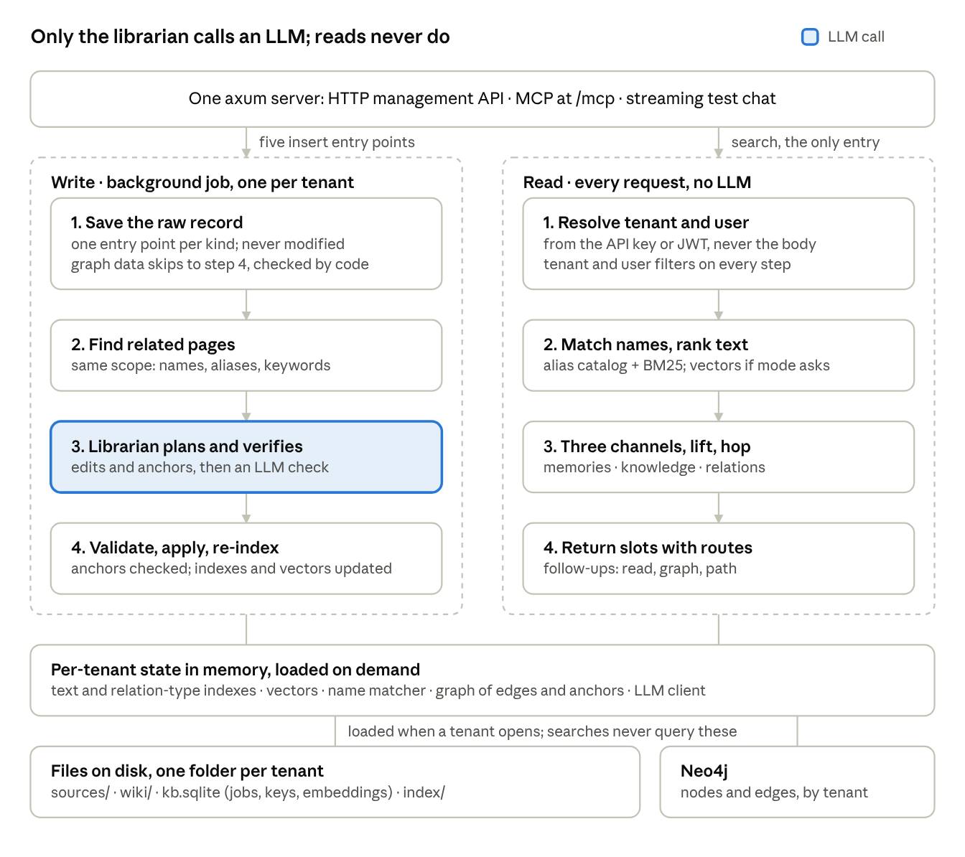
architecture · five insert paths, one search entry, shared state
Only step 3 of the write path calls an LLM, and graph data skips it entirely. The read path is lookups, keyword search, graph walks and an optional query embedding, so its speed doesn't depend on any LLM.

The librarian: how new content is filed
Content arrives through five insert entry points, one per kind. Every write is a background job: the API returns a job id right away, and the librarian updates the wiki shortly after. Graph data is the exception; code checks it and applies it without the librarian.
- Receive. Content arrives at the insert entry point for its kind, and its scope comes from the credentials. The raw record is saved unchanged.
- Find related pages. Without an LLM, the service finds pages in the same scope that share names, identifiers, aliases or keywords with the new content, and keeps the best 5–10. A cheap first LLM call can extract keywords to sharpen this.
- Plan the edits (LLM). The librarian's main LLM call gets the new content, those pages and the rules for this kind. It returns a structured edit plan: create a page, update part of a page, add an anchor, or mark a claim as superseded.
- Verify the edits (LLM). A second LLM call checks each edit against the new content and the cited sources. Every changed claim and every anchor must be supported, must not contradict another page, and must follow the rules for its kind. A failed edit goes back to step 3 once with the reasons; if it fails again, it's held as a proposal for review. This check can use a cheaper model.
- Apply. The service checks every edit for the same scope, allowed paths and required fields, and every memory for at least one anchor. Code, not the model, writes ids, dates and front matter.
- Record. The changed pages are re-indexed and re-embedded, the name matcher and anchors are updated, index.md gets their new summaries, and log.md gets one line for the job.
Manual edits get the same check. An edit through PUT /pages goes through step 4 before it's saved. If the verifier objects, the edit is held as a proposal with its reasons, and an admin can approve it anyway.
Each kind has its own merge rule:
Kind | How new content is merged
Agent experience | Into the playbook for that task type; repeats are counted instead of duplicated. Anchored to the entities and concepts the task touched
User decision history | Appended to the topic page as a new decision and outcome; past entries are never overwritten. Anchored to what the decision was about
Vertical expertise | Integrated into concept pages; contradictions are flagged, not silently resolved
Business graph | A schema change replaces the space's description, and the librarian verifies it. Nodes and edges are checked by code against the schema and applied without the librarian; no change summary is written
Preferences | The latest statement wins; the profile stays short
Volume and cost. Agents can produce many task records. The service batches them per tenant, and can be configured to file only notable ones, such as failures and new approaches. Superseded claims are marked, not deleted, so the history stays readable.

Filling gaps from outside, with approval
The wiki can grow on its own: the service finds what it's missing, searches external sources, and proposes new material. Nothing enters the wiki until a person approves it. The loop is off by default, runs in the background after each lint pass, and never touches the read path.
- Find gaps. Frequent weak slots, lint findings and stale pages mark what's missing.
- Search outside. External sources are pluggable connectors, like the LLM backends: a web search API, documentation sites, vendor APIs. Each tenant opts in and keeps an allowlist of the sources it trusts.
- Propose. The librarian ranks the candidates by relevance, by novelty compared with existing pages, and by source credibility. Each proposal says which gap it fills.
- Approve. Proposals land in the same queue as held edits (/proposals). Approved sources go through normal ingest, including the verify step. Rejections are stored with their reasons, to improve later proposals.
- Keep provenance. The URL, fetch date and license are stored with the raw record, and pages built from external content are marked as lower trust.
Four risks are designed for from the start:
Risk | What could happen | Safeguard
Prompt injection | A fetched page contains instructions aimed at the librarian | Fetched text is treated as data only; the verify step and human approval are backstops
Privacy | Search queries built from a tenant's gaps reveal its business to an outside provider | Opt-in per tenant, allowlisted providers, and queries shown in the proposal
Licensing | Copying content the tenant has no right to store | When the license is unclear, keep a summary and a link, not a copy
Cost | Unbounded searching and LLM calls | A daily token budget per tenant

Storage layout
Wiki pages and raw records are plain files, one folder per tenant, so developers can inspect them, back them up or keep them in git. Each tenant also has one SQLite file for operational data and embeddings, and graph data lives in Neo4j. The search index and the in-memory copies can be rebuilt from these at any time.
data/
├── rules/ default rules per kind, shipped with the project
│ ├── experience.md
│ ├── decision.md
│ ├── expertise.md
│ ├── graph.md
│ └── preference.md
└── tenants/
└── t_3f9a1c05/ folder name derived from the tenant id
├── rules/ optional overrides of the default rules
├── sources/ raw records, never modified
├── wiki/
│ ├── index.md catalog: every page with its summary
│ ├── log.md one line per ingest, edit and lint run
│ ├── experience/ e.g. refund-handling.md
│ ├── expertise/ e.g. refund-regulations.md
│ ├── graph/ one schema description per space, e.g. commerce.md
│ └── users/
│ └── u_7b21e0d4/ folder name derived from the user id
│ ├── preferences.md
│ └── decisions/ e.g. refund-policy.md
├── kb.sqlite jobs, proposals, API keys, audit log, embeddings
└── index/ derived, safe to delete
└── tantivy/ wiki pages and relation types
Each page starts with front matter that the service writes and reads. Memory pages carry about anchors to the entities and pages they concern:
---
kind: experience
title: Handling partial refunds
aliases: [partial refund, 部分退款, refund after shipment]
summary: Check shipment status first; partial refunds after shipment need a manual ledger entry.
about: [commerce:order, expertise/refund-regulations]
sources: [2026-09-28-task-4812.json]
updated: 2026-09-28
---
Pages link to each other as [[page-name]]. Entities are named space:type for a node type and space:type/key for a single node, such as commerce:order/1042. On load, page anchors and graph data go into one in-memory graph per tenant. In version 1, job status lives in memory, and finished jobs are dropped after a configurable time.
What SQLite holds. One file per tenant, opened in WAL mode so reads carry on while the tenant's single writer works. It holds the job queue, proposals, API keys, the audit log and the embeddings:
CREATE TABLE embeddings (
page TEXT NOT NULL, -- e.g. experience/refund-handling
heading TEXT NOT NULL, -- the section this vector covers
model TEXT NOT NULL, -- e.g. multilingual-e5-small
hash TEXT NOT NULL, -- hash of the section text it was built from
vector BLOB NOT NULL, -- 384 float32 values, about 1.5 KB
PRIMARY KEY (page, heading, model)
);
Vectors stay out of the Markdown files: they are derived data, like the search index. The hash catches hand edits, so a section whose text no longer matches is re-embedded, and changing the embedding model rebuilds this table without touching a single page.
What Neo4j holds. The graph nodes and edges of every tenant, in one database, since the Community edition has only one. Each node is labelled with its type and carries the tenant id and its key, and an index on the tenant id keeps every query scoped. The service writes to Neo4j from /ingest/graph and reads a tenant's graph into memory when the tenant opens; searches never query it. A GraphStore trait keeps an SQLite backend beside Neo4j, for tests and for trying the service without it.

Interfaces
One axum server exposes three interfaces, and all of them call the same core functions. Every request carries credentials: an API key (plus X-User-Id for user-scoped calls), or a JWT.

HTTP API
Method | Path | What it does
POST | /ingest/experience | Add an agent task outcome; returns a job id
POST | /ingest/decision | Add a user's decision and its outcome; returns a job id
POST | /ingest/expertise | Add a domain document or manual; returns a job id
POST | /ingest/graph | Add or change a space's schema description, which the librarian verifies, or add nodes and edges, which code checks
POST | /ingest/preference | Add a user's stated preference or observed habit; returns a job id
GET | /jobs/{id} | Status and result of an ingest or lint job
POST | /search | The only search entry: memories, knowledge and relations in slots, with a route per hit
POST | /graph | Follow-up: walk the graph from a node that /search returned
POST | /graph/path | Follow-up: the shortest chain of relations between two nodes
POST | /read | Follow-up: full text of pages or sources, whole or one heading, with the read tracker
GET | /pages | List pages, filtered by kind
GET | /pages/{path} | Read one page (for browsing)
PUT | /pages/{path} | Edit a page by hand; the librarian verifies it before it's saved
GET | /proposals | Held edits and external-source candidates awaiting approval, with reasons
POST | /proposals/{id}/approve | Approve a held edit or an external source (admin key only)
POST | /lint | Queue a lint pass for the tenant
DELETE | /users/{user_id} | Delete a user's decision history and preferences in this tenant
POST | /admin/tenants | Create a tenant and its first API key (admin key only)
DELETE | /admin/tenants/{id} | Delete a tenant and all its data (admin key only)
GET | /health | Liveness check
Here is an example insert, a decision record. The search example is in "Retrieval for agents":
POST /ingest/decision
{ "topic": "refund policy",
"decision": "Refund shipping costs on partial refunds for repeat customers",
"context": "The customer asked for a partial refund on order 1042 after shipment",
"outcome": "The customer kept the rest of the order",
"entities": ["commerce:order/1042"],
"date": "2026-09-28" }
202 Accepted
{ "job": "j_81c2", "status": "queued" }

MCP server
The MCP server lives at /mcp. It uses rmcp, the official Rust MCP SDK, over Streamable HTTP, mounted in the same axum app. MCP clients authenticate the same way as HTTP callers.
Tool | Same as
search | POST /search
graph | POST /graph
path | POST /graph/path
read | POST /read
record_experience | POST /ingest/experience
record_decision | POST /ingest/decision
record_preference | POST /ingest/preference
The tool descriptions carry the retrieval guidance from "Retrieval for agents". They also say when to record: experience after finishing a task, a decision after a user makes one, and a preference when a user states one. Expertise and graph inserts come from host systems, so they are HTTP-only, like the management operations (lint, proposals, deletion, admin).

Streaming test chat
The test chat is for developers trying the service out, not part of the real API. A small page at /dev sends questions to POST /dev/chat, which builds an LLM answer from /search results and the follow-ups they point to. The answer streams back as Server-Sent Events, next to the slots it used. Both routes exist only when KB_DEV=1 is set.

Crates we'll use
A crate is a Rust library published on crates.io. About seventeen of them cover version 1, including local embeddings, SQLite and the Neo4j driver.
Crate | Version | Job in this project
tokio | 1.x | Async runtime
axum | 0.8 | HTTP server and routing
serde, serde_json | 1.x | JSON in and out
tantivy | 0.26 | BM25 search index, one per tenant
tantivy-jieba | 0.20 | Chinese word segmentation for tantivy, built on jieba-rs
aho-corasick | 1.x | The name matcher: finds every known alias in a query in one pass
petgraph | 0.8 | The in-memory copy of the graph: edges, anchors, walks and paths
fastembed | latest | Local multilingual embeddings, such as multilingual-e5-small
rusqlite | latest | One SQLite file per tenant: jobs, proposals, keys, audit log, embeddings
neo4rs | 0.9 (release candidate) | Neo4j driver for the graph store; a Neo4j Labs project, so pin its version
moka | latest | Size-limited caches for open tenants' indexes, vectors, graphs and hot pages
reqwest | latest | HTTP client for the librarian's LLM calls
async-trait | latest | Async methods on the pluggable LLM trait and the storage traits
rmcp | latest | Official MCP SDK, used for /mcp
jsonwebtoken | latest | Verifying tokens in JWT mode
anyhow, thiserror | 1.x, 2.x | Error handling
tracing, tracing-subscriber | 0.1, 0.3 | Logs, with a timing for each step
We're deliberately leaving these out of version 1:
- usearch is only needed if brute-force vector search gets slow, around a million vectors in one tenant.
- Milvus, Qdrant or LanceDB would add a service for vectors that fit comfortably in SQLite and memory.
- TiDB or MySQL are built for many machines sharing one database. Version 1 runs on one machine; if a hosted version ever spreads across machines, Postgres is the step up, behind the same storage trait.
- rig is a multi-provider LLM library. We keep our own small LLM trait, and rig can replace it later without touching the rest of the code.

Rust concepts you'll meet
Claude Code will write most of the code, but you'll review it. The ideas below cover almost every line, and each one links to the part of the official Rust Book or crate docs that teaches it.
Concept | Where it shows up here | Read
Cargo, crates, modules | Project layout and dependencies | Book ch. 1, ch. 7
Ownership and borrowing | Passing text and pages around without copying them | ch. 4
Structs and enums | Page, Hit, Slot; enum Mode { Keyword, Semantic, Both, Auto } | ch. 5, ch. 6
Vec, String, HashMap | Hit lists, the alias catalog, the graph's adjacency lists | ch. 8
Result and the ? operator | Every step that can fail, such as reading a file or calling the network | ch. 9
Traits | The pluggable LLM backend, and the Store and GraphStore storage backends | ch. 10.2
Trait objects (dyn) | Choosing Claude or OpenAI-compatible at startup | ch. 18.2
Arc (shared ownership) | One AppState shared by every request | ch. 16.3
async / .await | HTTP handlers and LLM calls | ch. 17, Tokio tutorial
spawn_blocking | Embedding queries and committing index writes without stalling requests | tokio docs
Serde derive | JSON request and response types | serde.rs
Here is how several of these fit together in the pluggable LLM backend. The trait says what any backend must do. Each provider implements it, and config picks one at startup:
// src/llm/mod.rs
use async_trait::async_trait;
pub struct Prompt {
pub system: String,
pub user: String,
pub max_tokens: u32,
}
#[async_trait]
pub trait LlmClient: Send + Sync {
async fn complete(&self, prompt: &Prompt) -> anyhow::Result<String>;
}
// Each struct implements LlmClient with one HTTP POST via reqwest.
pub struct Anthropic { /* http client, api key, model */ }
pub struct OpenAiCompatible { /* http client, base_url, optional key, model */ }
// In main.rs, chosen once from config:
let llm: Arc<dyn LlmClient> = match cfg.provider.as_str() {
"anthropic" => Arc::new(Anthropic::new(&cfg)?),
_ => Arc::new(OpenAiCompatible::new(&cfg)?),
};
Nothing else in the program knows which provider is running. A new backend is one new file that implements LlmClient.
Here is what an HTTP handler looks like. axum pulls the shared state, the caller's scope and the parsed JSON body out of the request. Because every search function takes a Scope, a query that forgets the tenant filter won't compile:
async fn search(
State(app): State<AppState>,
scope: Scope, // tenant + user, from the API key or JWT
Json(req): Json<SearchRequest>,
) -> Result<Json<SearchResponse>, ApiError> {
// the one entry: memories, knowledge and relations, each in its own slot
let response = app.search(&scope, &req).await?;
Ok(Json(response))
}

Project layout
The project is a single crate, with one module per job. Everything a developer might want to change without touching code lives in config.toml, rules/ and prompts/.
kb/
├── Cargo.toml
├── Dockerfile build on the official Rust image, run on a slim one
├── docker-compose.yml the service plus the official Neo4j image
├── config.toml identity mode, librarian LLM, data folder, port, Neo4j
├── rules/ default rules per knowledge kind
├── prompts/ librarian prompts: ingest.md, lint.md
└── src/
├── main.rs read config, start the server
├── config.rs Config struct, loaded with serde
├── identity.rs API key and JWT modes, producing Scope { tenant, user }
├── tenants.rs id-to-folder mapping, cache of open tenants
├── kinds.rs the five knowledge kinds and their rules
├── api/ HTTP handlers: the five inserts, jobs, search, follow-ups, pages, admin
├── mcp.rs MCP tools, calling the same core functions
├── dev.rs test chat: SSE stream and a small HTML page
├── llm/ LlmClient trait, anthropic.rs, openai.rs
├── store/ Store trait and its SQLite backend: jobs, proposals, keys, audit, embeddings
├── librarian/ find related pages, plan edits, validate, anchor, apply
├── wiki/ pages, front matter, [[links]], anchors, the alias catalog
├── search/ name matcher, tokenizers, tantivy, vectors, channels, slots, hop
├── graph/ GraphStore trait (Neo4j and SQLite backends), schema descriptions,
│ relation-type index, the petgraph copy, walks
├── acquisition/ gap finding, external source connectors, candidate proposals
└── jobs.rs per-tenant write queue and job status
Here is an example config. API keys and passwords stay in environment variables, such as ANTHROPIC_API_KEY and NEO4J_PASSWORD, never in the file:
[server]
port = 8080
[data]
dir = "/data" # the Docker volume
[identity]
mode = "api_key" # or "jwt"
user_header = "X-User-Id"
# jwt mode:
# public_key_file = "keys/auth.pem"
# tenant_claim = "tenant_id"
# user_claim = "sub"
[librarian] # the only LLM the service calls
provider = "anthropic" # or "openai_compatible"
model = "claude-sonnet-5"
# base_url = "http://localhost:11434/v1" # for openai_compatible
[store] # one SQLite file per tenant, WAL mode
file_name = "kb.sqlite"
[search]
languages = ["en", "zh"]
default_mode = "keyword" # keyword, semantic, both or auto
slots = { memories = 3, knowledge = 3, relations = 5 }
hop = { top_memories = 3, depth = 1 }
[embedding] # local, runs inside the process
model = "multilingual-e5-small"
[graph]
backend = "neo4j" # or "sqlite", for tests and trying it out
max_depth = 3
max_nodes = 100
[neo4j]
uri = "bolt://neo4j:7687"
user = "neo4j" # password from NEO4J_PASSWORD
[acquisition] # off by default, opt-in per tenant
enabled = false
providers = [] # e.g. a web search API, documentation sites
daily_token_budget = 200000
[jobs]
keep_finished_minutes = 60

Packaging with Docker
The service ships as one image built from the official Rust image, and runs beside the official Neo4j image under Docker Compose. docker compose up starts both, and all of the service's own data sits in one volume.
FROM rust:1-bookworm AS build
WORKDIR /src
COPY . .
RUN cargo build --release
FROM debian:bookworm-slim
RUN apt-get update && apt-get install -y --no-install-recommends ca-certificates \
&& rm -rf /var/lib/apt/lists/*
WORKDIR /app
COPY --from=build /src/target/release/kb /usr/local/bin/kb
COPY config.toml ./
COPY rules ./rules
COPY prompts ./prompts
VOLUME ["/data"]
EXPOSE 8080
CMD ["kb"]

services:
kb:
build: .
ports: ["8080:8080"]
volumes: ["kb-data:/data"]
environment:
ANTHROPIC_API_KEY: ${ANTHROPIC_API_KEY}
NEO4J_PASSWORD: ${NEO4J_PASSWORD}
depends_on: [neo4j]
neo4j:
image: neo4j:5-community
environment:
NEO4J_AUTH: neo4j/${NEO4J_PASSWORD}
volumes: ["neo4j-data:/data"]
volumes:
kb-data:
neo4j-data:
Four things to get right:
- Pin Neo4j. Replace the moving 5-community tag with the exact 5.x version the neo4rs driver is tested against.
- Wait for Neo4j. depends_on only orders the start, so the service retries its Neo4j connection at startup instead of failing.
- Keep the embedding model offline. fastembed downloads model files on first use; point its cache at the /data volume, or download them during the build.
- Check the ONNX Runtime library. fastembed runs on ONNX Runtime; make sure the library it needs ends up in the slim runtime image, which is why both stages use the same Debian release.

Building it with Claude Code
Claude Code writes the code one milestone at a time, and you review each milestone before starting the next.
- Install Rust with rustup, following the Book's Installation page. Check it with rustc --version and cargo --version.
- Install Docker, and start Neo4j with docker compose up neo4j so tests can reach it from M3 on.
- Create an empty git repository and put this design doc in it, for example as docs/design.md.
- Add a CLAUDE.md with the project rules (below).
- Write the test set before M2: 30–50 questions per knowledge kind, each tagged with its answer and slot, plus your predictions for the hypotheses in the Research plan.
- Ask Claude Code for one milestone at a time, starting with M1, and have it write tests for each.
- Before moving on, run the milestone's "done when" check yourself.
Here are some example rules for CLAUDE.md:
# Rules
- The design is in docs/design.md. Build one milestone at a time.
- Before calling a task done, run: cargo fmt, cargo clippy -- -D warnings, cargo test.
- Every read and write path takes a Scope (tenant + user); never take tenant or user ids from request bodies.
- /search is the only search entry. /graph, /graph/path and /read only take ids that /search returns.
- No LLM calls on the read path (/search, /graph, /read, /pages).
- Searches read only the in-memory copies; never query SQLite or Neo4j on the read path.
- Storage sits behind the Store and GraphStore traits, from M1 on.
- Every Neo4j node and edge carries the tenant id, and every Cypher query filters on it.
- Every search stage gets a tracing span with its timing.
- Embeddings use the e5 prefixes: "query: " for queries, "passage: " for stored text.
- The librarian never writes graph data, and every memory page has at least one anchor.
- Tenant and user folder names come from the id-mapping function, never from raw ids.
To review the code comfortably, skim these parts of the Rust Book first: ch. 4 (ownership), ch. 9 (errors), ch. 10.2 (traits) and ch. 17 (async). The concepts table above links to each one.

Build milestones
There are nine milestones, and each ends with a check you can run yourself. Isolation comes first, because every later milestone builds on it.
# | Build | Done when
M1 | Skeleton: config, identity in API key mode, tenant folders and id mapping, the Store trait with one SQLite file per tenant, pages as files, /pages, a tracing span per step | Two tenants' pages and SQLite files are completely invisible to each other over HTTP
M2 | One entry, keyword mode: name matcher, English and Chinese tokenizers with the jieba dictionary, per-tenant tantivy index, the three channels and their slots, routes, /read with the read tracker | The test set's questions come back in the right slot, in both languages
M3 | Graph: /ingest/graph, schema descriptions, the relation-type index, the GraphStore trait with Neo4j and SQLite backends, graph data checked against schemas, page anchors, the petgraph copy, lifting, /graph and /graph/path | Relationship questions return the right edges in the relations slot, even when knowledge pages share their keywords, and the tests pass against the Neo4j container
M4 | Librarian and inserts: LlmClient with both backends, plan and verify steps, the other four insert entry points, anchoring, per-tenant write queue, /jobs, proposals, rules for all five kinds | New content updates the related pages instead of duplicating them, every memory is anchored, and unsupported edits are held for review
M5 | Hop and meaning: the memory-to-knowledge hop, embeddings computed at write time with the e5 prefixes and stored in SQLite, mode with semantic, both and auto | Questions that need a memory plus the knowledge it leads to are answered, and semantic mode recovers cross-language misses
M6 | Speed: caches, loading tenants on demand, a benchmark at 1k, 10k and 100k pages | Per-step timings meet the targets in "How it stays fast", in both modes
M7 | MCP, test chat and packaging: the /mcp tools with their strategy descriptions, JWT mode, /dev chat with streaming, the Dockerfile and docker-compose.yml | An MCP client can search, follow routes and record, choosing its own order of calls, and docker compose up starts the service and Neo4j on a clean machine
M8 | Lint and deletion: contradictions, stale claims, duplicates, broken links, unanchored memories, frequent weak slots; user and tenant deletion | Lint returns findings with page links, and deleted data is gone from files, SQLite, indexes, vectors and Neo4j
M9 | Acquisition: gap finding, one external connector, candidate proposals, approval flow, provenance, budgets | An approved external source fills a logged gap, and a planted bad page is stopped before it reaches the wiki
The thesis experiments run on M2 to M6. Other search entry points are opened only after that, and compared against the wiki-only design, as the Research plan tab describes.

Open questions
- ☐ Default identity mode. Should the first release default to API keys, or to JWTs signed by the host system?
- ☐ How much agent history to file. Every task, or only failures and new approaches?
- ☐ Retention. How long should raw records be kept, especially task records and user decisions?
- ☐ Instance data in graph spaces. Do spaces hold individual nodes, such as specific orders, or only the schema? With instances, their names go into the name matcher as they are written. Decide before M3.
- ☐ Neo4j at scale. The Community edition keeps every tenant in one database. Is that enough, or do large deployments need the Enterprise edition, or one Neo4j per group of tenants?
- ☐ Which entry point to open first. After the wiki-only experiment: direct graph queries, search over raw chunks, or per-kind search tools?
- ☐ Embedding model. Is multilingual-e5-small accurate enough for Chinese, or is a larger model worth the extra latency?
- ☐ First external sources. Which connector comes first for acquisition: a general web search API, or specific documentation sites?
- ☐ License. MIT, Apache-2.0, or both (the usual choice for Rust crates)?

Sources
- Andrej Karpathy, llm-wiki (gist, April 2026)
- Du et al., A-RAG: Scaling Agentic Retrieval-Augmented Generation via Hierarchical Retrieval Interfaces (arXiv, February 2026)
- tantivy on crates.io
- tantivy-jieba on crates.io
- aho-corasick on crates.io
- petgraph on crates.io
- rusqlite on crates.io
- SQLite write-ahead logging
- neo4rs, the Neo4j Labs Rust driver
- Neo4j official Docker image
- axum on crates.io
- MCP Rust SDK (rmcp)
- fastembed docs
- usearch docs
- rig-core on crates.io
- The Rust Programming Language

