A Balanced Light Control Framework Combining Central and Personalized Systems under Dynamic Occupancy Conditions
--- A Surrogate-Based Optimization Approach Validated with Historical Data

Kefan Chen¹, Guanli Feng², Yu Qian Ang¹

¹Department of Built Environment, National University of Singapore, Singapore
²Department of Architecture, National University of Singapore, Singapore

ABSTRACT
As the intelligence level of building environments increases, optimizing lighting system energy consumption and regulating individual comfort have emerged as promising research topics in building performance studies. Currently, building lighting primarily relies on centralized background systems for unified control, yet such systems struggle to accommodate individual preferences in high efficiency. Meanwhile, Personalized Environmental Control Systems (PECS) enable each occupant to adjust their microenvironments according to personal needs, yet lack coordination mechanisms with the overall system. Addressing this contradiction, this paper proposes a balanced light control framework that balances background systems and PECS. This framework aims to achieve dual optimization of visual light comfort and lighting energy consumption under varying occupancy conditions.
This research focuses on the light environment because lighting acts as a crucial component of indoor environments. Also, we could utilize ClimateStudio to simulate comfort and energy consumption through relatively intuitive visualization methods. This provides a foundation for broader, more in-depth future research. The study first constructs a simulated lighting environment based on the 3D building model of a real office room and random occupancy distribution data. The background system and PECS parameters are set as decision variables. An optimizer evaluates lighting energy consumption and visual comfort metrics to generate optimal control strategies. Building upon this, the paper further combines optimization results under multiple occupancy distributions to construct training dataset pairs. An agent model is trained to quickly and accurately predict optimal control strategies. Finally, case studies use historical occupancy data from real office buildings to compare energy consumption differences between traditional centralized control and the balanced control model.
Results indicate that the surrogate model achieves high prediction accuracy (validation loss ≈ 0.005) and that the optimized control strategy reduces lighting energy consumption from 39.92 kWh to 34.72 kWh in the studied period, a 13% reduction compared with simply controlled lighting despite some inaccuracy in the predictions at low occupancies. Additional comparisons show energy savings of up to 68.3% at certain occupancy levels relative to traditional methods. Overall, the proposed balanced control framework demonstrates strong potential to support intelligent, occupant-aware lighting management in real office environments.
KEYWORDS
Indoor lighting comfort; PECS & Background control; Energy saving; Multi-object optimization; Surrogate model
INTRODUCTION & LITERATURE REVIEW
In smart building performance research, balancing lighting system energy optimization with visual comfort remains a critical issue in building environmental control. Lighting not only directly impacts occupants' visual perception and work efficiency but also accounts for a significant proportion of overall building energy consumption. As building intelligence advances, traditional centrally controlled background lighting systems increasingly struggle to meet diverse occupant needs. Concurrently, Personalized Environmental Control Systems (PECS) have been introduced into office and educational spaces, enabling individuals to actively adjust their local microenvironments—such as task lighting and radiant temperatures—to enhance comfort and satisfaction (De Korte et al., 2015). However, current building lighting control strategies remain predominantly centralized, lacking systematic research on the synergistic relationship between PECS and background systems.
In real-world office environments, occupancy exhibits highly dynamic temporal and spatial characteristics. Changes in occupancy density, distribution, and dwell time directly influence building energy consumption patterns and lighting demands (Tekler et al., 2022). If lighting systems fail to flexibly adjust to occupancy variations, issues like “localized over-illumination” or “energy waste” readily occur. Existing research often focuses on optimizing individual systems, such as adjusting central lighting based on occupant counts (Lesina Debiasi, 2020) or evaluating PECS usage preferences and effectiveness (Papinutto et al., 2021). However, few studies explore joint optimization strategies for both systems under dynamic occupancy conditions at an integrated level. This results in potential imbalances between energy consumption and comfort in actual building lighting operations.
This study adopts the light environment as an entry point, serving as an initial pathway to explore the synergy between personalized and systemic controls. Compared to complex variables like thermal environments or air quality, simulating lighting conditions offers greater intuitiveness and quantifiability. It enables clearer visualization of the coupling relationship between energy consumption and comfort, thereby providing a validation framework for subsequent multi-factor integrated control research. Based on this, this paper proposes a Balanced Light Control Framework. By integrating a central background system with PECS, it achieves an optimized balance between minimizing energy consumption and maintaining visual comfort under varying occupancy distributions.
To achieve the goals, this study first constructs a three-dimensional lighting environment simulation model integrating architectural geometric features and occupancy distribution parameters. Background lights and task lights’ (PECS) lumen levels serve as decision variables, while lighting energy consumption and visual comfort jointly constitute the objective variables. This study employs a penalty-based single-objective optimization strategy within a multi-objective framework: visual comfort requirements (e.g., illuminance and uniformity standards for task and peripheral zones) are converted into penalty terms. The severity of penalties guides the optimizer to prioritize meeting lighting standards, followed by minimizing energy consumption within the feasible solution set. This approach avoids the computational complexity of solving rigid constraints, making it more suitable for batch optimization processes involving numerous occupancy scenarios.
Subsequently, the optimal solutions obtained under different occupancy patterns are expanded into a large input-output sample set. Machine learning methods are then employed to construct a CNN-based surrogate model capable of rapidly predicting optimal lighting control strategies based on new occupancy distributions. Finally, this framework is validated using historical occupancy data from the real-world office building BEE Hub (Tekler et al., 2022) to assess its applicability and energy-saving potential under dynamic occupancy scenarios.
METHODOLOGY
The overall methodology of this study is illustrated in Fig. 1. with six main components: environmental inputs, decision variables, objective variables, optimization, surrogate model construction, and case validation.

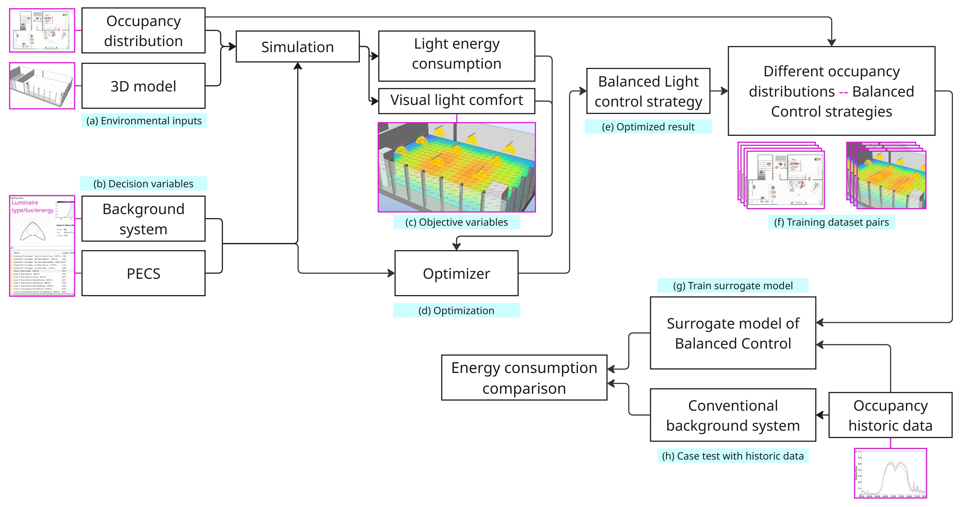
Fig. 1. Methodology Illustration. (a) - Environmental Inputs, (b) - Decision Variables, (c) - Objective Variables, (d)&(e) - Optimization Process, (f) & (g) - Surrogate Model Construction, (h) Case Validation

(1) Environmental Inputs and Space Modeling
Researchers constructed a three-dimensional geometric model based on the open-plan office space and configured key parameters such as indoor material reflectance, luminaire luminous flux, and task illuminance using ClimateStudio. As shown in Fig.2, the model incorporates both background lighting fixtures for the entire space and personalized lighting equipment (PECS) positioned at each workstation. The study space features 24 fixed seats, each equipped with an independent task light, providing a foundation for analyzing synergies between different lighting systems and seating arrangements. To assess lighting control requirements under various occupancy patterns, multiple representative scenarios were generated, including sparse, partially clustered, uniform, and peak occupancy modes. Each occupancy distribution was encoded as input features for simulation and agent learning phases.

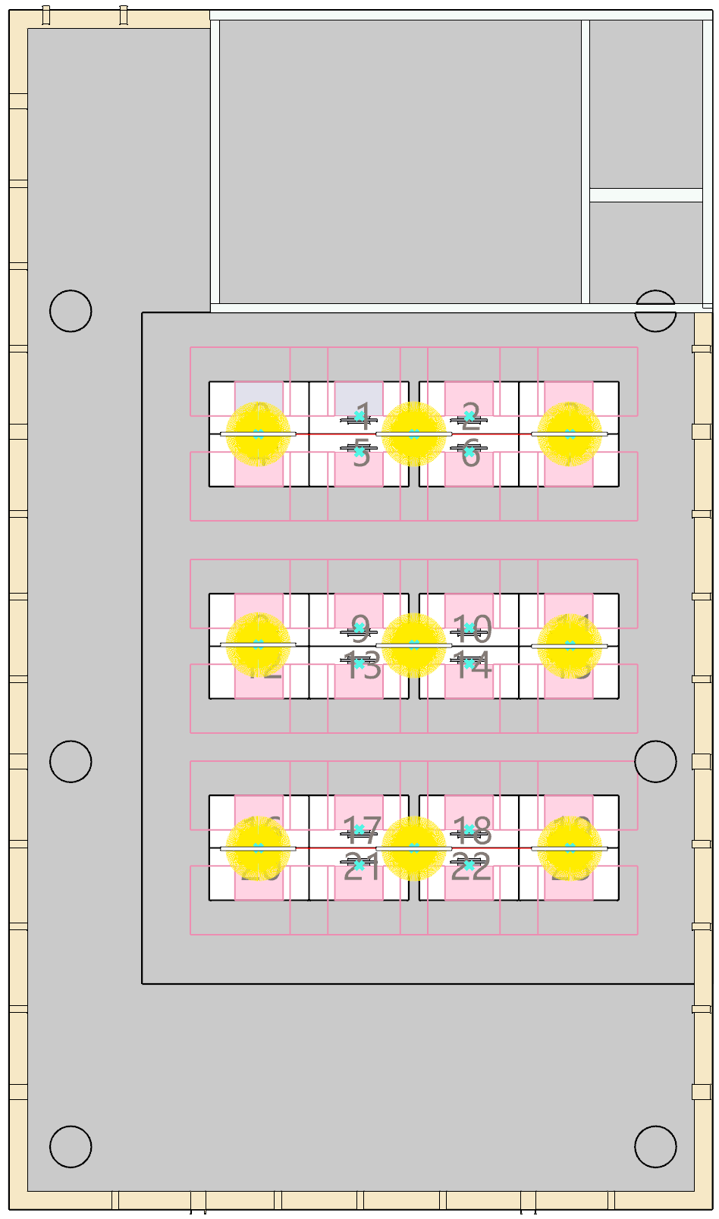 | 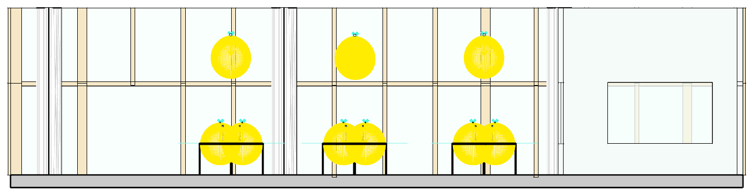
 | - Right View
 | 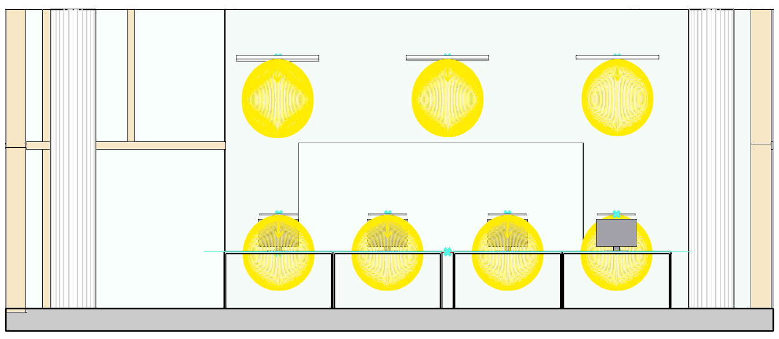
 | - Front View
 | 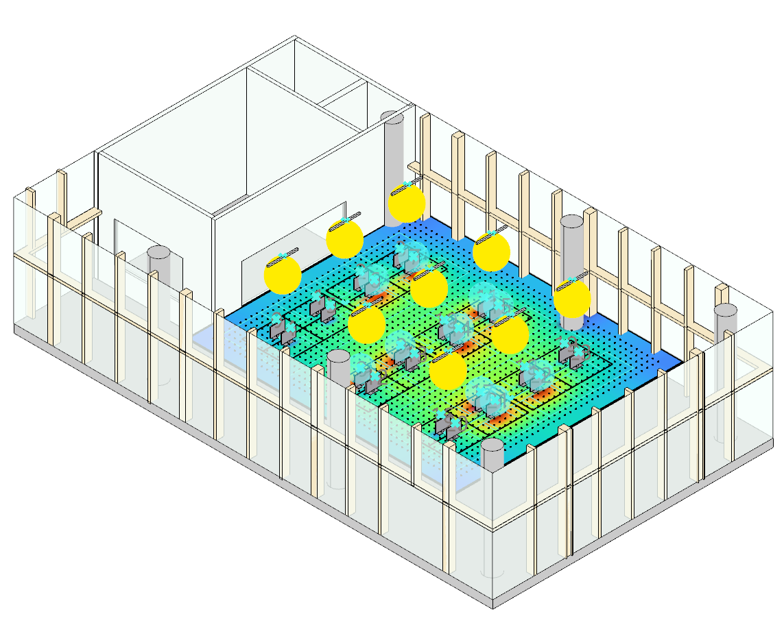
- Top View | - Perspective View
Fig.2. The layout of the simulation 3D space

(2) Decision Variables
The decision variables in this study comprise the level control parameters for two types of lighting systems: ceiling lights and task lights. Both types of variables are controlled using discrete levels, with each level corresponding to specific luminous flux and power outputs. This approach enables a unified description of different lighting combination schemes during optimization and surrogate modeling processes.
For the background lighting system, the decision variables are the output levels of three ceiling light columns, each illuminating a fixed seating area: Seats 0–7 correspond to the first column, seats 8–15 to the second column, and seats 16–23 to the third column. Each column is controlled via discrete levels, with different levels corresponding to distinct luminous flux and power outputs. This structure enables the background lighting system to implement zone-based dimming based on occupancy in different areas of the space, offering greater flexibility and energy-saving potential compared to a single global control.
For the personalized lighting system, the decision variables are the output levels of the task lights at each of the 24 seats, with each task light's level independently adjustable. The decision variables are the output levels of the task lights at each of the 24 seats. The task light level for each seat can be independently set based on whether the seat is occupied and its local illuminance requirements. This ensures adequate illuminance at individual work surfaces while avoiding unnecessary lighting for unoccupied seats.
Based on this, all decision variables can be uniformly represented as a level control vector x = [x_c, x_t], where x_c denotes the output levels of the three rows of ceiling lights, and x_t denotes the level vector of the 24 task lights.
(3) Objective Variables
The optimization objectives of this study comprise lighting energy consumption and visual light comfort, unified through a single-objective penalty-based fitness function.
Table 1 summarizes the lighting comfort requirements following SS 531:2006 — Code of Practice for Lighting of Work Places (Part 1: Indoor Lighting).
Table 1
The work surface illuminance and uniformity from SS 531:2006
Metric | Task Area | Surrounding Area
Maintained Illuminance | ≥ 500 lux | ≥ 300 lux
Uniformity (E_{min}/E_{ave}) | ≥ 0.70 | ≥ 0.50

As the study space contains 24 seats, lighting comfort requirements are constrained on every seat. This means that for any occupied seat, the task surface must simultaneously meet both illuminance and uniformity thresholds; failure to meet either criterion renders the solution infeasible.
Lighting energy consumption is calculated by summing the power consumption of three rows of ceiling lights and 24 task lights at their corresponding levels, serving as the primary objective to minimize during optimization.
To integrate energy consumption with lighting comfort constraints, this study employs a single-objective penalty-based fitness function, expressed as:
Fitness=P+λ_{E1}​($v_{E1}$​)^{p}+λ_{E0}​($v_{E0}$​)^{p}+λ_{U1}​($v_{U1}$​)^{p}+λ_{U2}​($v_{U2 }$)^{p}
where
P is the total lighting power consumption;
$v_{E1}$, $v_{E0}$, $v_{U1}$, and $v_{U2 }$represent the normalized violations of illuminance and uniformity thresholds for task and surrounding areas;
$λ$denotes penalty coefficients scaled according to the magnitude of $P$;
$p=2$ensures smoother convergence.
(4) Optimization Process
This study employs Galapagos as an optimizer within the Grasshopper environment to solve for lighting control strategies under varying occupancy distribution conditions. The optimization objective is the single-objective penalty-based fitness function defined in the previous section, executed in Minimize mode. All decision variables—including the dimming control parameters for the three rows of ceiling lights and the 24 task lights—were encoded as Sliders and input into Galapagos.
For each occupancy distribution scenario, Galapagos iteratively evolved combinations of decision variables through evolutionary algorithms. It simultaneously invoked ClimateStudio and Python scripts to compute real-time illuminance, uniformity, and total power for both task zones and surrounding areas. The penalty function imposes high penalties on any solution failing to meet the 500/300 lux and 0.7/0.5 uniformity requirements, automatically eliminating them during evolution. Ultimately, the optimizer converges to the control vector with the lowest energy consumption within the feasible solution set.
For each occupancy pattern, Galapagos derives an optimal solution comprising the optimal combination of three ceiling light levels and 24 task light levels. This outcome constitutes the Balanced Light Control Strategy for the corresponding occupancy scenario, serving subsequent energy consumption comparisons and surrogate model training.
(5) Surrogate Model Construction
In this study, a multimodal machine learning surrogate model that performs multi-output regression from combined image and tabular inputs was trained to make predictions of optimal lighting control and lighting power. The model consists of 2 parts: image part (as shown in Fig.3. (a)), which uses a convolutional neural network (CNN) branch to extract features from a plan image of the seating layout at BEE hub, and tabular part, which uses a fully connected network branch to process input tabular data. Then the model fuses both feature streams and maps them to continuous output variables, as shown in Fig.3. (b).

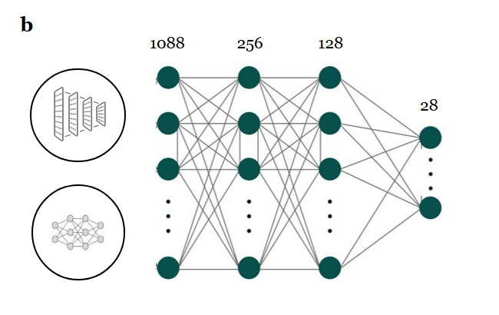
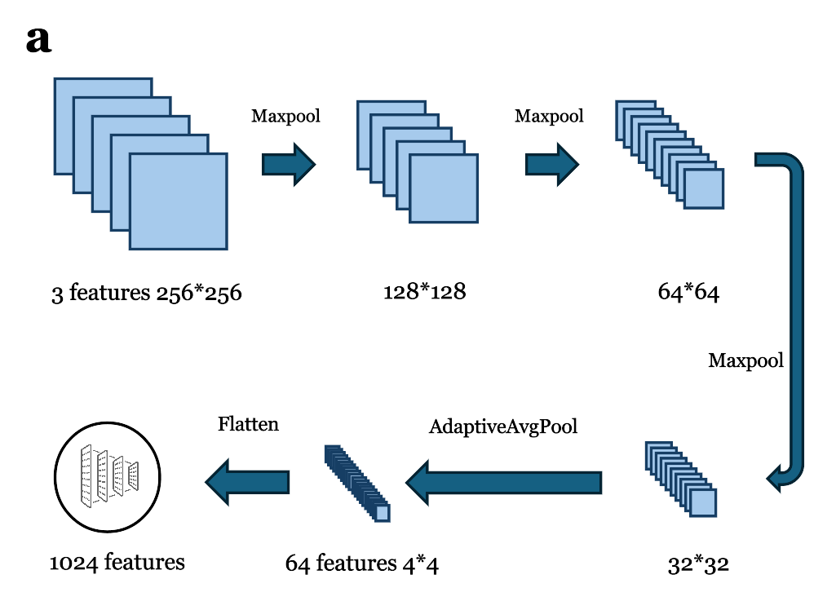
Fig.3. The structure of surrogate model (a) image part (b) fusion MLP
The model accepts two synchronized inputs for each sample: (i) an RGB plan image of size 256×256, which encodes the spatial configuration of the room and seating layout; and (ii) a 25-dimensional tabular vector comprising an overall occupant count and 24 binary seat-occupancy indicators.
The image branch consists of three sequential convolutional blocks, which progressively increase the channel depth from 3 to 64 while reducing the spatial resolution from 256×256 to 32×32 before being compressed via Adaptive Average Pooling to a fixed 4×4 spatial size; the resulting 64×4×4 tensor is flattened into a 1024-dimensional latent representation. In parallel, the tabular branch processes the 25 dimensions (occupancy count and 24 seat occupancy) into 64 features. These two modalities are concatenated into a joint 1088-dimensional latent vector, which is passed through a fusion MLP layers with nonlinear activations.
The predicted outputs 28 features, corresponding to the full lighting state of the room, including 24 task lighting levels, 3 ceiling light levels, and a total lighting power value.
(6) Case Validation
To validate the applicability of this method in real office scenarios, this study conducted a case analysis using historical occupancy data from BEE Hub. First, the actual occupancy recorded by sensors within the building was converted into an hourly occupancy matrix, followed by necessary data cleaning and temporal classification. Subsequently, the actual occupancy distribution for each time period was input into the proxy model to generate corresponding lighting control strategies, based on which lighting energy consumption was calculated. To assess energy-saving potential, this study compared the hybrid lighting strategy based on the surrogate model with a traditional centralized lighting strategy and a strategy combining ceiling lights and task lights without dynamic adjustment based on occupancy. Furthermore, energy consumption differences across the entire office cycle were summarized and analyzed to quantify the energy-saving effects of this method under actual operating conditions.
RESULTS
This section first presents the training results and performance evaluation of the surrogate model, including training parameter settings, loss function convergence, and model accuracy assessment. Subsequently, the study conducts comprehensive validation using historical occupancy data from BEE Hub to evaluate the proposed framework's applicability and energy-saving potential under dynamic occupancy conditions.
Surrogate Model Training Performance
To efficiently predict optimal lighting strategies under varying occupancy conditions, this study employs MLP as a surrogate model, trained on data pairs generated through simulation-optimization. Training parameters are as follows:
Table 2
The model training parameters
Parameters | Batch Size | Epochs | Learning Rate | Validation Split
Value | 32 | 300 | 0.002 | 0.2

The model employs Mean Squared Error (MSE) as its loss function. Figure Training and Validation Loss Curve shows both training and validation losses rapidly decrease within the first 50 epochs, gradually converging thereafter. The validation loss consistently remains slightly below the training loss, indicating the model exhibits no significant overfitting and maintains stable generalization performance.
Overall, Fig.4 indicates that the model's training loss eventually stabilizes within the range of approximately 0.01–0.005, while the validation loss stabilizes between 0.005–0.00. This indicates the model accurately maps occupancy distributions to optimal lighting control strategies. This performance sufficiently supports rapid prediction of lighting control solutions for diverse occupancy patterns.
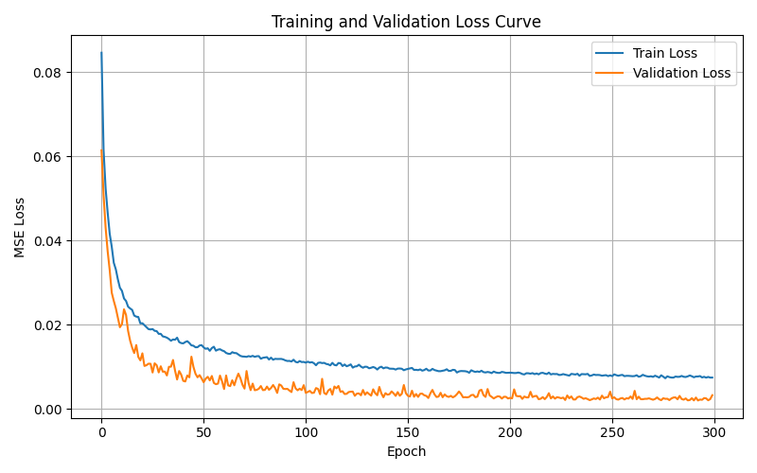
Fig.4. The training and validation loss curve
The predicted energy use (Optimized Power) was then compared with traditional use of ceiling light solely (Previous Power), and PECS & Ceiling hybrid lighting which is not dynamically linked to occupant count (Simple Combined). Optimized Power reduced the total energy use from 39.92 kWh to 34.72 kWh in the studied 285 hours. The lighting power under different occupancies were analysed under the three scenarios of light control. Results demonstrate that both Simple Combined and Optimize Power can significantly reduce the lighting power compared to Previous Power, up to 55.5% and 68.3%, respectively, as shown in Fig.5. It also reveals that Optimized Power achieved better performance than Simple Combined in terms of lighting energy reduction in general except when the count is 1. The improvement from Simple Combined to Optimized Power is also indicated to grow as the occupancy count increases.

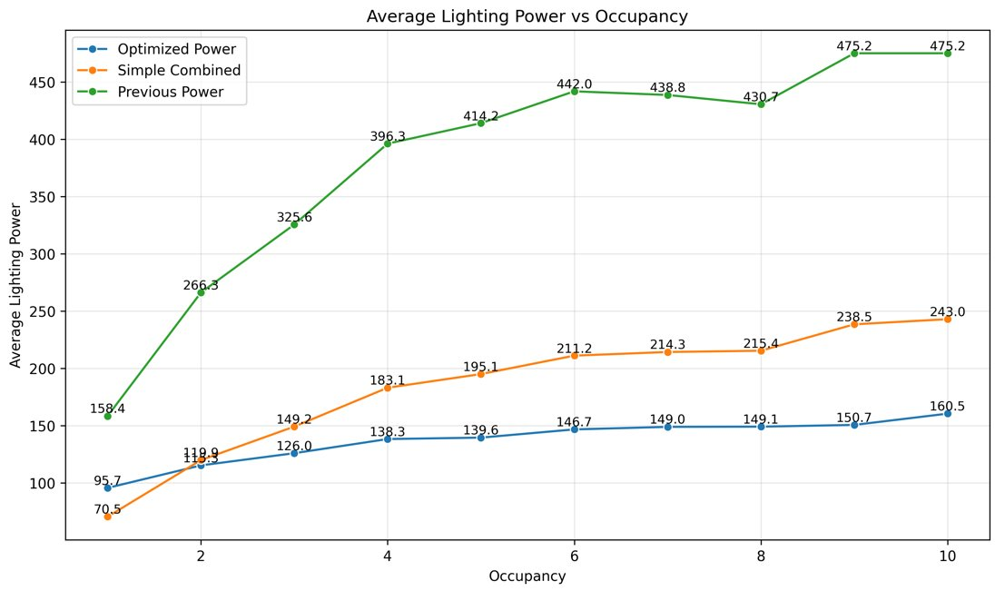
Fig.5. Lighting power of different lighting controls with occupancy count from 1 to 10
Fig.6 shows the lighting power during the nighttime in the entire study period (timestep is 5 minutes). The results align with the observations in Fig.5, showing a great reduction of energy use in Simple Combined and Optimized Power compared to the traditional way. In most timesteps, Optimized Power provides better performance than Simple Combined, but the result also indicates that the predictions at low occupancy are often not optimal.
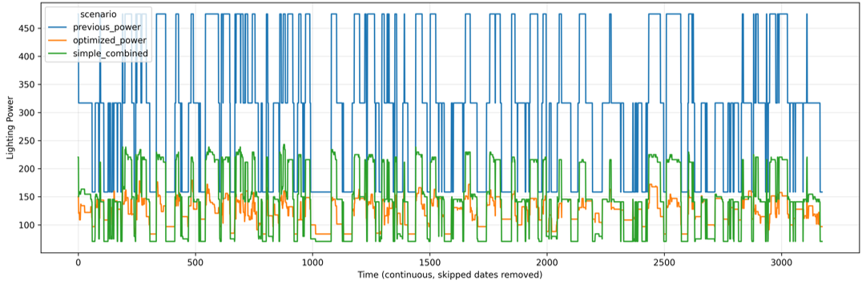Fig.6. Lighting power variation of different lighting controls during the entire study period

CONCLUSION
This study demonstrates an effective framework that integrates simulation-optimization and a multimodal surrogate model to achieve intelligent lighting control in open-plan offices. First, genetic algorithm was used to generate high-quality optimal lighting solutions under diverse occupancy scenarios, forming the training dataset for the surrogate model. Then the surrogate model was trained, validated and accurately predicts optimal lighting states (validation loss ≈ 0.005) from occupancy patterns, enabling fast, real-time control. Using historical BEE Hub data, the optimized strategy reduced total lighting energy use from 39.92 kWh (non-adaptive hybrid lighting) to 34.72 kWh. Compared with traditional ceiling lighting, the optimized approach further improved energy savings, offering up to 68.3% lower power demand at certain occupancy levels. These results confirm the proposed framework’s potential to support adaptive, occupancy-aware lighting management in real office environments.
There are several limitations in this study. The optimization data used for training were generated under idealized simulation conditions, meaning the surrogate model may not fully capture real-world variability in lighting behavior, sensor noise, or occupant preferences. Secondly, prediction accuracy decreases at very low occupancy levels, indicating that the model may require more targeted training samples for low-use scenarios. Furthermore, this research only considered nighttime lighting control, while daylighting is an essential factor in climate simulation. Future work should extend the training dataset by incorporating more diverse occupancy scenarios and real-world measurements to improve robustness under low-occupancy and noisy conditions, and expand the study period to whole day measurement and simulation to incorporate daylighting influence.

AI ACKNOWLEDGEMENT
Use ChatGPT to help understand the possible optimization process.
Use DeepL for accurate expression.

REFERENCES
De Korte, E. M., Spiekman, M., Hoes-van Oeffelen, L., Van Der Zande, B., Vissenberg, G., Huiskes, G., & Kuijt-Evers, L. F. M. (2015). Personal environmental control: Effects of pre-set conditions for heating and lighting on personal settings, task performance and comfort experience. Building and Environment, 86, 166–176. https://doi.org/10.1016/j.buildenv.2015.01.002
Lesina Debiasi, L. (2020). Illuminating Preference: Rethinking Colored Lighting in Workplace Environments [Thesis, Massachusetts Institute of Technology]. https://dspace.mit.edu/handle/1721.1/130183
Papinutto, M., Colombo, M., Golsouzidou, M., Reutter, K., Lalanne, D., & Nembrini, J. (2021). Towards the integration of personal task-lighting in an optimised balance between electric lighting and daylighting: A user-centred study of emotion, visual comfort, interaction and form-factor of task lights. Journal of Physics: Conference Series, 2042(1), 012115. https://doi.org/10.1088/1742-6596/2042/1/012115
Tekler, Z. D., Ono, E., Peng, Y., Zhan, S., Lasternas, B., & Chong, A. (2022). ROBOD, room-level occupancy and building operation dataset. Building Simulation, 15(12), 2127–2137. https://doi.org/10.1007/s12273-022-0925-9

