环境Oracle版本19c

**1命令行登录oracle数据库**

[root@opengauss3 ~]# su oracle

[oracle@opengauss3 root]$ sqlplus / as sysdba

给目录执行权限

chmod +x /opt/oracle/oradata/recovery_area

Oracle 数据库日志归档配置命令集

根据您提供的图片信息，以下是完整的日志归档配置命令序列：

**1. 检查当前归档状态**

ARCHIVE LOG LIST;

**2. 配置归档日志参数**

-- 设置归档日志存储空间大小(示例为100GB)

ALTER SYSTEM SET db_recovery_file_dest_size=100G;

-- 设置归档日志存储路径(请确保路径已存在)

ALTER SYSTEM SET db_recovery_file_dest='/opt/oracle/oradata/recovery_area' SCOPE=SPFILE;

**3. 开启日志归档模式**

-- 必须先以mount模式启动数据库

SHUTDOWN IMMEDIATE;

STARTUP MOUNT;

-- 启用归档模式

ALTER DATABASE ARCHIVELOG;

-- 打开数据库

ALTER DATABASE OPEN;

**4. 验证归档模式**

-- 再次检查确认归档已启用

ARCHIVE LOG LIST;

查看拔插式ORCPDB是否启动成功了

show pdbs;

如果如下面图是

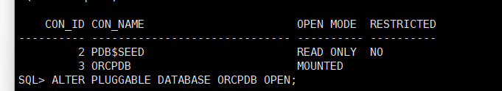

ORCPDB没有启动成功

运行 ALTER PLUGGABLE DATABASE ORCPDB OPEN;

再次运行show pdbs;

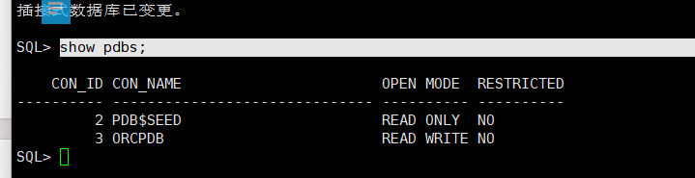

ORCPDB启动成功了

完整LogMiner安装配置流程

**1. 连接数据库**

sqlplus sys/password@host:port/SID as sysdba

password：sys用户密码

host：数据库服务器IP

port：数据库端口

SID：实例名

**2. 检查LogMiner是否已安装**

DESC DBMS_LOGMNR;

DESC DBMS_LOGMNR_D;

无输出表示未安装，有输出表示已安装

**3. 安装LogMiner（图片1修正版）**

@$ORACLE_HOME/rdbms/admin/dbmslm.sql

@$ORACLE_HOME/rdbms/admin/dbmslmd.sql

create role roma_logminer_privs;

grant create session,

execute_catalog_role,

select any transaction,

flashback any table,

select any table,

lock any table,

select any dictionary to roma_logminer_privs;

grant select on SYSTEM.LOGMNR_COL$ to roma_logminer_privs;

grant select on SYSTEM.LOGMNR_OBJ$ to roma_logminer_privs;

grant select on SYSTEM.LOGMNR_USER$ to roma_logminer_privs;

grant select on SYSTEM.LOGMNR_UID$ to roma_logminer_privs;

grant select on V_$DATABASE to roma_logminer_privs;

grant create table to roma_logminer_privs;

grant select_catalog_role to roma_logminer_privs;

grant LOGMINING to roma_logminer_privs;

grant lock any TABLE to roma_logminer_privs;

grant create SEQUENCE to roma_logminer_privs;

grant execute on DBMS_LOGMNR to roma_logminer_privs;

grant execute on DBMS_LOGMNR_D to roma_logminer_privs;

grant select on V_$LOG to roma_logminer_privs;

grant select on V_$LOG_HISTORY to roma_logminer_privs;

grant select on V_$LOGMNR_LOGS to roma_logminer_privs;

grant select on V_$LOGMNR_CONTENTS to roma_logminer_privs;

grant select on V_$LOGMNR_PARAMETERS to roma_logminer_privs;

grant select on V_$LOGFILE to roma_logminer_privs;

grant select on V_$ARCHIVED_LOG to roma_logminer_privs;

grant select on V_$ARCHIVE_DEST_STATUS to roma_logminer_privs;

grant select on V_$TRANSACTION to roma_logminer_privs;

alter database add supplemental log data (all) columns;

已参考1.3.1.1完成c##roma_logminer_privs配置

在CDB下创建用户c##drs_pdb用于DRS数据同步用户，

sqlplus / as sysdba

create user c##drs_pdb IDENTIFIED BY password_123;

grant CREATE SESSION to c##drs_pdb;

grant SELECT ANY DICTIONARY to c##drs_pdb;

grant EXECUTE_CATALOG_ROLE to c##drs_pdb;

grant SELECT ANY TRANSACTION to c##drs_pdb;

GRANT EXECUTE ON DBMS_LOGMNR to c##drs_pdb; -----LOGMINING

GRANT SET CONTAINER TO c##drs_pdb CONTAINER=ALL;

GRANT RESTRICTED SESSION TO c##drs_pdb;

grant c##roma_logminer_privs to c##drs_pdb container=all; -----c##roma_logminer_privs这个权限参考roma文档中创建

使用管理员账户，切换到对应的pdb

ALTER SESSION SET CONTAINER=pdb_ts;

GRANT RESTRICTED SESSION TO c##drs_pdb; -------必须在对应pdb中单独执行一次

GRANT CONNECT, RESOURCE TO c##drs_pdb;

grant CREATE SESSION to c##drs_pdb;

grant SELECT ANY DICTIONARY to c##drs_pdb;

grant EXECUTE_CATALOG_ROLE to c##drs_pdb;

grant SELECT ANY TRANSACTION to c##drs_pdb;

GRANT SELECT ON drs_pdb_ts.test to c##drs_pdb;

SELECT tablespace_name FROM dba_tablespaces;

找默认的表空间

alter user c##drs_pdb default tablespace USERS;

GRANT SELECT any table to c##drs_pdb;

------可选

注意：这个用户，必须是在CDB下创建的，并对pdb库有查询权限的用户

在PDB下创建业务账号，已经有就不必创建，上面有在pdb赋权的命令

create USER drs_pdb_ts IDENTIFIED BY password_123;

GRANT RESTRICTED SESSION TO drs_pdb_ts;

ALTER SESSION SET CONTAINER=pdb_ts1;

GRANT CONNECT, RESOURCE TO drs_pdb_ts;

grant CREATE SESSION to drs_pdb_ts;

grant SELECT ANY DICTIONARY to drs_pdb_ts;

grant EXECUTE_CATALOG_ROLE to drs_pdb_ts;

grant SELECT ANY TRANSACTION to drs_pdb_ts;

GRANT SELECT ON drs_pdb_ts.test to c##drs_pdb;