Chen, Kunyu

A54470631

CSE402

PROJECT 1

Question 1:

count finger genuine : 450

count finger impostor : 450

count hand genuine : 450

count hand impostor : 450

Question 2:

max finger genuine : 966

max finger impostor : 73

max hand genuine : 266

max hand impostor : 626

min finger genuine : 0

min finger impostor : 1

min hand genuine : 0

min hand impostor : 44

Question 3:

mean finger genuine : 306.5822

mean finger impostor : 7.9711

mean hand genuine : 50.6444

mean hand impostor : 144.4356

variance finger genuine : 4.0916e+04 (40916)

variance finger impostor : 91.0081

variance hand genuine : 1.5197e+03 (1519.7)

variance hand impostor : 6.9411e+03 (6941.1)

Question 4:

dprime finger : 2.0854

dprime hand : 1.4420

Question 5:

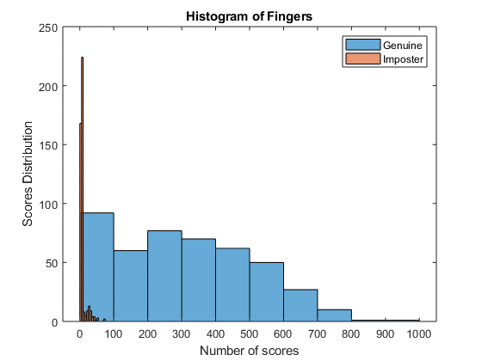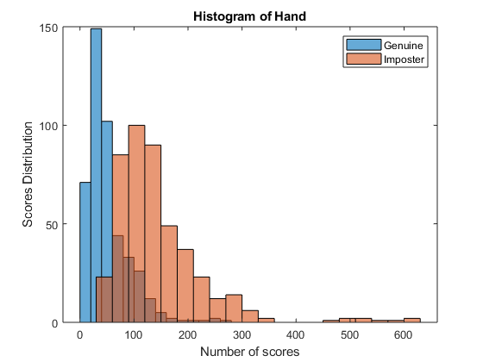

Question 6:

FMR finger : 0.0422(4.22%)

FNMR finger : 0.0933(9.34%)

FMR hand : 0.0044(0.45%)

FNMR hand genuine : 0.4489(44.89%)

Question 7:

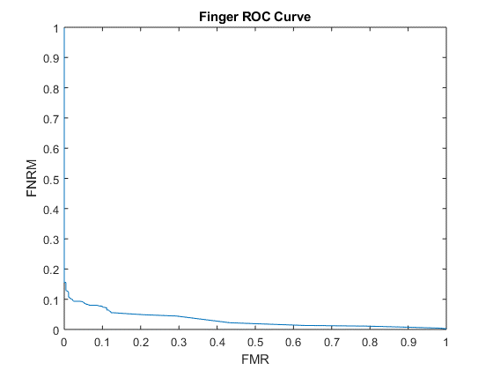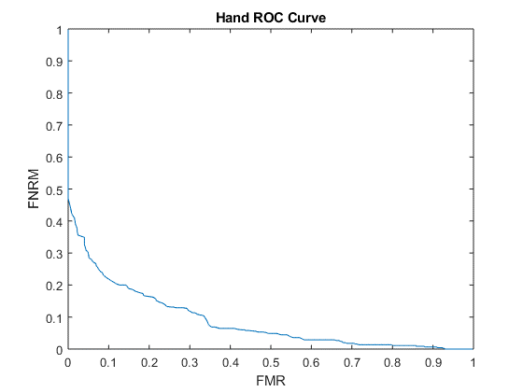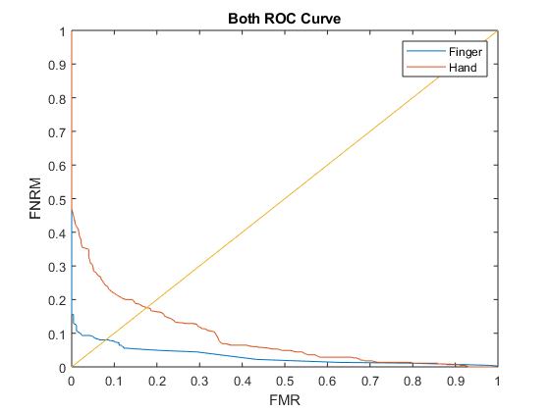

ERR hand : 0.176 finger : 0.08

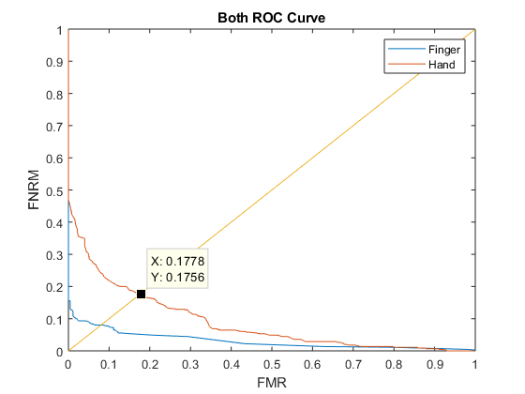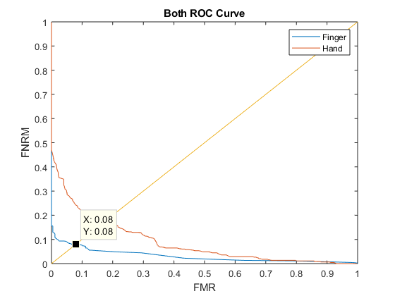

AUC

hand AUC : 0.0873

finger AUC : 0.0309

Question 8:

By seeing the ROC graph I get

When FMR (FAR) = 10%

Fingerprint FMNR (FRR) = 7.56%

Hand FMNR (FRR) = 22.22%

When FMR (FAR) = 1%

Fingerprint FMNR (FRR) = 12.4%

Hand FMNR (FRR) = 42.0%

When FMR (FAR) = 0.1%

Fingerprint FMNR (FRR) = 15.56%

Hand FMNR (FRR) = 46.45%

Question 9:

By looking at all the statistics and graphs I have got. I think the fingerprint matcher is better than the hand matcher. Frst, the fingerprint matcher has higer D-primer value than the hand matcher one. It means that the fingerprint is the better matched one. Second, the ERR of the fingerprint is less than the ERR of the hand and the fingerprint FMNR’s value is less than the hand FMNR’s value when FAR are 10%, 1% and 0.1%, so the fingerprint matcher is more accurate than the hand matcher.

%load file

finger_genuine = load('finger_genuine.score');

finger_impostor = load('finger_impostor.score');

hand_genuine = load('hand_genuine.score');

hand_impostor =load('hand_impostor.score');

%get the size of the file

finger1=length(finger_genuine);

finger2=length(finger_impostor);

hand1=length(hand_genuine);

hand2=length(hand_impostor);

disp('count finger genuine');

disp(finger1);

disp('count finger impostor');

disp(finger2);

disp('count hand genuine');

disp(hand1);

disp('count hand impostor');

disp(hand2);

finger1_max = max(finger_genuine);

finger2_max = max(finger_impostor);

hand1_max = max(hand_genuine);

hand2_max = max(hand_impostor);

finger1_min = min(finger_genuine);

finger2_min = min(finger_impostor);

hand1_min = min(hand_genuine);

hand2_min = min(hand_impostor);

finger1_mean = mean(finger_genuine);

finger2_mean = mean(finger_impostor);

hand1_mean = mean(hand_genuine);

hand2_mean = mean(hand_impostor);

finger1_variance = var(finger_genuine);

finger2_variance = var(finger_impostor);

hand1_variance = var(hand_genuine);

hand2_variance = var(hand_impostor);

disp('max finger genuine');

disp(finger1_max);

disp('max finger impostor');

disp(finger2_max);

disp('max hand genuine');

disp(hand1_max);

disp('max hand impostor');

disp(hand2_max);

disp('min finger genuine');

disp(finger1_min);

disp('min finger impostor');

disp(finger2_min);

disp('min hand genuine');

disp(hand1_min);

disp('min hand impostor');

disp(hand2_min);

disp('mean finger genuine');

disp(finger1_mean);

disp('mean finger impostor');

disp(finger2_mean);

disp('mean hand genuine');

disp(hand1_mean);

disp('mean hand impostor');

disp(hand2_mean);

disp('variance finger genuine');

disp(finger1_variance);

disp('variance finger impostor');

disp(finger2_variance);

disp('variance hand genuine');

disp(hand1_variance);

disp('variance hand impostor');

disp(hand2_variance);

finger_dprime = abs((finger1_mean-finger2_mean))/sqrt((finger1_variance+finger2_variance)/2);

hand_dprime = abs((hand1_mean-hand2_mean))/sqrt((hand1_variance+hand2_variance)/2);

disp('dprime finger');

disp(finger_dprime);

disp('dprime hand');

disp(hand_dprime);

figure;

histogram(finger_genuine,'orientation','vertical');

hold on

histogram(finger_impostor,'orientation','vertical');

legend('Genuine', 'Imposter')

title('Histogram of Fingers')

xlabel('Number of scores')

ylabel('Scores Distribution')

hold off

figure;

histogram(hand_genuine,'orientation','vertical');

hold on;

histogram(hand_impostor,'orientation','vertical');

legend('Genuine', 'Imposter')

title('Histogram of Hand')

xlabel('Number of scores')

ylabel('Scores Distribution')

hold off;

Fingerprint_matcher = 32;

Hand_matcher = 45;

finger_fmr = size(find(finger_impostor>=Fingerprint_matcher),1)/finger1;

disp('FMR finger');

disp(finger_fmr);

finger_fnmr = size(find(finger_genuine<Fingerprint_matcher),1)/finger2;

disp('FNMR finger');

disp(finger_fnmr);

hand_fmr = size(find(hand_impostor<Hand_matcher),1)/hand1;

disp('FMR hand');

disp(hand_fmr);

hand_fnmr = size(find(hand_genuine>=Hand_matcher),1)/hand2;

disp('FNMR hand genuine');

disp(hand_fnmr);

%ROC Curves

% Opening and reading file

Finger_Gen = fopen('finger_genuine.score','r');

Finger_Imp = fopen('finger_impostor.score','r');

Hand_Gen = fopen('hand_genuine.score','r');

Hand_Imp = fopen('hand_impostor.score','r');

% extracting files

Gen_Finger_Array = fscanf(Finger_Gen,'%f');

Imp_Finger_Array = fscanf(Finger_Imp,'%f');

Gen_Hand_Array = fscanf(Hand_Gen,'%f');

Imp_Hand_Array = fscanf(Hand_Imp,'%f');

fprintf('\nDraw the ROC curve by the given genuine and impostor scores: \n')

c = input('Would you like to provide Genuine and Imposter scores [Y/N]: ','s');

if(c == 'Y')

gen = input('Genuine Scores:', 's');

imp = input('Imposter Scores:', 's');

d = input('Type of the score: \n1)Distance 2)Similarity\n Type 1 or 2: ','s');

load_gen = load(gen);

load_imp = load(imp);

Start_Array = min([load_gen;load_imp]);

End_Array = max([load_gen;load_imp]);

if(Start_Array == 0)

Start_Array = 1;

end

if(End_Array == 0)

End_Arrya = 1;

end

if(d=='1')

[Imp_ROC, Gen_ROC] = ROCDIS(load_gen,load_imp,Start_Array,End_Array);

elseif(d=='2')

[Imp_ROC, Gen_ROC] = ROC(load_gen,load_imp,Start_Array,End_Array);

end

for i = 1:length(Imp_ROC)

if(Imp_ROC(i)==Gen_ROC(i))

disp('EER');

disp(Imp_ROC(i));

end

end

figure;

plot(Imp_ROC,Gen_ROC)

title('ROC Curve')

xlabel('FMR')

ylabel('FNRM')

AUC=abs(trapz(Imp_ROC,Gen_ROC));

disp('AUC');

disp(AUC);

end

if(c == 'N')

Start_Array = min([Gen_Hand_Array;Imp_Hand_Array]);

End_Array = max([Gen_Hand_Array;Imp_Hand_Array]);

if(Start_Array == 0)

Start_Array = 1;

end

if(End_Array == 0)

End_Arrya = 1;

end

[Hand_Imp_ROC, Hand_Gen_ROC] = ROCDIS(Gen_Hand_Array,Imp_Hand_Array,Start_Array,End_Array);

for A = 1:length(Hand_Imp_ROC)

if(Hand_Imp_ROC(A)==Hand_Gen_ROC(A))

disp('hand');

disp(Hand_Imp_ROC(A));

end

end

figure;

plot(Hand_Imp_ROC,Hand_Gen_ROC)

title('Hand ROC Curve')

xlabel('FMR')

ylabel('FNRM')

Start_Array = min([Gen_Finger_Array;Imp_Finger_Array]);

End_Array = max([Gen_Finger_Array;Imp_Finger_Array]);

if(Start_Array == 0)

Start_Array = 1;

end

if(End_Array == 0)

End_Arrya = 1;

end

[Finger_Imp_ROC, Finger_Gen_ROC] = ROC(Gen_Finger_Array,Imp_Finger_Array,Start_Array,End_Array);

for i = 1:length(Finger_Imp_ROC)

if(Finger_Imp_ROC(i)==Finger_Gen_ROC(i))

disp('finger EER');

disp(Finger_Imp_ROC(i));

end

end

figure;

plot(Finger_Imp_ROC,Finger_Gen_ROC)

title('Finger ROC Curve')

xlabel('FMR')

ylabel('FNRM')

AUC=trapz(Hand_Imp_ROC,Hand_Gen_ROC);

disp('hand AUC');

disp(AUC);

AUC1=abs(trapz(Finger_Imp_ROC,Finger_Gen_ROC));

disp('finger AUC');

disp(AUC1);

figure;

x = 0:1;

y = x;

plot(Finger_Imp_ROC,Finger_Gen_ROC)

hold on

plot(Hand_Imp_ROC,Hand_Gen_ROC)

hold on

plot(x,y)

title('Both ROC Curve')

legend('Finger', 'Hand')

xlabel('FMR')

ylabel('FNRM')

end

ROC Function

function [fmr, fnrm] = ROC( scores_gen,scores_imp,start,end1)

fnrm = end1;

fmr = end1;

for i = start:end1

fmr(i) =length(find(scores_imp >= i))/length(scores_imp);

fnrm(i) = length(find(scores_gen <i))/length(scores_gen);

end

end

ROCDIS Function

function [fmr, fnrm] = ROCDIS( scores_gen,scores_imp,start,end1)

fnrm = end1;

fmr = end1;

for i = start:end1

fmr(i) = length(find(scores_imp <i))/length(scores_imp);

fnrm(i) = length(find(scores_gen >=i))/length(scores_gen);

end

end