Here is my structure:

One story has many blocks; one story has many collages; each collage of the story can add and delete blocks of the story.

The functionalities I did not show are Collage can add available blocks and delete the blocks in it, which become available blocks again. I have “UnachiveAll” functionality, which can release all the archived stories and let them visible to the users.

1. Collage CRUD Operation

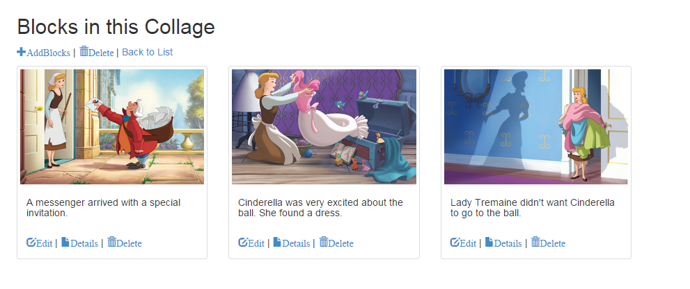

Image 1

In the image 1, you can choose to add blocks and delete the existed blocks here.

1. Add Blocks Page : show all the available blocks that belong to the story but not in this collage now.

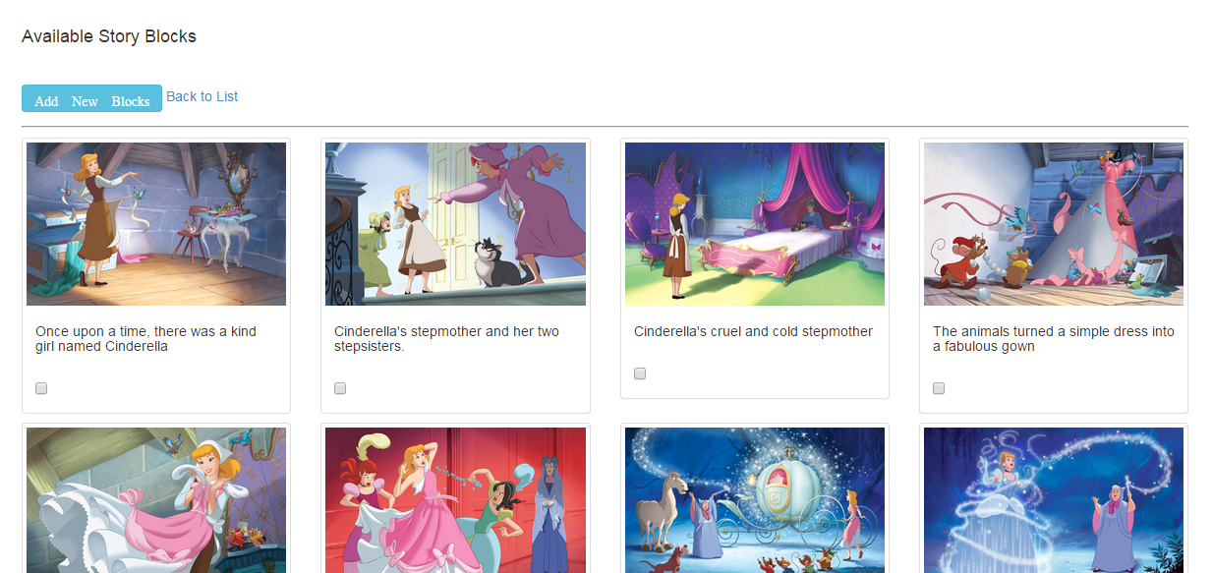

Image2

1. Delete blocks page: delete the blocks those are already in this collage, the deleted blocks will become available blocks that can show in the “AddBlocks” page

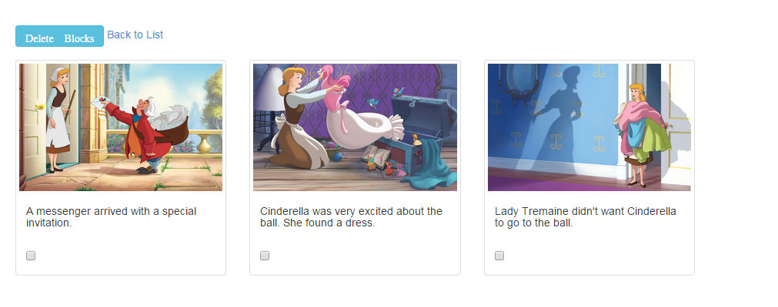 Image3

1. Un Archive all function, which can release all the archive file.

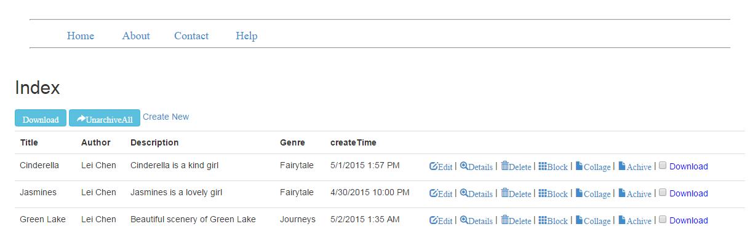

Image 4

Click the “Achive” link, the story will be achived. In image5 I have archive the second and the third stories. And the archive as zip files in the specific location.



Image 5

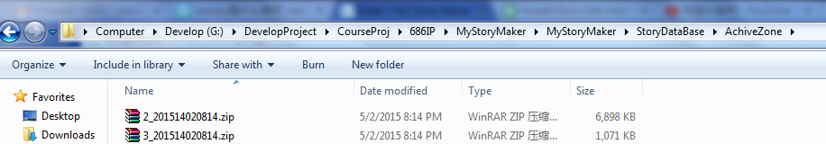

Image6

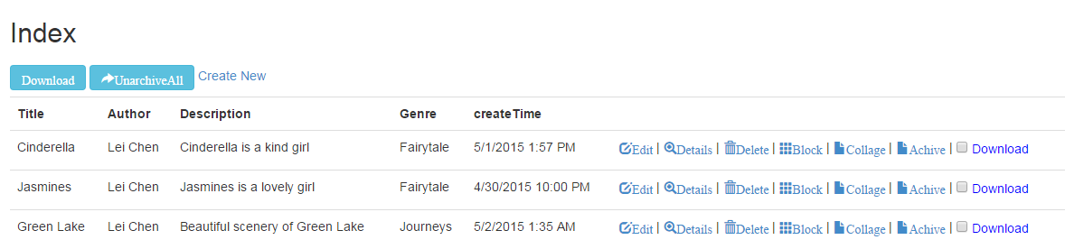

Image7

After I click “UnarchiveAll” the stories are visible to the users.