Portfolio Document
1. Full Crow’s Foot ERD: A professional diagram of your 10-table fortress.
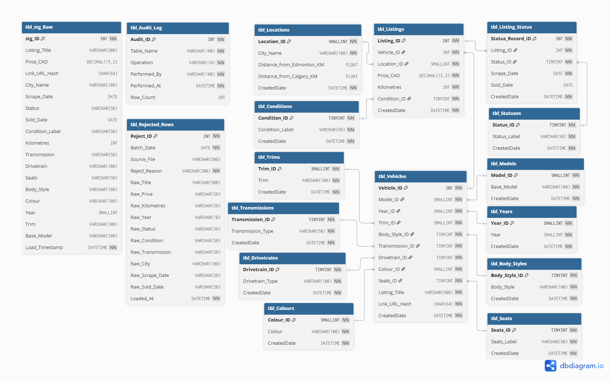
Figure 1: Full Crow’s Foot Entity-Relationship Diagram (ERD) illustrating the 10+ table 3NF SQL Fortress, featuring optimized data types, referential integrity constraints, and ETL audit tables.
Data Dictionary: To complement the visual ERD and satisfy the strict requirements of our Data Fortress, the following data dictionary defines the core business attributes, optimized data types, and constraint rules applied at the database level to ensure data integrity.
Table Name | Column Name | Data Type | Allow NULL | Default Value | Business Meaning | Constraint Rules
tbl_Models | Base_Model | VARCHAR(100) | No | 'UNKNOWN' | Vehicle base model name | Length > 0
tbl_Years | Year | SMALLINT | No | None | Manufacturing year | Between 1900 and 2027
tbl_Trims | Trim | VARCHAR(100) | No | 'UNKNOWN' | Specific trim level/package | Length > 0
tbl_Locations | City_Name | VARCHAR(100) | No | None | City where vehicle is located | Length > 0
tbl_Locations | Distance_from_Edmonton_KM | FLOAT | Yes | None | Driving distance to Edmonton | >= 0
tbl_Locations | Distance_from_Calgary_KM | FLOAT | Yes | None | Driving distance to Calgary | >= 0
tbl_Statuses | Status_Label | VARCHAR(50) | No | None | Current status of the listing | 'SOLD', 'ACTIVE', 'ACTIVE_REPOST', 'RESHELVED'
tbl_Conditions | Condition_Label | VARCHAR(50) | No | 'UNKNOWN' | Vehicle condition classification | 'USED', 'DAMAGED', 'SALVAGE', 'LEASE TAKEOVER', 'UNKNOWN'
tbl_Transmissions | Transmission_Type | VARCHAR(50) | No | 'UNKNOWN' | Type of transmission | 'AUTOMATIC', 'MANUAL', 'SEMI-AUTOMATIC', 'OTHER', 'UNKNOWN'
tbl_Drivetrains | Drivetrain_Type | VARCHAR(100) | No | 'UNKNOWN' | Drivetrain configuration | Length > 0
tbl_Body_Styles | Body_Style | VARCHAR(100) | No | 'UNKNOWN' | Physical body style of vehicle | Length > 0
tbl_Colours | Colour | VARCHAR(100) | No | 'UNKNOWN' | Exterior vehicle color | Length > 0
tbl_Seats | Seats_Label | VARCHAR(50) | No | 'UNKNOWN' | Number of seats | None
tbl_Vehicles | Listing_Title | VARCHAR(500) | No | None | Original raw title from the ad | Length > 0
tbl_Vehicles | Link_URL_Hash | CHAR(64) | No | None | SHA-256 hashed URL for PII masking | Exact length 64
tbl_Listings | Price_CAD | DECIMAL(15,2) | No | None | Seller's asking price (in CAD) | Between 1 and 10,000,000
tbl_Listings | Kilometres | INT | No | None | Vehicle mileage (in kilometres) | Between 0 and 2,000,000
tbl_Listing_Status | Scrape_Date | DATE | No | None | Date the listing was scraped | >= '2020-01-01'
tbl_Listing_Status | Sold_Date | DATE | Yes | None | Date the listing was sold | >= Scrape_Date
(All Tables) | CreatedDate | DATETIME | No | GETDATE() | ETL insertion timestamp | Auto-populated by SQL Server

2. ETL Architecture Flowchart: Diagram Source - Python - SQL.
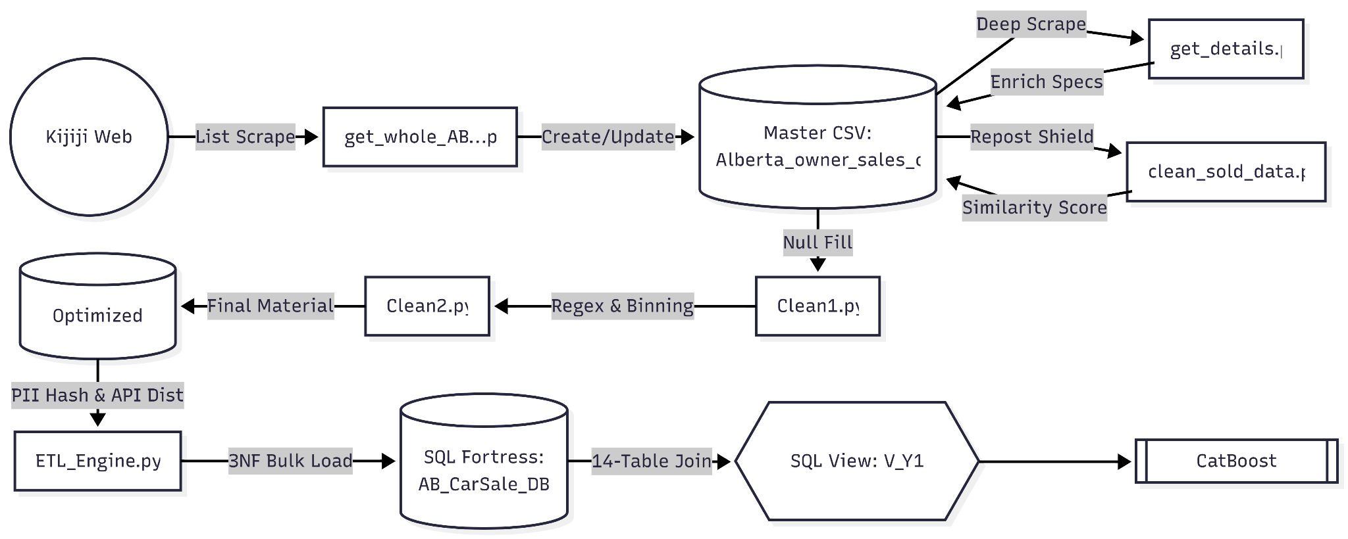
Figure 2: Automated ETL Architecture Flowchart detailing the end-to-end data pipeline, illustrating multi-region web ingestion, heuristic-based repost detection via similarity scoring, regex-driven feature extraction with cardinality optimization, and secure transactional loading featuring SHA-256 PII masking.
Step 1: Orchestrated Web Ingestion (Python)
- The pipeline begins with a multi-region Python scraper (get_whole_...py) targeting 11 Alberta cities on Kijiji.
- It identifies new listings and marks records as "Sold" based on link disappearance between daily scrapes.
- A secondary deep-scraper (get_details.py) then crawls individual ad pages to extract granular technical specs like transmission and drivetrain.
Step 2: Anti-False-Positive Engine (Data Integrity)
- To prevent "Sold" metrics from being inflated by sellers deleting and reposting ads, the clean_sold_data.py script applies a heuristic scoring model.
- By comparing title similarity, price ratios, and odometer readings within a 24-hour window, the system reclassifies phantom "Sold" events as "Active_Repost," ensuring high-fidelity labels for the ML model.
Step 3: Feature Engineering & Cardinality Optimization
- The transformation layer (Clean2.py) decomposes raw string data into structured features, including Year, Trim, and Base_Model.
- Crucially, a binning strategy is applied where categorical variables with fewer than 10 occurrences (e.g., rare trims or remote locations) are grouped into an "OTHER" bucket.
- This significantly reduces feature sparsity and prevents model overfitting during the machine learning phase.
Step 4: Transactional Loading (SQL Fortress)
- The finalized CSV is ingested into a 10-table 3NF schema using an ACID-compliant engine.
- This phase handles complex foreign key mapping, PII masking via SHA-256 hashing for privacy, and automated auditing via SQL Triggers.
- The process results in a model-ready, 14-table joined view (V_Y1) optimized for feature extraction.
3. The "Accuracy Paradox" Defense: Why accuracy was NOT your primary metric.

4. Cost-of-Error Analysis: Define the specific cost of a False Negative (FN).

5. SQL View Logic Walkthrough: Explain the query used for ML features.
SQL View Logic Walkthrough: Feature Extraction via V_Y1
To bridge the gap between our strict 3NF Data Fortress and the data ingestion requirements of the Machine Learning pipeline, a comprehensive SQL View named V_Y1 was engineered. The primary objective of this view is to flatten the highly normalized schema into a single, wide feature matrix without exposing the underlying transactional tables to raw analytical queries.
Core Query Logic & Massive Table JOINs:
Exceeding the project requirement of a 5-table join, V_Y1 executes a massive 14-table INNER JOIN to reconstruct the complete vehicle profiles. It centralizes the fact tables (tbl_Listings and tbl_Vehicles) and maps their Foreign Keys back to human-readable categorical strings and derived numerical features, successfully delivering exactly 18,614 verified "SOLD" records to the ML pipeline.
Dynamic Filtering Architecture:
Unlike hardcoding a specific status filter inside the view, V_Y1 is designed as a full-dataset view. This allows the ML pipeline to dynamically filter for "SOLD" records during model training, while effortlessly reusing the exact same view to pull "ACTIVE" records for live price inference.
Serving Derived Features (API Integration):
Instead of calculating geographical distances iteratively in Python during model training, the view directly serves the pre-calculated distance metrics from Edmonton and Calgary. This drastically reduces preprocessing latency for the ML team.
Optimized Categorical Retrieval:
CatBoost natively handles categorical variables highly efficiently. The view seamlessly un-normalizes the IDs (such as Model_ID or Colour_ID) back to descriptive strings, allowing the ML engine to immediately apply its internal Target Encoding without requiring complex mapping dictionaries.

6. Hyperparameter Log: Document results of tuning experiments.

7. Inference Instruction: A guide for processing new rows for prediction.

8. Drift Monitoring Plan: How to detect when the model becomes obsolete.

9. Ethical Sign-off: Reflection on privacy and data protection.
In the development of this vehicle pricing intelligence system, data privacy and the ethical handling of web-scraped information were prioritized. While used car listings are public, they often contain or link to Personal Identifiable Information (PII) such as seller contact details or precise neighborhood locations. To mitigate the risk of exposing seller identities or enabling malicious re-identification, a strict PII masking protocol was implemented directly within the ETL pipeline's transformation phase.
Specifically, the system intercepts the original web URL of the listing and applies a one-way SHA-256 cryptographic hash before it ever reaches the database. As a result, the transactional tbl_Vehicles table stores a 64-character hash rather than the raw URL. This ensures that the Machine Learning model and subsequent analytics dashboards can uniquely identify and track listings without storing any traceable digital footprints back to individual citizens, fully aligning with modern data protection standards.

10. Project Retrospective: Scaling considerations for 1 million+ rows.
While the current ETL architecture successfully ingests, validates, and routes the dataset into a strict 3NF fortress, scaling this pipeline to handle 1,000,000+ rows requires addressing several operational bottlenecks. The current pipeline establishes a strong foundation by utilizing chunked bulk inserts (1000 rows per batch) and SQLAlchemy's fast_executemany parameter to optimize database I/O within a single transaction block. However, hyper-growth would necessitate three primary architectural upgrades.
First, the API enrichment layer for geographical features represents a significant latency risk. The current pipeline utilizes a synchronous loop with a one-second sleep timer to respect Open-Meteo and OSRM API rate limits. Processing one million rows sequentially would take weeks. To resolve this, we would migrate to a locally hosted OSRM Docker container for routing and utilize asynchronous Python requests to process coordinates in parallel.
Second, from a database perspective, as tbl_Listings and tbl_Vehicles grow exponentially, the current non-clustered indexes will face fragmentation. We would need to implement Table Partitioning based on CreatedDate or Location_ID to ensure that the massive 14-table JOIN required for the Machine Learning View (V_Y1) remains performant.
Finally, the monolithic single-click ETL script would be decoupled. We would transition the orchestration to a framework like Apache Airflow, breaking the Extract, Transform, API Enrichment, and Load phases into a Directed Acyclic Graph (DAG). This would allow distributed processing and automated failure recovery on a per-task basis, transforming our robust script into an enterprise-grade data engineering pipeline.

