Portfolio Document
1. Full Crow’s Foot ERD: A professional diagram of your 10-table fortress.
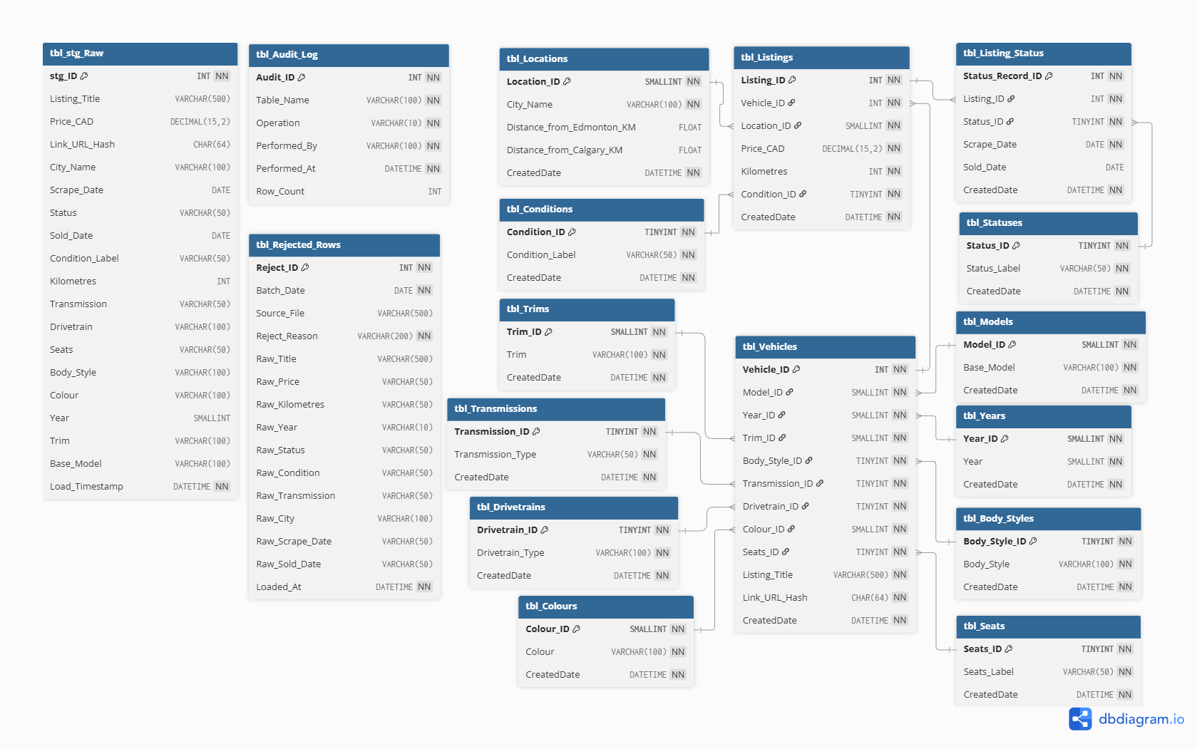
Figure 1: Full Crow’s Foot Entity-Relationship Diagram (ERD) illustrating the 10+ table 3NF SQL Fortress, featuring optimized data types, referential integrity constraints, and ETL audit tables.
Data Dictionary: To complement the visual ERD and satisfy the strict requirements of our Data Fortress, the following data dictionary defines the core business attributes, optimized data types, and constraint rules applied at the database level to ensure data integrity.
Table Name | Column Name | Data Type | Allow NULL | Default Value | Business Meaning | Constraint Rules
tbl_Models | Base_Model | VARCHAR(100) | No | 'UNKNOWN' | Vehicle base model name | Length > 0
tbl_Years | Year | SMALLINT | No | None | Manufacturing year | Between 1900 and 2027
tbl_Trims | Trim | VARCHAR(100) | No | 'UNKNOWN' | Specific trim level/package | Length > 0
tbl_Locations | City_Name | VARCHAR(100) | No | None | City where vehicle is located | Length > 0
tbl_Locations | Distance_from_Edmonton_KM | FLOAT | Yes | None | Driving distance to Edmonton | >= 0
tbl_Locations | Distance_from_Calgary_KM | FLOAT | Yes | None | Driving distance to Calgary | >= 0
tbl_Statuses | Status_Label | VARCHAR(50) | No | None | Current status of the listing | 'SOLD', 'ACTIVE', 'ACTIVE_REPOST', 'RESHELVED'
tbl_Conditions | Condition_Label | VARCHAR(50) | No | 'UNKNOWN' | Vehicle condition classification | 'USED', 'DAMAGED', 'SALVAGE', 'LEASE TAKEOVER', 'UNKNOWN'
tbl_Transmissions | Transmission_Type | VARCHAR(50) | No | 'UNKNOWN' | Type of transmission | 'AUTOMATIC', 'MANUAL', 'SEMI-AUTOMATIC', 'OTHER', 'UNKNOWN'
tbl_Drivetrains | Drivetrain_Type | VARCHAR(100) | No | 'UNKNOWN' | Drivetrain configuration | Length > 0
tbl_Body_Styles | Body_Style | VARCHAR(100) | No | 'UNKNOWN' | Physical body style of vehicle | Length > 0
tbl_Colours | Colour | VARCHAR(100) | No | 'UNKNOWN' | Exterior vehicle color | Length > 0
tbl_Seats | Seats_Label | VARCHAR(50) | No | 'UNKNOWN' | Number of seats | None
tbl_Vehicles | Listing_Title | VARCHAR(500) | No | None | Original raw title from the ad | Length > 0
tbl_Vehicles | Link_URL_Hash | CHAR(64) | No | None | SHA-256 hashed URL for PII masking | Exact length 64
tbl_Listings | Price_CAD | DECIMAL(15,2) | No | None | Seller's asking price (in CAD) | Between 1 and 10,000,000
tbl_Listings | Kilometres | INT | No | None | Vehicle mileage (in kilometres) | Between 0 and 2,000,000
tbl_Listing_Status | Scrape_Date | DATE | No | None | Date the listing was scraped | >= '2020-01-01'
tbl_Listing_Status | Sold_Date | DATE | Yes | None | Date the listing was sold | >= Scrape_Date
(All Tables) | CreatedDate | DATETIME | No | GETDATE() | ETL insertion timestamp | Auto-populated by SQL Server

2. ETL Architecture Flowchart: Diagram Source - Python - SQL.
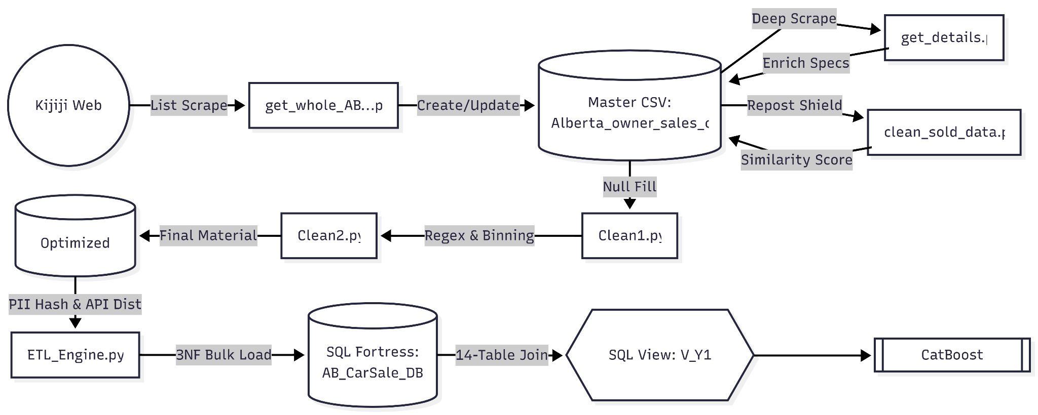
Figure 2: Automated ETL Architecture Flowchart detailing the end-to-end data pipeline, illustrating multi-region web ingestion, heuristic-based repost detection via similarity scoring, regex-driven feature extraction with cardinality optimization, and secure transactional loading featuring SHA-256 PII masking.
Step 1: Orchestrated Web Ingestion (Python)
- The pipeline begins with a multi-region Python scraper (get_whole_...py) targeting 11 Alberta cities on Kijiji.
- It identifies new listings and marks records as "Sold" based on link disappearance between daily scrapes.
- A secondary deep-scraper (get_details.py) then crawls individual ad pages to extract granular technical specs like transmission and drivetrain.
Step 2: Anti-False-Positive Engine (Data Integrity)
- To prevent "Sold" metrics from being inflated by sellers deleting and reposting ads, the clean_sold_data.py script applies a heuristic scoring model.
- By comparing title similarity, price ratios, and odometer readings within a 24-hour window, the system reclassifies phantom "Sold" events as "Active_Repost," ensuring high-fidelity labels for the ML model.
Step 3: Feature Engineering & Cardinality Optimization
- The transformation layer (Clean2.py) decomposes raw string data into structured features, including Year, Trim, and Base_Model.
- Crucially, a binning strategy is applied where categorical variables with fewer than 10 occurrences (e.g., rare trims or remote locations) are grouped into an "OTHER" bucket.
- This significantly reduces feature sparsity and prevents model overfitting during the machine learning phase.
Step 4: Transactional Loading (SQL Fortress)
- The finalized CSV is ingested into a 10-table 3NF schema using an ACID-compliant engine.
- This phase handles complex foreign key mapping, PII masking via SHA-256 hashing for privacy, and automated auditing via SQL Triggers.
- The process results in a model-ready, 14-table joined view (V_Y1) optimized for feature extraction.
3. The "Accuracy Paradox" Defense: Why accuracy was NOT your primary metric.
This is a regression problem — we predict a continuous dollar value (Price_CAD), not a class label. Accuracy is mathematically undefined for regression tasks. Our primary metrics and their business meaning:

Metric | Business Meaning
R² (R-Squared) | What percentage of price differences between cars does the model explain? R² = 0.89 means 89% of why one car costs more than another is captured by our features.
MAE (Mean Absolute Error) | On average, our prediction is off by $3,039 CAD. This is what a seller actually cares about — how wrong is the system in dollar terms?
RMSE (Root Mean Squared Error) | Penalizes large errors more than small ones. A $20,000 mistake is far worse than two $10,000 mistakes. RMSE captures this asymmetry.

Our final model results demonstrate strong performance across all three metrics:

Metric | CV Result (5-Fold) | Held-Out Test Result
R² | 0.7557 ± 0.0277 | 0.8886
MAE | $4,161 ± $174 | $3,039 CAD
RMSE | $7,711 ± $567 | $5,593 CAD
4. Cost-of-Error Analysis: Define the specific cost of a False Negative (FN).
False Negative (Underpricing):
The model predicts $18,000 when the true market value is $22,000. The seller lists too low, the car sells immediately, and the seller permanently loses $4,000 in potential revenue. This is the most financially damaging error because the money cannot be recovered after the sale.

False Positive (Overpricing):
The model predicts $25,000 when the true market value is $21,000. The car sits unsold for weeks. The seller can reduce the price and relist. The cost is time and inconvenience, not permanent financial loss.

Our three pricing strategies directly address both risks:
- Quick Sale (−10%) — protects against overpricing; guarantees a faster sale
- Balanced — the model’s best estimate of fair market value
- Max Profit (+8%) — lets the seller test the upper bound; accepts a longer listing period

5. SQL View Logic Walkthrough: Explain the query used for ML features.
SQL View Logic Walkthrough: Feature Extraction via V_Y1
To bridge the gap between our strict 3NF Data Fortress and the data ingestion requirements of the Machine Learning pipeline, a comprehensive SQL View named V_Y1 was engineered. The primary objective of this view is to flatten the highly normalized schema into a single, wide feature matrix without exposing the underlying transactional tables to raw analytical queries.
Core Query Logic & Massive Table JOINs:
Exceeding the project requirement of a 5-table join, V_Y1 executes a massive 14-table INNER JOIN to reconstruct the complete vehicle profiles. It centralizes the fact tables (tbl_Listings and tbl_Vehicles) and maps their Foreign Keys back to human-readable categorical strings and derived numerical features, successfully delivering exactly 18,614 verified "SOLD" records to the ML pipeline.
Dynamic Filtering Architecture:
Unlike hardcoding a specific status filter inside the view, V_Y1 is designed as a full-dataset view. This allows the ML pipeline to dynamically filter for "SOLD" records during model training, while effortlessly reusing the exact same view to pull "ACTIVE" records for live price inference.
Serving Derived Features (API Integration):
Instead of calculating geographical distances iteratively in Python during model training, the view directly serves the pre-calculated distance metrics from Edmonton and Calgary. This drastically reduces preprocessing latency for the ML team.
Optimized Categorical Retrieval:
CatBoost natively handles categorical variables highly efficiently. The view seamlessly un-normalizes the IDs (such as Model_ID or Colour_ID) back to descriptive strings, allowing the ML engine to immediately apply its internal Target Encoding without requiring complex mapping dictionaries.

6. Hyperparameter Log: Document results of tuning experiments.
The following table documents the final hyperparameter configuration for the Y1 CatBoost price prediction model and the rationale for each choice.

Parameter | Value | Rationale
iterations | 2000 | Maximum boosting rounds. Early stopping automatically finds the optimal number, so 2000 is a safe upper bound.
learning_rate | 0.05 | Low learning rate with high iterations — standard CatBoost best practice for stable convergence.
depth | 8 | Tree depth of 8 captures complex feature interactions (e.g. year × model × condition) without overfitting.
l2_leaf_reg | 3.0 | L2 regularization term on leaf values; controls overfitting.
subsample | 0.8 | 80% row sampling per tree; reduces variance and speeds up training.
early_stopping_rounds | 50 | Training stops automatically if no improvement for 50 consecutive rounds. Removes the need for manual iteration tuning.
loss_function | RMSE | Standard regression loss. Penalizes large errors more than MAE, which is appropriate for price prediction.
cat_features | 9 columns | Native categorical encoding via CatBoost’s internal Target Encoding. No One-Hot Encoding required.
random_seed | 42 | Fixed seed for full reproducibility across all training runs.

Model Comparison Results (5-Fold Cross-Validation)
Model | CV R² | CV MAE | CV RMSE | Decision
Dummy Baseline | -0.0010 | $10,661 | $15,633 | Rejected — no predictive power
Random Forest | 0.6940 | $4,442 | $8,649 | Rejected — lower than CatBoost
CatBoost | 0.7557 | $4,161 | $7,711 | Selected as production model

CatBoost was selected because it achieved the highest R², lowest MAE, and lowest RMSE across all five folds. It also handles categorical features natively without One-Hot Encoding, and early stopping eliminates the need for manual iteration tuning.

7. Inference Instruction: A guide for processing new rows for prediction.
Prerequisites
- Python 3.9 or higher installed
- SQL Server with AB_CarSale_DB populated via ETL_Engine.py
- ODBC Driver 17 for SQL Server installed
- OpenRouteService API key (free tier available at openrouteservice.org)

Step 1 — Install Dependencies
pip install streamlit catboost scikit-learn joblib pandas requests python-dotenv sqlalchemy pyodbc

Step 2 — Configure the API Key
Create a file named .env in the project root directory containing:
ORS_API_KEY=your_openrouteservice_key_here

Step 3 — Verify the Trained Model
Ensure catboost_price_model.pkl exists in the models/ folder. To retrain from scratch, run:
python training/Y1_model_catboost.py

Step 4 — Launch the Application
streamlit run app.py
The application opens automatically in the browser. The user enters vehicle details and selects a city to receive a real-time price prediction with three pricing strategy recommendations.

How a New Record is Processed at Inference Time
Step | Action | Component
1 | User enters vehicle details and city name in the Streamlit UI | app.py
2 | City name geocoded to (longitude, latitude) via open-meteo API | predict.py
3 | Road distances to Edmonton and Calgary fetched via OpenRouteService API | predict.py
4 | Feature row assembled: vehicle attributes + two distance values | predict.py
5 | Saved CatBoost pipeline loaded from catboost_price_model.pkl | predict.py
6 | Prediction generated; three pricing strategies calculated (−10%, market, +8%) | app.py
7 | Results displayed to user as three pricing strategy cards | app.py

8. Drift Monitoring Plan: How to detect when the model becomes obsolete.
A model trained on 2023–2024 data will degrade as market conditions change (inflation, new vehicle models, shifting demand patterns). The following signals indicate when retraining is needed.

Signal | Threshold | Meaning | Action
Mean residual on recent SOLD listings | > ±$2,000 | Model is systematically over- or under-predicting new data | Retrain immediately
R² on most recent 30-day SOLD data | < 0.70 | Model performance has degraded significantly from baseline | Retrain immediately
New Base_Model values in active listings | Any unseen model | New vehicle models have entered the Alberta market | Flag and retrain
Year distribution shift (KS test) | p < 0.05 | Fleet age distribution has shifted significantly | Retrain within 30 days

Retraining Process
Retraining is straightforward because the ETL pipeline handles incremental data loading automatically:
- New SOLD records are appended to AB_CarSale_DB via the regular ETL pipeline run
- Re-run Y1_model_catboost.py against the updated V_Y1 view to produce a new model
- Replace the catboost_price_model.pkl file with the newly trained model
- No changes to the Streamlit application or inference code are required

9. Ethical Sign-off: Reflection on privacy and data protection.
In the development of this vehicle pricing intelligence system, data privacy and the ethical handling of web-scraped information were prioritized. While used car listings are public, they often contain or link to Personal Identifiable Information (PII) such as seller contact details or precise neighborhood locations. To mitigate the risk of exposing seller identities or enabling malicious re-identification, a strict PII masking protocol was implemented directly within the ETL pipeline's transformation phase.
Specifically, the system intercepts the original web URL of the listing and applies a one-way SHA-256 cryptographic hash before it ever reaches the database. As a result, the transactional tbl_Vehicles table stores a 64-character hash rather than the raw URL. This ensures that the Machine Learning model and subsequent analytics dashboards can uniquely identify and track listings without storing any traceable digital footprints back to individual citizens, fully aligning with modern data protection standards.

10. Project Retrospective: Scaling considerations for 1 million+ rows.
While the current ETL architecture successfully ingests, validates, and routes the dataset into a strict 3NF fortress, scaling this pipeline to handle 1,000,000+ rows requires addressing several operational bottlenecks. The current pipeline establishes a strong foundation by utilizing chunked bulk inserts (1000 rows per batch) and SQLAlchemy's fast_executemany parameter to optimize database I/O within a single transaction block. However, hyper-growth would necessitate three primary architectural upgrades.
First, the API enrichment layer for geographical features represents a significant latency risk. The current pipeline utilizes a synchronous loop with a one-second sleep timer to respect Open-Meteo and OSRM API rate limits. Processing one million rows sequentially would take weeks. To resolve this, we would migrate to a locally hosted OSRM Docker container for routing and utilize asynchronous Python requests to process coordinates in parallel.
Second, from a database perspective, as tbl_Listings and tbl_Vehicles grow exponentially, the current non-clustered indexes will face fragmentation. We would need to implement Table Partitioning based on CreatedDate or Location_ID to ensure that the massive 14-table JOIN required for the Machine Learning View (V_Y1) remains performant.
Finally, the monolithic single-click ETL script would be decoupled. We would transition the orchestration to a framework like Apache Airflow, breaking the Extract, Transform, API Enrichment, and Load phases into a Directed Acyclic Graph (DAG). This would allow distributed processing and automated failure recovery on a per-task basis, transforming our robust script into an enterprise-grade data engineering pipeline.

