Since the MO-PGDRPPLRIF is a new problem and no standard instances are available in literature, we generated our own files by converting two classical sets of CARP instances (e.g., the *kshs*.zip files and the *gdb*.zip files, these two classical data sets are publicly available at [*http://www.uv.es/~belengue/carp.html*](http://www.uv.es/~belengue/carp.html)).

The converted files named the *kshs*-PGLRIF.zip and *gdb*-PGLRIF.zip, each compressed file contains multiple EXCEL files. The description of each EXCEL is as follows.

The Sheet1 named “*Q*”, which means the longest distance traveled by the vehicle in each trip. As shown in the Figure 1, the *Q*=150 indicates that the vehicle can travel up to 150 meters in each trip.

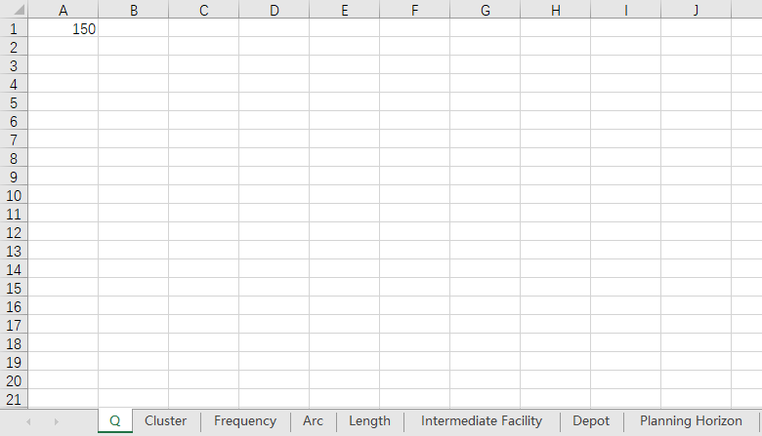

Figure 1. Schematic diagram of the Sheet1.

The Sheet2 named “Cluster”. In this Sheet, every row represents a cluster, and the non-zero elements in each row represent the identifier of arcs. The number of rows in this Sheet means the number of Cluster the instance contains. As shown in the Figure 2, there are eight clusters in the instance. The cluster1 contains arc1 and arc2. The cluster2 contains arc3, arc4, arc5, arc6, and arc7. The arcs contained in other clusters can be understood in the same way.

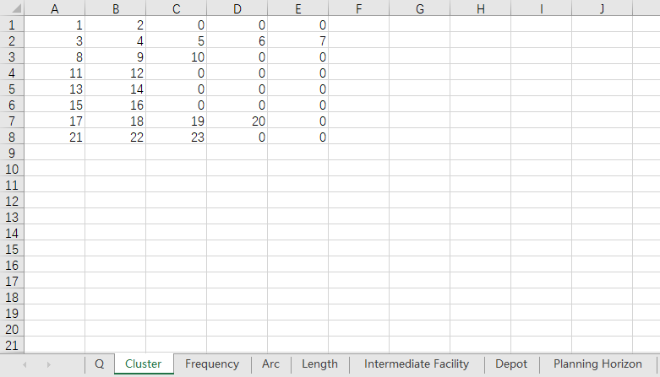

Figure 2. Schematic diagram of the Sheet2.

The Sheet 3 named “Frequency”. In this Sheet, every row indicates the prescribed service frequency for the corresponding Cluster. As shown in the Figure 3, the cluster1 shall be serviced twice. The cluster2 shall be serviced twice. The cluster3 required to be serviced three times. The service frequencies of other clusters can be understood in the same way.

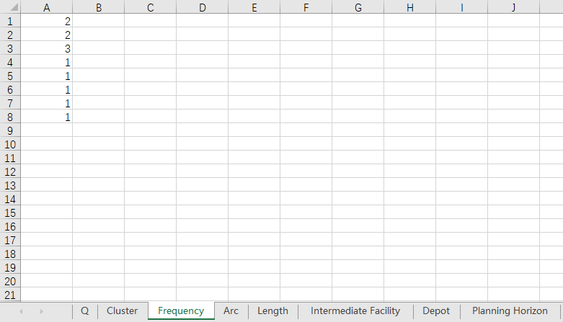

Figure 3. Schematic diagram of the Sheet3.

The Sheet 4 named “Arc”. In this Sheet, every row represents an arc, the left number is the starting vertex of the arc, and the right number is the ending vertex of the arc. As shown in the Figure 4, there are 28 arcs in the instance. The starting vertex of the arc1 is the vertex1, and the ending vertex of this arc is the vertex5. The starting vertex of the arc2 is the vertex4, and the ending vertex of this arc is the vertex6. The starting and ending vertices of other arcs can be understood in the same way.

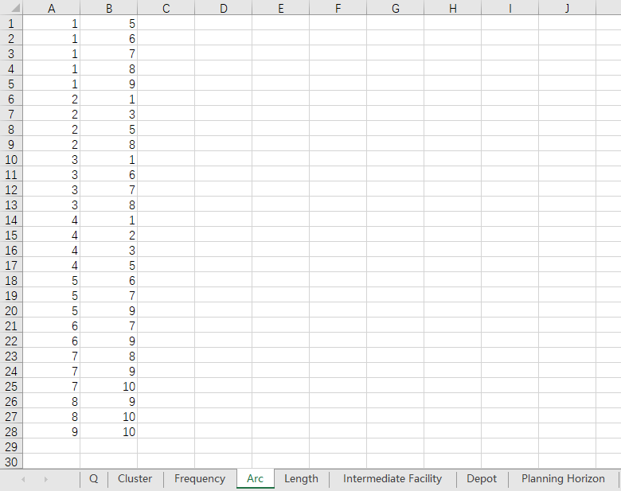

Figure 4. Schematic diagram of the Sheet4.

The Sheet 5 named “Length”. In this Sheet, the number in each row means the length of the corresponding arc. As shown in the Figure 5, the length of the arc1 is seven meters, and the length of the arc2 is 18 meters. The lengths of other arcs can be understood in the same way.

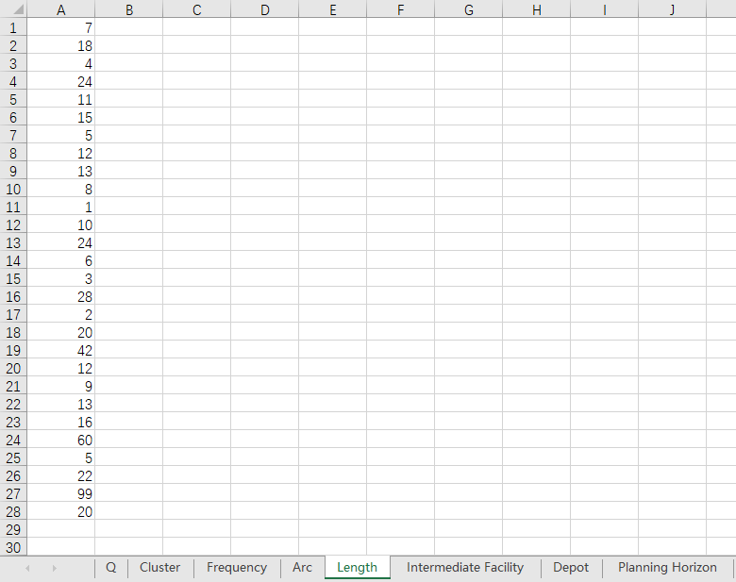

Figure 5. Schematic diagram of the Sheet5.

The Sheet 6 named “Intermediate Facility”. In this Sheet, the row number represents the identification of the vertex. If the number in a row is 1, it means that the corresponding vertex is an intermediate facility; if it is 0, it means that the vertex is not the intermediate facility. As shown in the Figure 6, the vertex1, vertex2 and vertex3 are intermediate facilities. The vertex4 is non-intermediate facility.

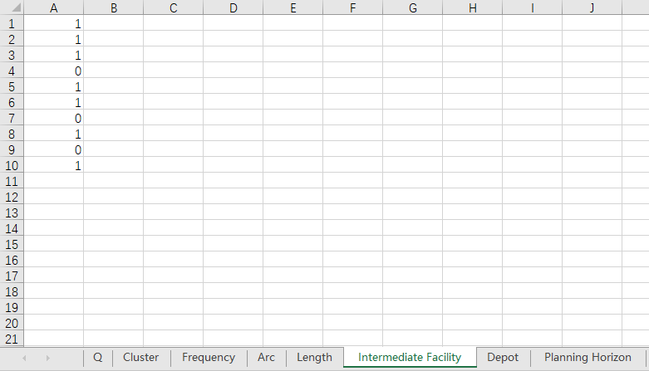

Figure 6. Schematic diagram of the Sheet6.

The Sheet 7 named “Depot”. This Sheet implies the depot vertex. As shown in the Figure 7, the vertex1 is the depot.

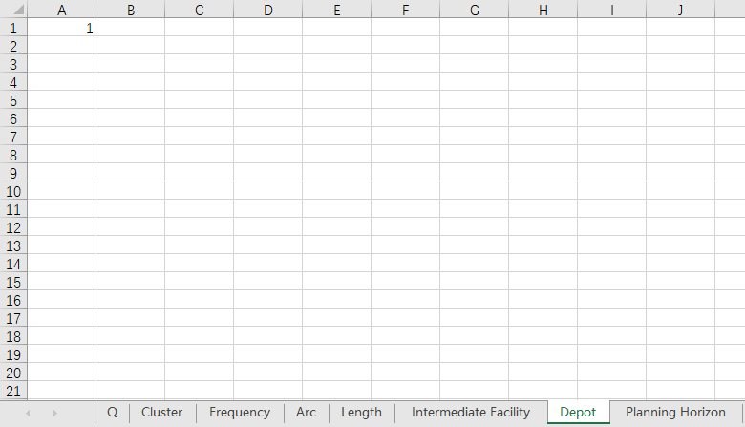

Figure 7. Schematic diagram of the Sheet7.

The Sheet 8 named “Planning Horizon”. This Sheet gives the prescribed planning horizon. As shown in the Figure 8, the planning horizon is 30 days.

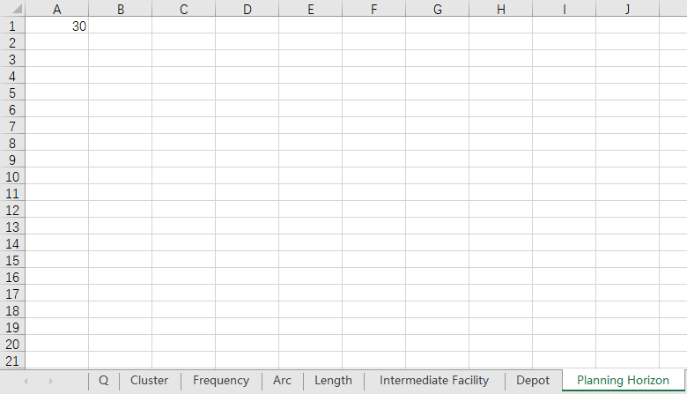

Figure 8. Schematic diagram of the Sheet8.