Since the CTIR-HVPD is a new problem and no standard instances are available in literature, we generated our own files by converting two classical sets of CARP instances (e.g., the *kshs*.zip files and the *gdb*.zip files, these two classical data sets are publicly available at [*http://www.uv.es/~belengue/carp.html*](http://www.uv.es/~belengue/carp.html)).

The converted files named the *kshs*-CTIR-HVPD.zip and *gdb*-CTIR-HVPD.zip, each compressed file contains multiple EXCEL files. The description of each EXCEL is as follows.

The Sheet 1 named “*Q*”, which means the longest distance traveled by the vehicle in each trip. As shown in the Figure 1, the *Q*=1500 indicates that the vehicle can travel up to 1500 meters in each trip.

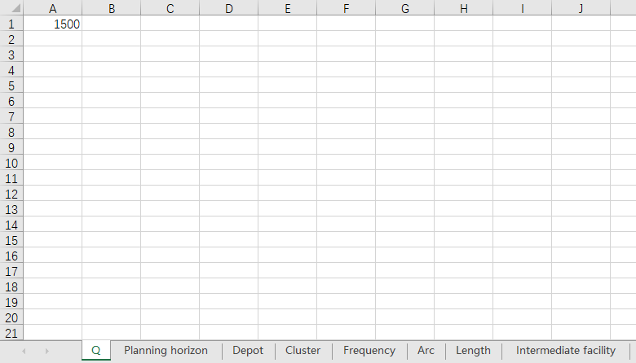

Figure 1. Schematic diagram of the Sheet 1.

The Sheet 2 named “Planning horizon”. This Sheet gives the prescribed planning horizon. As shown in the Figure 2, the planning horizon is 10 days.

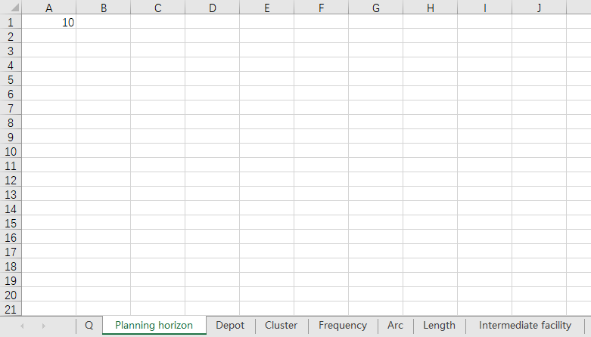

Figure 2. Schematic diagram of the Sheet 2.

The Sheet 3 named “Depot”. This Sheet implies the depot vertex. As shown in the Figure 3, the vertex *v*9 is the depot.

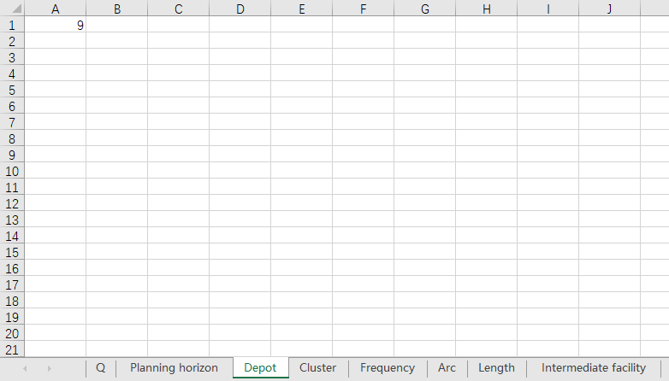

Figure 3. Schematic diagram of the Sheet 3.

The Sheet 4 named “Cluster”. In this Sheet, every row represents a cluster, and the non-zero elements in each row represent the identifier of arcs. The number of rows in this Sheet means the number of Cluster the instance contains. As shown in the Figure 4, there are six clusters in the instance. The cluster1 contains arc1 and arc2. The cluster2 contains arc3, arc4, arc5, arc6, and arc7. The arcs contained in other clusters can be understood in the same way.

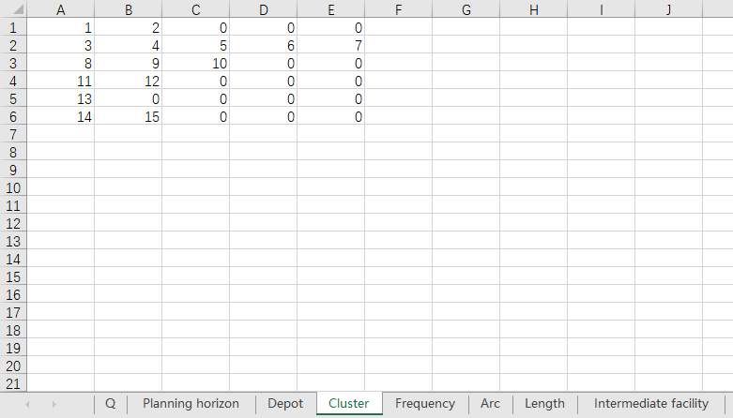

Figure 4. Schematic diagram of the Sheet 4.

The Sheet 5 named “Frequency”. In this Sheet, every row indicates the prescribed service frequency for the corresponding Cluster by track geometry vehicles and ultrasonic vehicles respectively. As shown in the Figure 5, the cluster1 shall be detected twice by track geometry vehicles and need not to be detected by ultrasonic vehicles. the cluster3 shall be detected once by track geometry vehicles and ultrasonic vehicles respectively. The service frequencies of other clusters can be understood in the same way.

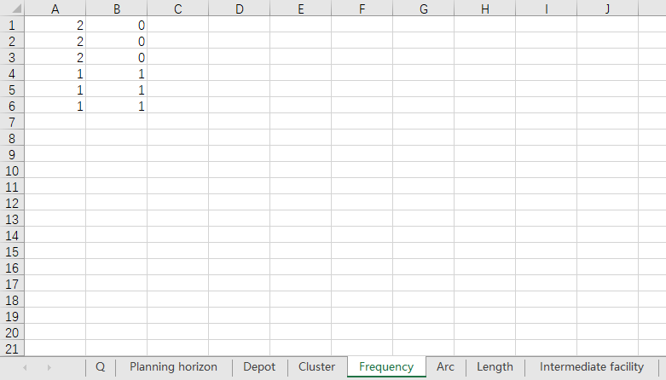

Figure 5. Schematic diagram of the Sheet 5.

The Sheet 6 named “Arc”. In this Sheet, every row represents an arc, the left number is the starting vertex of the arc, and the right number is the ending vertex of the arc. As shown in the Figure 6, there are 15 arcs in the instance. The starting vertex of the arc1 is the vertex1, and the ending vertex of this arc is the vertex5. The starting vertex of the arc2 is the *v*1, and the ending vertex of this arc is the *v*8. The starting and ending vertices of other arcs can be understood in the same way.

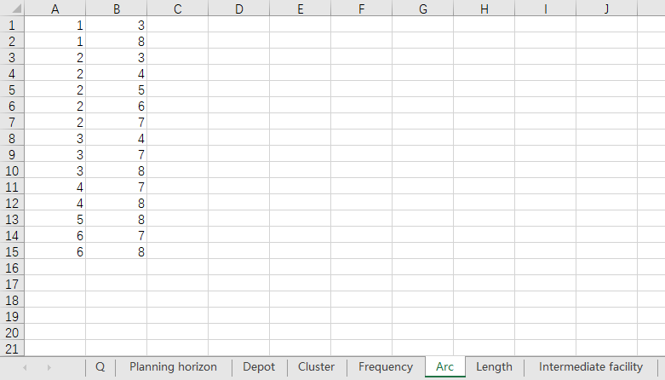

Figure 6. Schematic diagram of the Sheet 6.

The Sheet 7 named “Length”. In this Sheet, the number in each row means the length of the corresponding arc. As shown in the Figure 7, the length of the arc1 is 737 meters, and the length of the arc2 is 1082 meters. The lengths of other arcs can be understood in the same way.

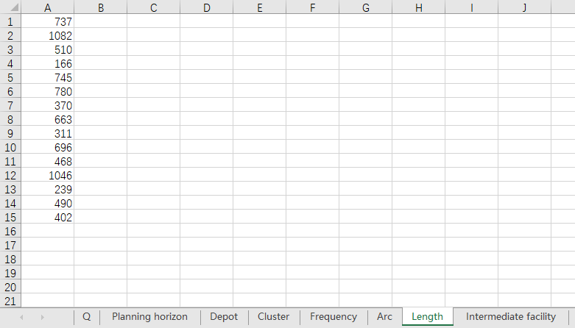

Figure 7. Schematic diagram of the Sheet 7.

The Sheet 8 named “Intermediate facility”. In this Sheet, intermediate facilities are recorded. As shown in the Figure 8, the *v*9, *v*10, …, *v*14 are intermediate facilities.

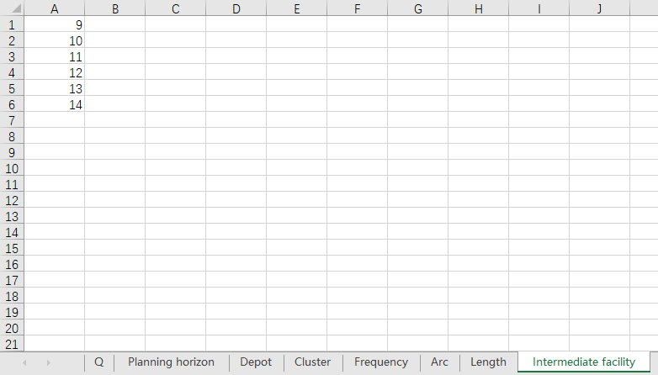

Figure 8. Schematic diagram of the Sheet 8.