单元格插入图片与读取图片
【参考：https://www.cnblogs.com/huajiezh/p/5467821.html】

插入图片：

实例：
@Test
public void testInsertPicture() throws IOException {
//创建一个工作簿
HSSFWorkbook wb = new HSSFWorkbook();
//创建一张工作表
HSSFSheet sheet = wb.createSheet();

FileInputStream fis = new FileInputStream("F:\\GitReponsitory\\Note\\Note\\后端\\知识点\\POI\\知识点\\POI测试文件夹\\image\\IOC容器工作原理.jpg");
byte[] bytes = new byte[(int) fis.getChannel().size()];
//读取图片到二进制数据
fis.read(bytes);
int pictureIdx = wb.addPicture(bytes, HSSFWorkbook.PICTURE_TYPE_JPEG);
HSSFPatriarch patriarch = sheet.createDrawingPatriarch();
HSSFClientAnchor anchor = new HSSFClientAnchor(0,0,0,0,(short)0,0,(short)5,5);
HSSFPicture picture = patriarch.createPicture(anchor, pictureIdx);
//自动调节图片大小,图片位置信息可能丢失
//picture.resize();

fis.close();

OutputStream os = new FileOutputStream("F:\\GitReponsitory\\Note\\Note\\后端\\知识点\\POI\\知识点\\POI测试文件夹\\write\\testInsertPicture.xls");
wb.write(os);

wb.close();
os.close();
}

效果：
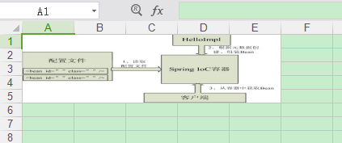

读取图片：

实例：
@Test
public void testReadPicture() throws IOException{
InputStream inp = new FileInputStream("F:\\GitReponsitory\\Note\\Note\\后端\\知识点\\POI\\知识点\\POI测试文件夹\\write\\testInsertPicture.xls");
HSSFWorkbook workbook = new HSSFWorkbook(inp);// 读取现有的Excel文件
List<HSSFPictureData> pictures = workbook.getAllPictures();
for (int i = 0; i < pictures.size(); i++){
HSSFPictureData pic = pictures.get(i);
String ext = pic.suggestFileExtension();
if (ext.equals("png"))// 判断文件格式
{
FileOutputStream png = new FileOutputStream("F:\\GitReponsitory\\Note\\Note\\后端\\知识点\\POI\\知识点\\POI测试文件夹\\write\\IOC.png");
png.write(pic.getData());
png.close();// 保存图片
}
}
}

