Bean的生命周期
前言：
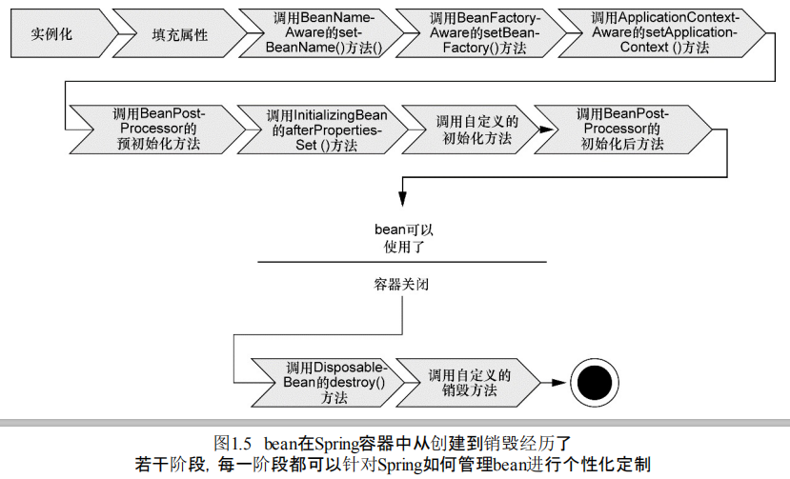

一、生命周期流程：
在Bean准备就绪之前，Bean工厂执行了若干启动步骤，我们对上图进行详细描述：
- Spring对Bean进行实例化；
- Spring将值和Bean的引用注入到Bean对应的属性中；
- 如果Bean实现了BeanNameAware接口，Spring将Bean的ID传递给setBeanName()方法；
- 如果Bean实现了BeanFactoryAware接口，Spring将调用setBeanFactory()方法，将BeanFactory容器实例传入；
- 如果Bean实现了ApplicationContextAware接口，Spring将调用setApplicationContext()方法，将Bean所在的应用上下文的引用传入进来；
- 如果Bean实现了BeanPostProcessor接口，Spring将调用它们的postProcessorBeforeInitialization()方法；
- 如果Bean实现了InitializingBean接口，Spring将调用它们的afterPropertiesSet()方法；
- 如果Bean实现了BeanPostProcessor接口，Spring将调用它们的postProcessorAfterInitialization()方法；
- 此时，Bean已经准备就绪，可以被应用程序使用了，他们将一直驻留在应用上下文中，直到该应用上下文被销毁。
- 如果Bean实现了DisposableBean接口，Spring将调用它们的destory()接口方法。同样，如果Bean使用destory-method声明了销毁方法，该方法也会被调用。

实例：
【Bean】
public class HelloImpl implements BeanNameAware,BeanFactoryAware,ApplicationContextAware,BeanPostProcessor,InitializingBean,DisposableBean {

private String name;

private String gender;

private Integer age;

public String getName() {
System.out.println("HelloImpl...getName()...");
return name;
}

public void setName(String name) {
System.out.println("HelloImpl...setName()...,name: "+name);
this.name = name;
}

public String getGender() {
System.out.println("HelloImpl...getGender()...");
return gender;
}

public void setGender(String gender) {
System.out.println("HelloImpl...setGender()...,gender: "+gender);
this.gender = gender;
}

public Integer getAge() {
System.out.println("HelloImpl...getAge()...");
return age;
}

public void setAge(Integer age) {
System.out.println("HelloImpl...setAge()...,age: "+age);
this.age = age;
}

public void myDestroy() {
System.out.println("HelloImpl...myDestroy()...");
}

@Override
public void setBeanName(String name) {
System.out.println("HelloImpl...setBeanName()...,name: "+name);
}

@Override
public void setBeanFactory(BeanFactory beanFactory) throws BeansException {
System.out.println("HelloImpl...setBeanFactory()...,beanFactory: "+beanFactory.getClass());
}

@Override
public void setApplicationContext(ApplicationContext applicationContext) throws BeansException {
System.out.println("HelloImpl...setApplicationContext()...,applicationContext: "+applicationContext.getBeanDefinitionCount());
}

@Override
public Object postProcessBeforeInitialization(Object bean, String beanName) throws BeansException {
System.out.println("HelloImpl...setApplicationContext()...,bean: "+beanName.toString()+"beanName: "+beanName);
return null;
}

@Override
public Object postProcessAfterInitialization(Object bean, String beanName) throws BeansException {
System.out.println("HelloImpl...setApplicationContext()...,bean: "+beanName.toString()+"beanName: "+beanName);
return null;
}

@Override
public void afterPropertiesSet() throws Exception {
System.out.println("HelloImpl...afterPropertiesSet()...");
}

@Override
public void destroy() throws Exception {
System.out.println("HelloImpl...destroy()...");
}

}

【配置文件】
<bean id="hello_1_id" name="hello_1_name" class="basic.basic_03_8_beanLife.bean.HelloImpl" destroy-method="myDestroy">
<property name="name" value="cm"></property>
<property name="gender" value="male"></property>
<property name="age" value="24"></property>
</bean>

<bean id="hello_2_id" name="hello_2_name" class="basic.basic_03_8_beanLife.bean.HelloImpl">
<property name="name" value="xiaohong"></property>
<property name="gender" value="female"></property>
<property name="age" value="22"></property>
</bean>

【测试案例】
public class BeanLifeTest {

@SuppressWarnings("resource")
@Test
public void testMethod1() {
ClassPathXmlApplicationContext context = new ClassPathXmlApplicationContext("basic/basic_03_8_beanLife/beanLife.xml");
context.close();
}
}

【源码】
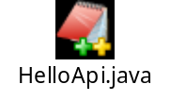
【SpringDemo01/src/basic/basic_03_8_beanLife/*】
【SpringDemo01/resources/basic/basic_03_8_beanLife/beanLife.xml】

