Comprehensive Area Models Document for SKY130

1. MOSFET Devices
MOSFET area is modeled using a bounding-box approach rather than a flat linear sum. The bounding box Height depends linearly on Width (W), and the bounding box Width depends on Finger Length (L) and Number of Fingers (nf). Area is given by the cross-product:
Area = (ah*W + bh) * (aw*L*nf + bw*nf + cw)

Device: nfet_01v8
Parameters: ah=1.0000, bh=2.1000, aw=0.9971, bw=0.3176, cw=1.6414
Height Model: h_um = 1.0000*W + 2.1000
Width Model: w_um = 0.9971*(L*nf) + 0.3176*nf + 1.6414
Dimensions | Actual (µm²) | Old Model Err | New Model Err
W=0.42 L=0.15 nf=1 | 5.32 | -43.38 (915.9%) | 5.31 (0.1%)
W=0.42 L=0.15 nf=2 | 6.63 | -41.26 (722.5%) | 6.49 (2.1%)
W=0.42 L=0.15 nf=4 | 9.05 | -37.00 (509.0%) | 8.85 (2.2%)
W=0.42 L=0.5 nf=1 | 6.20 | -32.40 (622.7%) | 6.19 (0.1%)
W=0.42 L=1.0 nf=1 | 7.46 | -16.72 (324.1%) | 7.45 (0.1%)
W=0.45 L=0.15 nf=1 | 5.38 | -43.23 (903.5%) | 5.38 (0.1%)
W=0.45 L=0.15 nf=2 | 6.71 | -40.95 (710.6%) | 6.57 (2.1%)
W=0.45 L=0.15 nf=4 | 9.15 | -36.39 (497.5%) | 8.95 (2.2%)
W=0.6 L=0.15 nf=1 | 5.70 | -42.47 (845.5%) | 5.69 (0.1%)
W=0.6 L=0.15 nf=2 | 7.10 | -39.43 (655.3%) | 6.95 (2.1%)
W=0.6 L=0.15 nf=4 | 9.69 | -33.35 (444.1%) | 9.48 (2.2%)
W=1.0 L=0.15 nf=1 | 6.54 | -40.45 (718.3%) | 6.54 (0.1%)
W=1.0 L=0.15 nf=2 | 8.15 | -35.38 (533.9%) | 7.98 (2.1%)
W=1.0 L=0.5 nf=1 | 7.63 | -29.46 (486.4%) | 7.62 (0.1%)
W=1.0 L=0.5 nf=2 | 10.07 | -24.40 (342.2%) | 10.15 (0.7%)
W=1.0 L=0.5 nf=4 | 14.97 | -14.26 (195.3%) | 15.21 (1.6%)
W=1.0 L=2.0 nf=2 | 19.38 | 22.66 (17.0%) | 19.42 (0.2%)
W=1.2 L=0.15 nf=1 | 6.96 | -39.43 (666.3%) | 6.96 (0.1%)
W=1.2 L=0.15 nf=2 | 8.68 | -33.35 (484.3%) | 8.50 (2.1%)
W=1.2 L=0.15 nf=4 | 11.85 | -21.19 (278.9%) | 11.58 (2.2%)
W=1.5 L=0.5 nf=1 | 8.86 | -26.93 (404.1%) | 8.85 (0.1%)
W=1.5 L=0.5 nf=2 | 11.70 | -19.33 (265.2%) | 11.79 (0.7%)
W=1.5 L=0.5 nf=4 | 17.39 | -4.13 (123.8%) | 17.66 (1.6%)
W=2.0 L=0.15 nf=4 | 14.72 | -4.98 (133.8%) | 14.39 (2.2%)
W=2.0 L=0.35 nf=2 | 12.10 | -18.97 (256.8%) | 12.20 (0.8%)
W=2.0 L=0.5 nf=1 | 10.09 | -24.40 (341.9%) | 10.08 (0.1%)
W=2.0 L=0.5 nf=2 | 13.32 | -14.26 (207.0%) | 13.42 (0.7%)
W=2.0 L=0.5 nf=4 | 19.80 | 6.00 (69.7%) | 20.11 (1.6%)
W=2.0 L=1.0 nf=1 | 12.14 | -8.71 (171.8%) | 12.12 (0.1%)
W=2.0 L=1.0 nf=2 | 17.43 | 1.42 (91.8%) | 17.51 (0.5%)
W=2.0 L=1.0 nf=4 | 28.00 | 21.69 (22.5%) | 28.29 (1.0%)
W=2.0 L=5.0 nf=2 | 50.23 | 126.92 (152.7%) | 50.22 (0.0%)
W=3.0 L=1.0 nf=1 | 15.10 | -3.64 (124.1%) | 15.08 (0.1%)
W=3.0 L=1.0 nf=2 | 21.68 | 11.56 (46.7%) | 21.78 (0.5%)
W=3.0 L=1.0 nf=4 | 34.83 | 41.96 (20.5%) | 35.19 (1.0%)
W=4.0 L=0.15 nf=4 | 21.90 | 35.56 (62.4%) | 21.41 (2.2%)
W=4.0 L=0.5 nf=1 | 15.01 | -14.26 (195.1%) | 14.99 (0.1%)
W=4.0 L=0.5 nf=2 | 19.82 | 6.00 (69.7%) | 19.97 (0.7%)
W=4.0 L=0.5 nf=4 | 29.46 | 46.54 (58.0%) | 29.93 (1.6%)
W=4.0 L=1.0 nf=1 | 18.06 | 1.42 (92.1%) | 18.03 (0.1%)
W=4.0 L=1.0 nf=2 | 25.93 | 21.69 (16.3%) | 26.05 (0.5%)
W=4.0 L=1.0 nf=4 | 41.66 | 62.23 (49.4%) | 42.09 (1.0%)
W=4.0 L=2.0 nf=1 | 24.16 | 32.80 (35.8%) | 24.11 (0.2%)
W=4.0 L=2.0 nf=2 | 38.12 | 53.06 (39.2%) | 38.22 (0.2%)
W=4.0 L=2.0 nf=4 | 66.06 | 93.60 (41.7%) | 66.42 (0.5%)
W=4.0 L=5.0 nf=8 | 268.34 | 268.79 (0.2%) | 268.80 (0.2%)
W=4.0 L=10.0 nf=4 | 261.26 | 344.59 (31.9%) | 261.05 (0.1%)
W=6.0 L=2.0 nf=1 | 32.08 | 42.93 (33.8%) | 32.02 (0.2%)
W=6.0 L=2.0 nf=2 | 50.62 | 73.33 (44.9%) | 50.75 (0.2%)
W=6.0 L=2.0 nf=4 | 87.72 | 134.14 (52.9%) | 88.20 (0.5%)
W=8.0 L=1.0 nf=1 | 29.90 | 21.69 (27.4%) | 29.86 (0.1%)
W=8.0 L=1.0 nf=2 | 42.92 | 62.23 (45.0%) | 43.14 (0.5%)
W=8.0 L=1.0 nf=4 | 68.98 | 143.30 (107.7%) | 69.69 (1.0%)
W=8.0 L=2.0 nf=1 | 40.00 | 53.06 (32.7%) | 39.93 (0.2%)
W=8.0 L=2.0 nf=2 | 63.12 | 93.60 (48.3%) | 63.28 (0.2%)
W=8.0 L=2.0 nf=4 | 109.38 | 174.67 (59.7%) | 109.97 (0.5%)
W=10.0 L=0.15 nf=1 | 25.53 | 5.16 (79.8%) | 25.51 (0.1%)
W=10.0 L=0.15 nf=4 | 43.44 | 157.16 (261.8%) | 42.47 (2.2%)
W=10.0 L=0.15 nf=8 | 66.67 | 359.84 (439.7%) | 65.08 (2.4%)
W=10.0 L=5.0 nf=1 | 84.22 | 157.32 (86.8%) | 84.03 (0.2%)
W=10.0 L=5.0 nf=2 | 148.22 | 207.99 (40.3%) | 148.20 (0.0%)
W=10.0 L=5.0 nf=4 | 276.24 | 309.33 (12.0%) | 276.53 (0.1%)
W=10.0 L=10.0 nf=1 | 144.72 | 314.19 (117.1%) | 144.35 (0.3%)
W=10.0 L=10.0 nf=4 | 518.24 | 466.20 (10.0%) | 517.83 (0.1%)
W=10.0 L=10.0 nf=10 | 1265.30 | 770.21 (39.1%) | 1264.78 (0.0%)
W=15.0 L=5.0 nf=1 | 119.02 | 182.65 (53.5%) | 118.75 (0.2%)
W=15.0 L=5.0 nf=2 | 209.47 | 258.66 (23.5%) | 209.43 (0.0%)
W=15.0 L=5.0 nf=4 | 390.39 | 410.67 (5.2%) | 390.80 (0.1%)
W=16.0 L=2.0 nf=1 | 71.68 | 93.60 (30.6%) | 71.55 (0.2%)
W=16.0 L=2.0 nf=2 | 113.12 | 174.67 (54.4%) | 113.40 (0.2%)
W=16.0 L=2.0 nf=4 | 196.02 | 336.81 (71.8%) | 197.08 (0.5%)
W=20.0 L=5.0 nf=1 | 153.82 | 207.99 (35.2%) | 153.47 (0.2%)
W=20.0 L=5.0 nf=2 | 270.73 | 309.33 (14.3%) | 270.67 (0.0%)
W=20.0 L=5.0 nf=4 | 504.54 | 512.00 (1.5%) | 505.07 (0.1%)
W=40.0 L=5.0 nf=1 | 293.02 | 309.33 (5.6%) | 292.36 (0.2%)
W=40.0 L=5.0 nf=2 | 515.73 | 512.00 (0.7%) | 515.62 (0.0%)
W=40.0 L=5.0 nf=4 | 961.14 | 917.36 (4.6%) | 962.14 (0.1%)
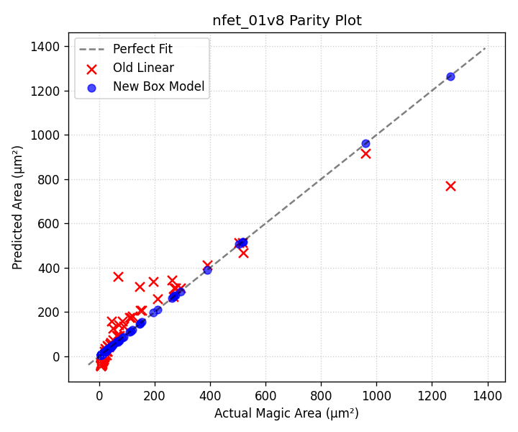

Device: pfet_01v8
Parameters: ah=1.0000, bh=2.1900, aw=0.9971, bw=0.3176, cw=1.6414
Height Model: h_um = 1.0000*W + 2.1900
Width Model: w_um = 0.9971*(L*nf) + 0.3176*nf + 1.6414
Dimensions | Actual (µm²) | Old Model Err | New Model Err
W=0.42 L=0.15 nf=1 | 5.51 | -43.39 (887.8%) | 5.50 (0.1%)
W=0.42 L=0.15 nf=2 | 6.86 | -41.25 (701.0%) | 6.72 (2.1%)
W=0.42 L=0.15 nf=4 | 9.37 | -36.99 (494.7%) | 9.16 (2.2%)
W=0.42 L=0.5 nf=1 | 6.42 | -32.30 (603.1%) | 6.41 (0.1%)
W=0.42 L=1.0 nf=1 | 7.73 | -16.46 (313.1%) | 7.72 (0.1%)
W=0.45 L=0.15 nf=1 | 5.57 | -43.23 (876.1%) | 5.57 (0.1%)
W=0.45 L=0.15 nf=2 | 6.94 | -40.95 (689.8%) | 6.80 (2.1%)
W=0.45 L=0.15 nf=4 | 9.48 | -36.38 (483.8%) | 9.27 (2.2%)
W=0.6 L=0.15 nf=1 | 5.89 | -42.47 (821.5%) | 5.88 (0.1%)
W=0.6 L=0.15 nf=2 | 7.34 | -39.43 (637.3%) | 7.19 (2.1%)
W=0.6 L=0.15 nf=4 | 10.02 | -33.33 (432.8%) | 9.79 (2.2%)
W=1.0 L=0.15 nf=1 | 6.73 | -40.44 (700.8%) | 6.73 (0.1%)
W=1.0 L=0.15 nf=2 | 8.39 | -35.36 (521.5%) | 8.22 (2.1%)
W=1.0 L=0.5 nf=1 | 7.85 | -29.35 (474.1%) | 7.84 (0.1%)
W=1.0 L=0.5 nf=2 | 10.37 | -24.27 (334.1%) | 10.44 (0.7%)
W=1.0 L=0.5 nf=4 | 15.41 | -14.12 (191.6%) | 15.65 (1.6%)
W=1.0 L=2.0 nf=2 | 19.94 | 23.24 (16.6%) | 19.99 (0.2%)
W=1.2 L=0.15 nf=1 | 7.15 | -39.43 (651.2%) | 7.15 (0.1%)
W=1.2 L=0.15 nf=2 | 8.92 | -33.33 (473.8%) | 8.73 (2.1%)
W=1.2 L=0.15 nf=4 | 12.17 | -21.14 (273.7%) | 11.90 (2.2%)
W=1.5 L=0.5 nf=1 | 9.08 | -26.81 (395.4%) | 9.07 (0.1%)
W=1.5 L=0.5 nf=2 | 11.99 | -19.20 (260.1%) | 12.08 (0.7%)
W=1.5 L=0.5 nf=4 | 17.82 | -3.96 (122.2%) | 18.10 (1.6%)
W=2.0 L=0.15 nf=4 | 15.04 | -4.89 (132.5%) | 14.71 (2.2%)
W=2.0 L=0.35 nf=2 | 12.36 | -18.87 (252.6%) | 12.46 (0.8%)
W=2.0 L=0.5 nf=1 | 10.31 | -24.27 (335.5%) | 10.30 (0.1%)
W=2.0 L=0.5 nf=2 | 13.62 | -14.12 (203.7%) | 13.72 (0.7%)
W=2.0 L=0.5 nf=4 | 20.24 | 6.20 (69.4%) | 20.56 (1.6%)
W=2.0 L=1.0 nf=1 | 12.40 | -8.44 (168.0%) | 12.39 (0.1%)
W=2.0 L=1.0 nf=2 | 17.81 | 1.72 (90.3%) | 17.89 (0.5%)
W=2.0 L=1.0 nf=4 | 28.62 | 22.04 (23.0%) | 28.91 (1.0%)
W=2.0 L=5.0 nf=2 | 51.33 | 128.43 (150.2%) | 51.32 (0.0%)
W=3.0 L=1.0 nf=1 | 15.36 | -3.36 (121.8%) | 15.34 (0.1%)
W=3.0 L=1.0 nf=2 | 22.06 | 11.88 (46.1%) | 22.17 (0.5%)
W=3.0 L=1.0 nf=4 | 35.45 | 42.36 (19.5%) | 35.81 (1.0%)
W=4.0 L=0.15 nf=4 | 22.22 | 35.75 (60.9%) | 21.73 (2.2%)
W=4.0 L=0.5 nf=1 | 15.23 | -14.12 (192.7%) | 15.21 (0.1%)
W=4.0 L=0.5 nf=2 | 20.12 | 6.20 (69.2%) | 20.26 (0.7%)
W=4.0 L=0.5 nf=4 | 29.90 | 46.83 (56.6%) | 30.37 (1.6%)
W=4.0 L=1.0 nf=1 | 18.32 | 1.72 (90.6%) | 18.30 (0.1%)
W=4.0 L=1.0 nf=2 | 26.31 | 22.04 (16.2%) | 26.44 (0.5%)
W=4.0 L=1.0 nf=4 | 42.28 | 62.67 (48.2%) | 42.71 (1.0%)
W=4.0 L=2.0 nf=1 | 24.51 | 33.40 (36.3%) | 24.47 (0.2%)
W=4.0 L=2.0 nf=2 | 38.69 | 53.72 (38.8%) | 38.78 (0.2%)
W=4.0 L=2.0 nf=4 | 67.04 | 94.35 (40.7%) | 67.40 (0.5%)
W=4.0 L=5.0 nf=8 | 272.30 | 270.65 (0.6%) | 272.77 (0.2%)
W=4.0 L=10.0 nf=4 | 265.12 | 347.77 (31.2%) | 264.91 (0.1%)
W=6.0 L=2.0 nf=1 | 32.43 | 43.56 (34.3%) | 32.38 (0.2%)
W=6.0 L=2.0 nf=2 | 51.19 | 74.03 (44.6%) | 51.31 (0.2%)
W=6.0 L=2.0 nf=4 | 88.70 | 134.98 (52.2%) | 89.18 (0.5%)
W=8.0 L=1.0 nf=1 | 30.16 | 22.04 (26.9%) | 30.12 (0.1%)
W=8.0 L=1.0 nf=2 | 43.31 | 62.67 (44.7%) | 43.52 (0.5%)
W=8.0 L=1.0 nf=4 | 69.60 | 143.94 (106.8%) | 70.31 (1.0%)
W=8.0 L=2.0 nf=1 | 40.35 | 53.72 (33.1%) | 40.28 (0.2%)
W=8.0 L=2.0 nf=2 | 63.69 | 94.35 (48.1%) | 63.84 (0.2%)
W=8.0 L=2.0 nf=4 | 110.36 | 175.62 (59.1%) | 110.95 (0.5%)
W=10.0 L=0.15 nf=1 | 25.72 | 5.27 (79.5%) | 25.70 (0.1%)
W=10.0 L=0.15 nf=4 | 43.76 | 157.64 (260.2%) | 42.79 (2.2%)
W=10.0 L=0.15 nf=8 | 67.17 | 360.81 (437.2%) | 65.57 (2.4%)
W=10.0 L=5.0 nf=1 | 84.84 | 158.91 (87.3%) | 84.65 (0.2%)
W=10.0 L=5.0 nf=2 | 149.33 | 209.70 (40.4%) | 149.30 (0.0%)
W=10.0 L=5.0 nf=4 | 278.30 | 311.28 (11.9%) | 278.59 (0.1%)
W=10.0 L=10.0 nf=1 | 145.79 | 317.30 (117.6%) | 145.43 (0.3%)
W=10.0 L=10.0 nf=4 | 522.10 | 469.67 (10.0%) | 521.68 (0.1%)
W=10.0 L=10.0 nf=10 | 1274.71 | 774.42 (39.2%) | 1274.19 (0.0%)
W=15.0 L=5.0 nf=1 | 119.64 | 184.30 (54.0%) | 119.38 (0.2%)
W=15.0 L=5.0 nf=2 | 210.58 | 260.49 (23.7%) | 210.54 (0.0%)
W=15.0 L=5.0 nf=4 | 392.45 | 412.87 (5.2%) | 392.86 (0.1%)
W=16.0 L=2.0 nf=1 | 72.03 | 94.35 (31.0%) | 71.91 (0.2%)
W=16.0 L=2.0 nf=2 | 113.69 | 175.62 (54.5%) | 113.96 (0.2%)
W=16.0 L=2.0 nf=4 | 197.00 | 338.15 (71.7%) | 198.06 (0.5%)
W=20.0 L=5.0 nf=1 | 154.44 | 209.70 (35.8%) | 154.10 (0.2%)
W=20.0 L=5.0 nf=2 | 271.83 | 311.28 (14.5%) | 271.77 (0.0%)
W=20.0 L=5.0 nf=4 | 506.60 | 514.45 (1.5%) | 507.13 (0.1%)
W=40.0 L=5.0 nf=1 | 293.64 | 311.28 (6.0%) | 292.99 (0.2%)
W=40.0 L=5.0 nf=2 | 516.83 | 514.45 (0.5%) | 516.73 (0.0%)
W=40.0 L=5.0 nf=4 | 963.20 | 920.78 (4.4%) | 964.20 (0.1%)
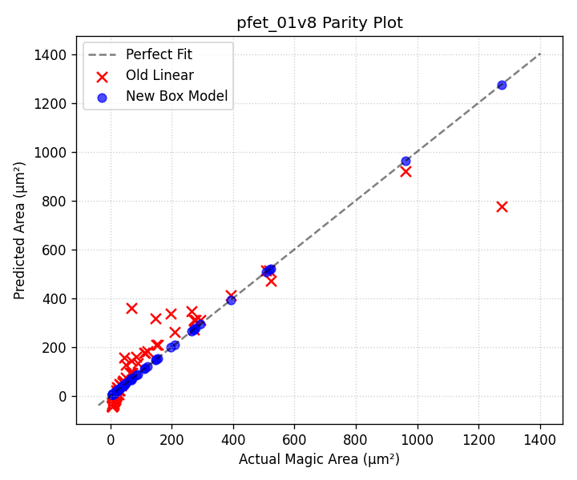

Device: nfet_01v8_lvt
Parameters: ah=1.0000, bh=2.1000, aw=0.9971, bw=0.3176, cw=1.6414
Height Model: h_um = 1.0000*W + 2.1000
Width Model: w_um = 0.9971*(L*nf) + 0.3176*nf + 1.6414
Dimensions | Actual (µm²) | Old Model Err | New Model Err
W=0.42 L=0.15 nf=1 | 5.32 | -43.38 (915.9%) | 5.31 (0.1%)
W=0.42 L=0.15 nf=2 | 6.63 | -41.26 (722.5%) | 6.49 (2.1%)
W=0.42 L=0.15 nf=4 | 9.05 | -37.00 (509.0%) | 8.85 (2.2%)
W=0.42 L=0.5 nf=1 | 6.20 | -32.40 (622.7%) | 6.19 (0.1%)
W=0.42 L=1.0 nf=1 | 7.46 | -16.72 (324.1%) | 7.45 (0.1%)
W=0.45 L=0.15 nf=1 | 5.38 | -43.23 (903.5%) | 5.38 (0.1%)
W=0.45 L=0.15 nf=2 | 6.71 | -40.95 (710.6%) | 6.57 (2.1%)
W=0.45 L=0.15 nf=4 | 9.15 | -36.39 (497.5%) | 8.95 (2.2%)
W=0.6 L=0.15 nf=1 | 5.70 | -42.47 (845.5%) | 5.69 (0.1%)
W=0.6 L=0.15 nf=2 | 7.10 | -39.43 (655.3%) | 6.95 (2.1%)
W=0.6 L=0.15 nf=4 | 9.69 | -33.35 (444.1%) | 9.48 (2.2%)
W=1.0 L=0.15 nf=1 | 6.54 | -40.45 (718.3%) | 6.54 (0.1%)
W=1.0 L=0.15 nf=2 | 8.15 | -35.38 (533.9%) | 7.98 (2.1%)
W=1.0 L=0.5 nf=1 | 7.63 | -29.46 (486.4%) | 7.62 (0.1%)
W=1.0 L=0.5 nf=2 | 10.07 | -24.40 (342.2%) | 10.15 (0.7%)
W=1.0 L=0.5 nf=4 | 14.97 | -14.26 (195.3%) | 15.21 (1.6%)
W=1.0 L=2.0 nf=2 | 19.38 | 22.66 (17.0%) | 19.42 (0.2%)
W=1.2 L=0.15 nf=1 | 6.96 | -39.43 (666.3%) | 6.96 (0.1%)
W=1.2 L=0.15 nf=2 | 8.68 | -33.35 (484.3%) | 8.50 (2.1%)
W=1.2 L=0.15 nf=4 | 11.85 | -21.19 (278.9%) | 11.58 (2.2%)
W=1.5 L=0.5 nf=1 | 8.86 | -26.93 (404.1%) | 8.85 (0.1%)
W=1.5 L=0.5 nf=2 | 11.70 | -19.33 (265.2%) | 11.79 (0.7%)
W=1.5 L=0.5 nf=4 | 17.39 | -4.13 (123.8%) | 17.66 (1.6%)
W=2.0 L=0.15 nf=4 | 14.72 | -4.98 (133.8%) | 14.39 (2.2%)
W=2.0 L=0.35 nf=2 | 12.10 | -18.97 (256.8%) | 12.20 (0.8%)
W=2.0 L=0.5 nf=1 | 10.09 | -24.40 (341.9%) | 10.08 (0.1%)
W=2.0 L=0.5 nf=2 | 13.32 | -14.26 (207.0%) | 13.42 (0.7%)
W=2.0 L=0.5 nf=4 | 19.80 | 6.00 (69.7%) | 20.11 (1.6%)
W=2.0 L=1.0 nf=1 | 12.14 | -8.71 (171.8%) | 12.12 (0.1%)
W=2.0 L=1.0 nf=2 | 17.43 | 1.42 (91.8%) | 17.51 (0.5%)
W=2.0 L=1.0 nf=4 | 28.00 | 21.69 (22.5%) | 28.29 (1.0%)
W=2.0 L=5.0 nf=2 | 50.23 | 126.92 (152.7%) | 50.22 (0.0%)
W=3.0 L=1.0 nf=1 | 15.10 | -3.64 (124.1%) | 15.08 (0.1%)
W=3.0 L=1.0 nf=2 | 21.68 | 11.56 (46.7%) | 21.78 (0.5%)
W=3.0 L=1.0 nf=4 | 34.83 | 41.96 (20.5%) | 35.19 (1.0%)
W=4.0 L=0.15 nf=4 | 21.90 | 35.56 (62.4%) | 21.41 (2.2%)
W=4.0 L=0.5 nf=1 | 15.01 | -14.26 (195.1%) | 14.99 (0.1%)
W=4.0 L=0.5 nf=2 | 19.82 | 6.00 (69.7%) | 19.97 (0.7%)
W=4.0 L=0.5 nf=4 | 29.46 | 46.54 (58.0%) | 29.93 (1.6%)
W=4.0 L=1.0 nf=1 | 18.06 | 1.42 (92.1%) | 18.03 (0.1%)
W=4.0 L=1.0 nf=2 | 25.93 | 21.69 (16.3%) | 26.05 (0.5%)
W=4.0 L=1.0 nf=4 | 41.66 | 62.23 (49.4%) | 42.09 (1.0%)
W=4.0 L=2.0 nf=1 | 24.16 | 32.80 (35.8%) | 24.11 (0.2%)
W=4.0 L=2.0 nf=2 | 38.12 | 53.06 (39.2%) | 38.22 (0.2%)
W=4.0 L=2.0 nf=4 | 66.06 | 93.60 (41.7%) | 66.42 (0.5%)
W=4.0 L=5.0 nf=8 | 268.34 | 268.79 (0.2%) | 268.80 (0.2%)
W=4.0 L=10.0 nf=4 | 261.26 | 344.59 (31.9%) | 261.05 (0.1%)
W=6.0 L=2.0 nf=1 | 32.08 | 42.93 (33.8%) | 32.02 (0.2%)
W=6.0 L=2.0 nf=2 | 50.62 | 73.33 (44.9%) | 50.75 (0.2%)
W=6.0 L=2.0 nf=4 | 87.72 | 134.14 (52.9%) | 88.20 (0.5%)
W=8.0 L=1.0 nf=1 | 29.90 | 21.69 (27.4%) | 29.86 (0.1%)
W=8.0 L=1.0 nf=2 | 42.92 | 62.23 (45.0%) | 43.14 (0.5%)
W=8.0 L=1.0 nf=4 | 68.98 | 143.30 (107.7%) | 69.69 (1.0%)
W=8.0 L=2.0 nf=1 | 40.00 | 53.06 (32.7%) | 39.93 (0.2%)
W=8.0 L=2.0 nf=2 | 63.12 | 93.60 (48.3%) | 63.28 (0.2%)
W=8.0 L=2.0 nf=4 | 109.38 | 174.67 (59.7%) | 109.97 (0.5%)
W=10.0 L=0.15 nf=1 | 25.53 | 5.16 (79.8%) | 25.51 (0.1%)
W=10.0 L=0.15 nf=4 | 43.44 | 157.16 (261.8%) | 42.47 (2.2%)
W=10.0 L=0.15 nf=8 | 66.67 | 359.84 (439.7%) | 65.08 (2.4%)
W=10.0 L=5.0 nf=1 | 84.22 | 157.32 (86.8%) | 84.03 (0.2%)
W=10.0 L=5.0 nf=2 | 148.22 | 207.99 (40.3%) | 148.20 (0.0%)
W=10.0 L=5.0 nf=4 | 276.24 | 309.33 (12.0%) | 276.53 (0.1%)
W=10.0 L=10.0 nf=1 | 144.72 | 314.19 (117.1%) | 144.35 (0.3%)
W=10.0 L=10.0 nf=4 | 518.24 | 466.20 (10.0%) | 517.83 (0.1%)
W=10.0 L=10.0 nf=10 | 1265.30 | 770.21 (39.1%) | 1264.78 (0.0%)
W=15.0 L=5.0 nf=1 | 119.02 | 182.65 (53.5%) | 118.75 (0.2%)
W=15.0 L=5.0 nf=2 | 209.47 | 258.66 (23.5%) | 209.43 (0.0%)
W=15.0 L=5.0 nf=4 | 390.39 | 410.67 (5.2%) | 390.80 (0.1%)
W=16.0 L=2.0 nf=1 | 71.68 | 93.60 (30.6%) | 71.55 (0.2%)
W=16.0 L=2.0 nf=2 | 113.12 | 174.67 (54.4%) | 113.40 (0.2%)
W=16.0 L=2.0 nf=4 | 196.02 | 336.81 (71.8%) | 197.08 (0.5%)
W=20.0 L=5.0 nf=1 | 153.82 | 207.99 (35.2%) | 153.47 (0.2%)
W=20.0 L=5.0 nf=2 | 270.73 | 309.33 (14.3%) | 270.67 (0.0%)
W=20.0 L=5.0 nf=4 | 504.54 | 512.00 (1.5%) | 505.07 (0.1%)
W=40.0 L=5.0 nf=1 | 293.02 | 309.33 (5.6%) | 292.36 (0.2%)
W=40.0 L=5.0 nf=2 | 515.73 | 512.00 (0.7%) | 515.62 (0.0%)
W=40.0 L=5.0 nf=4 | 961.14 | 917.36 (4.6%) | 962.14 (0.1%)
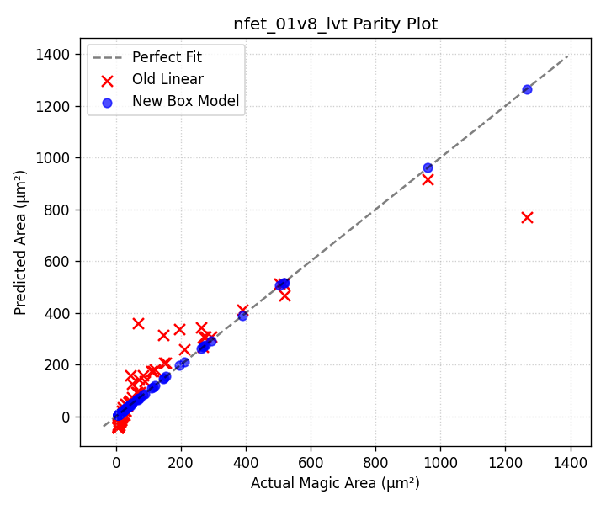

Device: pfet_01v8_hvt
Parameters: ah=1.0000, bh=2.1900, aw=0.9971, bw=0.3176, cw=1.6414
Height Model: h_um = 1.0000*W + 2.1900
Width Model: w_um = 0.9971*(L*nf) + 0.3176*nf + 1.6414
Dimensions | Actual (µm²) | Old Model Err | New Model Err
W=0.42 L=0.15 nf=1 | 5.51 | -43.39 (887.8%) | 5.50 (0.1%)
W=0.42 L=0.15 nf=2 | 6.86 | -41.25 (701.0%) | 6.72 (2.1%)
W=0.42 L=0.15 nf=4 | 9.37 | -36.99 (494.7%) | 9.16 (2.2%)
W=0.42 L=0.5 nf=1 | 6.42 | -32.30 (603.1%) | 6.41 (0.1%)
W=0.42 L=1.0 nf=1 | 7.73 | -16.46 (313.1%) | 7.72 (0.1%)
W=0.45 L=0.15 nf=1 | 5.57 | -43.23 (876.1%) | 5.57 (0.1%)
W=0.45 L=0.15 nf=2 | 6.94 | -40.95 (689.8%) | 6.80 (2.1%)
W=0.45 L=0.15 nf=4 | 9.48 | -36.38 (483.8%) | 9.27 (2.2%)
W=0.6 L=0.15 nf=1 | 5.89 | -42.47 (821.5%) | 5.88 (0.1%)
W=0.6 L=0.15 nf=2 | 7.34 | -39.43 (637.3%) | 7.19 (2.1%)
W=0.6 L=0.15 nf=4 | 10.02 | -33.33 (432.8%) | 9.79 (2.2%)
W=1.0 L=0.15 nf=1 | 6.73 | -40.44 (700.8%) | 6.73 (0.1%)
W=1.0 L=0.15 nf=2 | 8.39 | -35.36 (521.5%) | 8.22 (2.1%)
W=1.0 L=0.5 nf=1 | 7.85 | -29.35 (474.1%) | 7.84 (0.1%)
W=1.0 L=0.5 nf=2 | 10.37 | -24.27 (334.1%) | 10.44 (0.7%)
W=1.0 L=0.5 nf=4 | 15.41 | -14.12 (191.6%) | 15.65 (1.6%)
W=1.0 L=2.0 nf=2 | 19.94 | 23.24 (16.6%) | 19.99 (0.2%)
W=1.2 L=0.15 nf=1 | 7.15 | -39.43 (651.2%) | 7.15 (0.1%)
W=1.2 L=0.15 nf=2 | 8.92 | -33.33 (473.8%) | 8.73 (2.1%)
W=1.2 L=0.15 nf=4 | 12.17 | -21.14 (273.7%) | 11.90 (2.2%)
W=1.5 L=0.5 nf=1 | 9.08 | -26.81 (395.4%) | 9.07 (0.1%)
W=1.5 L=0.5 nf=2 | 11.99 | -19.20 (260.1%) | 12.08 (0.7%)
W=1.5 L=0.5 nf=4 | 17.82 | -3.96 (122.2%) | 18.10 (1.6%)
W=2.0 L=0.15 nf=4 | 15.04 | -4.89 (132.5%) | 14.71 (2.2%)
W=2.0 L=0.35 nf=2 | 12.36 | -18.87 (252.6%) | 12.46 (0.8%)
W=2.0 L=0.5 nf=1 | 10.31 | -24.27 (335.5%) | 10.30 (0.1%)
W=2.0 L=0.5 nf=2 | 13.62 | -14.12 (203.7%) | 13.72 (0.7%)
W=2.0 L=0.5 nf=4 | 20.24 | 6.20 (69.4%) | 20.56 (1.6%)
W=2.0 L=1.0 nf=1 | 12.40 | -8.44 (168.0%) | 12.39 (0.1%)
W=2.0 L=1.0 nf=2 | 17.81 | 1.72 (90.3%) | 17.89 (0.5%)
W=2.0 L=1.0 nf=4 | 28.62 | 22.04 (23.0%) | 28.91 (1.0%)
W=2.0 L=5.0 nf=2 | 51.33 | 128.43 (150.2%) | 51.32 (0.0%)
W=3.0 L=1.0 nf=1 | 15.36 | -3.36 (121.8%) | 15.34 (0.1%)
W=3.0 L=1.0 nf=2 | 22.06 | 11.88 (46.1%) | 22.17 (0.5%)
W=3.0 L=1.0 nf=4 | 35.45 | 42.36 (19.5%) | 35.81 (1.0%)
W=4.0 L=0.15 nf=4 | 22.22 | 35.75 (60.9%) | 21.73 (2.2%)
W=4.0 L=0.5 nf=1 | 15.23 | -14.12 (192.7%) | 15.21 (0.1%)
W=4.0 L=0.5 nf=2 | 20.12 | 6.20 (69.2%) | 20.26 (0.7%)
W=4.0 L=0.5 nf=4 | 29.90 | 46.83 (56.6%) | 30.37 (1.6%)
W=4.0 L=1.0 nf=1 | 18.32 | 1.72 (90.6%) | 18.30 (0.1%)
W=4.0 L=1.0 nf=2 | 26.31 | 22.04 (16.2%) | 26.44 (0.5%)
W=4.0 L=1.0 nf=4 | 42.28 | 62.67 (48.2%) | 42.71 (1.0%)
W=4.0 L=2.0 nf=1 | 24.51 | 33.40 (36.3%) | 24.47 (0.2%)
W=4.0 L=2.0 nf=2 | 38.69 | 53.72 (38.8%) | 38.78 (0.2%)
W=4.0 L=2.0 nf=4 | 67.04 | 94.35 (40.7%) | 67.40 (0.5%)
W=4.0 L=5.0 nf=8 | 272.30 | 270.65 (0.6%) | 272.77 (0.2%)
W=4.0 L=10.0 nf=4 | 265.12 | 347.77 (31.2%) | 264.91 (0.1%)
W=6.0 L=2.0 nf=1 | 32.43 | 43.56 (34.3%) | 32.38 (0.2%)
W=6.0 L=2.0 nf=2 | 51.19 | 74.03 (44.6%) | 51.31 (0.2%)
W=6.0 L=2.0 nf=4 | 88.70 | 134.98 (52.2%) | 89.18 (0.5%)
W=8.0 L=1.0 nf=1 | 30.16 | 22.04 (26.9%) | 30.12 (0.1%)
W=8.0 L=1.0 nf=2 | 43.31 | 62.67 (44.7%) | 43.52 (0.5%)
W=8.0 L=1.0 nf=4 | 69.60 | 143.94 (106.8%) | 70.31 (1.0%)
W=8.0 L=2.0 nf=1 | 40.35 | 53.72 (33.1%) | 40.28 (0.2%)
W=8.0 L=2.0 nf=2 | 63.69 | 94.35 (48.1%) | 63.84 (0.2%)
W=8.0 L=2.0 nf=4 | 110.36 | 175.62 (59.1%) | 110.95 (0.5%)
W=10.0 L=0.15 nf=1 | 25.72 | 5.27 (79.5%) | 25.70 (0.1%)
W=10.0 L=0.15 nf=4 | 43.76 | 157.64 (260.2%) | 42.79 (2.2%)
W=10.0 L=0.15 nf=8 | 67.17 | 360.81 (437.2%) | 65.57 (2.4%)
W=10.0 L=5.0 nf=1 | 84.84 | 158.91 (87.3%) | 84.65 (0.2%)
W=10.0 L=5.0 nf=2 | 149.33 | 209.70 (40.4%) | 149.30 (0.0%)
W=10.0 L=5.0 nf=4 | 278.30 | 311.28 (11.9%) | 278.59 (0.1%)
W=10.0 L=10.0 nf=1 | 145.79 | 317.30 (117.6%) | 145.43 (0.3%)
W=10.0 L=10.0 nf=4 | 522.10 | 469.67 (10.0%) | 521.68 (0.1%)
W=10.0 L=10.0 nf=10 | 1274.71 | 774.42 (39.2%) | 1274.19 (0.0%)
W=15.0 L=5.0 nf=1 | 119.64 | 184.30 (54.0%) | 119.38 (0.2%)
W=15.0 L=5.0 nf=2 | 210.58 | 260.49 (23.7%) | 210.54 (0.0%)
W=15.0 L=5.0 nf=4 | 392.45 | 412.87 (5.2%) | 392.86 (0.1%)
W=16.0 L=2.0 nf=1 | 72.03 | 94.35 (31.0%) | 71.91 (0.2%)
W=16.0 L=2.0 nf=2 | 113.69 | 175.62 (54.5%) | 113.96 (0.2%)
W=16.0 L=2.0 nf=4 | 197.00 | 338.15 (71.7%) | 198.06 (0.5%)
W=20.0 L=5.0 nf=1 | 154.44 | 209.70 (35.8%) | 154.10 (0.2%)
W=20.0 L=5.0 nf=2 | 271.83 | 311.28 (14.5%) | 271.77 (0.0%)
W=20.0 L=5.0 nf=4 | 506.60 | 514.45 (1.5%) | 507.13 (0.1%)
W=40.0 L=5.0 nf=1 | 293.64 | 311.28 (6.0%) | 292.99 (0.2%)
W=40.0 L=5.0 nf=2 | 516.83 | 514.45 (0.5%) | 516.73 (0.0%)
W=40.0 L=5.0 nf=4 | 963.20 | 920.78 (4.4%) | 964.20 (0.1%)
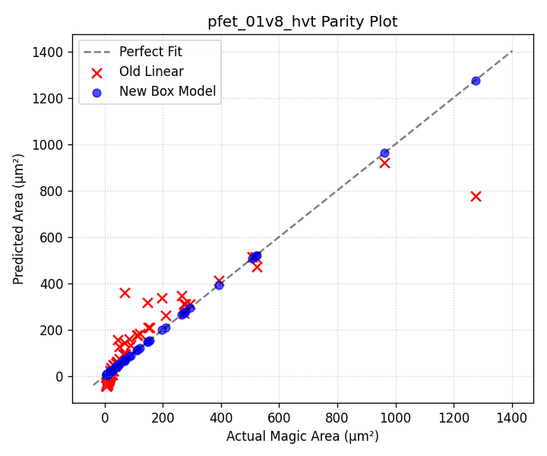

Device: pfet_01v8_lvt
Parameters: ah=1.0000, bh=2.1900, aw=0.9971, bw=0.3176, cw=1.6414
Height Model: h_um = 1.0000*W + 2.1900
Width Model: w_um = 0.9971*(L*nf) + 0.3176*nf + 1.6414
Dimensions | Actual (µm²) | Old Model Err | New Model Err
W=0.42 L=0.15 nf=1 | 5.51 | -43.39 (887.8%) | 5.50 (0.1%)
W=0.42 L=0.15 nf=2 | 6.86 | -41.25 (701.0%) | 6.72 (2.1%)
W=0.42 L=0.15 nf=4 | 9.37 | -36.99 (494.7%) | 9.16 (2.2%)
W=0.42 L=0.5 nf=1 | 6.42 | -32.30 (603.1%) | 6.41 (0.1%)
W=0.42 L=1.0 nf=1 | 7.73 | -16.46 (313.1%) | 7.72 (0.1%)
W=0.45 L=0.15 nf=1 | 5.57 | -43.23 (876.1%) | 5.57 (0.1%)
W=0.45 L=0.15 nf=2 | 6.94 | -40.95 (689.8%) | 6.80 (2.1%)
W=0.45 L=0.15 nf=4 | 9.48 | -36.38 (483.8%) | 9.27 (2.2%)
W=0.6 L=0.15 nf=1 | 5.89 | -42.47 (821.5%) | 5.88 (0.1%)
W=0.6 L=0.15 nf=2 | 7.34 | -39.43 (637.3%) | 7.19 (2.1%)
W=0.6 L=0.15 nf=4 | 10.02 | -33.33 (432.8%) | 9.79 (2.2%)
W=1.0 L=0.15 nf=1 | 6.73 | -40.44 (700.8%) | 6.73 (0.1%)
W=1.0 L=0.15 nf=2 | 8.39 | -35.36 (521.5%) | 8.22 (2.1%)
W=1.0 L=0.5 nf=1 | 7.85 | -29.35 (474.1%) | 7.84 (0.1%)
W=1.0 L=0.5 nf=2 | 10.37 | -24.27 (334.1%) | 10.44 (0.7%)
W=1.0 L=0.5 nf=4 | 15.41 | -14.12 (191.6%) | 15.65 (1.6%)
W=1.0 L=2.0 nf=2 | 19.94 | 23.24 (16.6%) | 19.99 (0.2%)
W=1.2 L=0.15 nf=1 | 7.15 | -39.43 (651.2%) | 7.15 (0.1%)
W=1.2 L=0.15 nf=2 | 8.92 | -33.33 (473.8%) | 8.73 (2.1%)
W=1.2 L=0.15 nf=4 | 12.17 | -21.14 (273.7%) | 11.90 (2.2%)
W=1.5 L=0.5 nf=1 | 9.08 | -26.81 (395.4%) | 9.07 (0.1%)
W=1.5 L=0.5 nf=2 | 11.99 | -19.20 (260.1%) | 12.08 (0.7%)
W=1.5 L=0.5 nf=4 | 17.82 | -3.96 (122.2%) | 18.10 (1.6%)
W=2.0 L=0.15 nf=4 | 15.04 | -4.89 (132.5%) | 14.71 (2.2%)
W=2.0 L=0.35 nf=2 | 12.36 | -18.87 (252.6%) | 12.46 (0.8%)
W=2.0 L=0.5 nf=1 | 10.31 | -24.27 (335.5%) | 10.30 (0.1%)
W=2.0 L=0.5 nf=2 | 13.62 | -14.12 (203.7%) | 13.72 (0.7%)
W=2.0 L=0.5 nf=4 | 20.24 | 6.20 (69.4%) | 20.56 (1.6%)
W=2.0 L=1.0 nf=1 | 12.40 | -8.44 (168.0%) | 12.39 (0.1%)
W=2.0 L=1.0 nf=2 | 17.81 | 1.72 (90.3%) | 17.89 (0.5%)
W=2.0 L=1.0 nf=4 | 28.62 | 22.04 (23.0%) | 28.91 (1.0%)
W=2.0 L=5.0 nf=2 | 51.33 | 128.43 (150.2%) | 51.32 (0.0%)
W=3.0 L=1.0 nf=1 | 15.36 | -3.36 (121.8%) | 15.34 (0.1%)
W=3.0 L=1.0 nf=2 | 22.06 | 11.88 (46.1%) | 22.17 (0.5%)
W=3.0 L=1.0 nf=4 | 35.45 | 42.36 (19.5%) | 35.81 (1.0%)
W=4.0 L=0.15 nf=4 | 22.22 | 35.75 (60.9%) | 21.73 (2.2%)
W=4.0 L=0.5 nf=1 | 15.23 | -14.12 (192.7%) | 15.21 (0.1%)
W=4.0 L=0.5 nf=2 | 20.12 | 6.20 (69.2%) | 20.26 (0.7%)
W=4.0 L=0.5 nf=4 | 29.90 | 46.83 (56.6%) | 30.37 (1.6%)
W=4.0 L=1.0 nf=1 | 18.32 | 1.72 (90.6%) | 18.30 (0.1%)
W=4.0 L=1.0 nf=2 | 26.31 | 22.04 (16.2%) | 26.44 (0.5%)
W=4.0 L=1.0 nf=4 | 42.28 | 62.67 (48.2%) | 42.71 (1.0%)
W=4.0 L=2.0 nf=1 | 24.51 | 33.40 (36.3%) | 24.47 (0.2%)
W=4.0 L=2.0 nf=2 | 38.69 | 53.72 (38.8%) | 38.78 (0.2%)
W=4.0 L=2.0 nf=4 | 67.04 | 94.35 (40.7%) | 67.40 (0.5%)
W=4.0 L=5.0 nf=8 | 272.30 | 270.65 (0.6%) | 272.77 (0.2%)
W=4.0 L=10.0 nf=4 | 265.12 | 347.77 (31.2%) | 264.91 (0.1%)
W=6.0 L=2.0 nf=1 | 32.43 | 43.56 (34.3%) | 32.38 (0.2%)
W=6.0 L=2.0 nf=2 | 51.19 | 74.03 (44.6%) | 51.31 (0.2%)
W=6.0 L=2.0 nf=4 | 88.70 | 134.98 (52.2%) | 89.18 (0.5%)
W=8.0 L=1.0 nf=1 | 30.16 | 22.04 (26.9%) | 30.12 (0.1%)
W=8.0 L=1.0 nf=2 | 43.31 | 62.67 (44.7%) | 43.52 (0.5%)
W=8.0 L=1.0 nf=4 | 69.60 | 143.94 (106.8%) | 70.31 (1.0%)
W=8.0 L=2.0 nf=1 | 40.35 | 53.72 (33.1%) | 40.28 (0.2%)
W=8.0 L=2.0 nf=2 | 63.69 | 94.35 (48.1%) | 63.84 (0.2%)
W=8.0 L=2.0 nf=4 | 110.36 | 175.62 (59.1%) | 110.95 (0.5%)
W=10.0 L=0.15 nf=1 | 25.72 | 5.27 (79.5%) | 25.70 (0.1%)
W=10.0 L=0.15 nf=4 | 43.76 | 157.64 (260.2%) | 42.79 (2.2%)
W=10.0 L=0.15 nf=8 | 67.17 | 360.81 (437.2%) | 65.57 (2.4%)
W=10.0 L=5.0 nf=1 | 84.84 | 158.91 (87.3%) | 84.65 (0.2%)
W=10.0 L=5.0 nf=2 | 149.33 | 209.70 (40.4%) | 149.30 (0.0%)
W=10.0 L=5.0 nf=4 | 278.30 | 311.28 (11.9%) | 278.59 (0.1%)
W=10.0 L=10.0 nf=1 | 145.79 | 317.30 (117.6%) | 145.43 (0.3%)
W=10.0 L=10.0 nf=4 | 522.10 | 469.67 (10.0%) | 521.68 (0.1%)
W=10.0 L=10.0 nf=10 | 1274.71 | 774.42 (39.2%) | 1274.19 (0.0%)
W=15.0 L=5.0 nf=1 | 119.64 | 184.30 (54.0%) | 119.38 (0.2%)
W=15.0 L=5.0 nf=2 | 210.58 | 260.49 (23.7%) | 210.54 (0.0%)
W=15.0 L=5.0 nf=4 | 392.45 | 412.87 (5.2%) | 392.86 (0.1%)
W=16.0 L=2.0 nf=1 | 72.03 | 94.35 (31.0%) | 71.91 (0.2%)
W=16.0 L=2.0 nf=2 | 113.69 | 175.62 (54.5%) | 113.96 (0.2%)
W=16.0 L=2.0 nf=4 | 197.00 | 338.15 (71.7%) | 198.06 (0.5%)
W=20.0 L=5.0 nf=1 | 154.44 | 209.70 (35.8%) | 154.10 (0.2%)
W=20.0 L=5.0 nf=2 | 271.83 | 311.28 (14.5%) | 271.77 (0.0%)
W=20.0 L=5.0 nf=4 | 506.60 | 514.45 (1.5%) | 507.13 (0.1%)
W=40.0 L=5.0 nf=1 | 293.64 | 311.28 (6.0%) | 292.99 (0.2%)
W=40.0 L=5.0 nf=2 | 516.83 | 514.45 (0.5%) | 516.73 (0.0%)
W=40.0 L=5.0 nf=4 | 963.20 | 920.78 (4.4%) | 964.20 (0.1%)
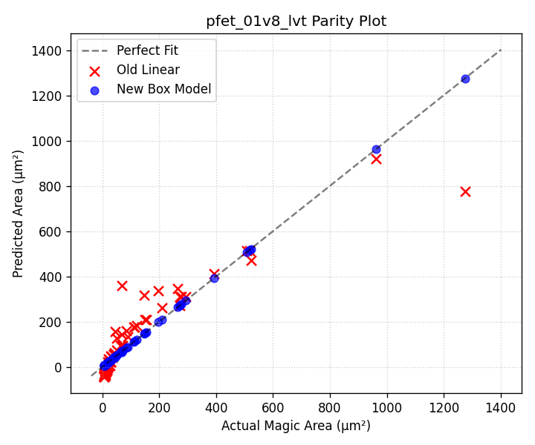

Device: nfet_g5v0d10v5
Parameters: ah=1.0000, bh=2.5800, aw=1.0000, bw=0.2900, cw=2.0100
Height Model: h_um = 1.0000*W + 2.5800
Width Model: w_um = 1.0000*(L*nf) + 0.2900*nf + 2.0100
Dimensions | Actual (µm²) | Old Model Err | New Model Err
W=0.42 L=0.15 nf=1 | 7.35 | -42.04 (672.0%) | 7.35 (0.0%)
W=0.42 L=0.15 nf=2 | 8.67 | -39.86 (559.8%) | 8.67 (0.0%)
W=0.42 L=0.15 nf=4 | 11.31 | -35.50 (413.8%) | 11.31 (0.0%)
W=0.42 L=0.5 nf=1 | 8.40 | -30.39 (461.8%) | 8.40 (0.0%)
W=0.42 L=1.0 nf=1 | 9.90 | -13.75 (238.9%) | 9.90 (0.0%)
W=0.45 L=0.15 nf=1 | 7.42 | -41.89 (664.3%) | 7.42 (0.0%)
W=0.45 L=0.15 nf=2 | 8.76 | -39.55 (551.6%) | 8.76 (0.0%)
W=0.45 L=0.15 nf=4 | 11.42 | -34.87 (405.3%) | 11.42 (0.0%)
W=0.6 L=0.15 nf=1 | 7.79 | -41.11 (627.6%) | 7.79 (0.0%)
W=0.6 L=0.15 nf=2 | 9.19 | -37.99 (513.4%) | 9.19 (0.0%)
W=0.6 L=0.15 nf=4 | 11.99 | -31.76 (364.9%) | 11.99 (0.0%)
W=1.0 L=0.15 nf=1 | 8.77 | -39.03 (545.0%) | 8.77 (0.0%)
W=1.0 L=0.15 nf=2 | 10.35 | -33.83 (427.0%) | 10.35 (0.0%)
W=1.0 L=0.5 nf=1 | 10.02 | -27.38 (373.1%) | 10.02 (0.0%)
W=1.0 L=0.5 nf=2 | 12.85 | -22.18 (272.6%) | 12.85 (0.0%)
W=1.0 L=0.5 nf=4 | 18.51 | -11.79 (163.7%) | 18.51 (0.0%)
W=1.0 L=2.0 nf=2 | 23.59 | 27.74 (17.6%) | 23.59 (0.0%)
W=1.2 L=0.15 nf=1 | 9.26 | -37.99 (510.2%) | 9.26 (0.0%)
W=1.2 L=0.15 nf=2 | 10.92 | -31.76 (390.7%) | 10.92 (0.0%)
W=1.2 L=0.15 nf=4 | 14.25 | -19.28 (235.3%) | 14.25 (0.0%)
W=1.5 L=0.5 nf=1 | 11.42 | -24.78 (316.9%) | 11.42 (0.0%)
W=1.5 L=0.5 nf=2 | 14.65 | -16.99 (216.0%) | 14.65 (0.0%)
W=1.5 L=0.5 nf=4 | 21.09 | -1.40 (106.6%) | 21.09 (0.0%)
W=2.0 L=0.15 nf=4 | 17.27 | -2.66 (115.4%) | 17.27 (0.0%)
W=2.0 L=0.35 nf=2 | 15.07 | -16.78 (211.4%) | 15.07 (0.0%)
W=2.0 L=0.5 nf=1 | 12.82 | -22.18 (273.0%) | 12.82 (0.0%)
W=2.0 L=0.5 nf=2 | 16.44 | -11.79 (171.7%) | 16.44 (0.0%)
W=2.0 L=0.5 nf=4 | 23.68 | 8.99 (62.0%) | 23.68 (0.0%)
W=2.0 L=1.0 nf=1 | 15.11 | -5.54 (136.7%) | 15.11 (0.0%)
W=2.0 L=1.0 nf=2 | 21.02 | 4.85 (76.9%) | 21.02 (0.0%)
W=2.0 L=1.0 nf=4 | 32.84 | 25.64 (21.9%) | 32.84 (0.0%)
W=2.0 L=5.0 nf=2 | 57.66 | 137.99 (139.3%) | 57.66 (0.0%)
W=3.0 L=1.0 nf=1 | 18.41 | -0.34 (101.9%) | 18.41 (0.0%)
W=3.0 L=1.0 nf=2 | 25.61 | 15.24 (40.5%) | 25.61 (0.0%)
W=3.0 L=1.0 nf=4 | 40.01 | 46.42 (16.0%) | 40.01 (0.0%)
W=4.0 L=0.15 nf=4 | 24.81 | 38.91 (56.9%) | 24.81 (0.0%)
W=4.0 L=0.5 nf=1 | 18.42 | -11.79 (164.0%) | 18.42 (0.0%)
W=4.0 L=0.5 nf=2 | 23.62 | 8.99 (61.9%) | 23.62 (0.0%)
W=4.0 L=0.5 nf=4 | 34.02 | 50.56 (48.6%) | 34.02 (0.0%)
W=4.0 L=1.0 nf=1 | 21.71 | 4.85 (77.7%) | 21.71 (0.0%)
W=4.0 L=1.0 nf=2 | 30.20 | 25.64 (15.1%) | 30.20 (0.0%)
W=4.0 L=1.0 nf=4 | 47.18 | 67.20 (42.4%) | 47.18 (0.0%)
W=4.0 L=2.0 nf=1 | 28.29 | 38.14 (34.8%) | 28.29 (0.0%)
W=4.0 L=2.0 nf=2 | 43.36 | 58.92 (35.9%) | 43.36 (0.0%)
W=4.0 L=2.0 nf=4 | 73.50 | 100.49 (36.7%) | 73.50 (0.0%)
W=4.0 L=5.0 nf=8 | 291.69 | 283.48 (2.8%) | 291.69 (0.0%)
W=4.0 L=10.0 nf=4 | 284.06 | 366.77 (29.1%) | 284.06 (0.0%)
W=6.0 L=2.0 nf=1 | 36.89 | 48.53 (31.5%) | 36.89 (0.0%)
W=6.0 L=2.0 nf=2 | 56.54 | 79.71 (41.0%) | 56.54 (0.0%)
W=6.0 L=2.0 nf=4 | 95.84 | 142.06 (48.2%) | 95.84 (0.0%)
W=8.0 L=1.0 nf=1 | 34.91 | 25.64 (26.6%) | 34.91 (0.0%)
W=8.0 L=1.0 nf=2 | 48.56 | 67.20 (38.4%) | 48.56 (0.0%)
W=8.0 L=1.0 nf=4 | 75.86 | 150.34 (98.2%) | 75.86 (0.0%)
W=8.0 L=2.0 nf=1 | 45.49 | 58.92 (29.5%) | 45.49 (0.0%)
W=8.0 L=2.0 nf=2 | 69.72 | 100.49 (44.1%) | 69.72 (0.0%)
W=8.0 L=2.0 nf=4 | 118.18 | 183.63 (55.4%) | 118.18 (0.0%)
W=10.0 L=0.15 nf=1 | 30.82 | 7.74 (74.9%) | 30.82 (0.0%)
W=10.0 L=0.15 nf=4 | 47.43 | 163.62 (245.0%) | 47.43 (0.0%)
W=10.0 L=0.15 nf=8 | 69.57 | 371.46 (434.0%) | 69.57 (0.0%)
W=10.0 L=5.0 nf=1 | 91.83 | 169.17 (84.2%) | 91.83 (0.0%)
W=10.0 L=5.0 nf=2 | 158.38 | 221.13 (39.6%) | 158.38 (0.0%)
W=10.0 L=5.0 nf=4 | 291.48 | 325.05 (11.5%) | 291.48 (0.0%)
W=10.0 L=10.0 nf=1 | 154.73 | 335.60 (116.9%) | 154.73 (0.0%)
W=10.0 L=10.0 nf=4 | 543.08 | 491.48 (9.5%) | 543.08 (0.0%)
W=10.0 L=10.0 nf=10 | 1319.77 | 803.25 (39.1%) | 1319.77 (0.0%)
W=15.0 L=5.0 nf=1 | 128.33 | 195.15 (52.1%) | 128.33 (0.0%)
W=15.0 L=5.0 nf=2 | 221.33 | 273.09 (23.4%) | 221.33 (0.0%)
W=15.0 L=5.0 nf=4 | 407.33 | 428.97 (5.3%) | 407.33 (0.0%)
W=16.0 L=2.0 nf=1 | 79.89 | 100.49 (25.8%) | 79.89 (0.0%)
W=16.0 L=2.0 nf=2 | 122.44 | 183.63 (50.0%) | 122.44 (0.0%)
W=16.0 L=2.0 nf=4 | 207.54 | 349.90 (68.6%) | 207.54 (0.0%)
W=20.0 L=5.0 nf=1 | 164.83 | 221.13 (34.2%) | 164.83 (0.0%)
W=20.0 L=5.0 nf=2 | 284.28 | 325.05 (14.3%) | 284.28 (0.0%)
W=20.0 L=5.0 nf=4 | 523.18 | 532.90 (1.9%) | 523.18 (0.0%)
W=40.0 L=5.0 nf=1 | 310.83 | 325.05 (4.6%) | 310.83 (0.0%)
W=40.0 L=5.0 nf=2 | 536.08 | 532.90 (0.6%) | 536.08 (0.0%)
W=40.0 L=5.0 nf=4 | 986.58 | 948.59 (3.9%) | 986.58 (0.0%)
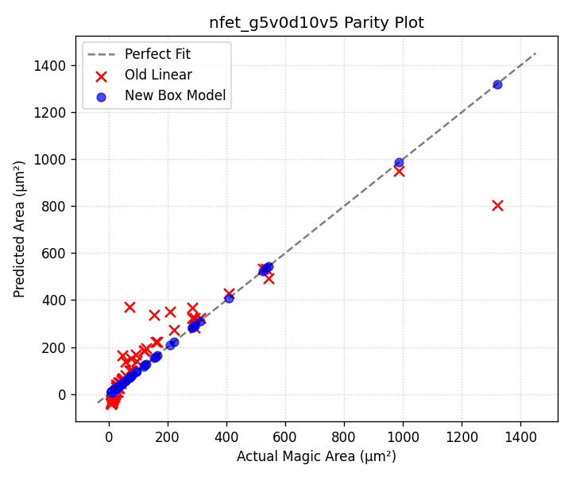

Device: pfet_g5v0d10v5
Parameters: ah=1.0000, bh=2.9700, aw=1.0000, bw=0.2900, cw=2.2900
Height Model: h_um = 1.0000*W + 2.9700
Width Model: w_um = 1.0000*(L*nf) + 0.2900*nf + 2.2900
Dimensions | Actual (µm²) | Old Model Err | New Model Err
W=0.42 L=0.15 nf=1 | 9.25 | -40.57 (538.4%) | 9.25 (0.0%)
W=0.42 L=0.15 nf=2 | 10.75 | -38.34 (456.8%) | 10.75 (0.0%)
W=0.42 L=0.15 nf=4 | 13.73 | -33.88 (346.8%) | 13.73 (0.0%)
W=0.42 L=0.5 nf=1 | 10.44 | -28.40 (372.0%) | 10.44 (0.0%)
W=0.42 L=1.0 nf=1 | 12.14 | -11.02 (190.8%) | 12.14 (0.0%)
W=0.45 L=0.15 nf=1 | 9.34 | -40.41 (532.9%) | 9.34 (0.0%)
W=0.45 L=0.15 nf=2 | 10.84 | -38.03 (450.7%) | 10.84 (0.0%)
W=0.45 L=0.15 nf=4 | 13.85 | -33.25 (340.0%) | 13.85 (0.0%)
W=0.6 L=0.15 nf=1 | 9.75 | -39.62 (506.5%) | 9.75 (0.0%)
W=0.6 L=0.15 nf=2 | 11.32 | -36.43 (421.9%) | 11.32 (0.0%)
W=0.6 L=0.15 nf=4 | 14.46 | -30.06 (307.9%) | 14.46 (0.0%)
W=1.0 L=0.15 nf=1 | 10.84 | -37.49 (445.9%) | 10.84 (0.0%)
W=1.0 L=0.15 nf=2 | 12.58 | -32.19 (355.8%) | 12.58 (0.0%)
W=1.0 L=0.5 nf=1 | 12.23 | -25.32 (307.1%) | 12.23 (0.0%)
W=1.0 L=0.5 nf=2 | 15.36 | -20.02 (230.3%) | 15.36 (0.0%)
W=1.0 L=0.5 nf=4 | 21.64 | -9.40 (143.4%) | 21.64 (0.0%)
W=1.0 L=2.0 nf=2 | 27.27 | 32.15 (17.9%) | 27.27 (0.0%)
W=1.2 L=0.15 nf=1 | 11.38 | -36.43 (420.0%) | 11.38 (0.0%)
W=1.2 L=0.15 nf=2 | 13.22 | -30.06 (327.4%) | 13.22 (0.0%)
W=1.2 L=0.15 nf=4 | 16.89 | -17.32 (202.6%) | 16.89 (0.0%)
W=1.5 L=0.5 nf=1 | 13.77 | -22.67 (264.7%) | 13.77 (0.0%)
W=1.5 L=0.5 nf=2 | 17.30 | -14.71 (185.0%) | 17.30 (0.0%)
W=1.5 L=0.5 nf=4 | 24.36 | 1.22 (95.0%) | 24.36 (0.0%)
W=2.0 L=0.15 nf=4 | 20.13 | -0.34 (101.7%) | 20.13 (0.0%)
W=2.0 L=0.35 nf=2 | 17.74 | -14.61 (182.4%) | 17.74 (0.0%)
W=2.0 L=0.5 nf=1 | 15.31 | -20.02 (230.8%) | 15.31 (0.0%)
W=2.0 L=0.5 nf=2 | 19.23 | -9.40 (148.9%) | 19.23 (0.0%)
W=2.0 L=0.5 nf=4 | 27.09 | 11.84 (56.3%) | 27.09 (0.0%)
W=2.0 L=1.0 nf=1 | 17.79 | -2.63 (114.8%) | 17.79 (0.0%)
W=2.0 L=1.0 nf=2 | 24.20 | 7.99 (67.0%) | 24.20 (0.0%)
W=2.0 L=1.0 nf=4 | 37.03 | 29.22 (21.1%) | 37.03 (0.0%)
W=2.0 L=5.0 nf=2 | 63.96 | 147.08 (129.9%) | 63.96 (0.0%)
W=3.0 L=1.0 nf=1 | 21.37 | 2.68 (87.5%) | 21.37 (0.0%)
W=3.0 L=1.0 nf=2 | 29.07 | 18.61 (36.0%) | 29.07 (0.0%)
W=3.0 L=1.0 nf=4 | 44.48 | 50.46 (13.4%) | 44.48 (0.0%)
W=4.0 L=0.15 nf=4 | 28.23 | 42.13 (49.3%) | 28.23 (0.0%)
W=4.0 L=0.5 nf=1 | 21.47 | -9.40 (143.8%) | 21.47 (0.0%)
W=4.0 L=0.5 nf=2 | 26.97 | 11.84 (56.1%) | 26.97 (0.0%)
W=4.0 L=0.5 nf=4 | 37.99 | 54.30 (43.0%) | 37.99 (0.0%)
W=4.0 L=1.0 nf=1 | 24.95 | 7.99 (68.0%) | 24.95 (0.0%)
W=4.0 L=1.0 nf=2 | 33.94 | 29.22 (13.9%) | 33.94 (0.0%)
W=4.0 L=1.0 nf=4 | 51.93 | 71.69 (38.1%) | 51.93 (0.0%)
W=4.0 L=2.0 nf=1 | 31.92 | 42.76 (34.0%) | 31.92 (0.0%)
W=4.0 L=2.0 nf=2 | 47.88 | 64.00 (33.6%) | 47.88 (0.0%)
W=4.0 L=2.0 nf=4 | 79.81 | 106.46 (33.4%) | 79.81 (0.0%)
W=4.0 L=5.0 nf=8 | 310.93 | 295.72 (4.9%) | 310.93 (0.0%)
W=4.0 L=10.0 nf=4 | 302.85 | 384.65 (27.0%) | 302.85 (0.0%)
W=6.0 L=2.0 nf=1 | 41.08 | 53.38 (29.9%) | 41.08 (0.0%)
W=6.0 L=2.0 nf=2 | 61.62 | 85.23 (38.3%) | 61.62 (0.0%)
W=6.0 L=2.0 nf=4 | 102.71 | 148.93 (45.0%) | 102.71 (0.0%)
W=8.0 L=1.0 nf=1 | 39.27 | 29.22 (25.6%) | 39.27 (0.0%)
W=8.0 L=1.0 nf=2 | 53.42 | 71.69 (34.2%) | 53.42 (0.0%)
W=8.0 L=1.0 nf=4 | 81.73 | 156.62 (91.6%) | 81.73 (0.0%)
W=8.0 L=2.0 nf=1 | 50.24 | 64.00 (27.4%) | 50.24 (0.0%)
W=8.0 L=2.0 nf=2 | 75.36 | 106.46 (41.3%) | 75.36 (0.0%)
W=8.0 L=2.0 nf=4 | 125.61 | 191.40 (52.4%) | 125.61 (0.0%)
W=10.0 L=0.15 nf=1 | 35.41 | 10.28 (71.0%) | 35.41 (0.0%)
W=10.0 L=0.15 nf=4 | 52.53 | 169.53 (222.7%) | 52.53 (0.0%)
W=10.0 L=0.15 nf=8 | 75.36 | 381.87 (406.8%) | 75.36 (0.0%)
W=10.0 L=5.0 nf=1 | 98.31 | 178.93 (82.0%) | 98.31 (0.0%)
W=10.0 L=5.0 nf=2 | 166.92 | 232.02 (39.0%) | 166.92 (0.0%)
W=10.0 L=5.0 nf=4 | 304.15 | 338.18 (11.2%) | 304.15 (0.0%)
W=10.0 L=10.0 nf=1 | 163.16 | 352.80 (116.2%) | 163.16 (0.0%)
W=10.0 L=10.0 nf=4 | 563.55 | 512.05 (9.1%) | 563.55 (0.0%)
W=10.0 L=10.0 nf=10 | 1364.31 | 830.56 (39.1%) | 1364.31 (0.0%)
W=15.0 L=5.0 nf=1 | 136.21 | 205.48 (50.8%) | 136.21 (0.0%)
W=15.0 L=5.0 nf=2 | 231.27 | 285.10 (23.3%) | 231.27 (0.0%)
W=15.0 L=5.0 nf=4 | 421.40 | 444.35 (5.4%) | 421.40 (0.0%)
W=16.0 L=2.0 nf=1 | 86.88 | 106.46 (22.5%) | 86.88 (0.0%)
W=16.0 L=2.0 nf=2 | 130.32 | 191.40 (46.9%) | 130.32 (0.0%)
W=16.0 L=2.0 nf=4 | 217.21 | 361.26 (66.3%) | 217.21 (0.0%)
W=20.0 L=5.0 nf=1 | 174.11 | 232.02 (33.3%) | 174.11 (0.0%)
W=20.0 L=5.0 nf=2 | 295.62 | 338.18 (14.4%) | 295.62 (0.0%)
W=20.0 L=5.0 nf=4 | 538.65 | 550.52 (2.2%) | 538.65 (0.0%)
W=40.0 L=5.0 nf=1 | 325.71 | 338.18 (3.8%) | 325.71 (0.0%)
W=40.0 L=5.0 nf=2 | 553.02 | 550.52 (0.5%) | 553.02 (0.0%)
W=40.0 L=5.0 nf=4 | 1007.65 | 975.19 (3.2%) | 1007.65 (0.0%)
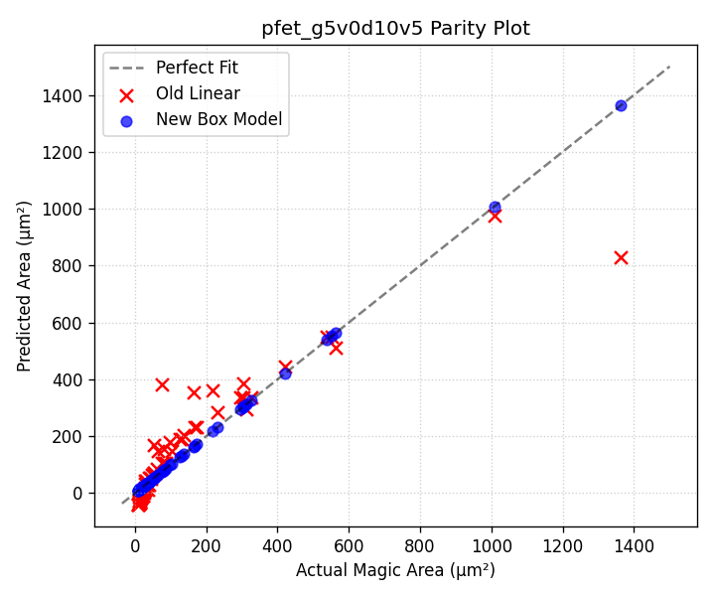

Device: nfet_g5v0d16v0
Parameters: ah=1.0000, bh=3.9800, aw=1.0000, bw=2.3139, cw=3.6741
Height Model: h_um = 1.0000*W + 3.9800
Width Model: w_um = 1.0000*(L*nf) + 2.3139*nf + 3.6741
Dimensions | Actual (µm²) | Old Model Err | New Model Err
W=0.42 L=0.15 nf=1 | 27.02 | -14.95 (155.3%) | 27.01 (0.0%)
W=0.42 L=0.15 nf=2 | 37.84 | -11.57 (130.6%) | 37.85 (0.0%)
W=0.42 L=0.15 nf=4 | 59.53 | -4.81 (108.1%) | 59.53 (0.0%)
W=0.42 L=0.5 nf=1 | 28.56 | -1.35 (104.7%) | 28.55 (0.0%)
W=0.42 L=1.0 nf=1 | 30.76 | 18.07 (41.2%) | 30.75 (0.0%)
W=0.45 L=0.15 nf=1 | 27.20 | -14.71 (154.1%) | 27.19 (0.0%)
W=0.45 L=0.15 nf=2 | 38.10 | -11.09 (129.1%) | 38.11 (0.0%)
W=0.45 L=0.15 nf=4 | 59.94 | -3.85 (106.4%) | 59.94 (0.0%)
W=0.6 L=0.15 nf=1 | 28.12 | -13.50 (148.0%) | 28.11 (0.0%)
W=0.6 L=0.15 nf=2 | 39.39 | -8.67 (122.0%) | 39.40 (0.0%)
W=0.6 L=0.15 nf=4 | 61.97 | 0.98 (98.4%) | 61.97 (0.0%)
W=1.0 L=0.15 nf=1 | 30.58 | -10.28 (133.6%) | 30.57 (0.0%)
W=1.0 L=0.15 nf=2 | 42.83 | -2.24 (105.2%) | 42.84 (0.0%)
W=1.0 L=0.5 nf=1 | 32.32 | 3.32 (89.7%) | 32.31 (0.0%)
W=1.0 L=0.5 nf=2 | 46.31 | 11.36 (75.5%) | 46.32 (0.0%)
W=1.0 L=0.5 nf=4 | 74.35 | 27.46 (63.1%) | 74.35 (0.0%)
W=1.0 L=2.0 nf=2 | 61.25 | 69.65 (13.7%) | 61.26 (0.0%)
W=1.2 L=0.15 nf=1 | 31.81 | -8.67 (127.3%) | 31.79 (0.0%)
W=1.2 L=0.15 nf=2 | 44.55 | 0.98 (97.8%) | 44.56 (0.0%)
W=1.2 L=0.15 nf=4 | 70.09 | 20.30 (71.0%) | 70.08 (0.0%)
W=1.5 L=0.5 nf=1 | 35.57 | 7.34 (79.4%) | 35.55 (0.0%)
W=1.5 L=0.5 nf=2 | 50.96 | 19.41 (61.9%) | 50.97 (0.0%)
W=1.5 L=0.5 nf=4 | 81.82 | 43.56 (46.8%) | 81.81 (0.0%)
W=2.0 L=0.15 nf=4 | 80.91 | 46.06 (43.1%) | 80.91 (0.0%)
W=2.0 L=0.35 nf=2 | 53.82 | 21.63 (59.8%) | 53.83 (0.0%)
W=2.0 L=0.5 nf=1 | 38.81 | 11.36 (70.7%) | 38.80 (0.0%)
W=2.0 L=0.5 nf=2 | 55.61 | 27.46 (50.6%) | 55.63 (0.0%)
W=2.0 L=0.5 nf=4 | 89.28 | 59.66 (33.2%) | 89.28 (0.0%)
W=2.0 L=1.0 nf=1 | 41.80 | 30.79 (26.3%) | 41.79 (0.0%)
W=2.0 L=1.0 nf=2 | 61.59 | 46.89 (23.9%) | 61.61 (0.0%)
W=2.0 L=1.0 nf=4 | 101.24 | 79.08 (21.9%) | 101.24 (0.0%)
W=2.0 L=5.0 nf=2 | 109.43 | 202.31 (84.9%) | 109.45 (0.0%)
W=3.0 L=1.0 nf=1 | 48.79 | 38.84 (20.4%) | 48.78 (0.0%)
W=3.0 L=1.0 nf=2 | 71.89 | 62.99 (12.4%) | 71.91 (0.0%)
W=3.0 L=1.0 nf=4 | 118.17 | 111.28 (5.8%) | 118.17 (0.0%)
W=4.0 L=0.15 nf=4 | 107.97 | 110.45 (2.3%) | 107.97 (0.0%)
W=4.0 L=0.5 nf=1 | 51.79 | 27.46 (47.0%) | 51.77 (0.0%)
W=4.0 L=0.5 nf=2 | 74.21 | 59.66 (19.6%) | 74.23 (0.0%)
W=4.0 L=0.5 nf=4 | 119.14 | 124.05 (4.1%) | 119.14 (0.0%)
W=4.0 L=1.0 nf=1 | 55.78 | 46.89 (15.9%) | 55.76 (0.0%)
W=4.0 L=1.0 nf=2 | 82.19 | 79.08 (3.8%) | 82.21 (0.0%)
W=4.0 L=1.0 nf=4 | 135.10 | 143.48 (6.2%) | 135.10 (0.0%)
W=4.0 L=2.0 nf=1 | 63.76 | 85.75 (34.5%) | 63.74 (0.0%)
W=4.0 L=2.0 nf=2 | 98.15 | 117.94 (20.2%) | 98.17 (0.0%)
W=4.0 L=2.0 nf=4 | 167.02 | 182.33 (9.2%) | 167.02 (0.0%)
W=4.0 L=5.0 nf=8 | 496.28 | 427.68 (13.8%) | 496.24 (0.0%)
W=4.0 L=10.0 nf=4 | 422.38 | 493.18 (16.8%) | 422.38 (0.0%)
W=6.0 L=2.0 nf=1 | 79.74 | 101.84 (27.7%) | 79.72 (0.0%)
W=6.0 L=2.0 nf=2 | 122.75 | 150.14 (22.3%) | 122.77 (0.0%)
W=6.0 L=2.0 nf=4 | 208.88 | 246.72 (18.1%) | 208.88 (0.0%)
W=8.0 L=1.0 nf=1 | 83.74 | 79.08 (5.6%) | 83.72 (0.0%)
W=8.0 L=1.0 nf=2 | 123.39 | 143.48 (16.3%) | 123.42 (0.0%)
W=8.0 L=1.0 nf=4 | 202.82 | 272.26 (34.2%) | 202.82 (0.0%)
W=8.0 L=2.0 nf=1 | 95.72 | 117.94 (23.2%) | 95.70 (0.0%)
W=8.0 L=2.0 nf=2 | 147.35 | 182.33 (23.7%) | 147.38 (0.0%)
W=8.0 L=2.0 nf=4 | 250.74 | 311.11 (24.1%) | 250.74 (0.0%)
W=10.0 L=0.15 nf=1 | 85.84 | 62.16 (27.6%) | 85.81 (0.0%)
W=10.0 L=0.15 nf=4 | 189.15 | 303.62 (60.5%) | 189.15 (0.0%)
W=10.0 L=0.15 nf=8 | 326.99 | 625.57 (91.3%) | 326.93 (0.0%)
W=10.0 L=5.0 nf=1 | 153.64 | 250.61 (63.1%) | 153.61 (0.0%)
W=10.0 L=5.0 nf=2 | 255.83 | 331.09 (29.4%) | 255.86 (0.0%)
W=10.0 L=5.0 nf=4 | 460.36 | 492.07 (6.9%) | 460.36 (0.0%)
W=10.0 L=10.0 nf=1 | 223.54 | 444.88 (99.0%) | 223.51 (0.0%)
W=10.0 L=10.0 nf=4 | 739.96 | 686.35 (7.2%) | 739.96 (0.0%)
W=10.0 L=10.0 nf=10 | 1772.94 | 1169.28 (34.0%) | 1772.85 (0.0%)
W=15.0 L=5.0 nf=1 | 208.59 | 290.85 (39.4%) | 208.55 (0.0%)
W=15.0 L=5.0 nf=2 | 347.33 | 411.58 (18.5%) | 347.37 (0.0%)
W=15.0 L=5.0 nf=4 | 625.01 | 653.05 (4.5%) | 625.01 (0.0%)
W=16.0 L=2.0 nf=1 | 159.64 | 182.33 (14.2%) | 159.60 (0.0%)
W=16.0 L=2.0 nf=2 | 245.75 | 311.11 (26.6%) | 245.79 (0.0%)
W=16.0 L=2.0 nf=4 | 418.18 | 568.68 (36.0%) | 418.18 (0.0%)
W=20.0 L=5.0 nf=1 | 263.54 | 331.09 (25.6%) | 263.49 (0.0%)
W=20.0 L=5.0 nf=2 | 438.83 | 492.07 (12.1%) | 438.88 (0.0%)
W=20.0 L=5.0 nf=4 | 789.66 | 814.02 (3.1%) | 789.65 (0.0%)
W=40.0 L=5.0 nf=1 | 483.34 | 492.07 (1.8%) | 483.25 (0.0%)
W=40.0 L=5.0 nf=2 | 804.83 | 814.02 (1.1%) | 804.92 (0.0%)
W=40.0 L=5.0 nf=4 | 1448.26 | 1457.93 (0.7%) | 1448.25 (0.0%)
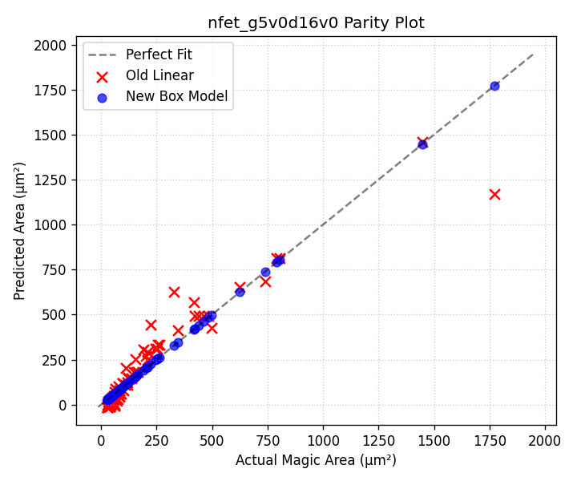

Device: pfet_g5v0d16v0
Parameters: ah=1.0000, bh=4.2800, aw=1.0000, bw=1.9200, cw=3.9700
Height Model: h_um = 1.0000*W + 4.2800
Width Model: w_um = 1.0000*(L*nf) + 1.9200*nf + 3.9700
Dimensions | Actual (µm²) | Old Model Err | New Model Err
W=0.42 L=0.15 nf=1 | 28.39 | -14.86 (152.4%) | 28.39 (0.0%)
W=0.42 L=0.15 nf=2 | 38.12 | -11.62 (130.5%) | 38.12 (0.0%)
W=0.42 L=0.15 nf=4 | 57.58 | -5.13 (108.9%) | 57.58 (0.0%)
W=0.42 L=0.5 nf=1 | 30.03 | -0.84 (102.8%) | 30.03 (0.0%)
W=0.42 L=1.0 nf=1 | 32.38 | 19.20 (40.7%) | 32.38 (0.0%)
W=0.45 L=0.15 nf=1 | 28.57 | -14.63 (151.2%) | 28.57 (0.0%)
W=0.45 L=0.15 nf=2 | 38.36 | -11.16 (129.1%) | 38.36 (0.0%)
W=0.45 L=0.15 nf=4 | 57.94 | -4.21 (107.3%) | 57.94 (0.0%)
W=0.6 L=0.15 nf=1 | 29.48 | -13.47 (145.7%) | 29.48 (0.0%)
W=0.6 L=0.15 nf=2 | 39.58 | -8.84 (122.3%) | 39.58 (0.0%)
W=0.6 L=0.15 nf=4 | 59.78 | 0.42 (99.3%) | 59.78 (0.0%)
W=1.0 L=0.15 nf=1 | 31.89 | -10.38 (132.6%) | 31.89 (0.0%)
W=1.0 L=0.15 nf=2 | 42.82 | -2.66 (106.2%) | 42.82 (0.0%)
W=1.0 L=0.5 nf=1 | 33.74 | 3.64 (89.2%) | 33.74 (0.0%)
W=1.0 L=0.5 nf=2 | 46.52 | 11.36 (75.6%) | 46.52 (0.0%)
W=1.0 L=0.5 nf=4 | 72.07 | 26.80 (62.8%) | 72.07 (0.0%)
W=1.0 L=2.0 nf=2 | 62.36 | 71.46 (14.6%) | 62.36 (0.0%)
W=1.2 L=0.15 nf=1 | 33.10 | -8.84 (126.7%) | 33.10 (0.0%)
W=1.2 L=0.15 nf=2 | 44.44 | 0.42 (99.0%) | 44.44 (0.0%)
W=1.2 L=0.15 nf=4 | 67.13 | 18.95 (71.8%) | 67.13 (0.0%)
W=1.5 L=0.5 nf=1 | 36.93 | 7.50 (79.7%) | 36.93 (0.0%)
W=1.5 L=0.5 nf=2 | 50.92 | 19.08 (62.5%) | 50.92 (0.0%)
W=1.5 L=0.5 nf=4 | 78.90 | 42.24 (46.5%) | 78.90 (0.0%)
W=2.0 L=0.15 nf=4 | 76.93 | 43.66 (43.3%) | 76.93 (0.0%)
W=2.0 L=0.35 nf=2 | 53.44 | 20.79 (61.1%) | 53.44 (0.0%)
W=2.0 L=0.5 nf=1 | 40.13 | 11.36 (71.7%) | 40.13 (0.0%)
W=2.0 L=0.5 nf=2 | 55.33 | 26.80 (51.6%) | 55.33 (0.0%)
W=2.0 L=0.5 nf=4 | 85.72 | 57.68 (32.7%) | 85.72 (0.0%)
W=2.0 L=1.0 nf=1 | 43.27 | 31.39 (27.4%) | 43.27 (0.0%)
W=2.0 L=1.0 nf=2 | 61.61 | 46.83 (24.0%) | 61.61 (0.0%)
W=2.0 L=1.0 nf=4 | 98.28 | 77.72 (20.9%) | 98.28 (0.0%)
W=2.0 L=5.0 nf=2 | 111.85 | 207.11 (85.2%) | 111.85 (0.0%)
W=3.0 L=1.0 nf=1 | 50.16 | 39.11 (22.0%) | 50.16 (0.0%)
W=3.0 L=1.0 nf=2 | 71.42 | 62.27 (12.8%) | 71.42 (0.0%)
W=3.0 L=1.0 nf=4 | 113.93 | 108.60 (4.7%) | 113.93 (0.0%)
W=4.0 L=0.15 nf=4 | 101.43 | 105.42 (3.9%) | 101.43 (0.0%)
W=4.0 L=0.5 nf=1 | 52.91 | 26.80 (49.3%) | 52.91 (0.0%)
W=4.0 L=0.5 nf=2 | 72.95 | 57.68 (20.9%) | 72.95 (0.0%)
W=4.0 L=0.5 nf=4 | 113.02 | 119.44 (5.7%) | 113.02 (0.0%)
W=4.0 L=1.0 nf=1 | 57.05 | 46.83 (17.9%) | 57.05 (0.0%)
W=4.0 L=1.0 nf=2 | 81.23 | 77.72 (4.3%) | 81.23 (0.0%)
W=4.0 L=1.0 nf=4 | 129.58 | 139.48 (7.6%) | 129.58 (0.0%)
W=4.0 L=2.0 nf=1 | 65.33 | 86.90 (33.0%) | 65.33 (0.0%)
W=4.0 L=2.0 nf=2 | 97.79 | 117.78 (20.4%) | 97.79 (0.0%)
W=4.0 L=2.0 nf=4 | 162.70 | 179.55 (10.4%) | 162.70 (0.0%)
W=4.0 L=5.0 nf=8 | 491.25 | 423.27 (13.8%) | 491.25 (0.0%)
W=4.0 L=10.0 nf=4 | 427.66 | 500.10 (16.9%) | 427.66 (0.0%)
W=6.0 L=2.0 nf=1 | 81.11 | 102.34 (26.2%) | 81.11 (0.0%)
W=6.0 L=2.0 nf=2 | 121.41 | 148.66 (22.5%) | 121.41 (0.0%)
W=6.0 L=2.0 nf=4 | 202.00 | 241.31 (19.5%) | 202.00 (0.0%)
W=8.0 L=1.0 nf=1 | 84.61 | 77.72 (8.1%) | 84.61 (0.0%)
W=8.0 L=1.0 nf=2 | 120.47 | 139.48 (15.8%) | 120.47 (0.0%)
W=8.0 L=1.0 nf=4 | 192.18 | 263.00 (36.8%) | 192.18 (0.0%)
W=8.0 L=2.0 nf=1 | 96.89 | 117.78 (21.6%) | 96.89 (0.0%)
W=8.0 L=2.0 nf=2 | 145.03 | 179.55 (23.8%) | 145.03 (0.0%)
W=8.0 L=2.0 nf=4 | 241.30 | 303.07 (25.6%) | 241.30 (0.0%)
W=10.0 L=0.15 nf=1 | 86.25 | 59.10 (31.5%) | 86.25 (0.0%)
W=10.0 L=0.15 nf=4 | 174.93 | 290.70 (66.2%) | 174.93 (0.0%)
W=10.0 L=0.15 nf=8 | 293.17 | 599.51 (104.5%) | 293.17 (0.0%)
W=10.0 L=5.0 nf=1 | 155.51 | 253.43 (63.0%) | 155.51 (0.0%)
W=10.0 L=5.0 nf=2 | 254.33 | 330.63 (30.0%) | 254.33 (0.0%)
W=10.0 L=5.0 nf=4 | 451.96 | 485.04 (7.3%) | 451.96 (0.0%)
W=10.0 L=10.0 nf=1 | 226.91 | 453.78 (100.0%) | 226.91 (0.0%)
W=10.0 L=10.0 nf=4 | 737.56 | 685.38 (7.1%) | 737.56 (0.0%)
W=10.0 L=10.0 nf=10 | 1758.87 | 1148.59 (34.7%) | 1758.87 (0.0%)
W=15.0 L=5.0 nf=1 | 209.96 | 292.03 (39.1%) | 209.96 (0.0%)
W=15.0 L=5.0 nf=2 | 343.38 | 407.83 (18.8%) | 343.38 (0.0%)
W=15.0 L=5.0 nf=4 | 610.21 | 639.44 (4.8%) | 610.21 (0.0%)
W=16.0 L=2.0 nf=1 | 160.01 | 179.55 (12.2%) | 160.01 (0.0%)
W=16.0 L=2.0 nf=2 | 239.51 | 303.07 (26.5%) | 239.51 (0.0%)
W=16.0 L=2.0 nf=4 | 398.50 | 550.11 (38.0%) | 398.50 (0.0%)
W=20.0 L=5.0 nf=1 | 264.41 | 330.63 (25.0%) | 264.41 (0.0%)
W=20.0 L=5.0 nf=2 | 432.43 | 485.04 (12.2%) | 432.43 (0.0%)
W=20.0 L=5.0 nf=4 | 768.46 | 793.84 (3.3%) | 768.46 (0.0%)
W=40.0 L=5.0 nf=1 | 482.21 | 485.04 (0.6%) | 482.21 (0.0%)
W=40.0 L=5.0 nf=2 | 788.63 | 793.84 (0.7%) | 788.63 (0.0%)
W=40.0 L=5.0 nf=4 | 1401.46 | 1411.45 (0.7%) | 1401.46 (0.0%)
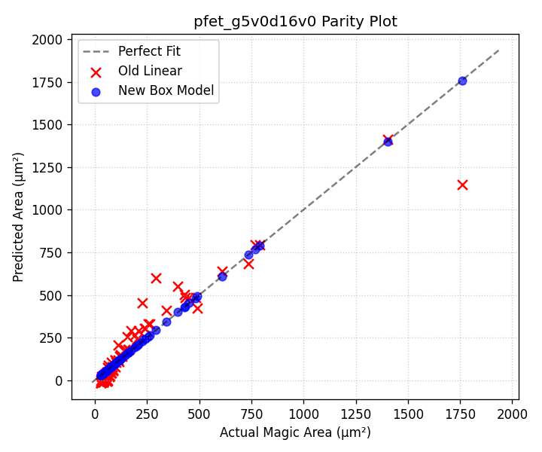

2. Poly Resistors
Poly resistor areas are modeled using a linear relationship with length (L) for a given fixed width (W). Each specific width has its own slope and intercept:
Area = slope * L + intercept

Device: res_high_po_0p35
Fixed Width (W) | Slope | Intercept
0.35 | 2.0100 | 11.6982

Device: res_high_po_0p69
Fixed Width (W) | Slope | Intercept
0.69 | 2.3500 | 13.6770

Device: res_high_po_1p41
Fixed Width (W) | Slope | Intercept
1.41 | 3.0700 | 17.8674

Device: res_high_po_2p85
Fixed Width (W) | Slope | Intercept
2.85 | 4.5100 | 26.2482

Device: res_high_po_5p73
Fixed Width (W) | Slope | Intercept
5.73 | 7.3900 | 43.0098

Device: res_xhigh_po_0p35
Fixed Width (W) | Slope | Intercept
0.35 | 2.0100 | 11.6982

Device: res_xhigh_po_0p69
Fixed Width (W) | Slope | Intercept
0.69 | 2.3500 | 13.6770

Device: res_xhigh_po_1p41
Fixed Width (W) | Slope | Intercept
1.41 | 3.0700 | 17.8674

Device: res_xhigh_po_2p85
Fixed Width (W) | Slope | Intercept
2.85 | 4.5100 | 26.2482

Device: res_xhigh_po_5p73
Fixed Width (W) | Slope | Intercept
5.73 | 7.3900 | 43.0098

Device: res_generic_po
Fixed Width (W) | Slope | Intercept
0.5 | 2.1600 | 12.8736
1.0 | 2.6600 | 15.8536
2.0 | 3.6600 | 21.8136

Device: res_generic_nd
Fixed Width (W) | Slope | Intercept
0.5 | 2.0800 | 5.4288
1.0 | 2.5800 | 6.7338
2.0 | 3.5800 | 9.3438

Device: res_generic_pd
Fixed Width (W) | Slope | Intercept
0.5 | 2.0800 | 5.4288
1.0 | 2.5800 | 6.7338
2.0 | 3.5800 | 9.3438

3. Capacitors

MIM Capacitors
MIM capacitors are modeled as a rectangle with a uniform border overhead (b) around the drawn dimensions:
Area = (W + 2b) * (L + 2b)
- cap_mim_m3_1: border overhead (b) = 0.6209 µm
- cap_mim_m3_2: border overhead (b) = 1.0484 µm

Varactor Capacitors
Varactors fall back to nearest-neighbor lookup because their scaling is highly non-linear depending on exact array layout.
- cap_var_lvt: 3 points in database for nearest-neighbor.
- cap_var_hvt: 3 points in database for nearest-neighbor.

4. Bipolar Junction Transistors (BJTs)
BJTs are fixed-size layout macros. Their areas are static.
Device | Width (µm) | Height (µm) | Area (µm²)
npn_05v5_W1p00L1p00 | 8.6200 | 8.6200 | 74.3044
npn_05v5_W1p00L2p00 | 8.6200 | 9.6200 | 82.9244
pnp_05v5_W0p68L0p68 | 3.9800 | 3.9800 | 15.8404
pnp_05v5_W3p40L3p40 | 6.7000 | 6.7000 | 44.8900

