**Requirements**

Windows 10 OS(built in Voice record app).

Pycharm or any python IDE

**Steps to set up**

1. Install Pycharm or any python IDE in your Windows 10 machine.
2. Load Voice_File_Python.txt code (Change the location at lines 15, 41, 42, 56, 60).
3. Create one IAM role with the permissions as shown below.

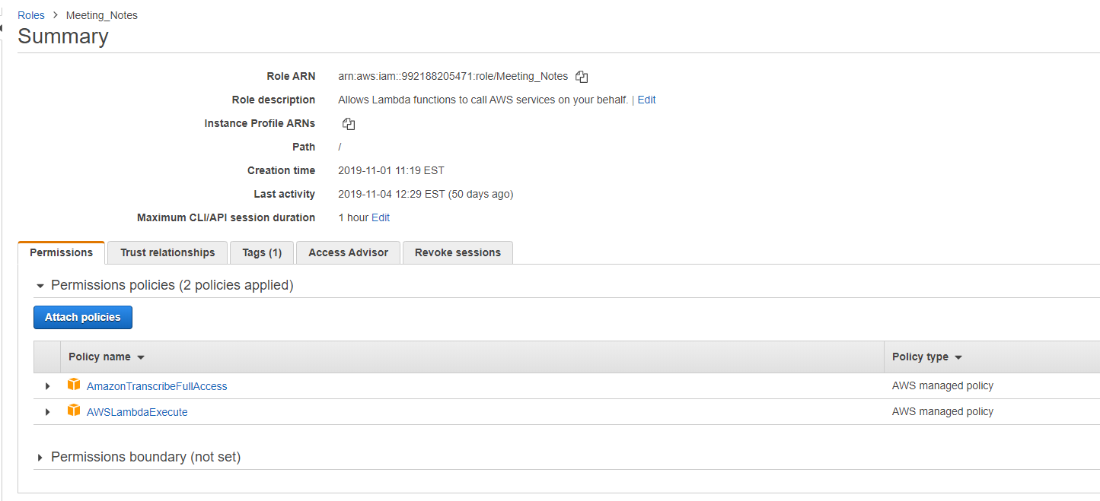

Policies expanded below.

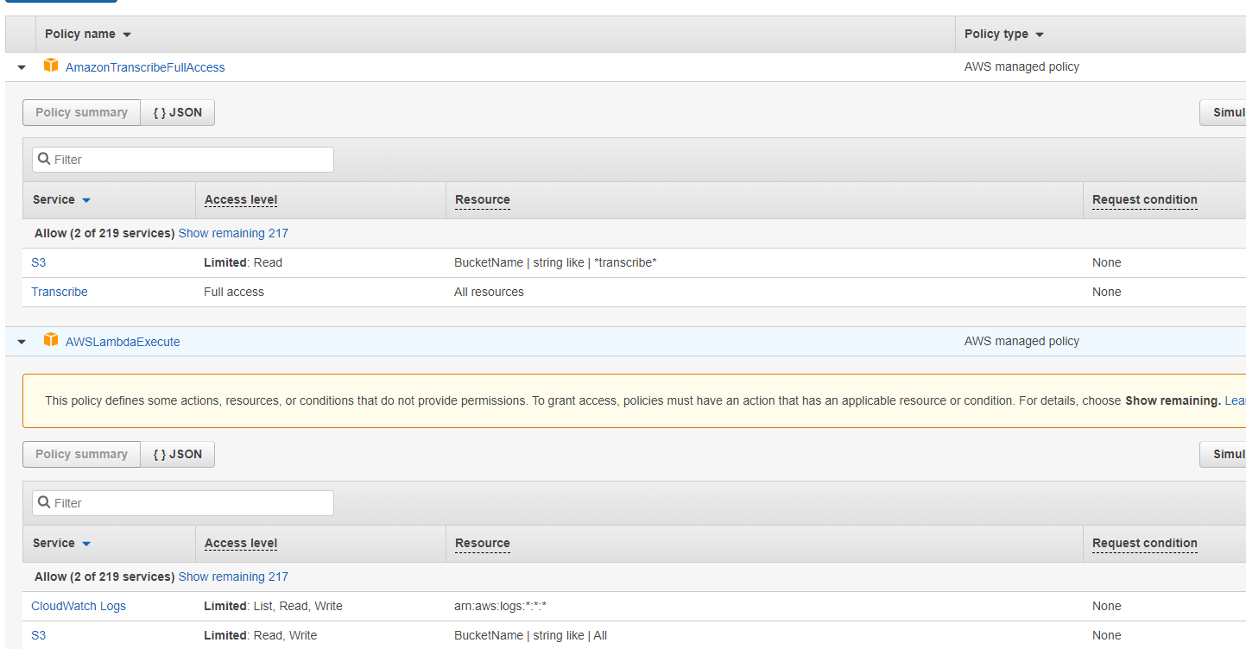

1. Create one IAM user as shown below. This gives full access to S3 bucket. Save secret access key and access key ID.

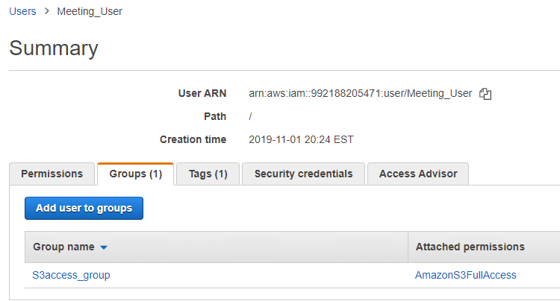

1. Create two S3 buckets. One for transcribe and another for back up. Here kesavabucket is to save voice recordings. Meetingnotes2019 bucket is to save the output.



1. Create a Lambda function(say Meeting_Lambda) with the python code given in Lambda_meeting_Python.txt
2. Set S3 as trigger for Lambda as shown below.

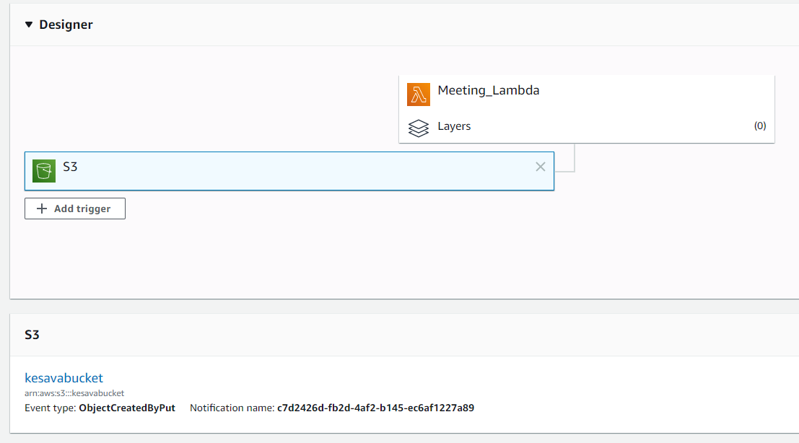

1. Create another Lambda function(say Lambda_s3_email) with the python code given in Lambda_Email_Python.txt
2. Set S3 as trigger as shown below.

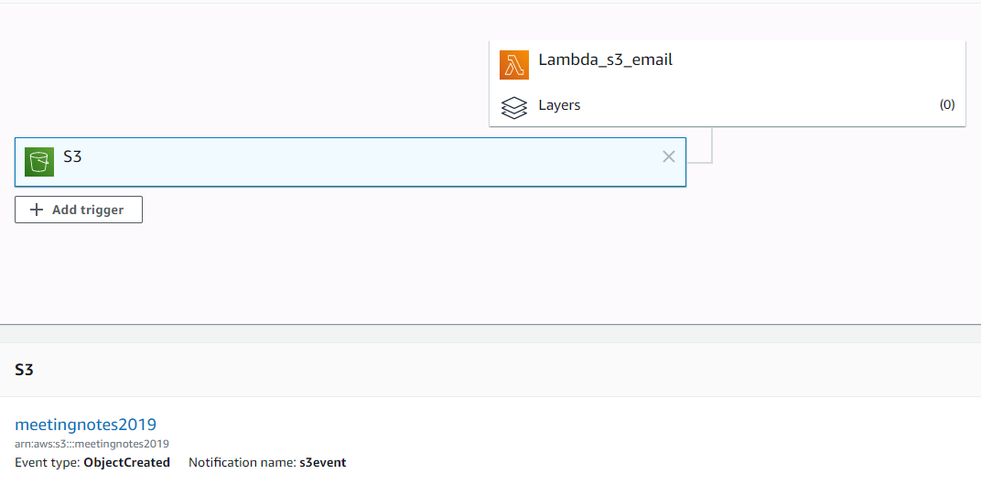

1. Register your email ID with AWS SES.

**Sample output.**

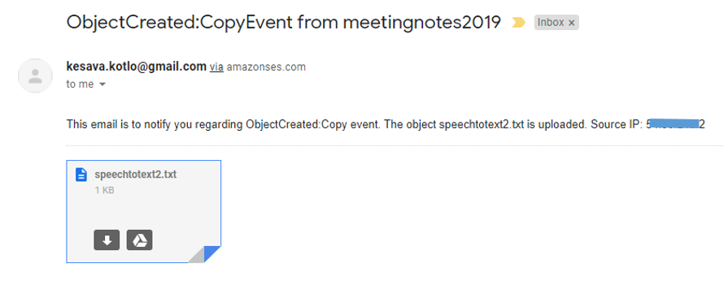

That’s it!!! Open voice recorder in your windows system and record the meeting summary /any important talk. You will see the transcribed voice record in your email immediately.

**Note**: I still have to work on scheduling the python code to start running on it’s own for the first time when you turn on the computer.