Project Title
Subset Optimization Tool Using SOS Dynamic Programming
Project Report submitted for the partial fulfilment of grade for the course

Data Structures and Algorithms -3 (25CS2103E)
in

A.Y. 2026-2027

Submitted by
B. Chenna Malleswar (2520030546)
S. Bheeshma (2520030528)
T. Abhinav (2520030075)

Team Number: 17
Section: 4

Under the guidance of

Yamini Devi

Assistant Professor, Department of CSE
Hyderabad-500090, Telangana, India.

K L (Deemed to be) University
DEPARTMENT OF COMPUTER SCIENCE ENGINEERING



DECLARATION

The Mini Project Report entitled “Subset Optimization Tool Using SOS Dynamic Programming” is a record of Bonafide work of B. Chenna Malleswar – 2520030546, S. Bheeshma – 2520030528, T. Abhinav – 2520030075 submitted in partial fulfillment for the award of B. Tech in Computer Science and Engineering to the K L University. The results embodied in this report have not been copied from any other departments/University/Institute.

B. Chenna Malleswar – 2520030546
S. Bheeshma – 2520030528
T. Abhinav – 2520030075

K L (Deemed to be) University
DEPARTMENT OF COMPUTER SCIENCE ENGINEERING
CERTIFICATE

This is to certify that the mini project based report entitled “Subset Optimization Tool Using SOS Dynamic Programming” is a bonafide work done and submitted by B. Chenna Malleswar – 2520030546, S. Bheeshma – 2520030528, T. Abhinav – 2520030075 in partial fulfillment of the requirements for the award of the degree of BACHELOR OF TECHNOLOGY in Department of Computer Science Engineering, K L (Deemed to be University), during the academic year 2026-2027.

Signature of the Supervisor

Signature of the HOD Signature of the External Examiner

ACKNOWLEDGEMENT

The success in this project would not have been possible but for the timely help and guidance rendered by many people. Our wish to express my sincere thanks to all those who has assisted us in one way or the other for the completion of my project.

Our greatest appreciation to our guide, Yamini Devi, Assistant Professor, Department of CSE, which cannot be expressed in words for his/her tremendous support, encouragement and guidance for this project.

We express our gratitude to Dr. P. Venkateshwar Rao (CSE), Head of the Department of Computer Science Engineering for providing us with adequate facilities, ways and means by which we are able to complete this project-based Lab.

We thank all the members of teaching and non-teaching staff members, and also who have assisted me directly or indirectly for successful completion of this project. Finally, I sincerely thank my parents, friends and classmates for their kind help and cooperation during my work.

B. Chenna Malleswar – 2520030546
S. Bheeshma – 2520030528
T. Abhinav – 2520030075

TABLE OF CONTENTS

S.No. | Contents | Page no.
1. | Abstract | 6
2. | Introduction | 7
3. | Literature survey | 8
4. | Problem Statement and Objectives | 9
5. | Hardware and Software requirements | 10
6. | Implementation | 11
7. | Results & Discussion | 14
8. | Conclusion & Future Scope | 15
9. | References | 16

1.ABSTRACT

The SOS Dynamic Programming Based Subset Optimization and Query Engine is a computational tool designed to efficiently answer multiple subset-based queries on an integer set using Sum Over Subsets (SOS) Dynamic Programming. The system represents elements and subsets using bitmasks, with the input size restricted to n ≤ 20, and computes aggregate subset values efficiently in O(n × 2ⁿ) time. Users can enter an integer set and perform different subset-sum queries while the system displays the corresponding results. The application also compares the execution time of SOS DP with a brute-force approach to demonstrate its efficiency for large numbers of subset queries. A visualization module can represent subset relationships and algorithm performance through graphs and bitmask-based representations. The project demonstrates important concepts of dynamic programming, bitmasking, subset optimization, algorithm analysis, and performance evaluation in a practical application.
Team Name: Team 17 – Subset Optimization Tool

Team Logo (if any): Not applicable

Team Members:
- B. Chenna Malleswar, 2520030546
- S. Bheeshma, 2520030528
- T. Abhinav, 2520030075

- INTRODUCTION

Subset-based problems are an important class of computational problems that require finding or calculating values for different subsets of a given set. When the number of elements increases, checking every possible subset separately can become computationally expensive because a set of n elements has 2ⁿ possible subsets. The Sum Over Subsets (SOS) Dynamic Programming technique provides an efficient way to preprocess information about all subsets and answer multiple subset-based queries quickly.
This project develops an SOS Dynamic Programming Based Subset Optimization and Query Engine for integer sets with n ≤ 20. The system uses bitmask representation to identify subsets and applies SOS DP to calculate aggregate subset values in O(n × 2ⁿ) time. It also compares the performance of SOS DP with a brute-force approach, allowing users to observe the improvement in execution time. Through subset visualization and performance analysis, the project demonstrates how advanced dynamic programming techniques can solve large numbers of subset queries efficiently.
The rest of this report is organised as follows: Section 3 reviews related techniques, Section 4 states the problem and objectives, Section 5 lists the hardware and software requirements, Section 6 presents the flow chart and implementation modules, Section 7 discusses the results, Section 8 gives the conclusion and future scope, and Section 9 lists the references.
- LITERATURE SURVEY
The following related topics and techniques were studied while developing this project. Each one is explained briefly together with its relevance to the proposed system.
1. Dynamic Programming: DP solves problems by storing the results of overlapping subproblems and avoiding repeated computation. It provides the foundation for SOS DP.
2. Bitmasking: Bitmasking represents subsets using binary numbers, allowing efficient subset manipulation. It is used here to represent all subsets of the integer set.
3. Subset Sum Problem: Traditional approaches enumerate the possible subsets, which becomes expensive as the input size increases. This motivates the need for optimization.
4. Sum Over Subsets (SOS) DP: SOS DP computes aggregate values over all submasks efficiently in O(n × 2ⁿ) time. It is the core algorithm used in the proposed system.
5. Performance Visualization: Graphs and execution-time measurements help demonstrate algorithmic efficiency. They are used here to compare SOS DP with the brute-force method.
- Problem Statement and Objectives

Problem Statement:
Traditional brute-force methods for answering multiple subset-sum queries become inefficient as the number of elements increases, because they repeatedly examine a large number of subsets.

Problem Description:
This project develops a Subset Optimization Tool using Sum Over Subsets (SOS) Dynamic Programming to efficiently compute subset aggregate values for an integer set with n ≤ 20. The system also provides query processing, subset visualization, and performance comparison between SOS DP and brute-force methods.
Objectives:
1. Develop an SOS Dynamic Programming-based subset optimization tool.
2. Compute subset sums efficiently for all possible bitmasks.
3. Answer multiple subset queries using precomputed SOS DP values.
4. Reduce execution time compared with brute-force subset enumeration.
5. Visualize subset relationships and bitmask representations.
6. Compare the performance of SOS DP and brute-force approaches.
7. Demonstrate scalability for integer sets with up to 20 elements.
- HARDWARE AND SOFTWARE REQUIREMENTS
Hardware Requirements:
- Processor: Intel Core i3 or equivalent and above
- RAM: Minimum 4 GB
- Storage: At least 500 MB of free disk space
- Display: Standard monitor / laptop display
Software Requirements:
- Programming languages: HTML, CSS, JavaScript (for the web interface)
- Operating system: Windows 10/11, Linux, or macOS
- Algorithm / technique: Sum Over Subsets (SOS) Dynamic Programming with bitmasking
- Development tools and libraries (optional): code editor and a modern web browser
- IMPLEMENTATION

Flow Chart of the Subset Optimization Tool
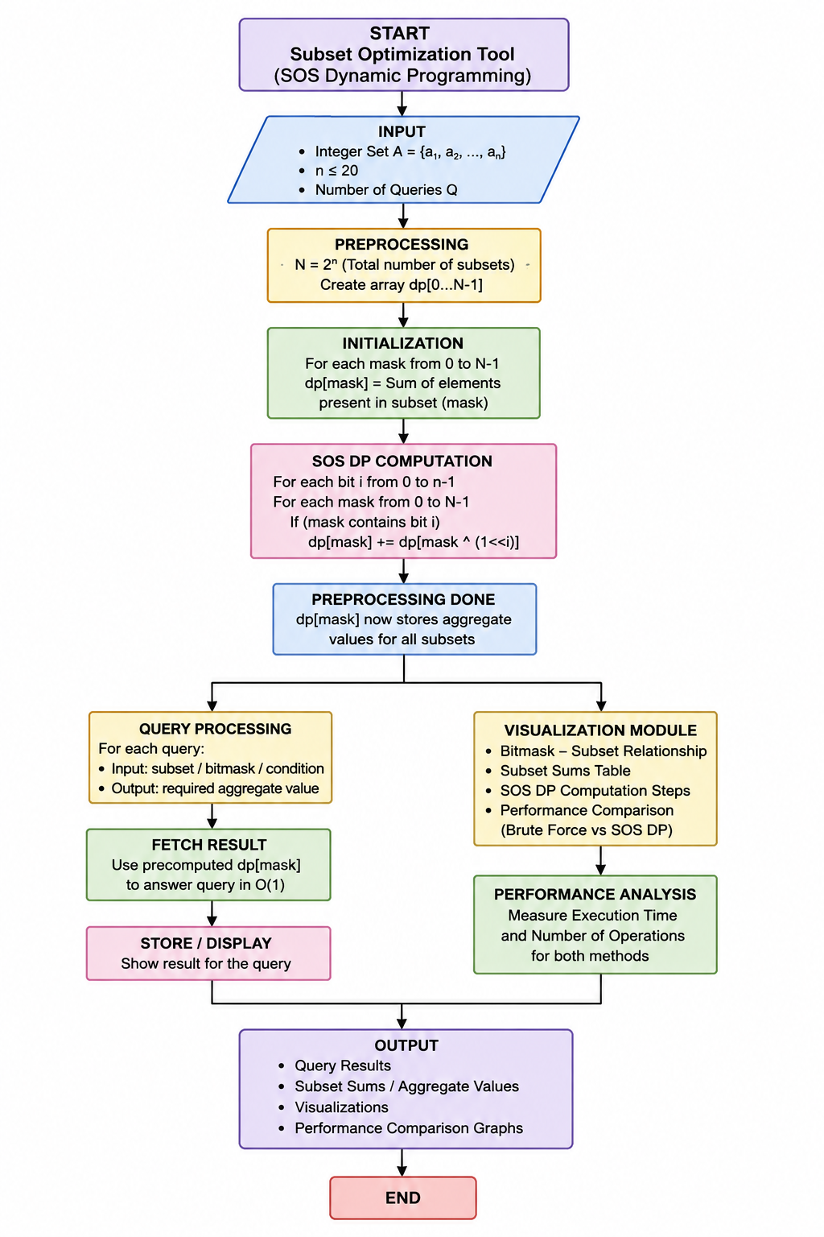
Figure 6.1: Flow chart of the SOS DP based Subset Optimization Tool
Module 1: Input Handling and Bitmask Initialisation
Reads and validates the integer set (n ≤ 20) and fills dp[mask] with the sum of the elements present in each subset (mask) in O(2ⁿ) time.
function readInput(text) {
const a = text.split(/[\s,]+/).filter(s => s.length).map(Number);
if (a.some(Number.isNaN)) throw new Error("Only integers are allowed");
if (a.length < 1 || a.length > 20) throw new Error("n must satisfy 1 <= n <= 20");
return a;
}

function initSubsetSums(a) {
const n = a.length, N = 1 << n;
const dp = new Float64Array(N); // dp[mask] = sum of elements in mask
for (let mask = 1; mask < N; mask++) {
const low = mask & -mask; // lowest set bit
dp[mask] = dp[mask ^ low] + a[31 - Math.clz32(low)];
}
return dp;
}

Module 2: SOS Dynamic Programming Computation
For every bit i, each mask containing bit i adds the value of mask without bit i. After the loops, dp[mask] holds the aggregate over all submasks, in O(n × 2ⁿ) time.
function sosDP(dp, n) {
const N = 1 << n;
for (let i = 0; i < n; i++)
for (let mask = 0; mask < N; mask++)
if (mask & (1 << i))
dp[mask] += dp[mask ^ (1 << i)]; // add contribution of mask without bit i
return dp; // dp[mask] = sum over all submasks
}

Module 3: Query Processing
A query mask is answered in O(1) from the precomputed dp array. The brute-force version enumerates every submask of the query mask and is used as the baseline.
function indicesToMask(idx) { return idx.reduce((m, i) => m | (1 << i), 0); }

function querySOS(dp, mask) { return dp[mask]; } // O(1) per query

function queryBruteForce(a, mask) { // enumerates every submask
let total = 0;
for (let s = mask; ; s = (s - 1) & mask) {
for (let i = 0; i < a.length; i++) if (s & (1 << i)) total += a[i];
if (s === 0) break;
}
return total;
}

Module 4: Performance Comparison (SOS DP vs Brute Force)
Runs both methods on the same set of queries, measures execution time with performance.now(), and verifies that the two methods give identical answers.
function compare(a, queries) {
const n = a.length;
let t0 = performance.now();
const dp = sosDP(initSubsetSums(a), n);
const rs = queries.map(m => querySOS(dp, m));
const tSOS = performance.now() - t0;

t0 = performance.now();
const rb = queries.map(m => queryBruteForce(a, m));
const tBF = performance.now() - t0;

const ok = rs.every((v, i) => v === rb[i]);
return { n, Q: queries.length, tSOS, tBF, ok, dp, rs };
}

- RESULTS & DISCUSSION
The tool was tested with a sample set A = {3, 5, 2, 7} (n = 4) and with random sets of larger sizes. The outputs of the test runs and their explanations are given below.

Set A = 3, 5, 2, 7 n = 4
Mask Subset Sum SOS dp[mask]
0000 {} 0 0
0001 {3} 3 3
0010 {5} 5 5
0011 {3,5} 8 16
0100 {2} 2 2
0101 {3,2} 5 10
0110 {5,2} 7 14
0111 {3,5,2} 10 40
1000 {7} 7 7
1001 {3,7} 10 20
1010 {5,7} 12 24
1011 {3,5,7} 15 60
1100 {2,7} 9 18
1101 {3,2,7} 12 48
1110 {5,2,7} 14 56
1111 {3,5,2,7} 17 136
Query mask 0011 -> SOS: 16 | Brute force: 16
Query mask 1110 -> SOS: 56 | Brute force: 56
Query mask 1111 -> SOS: 136 | Brute force: 136
Figure 7.1: Subset sums and SOS DP values for A = {3, 5, 2, 7}, with query results
Explanation: Each 4-bit mask identifies one subset. The 'Sum' column is the initial dp value, and the 'SOS dp[mask]' column is the aggregate over all submasks after SOS DP. Each query is answered in O(1) and matches the brute-force answer.

n Q SOS DP (ms) Brute force (ms) Match
10 1000 0.2 6.3 Yes
15 5000 2.8 150.9 Yes
18 10000 8.6 1108.1 Yes
20 10000 37.2 2718.6 Yes
Figure 7.2: Execution-time comparison of SOS DP and brute force (random integer sets; sample run)
Explanation: SOS DP includes preprocessing time and all queries, while the brute-force time grows rapidly with n. For n = 20 and 10,000 queries, SOS DP is far faster, and both methods always return identical results. Times depend on the machine used.

Summary of results:
1. Successfully developed a Subset Optimization Tool using SOS Dynamic Programming.
2. Computes subset sums efficiently for n ≤ 20 (up to 2²⁰ subsets).
3. Answers multiple subset-based queries with improved performance.
4. SOS DP uses O(n × 2ⁿ) preprocessing compared with slower brute-force approaches.
5. Visualizes bitmask–subset relationships and subset sums.
6. Performance comparison demonstrates the efficiency and scalability of SOS DP.
- CONCLUSION & FUTURE SCOPE
Conclusion: The SOS Dynamic Programming Based Subset Optimization and Query Engine demonstrates how dynamic programming and bitmasking can efficiently solve multiple subset-based queries. By using SOS DP, the system computes aggregate subset values in O(n × 2ⁿ) time, providing better performance than repeatedly checking subsets using brute force. The performance comparison and visualization help demonstrate the practical advantages of the algorithm. Overall, the project provides a simple and effective implementation of advanced dynamic programming concepts and can be further extended to support more complex subset queries and larger-scale optimization problems.

Future Scope:
1. Support larger input sizes beyond n ≤ 20 using advanced optimization techniques.
2. Add more query types such as subset maximum, minimum, XOR, AND, and frequency queries.
3. Improve visualization with interactive bitmask and subset relationship graphs.
4. Add parallel processing to speed up SOS DP computation for large datasets.
5. Develop a web-based interface for easier interaction and visualization.
6. Compare more algorithms such as Meet-in-the-Middle and other subset optimization techniques.
7. Use real-world applications such as resource allocation, scheduling, feature selection, and combinatorial optimization.
8. Provide real-time performance analysis for different input sizes and query counts.
- REFERENCES

1. Dynamic Programming – Wikipedia. https://en.wikipedia.org/wiki/Dynamic_programming
2. Subset Sum Problem – Wikipedia. https://en.wikipedia.org/wiki/Subset_sum_problem
3. Mask (computing) / Bitmasking – Wikipedia. https://en.wikipedia.org/wiki/Mask_(computing)
4. SOS Dynamic Programming [Tutorial] – Codeforces Blog. https://codeforces.com/blog/entry/45223
5. Enumerating all submasks of a bitmask – CP-Algorithms. https://cp-algorithms.com/algebra/all-submasks.html
6. JavaScript Guide – MDN Web Docs. https://developer.mozilla.org/en-US/docs/Web/JavaScript
7. Performance.now() – MDN Web Docs. https://developer.mozilla.org/en-US/docs/Web/API/Performance/now
8. T. H. Cormen, C. E. Leiserson, R. L. Rivest, C. Stein, Introduction to Algorithms, 4th ed., MIT Press, 2022.

