EXP 1 :

LAB EXPERIMENTIONS

DSA 0410 – FUNDAMENTALS OF DATA SCIENCE
CHENNAM VENKATA NAGA SATISH
192472162
PROGRAM :
import numpy as np
student_scores = np.loadtxt("Students_data.csv",delimiter=",",skiprows=1,usecols=(1, 2, 3, 4)) subjects = ["Math", "Science", "English", "History"]
average_scores = np.mean(student_scores, axis=0) highest_subject = subjects[np.argmax(average_scores)] print("Average scores:", np.round(average_scores,2)) print("Subject with highest average score:", highest_subject) OUTPUT :
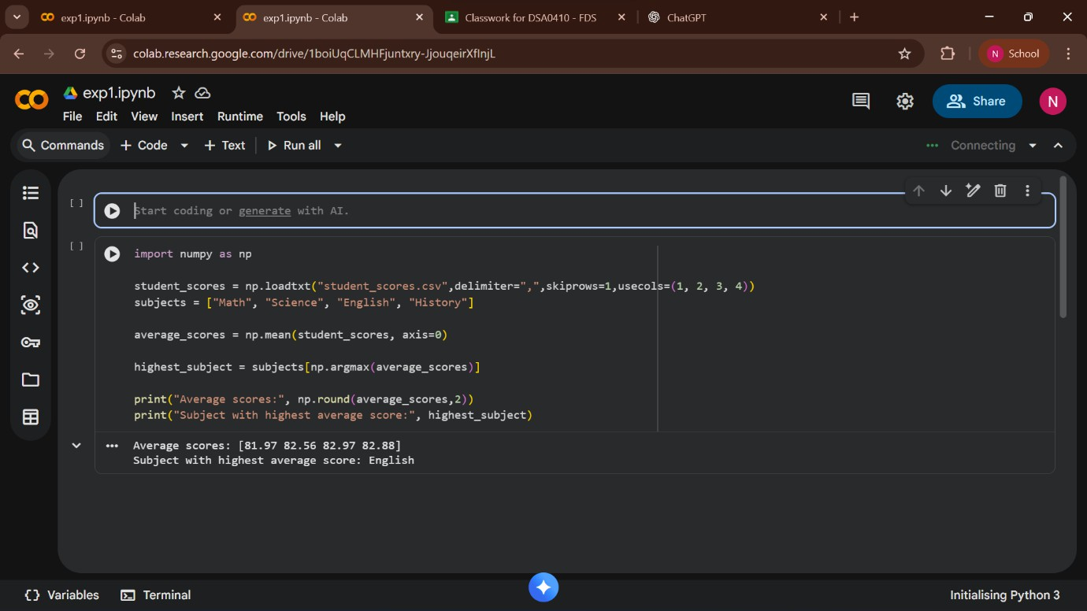

EXP 2 : PROGRAM:
import pandas as pd df=pd.read_csv("Sales_data.csv")
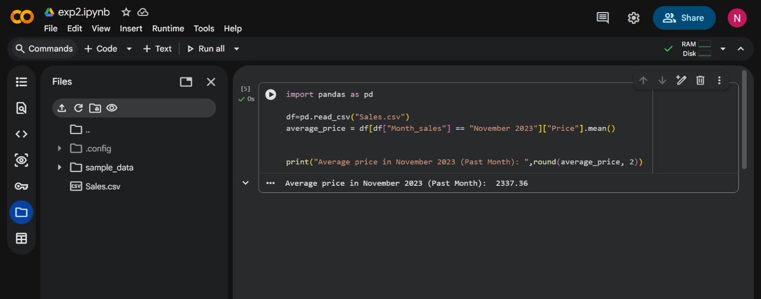
average_price = df[df["Month_sales"]==" November 2023"]["Price"].mean() print("Average price in November 2023 (Past Month): ",round(average_price, 2))

Output

EXP 3:
PROGRAM :
import numpy as np house_data=np.loadtxt('House_data.csv',delimiter=',',skiprows=1) houses_more_than_4=house_data[house_data[:,0]>4] average_price=np.mean(houses_more_than_4[:,5])
print("Average price of houses with more than 4 bedrooms: ",round(average_price,2))
OUTPUT:

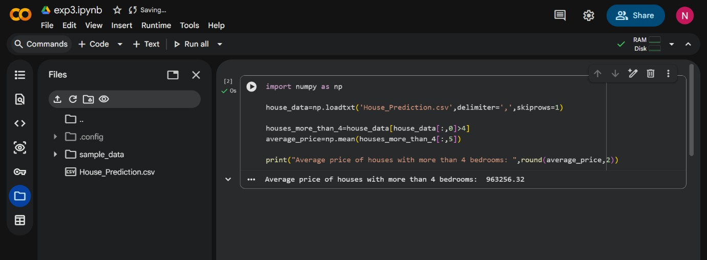

EXP 4: PROGRAM :
import numpy as np

sales_data = np.genfromtxt("Sales_data.csv",delimiter=",",skip_header=1,dtype=str) months = sales_data[:, 1]
sales = sales_data[:, 4].astype(float) Q1 = 0.0
Q4 = 0.0
for i in range(len(months)):
if ("January" in months[i]) or ("February" in months[i]) or ("March" in months[i]): Q1 += sales[i]
elif ("October" in months[i]) or ("November" in months[i]) or ("December" in months[i]): Q4 += sales[i]
total_sales_year = np.sum(sales) percentage_increase = ((Q4 - Q1) / Q1) * 100
print("Total sales for the year:", round(total_sales_year, 2))
print("Percentage increase from Q1 to Q4:", round(percentage_increase, 2), "%")
OUTPUT:
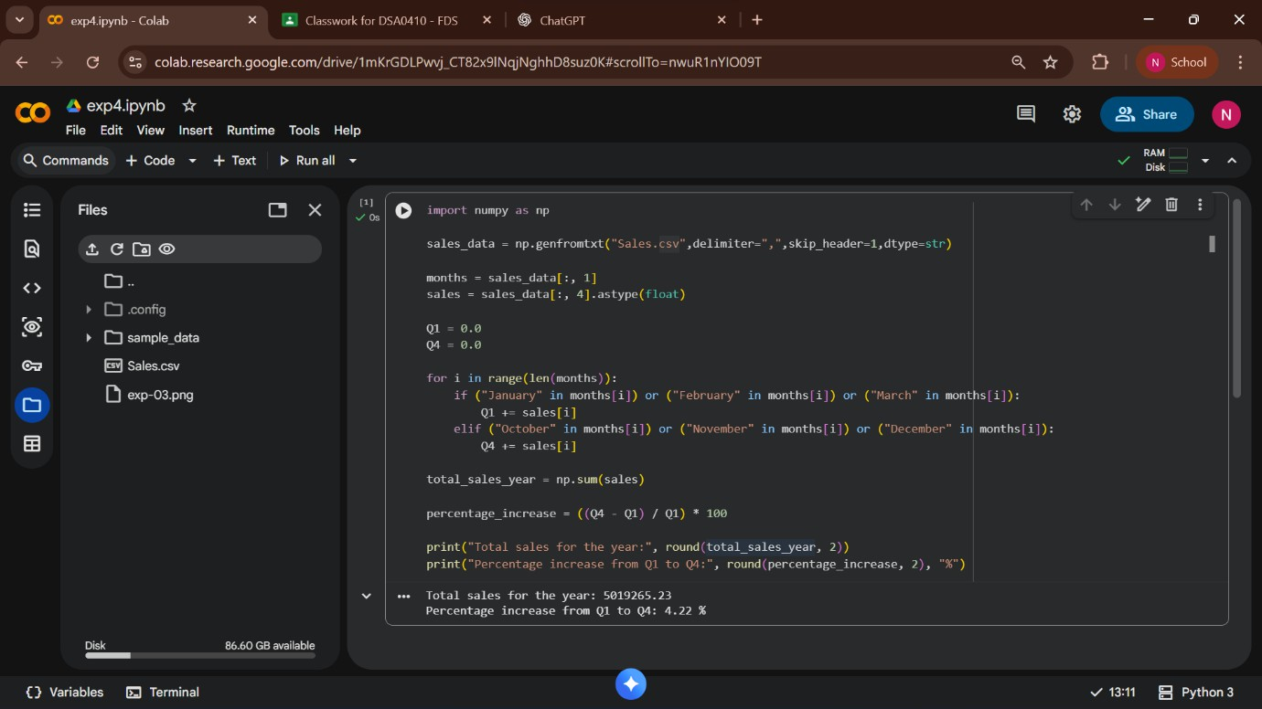

EXP 5:
PROGRAM :
import numpy as np
fuel_data=np.genfromtxt('Fuel_data.csv', delimiter=',', skip_header=1,dtype=str)

fuel_efficiency = fuel_data[:, 7].astype(float) make = fuel_data[:,8]
average_efficiency = np.mean(fuel_efficiency) mazda_eff = fuel_efficiency[make == "mazda"] audi_eff = fuel_efficiency[make == "audi"] mazda_avg = np.mean(mazda_eff)
audi_avg = np.mean(audi_eff)
percentage_improvement = ((mazda_avg - audi_avg) / audi_avg) * 100 print("Average Fuel Efficiency of all cars:", round(average_efficiency, 2), "MPG") print("Average Fuel Efficiency of Mazda:", round(mazda_avg, 2), "MPG") print("Average Fuel Efficiency of Audi:", round(audi_avg, 2), "MPG")
print("Percentage Improvement from Mazda to Audi:", round(percentage_improvement, 2), "%")
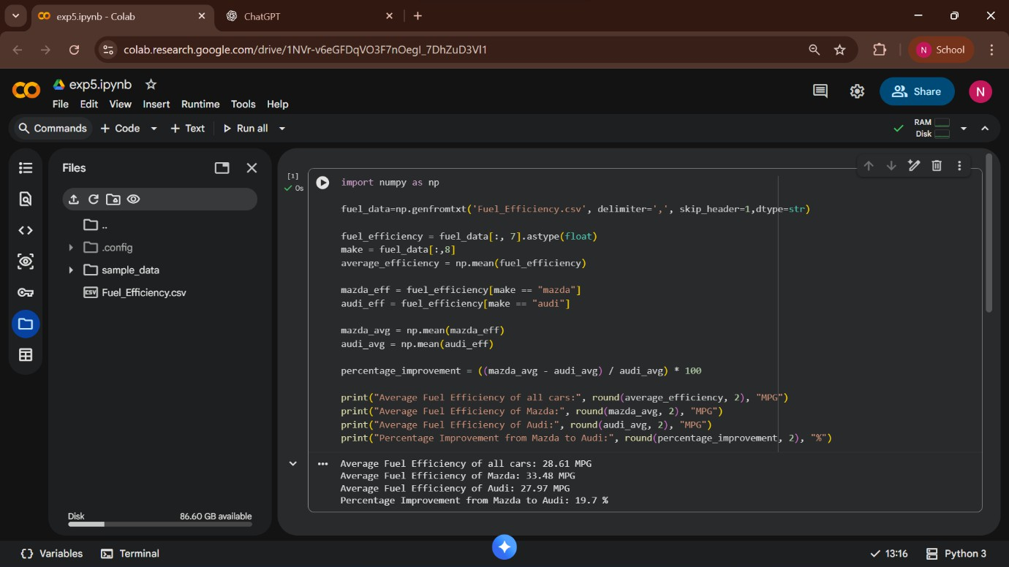
OUT

