Design

The proposed CoAPNonIP architecture consists of three layers. They are Developer Layer, Application Layer and Network Layer.

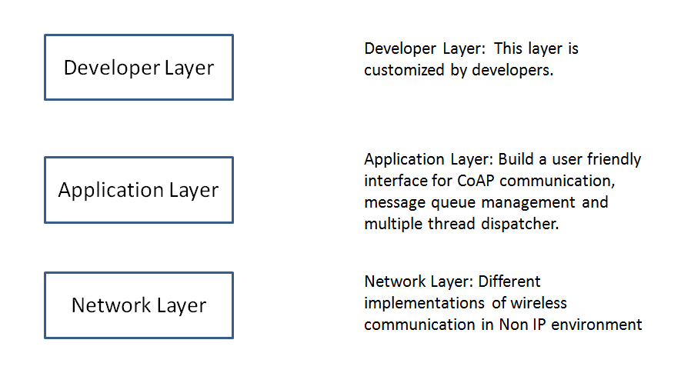

As shown above, the CoAPNonIP has defined the Application Layer and Network Layer. Application Layer focus on message management and interface build of CoAP message. On the other hand, Network Layer provides implementations in different Non-IP wireless commendation technologies

Network layer

The network layer defines some basic functions which has different implementation for different technologies. In the proposed architecture, it adopts a network layer to support upper layer actions. Wireless communication has different implementation in different technologies. However, those technologies are similar in some basic concepts. We summarize the most important similarities and describe them below.

1. Broadcast

As a server (group owner) in wireless p2p communication, a device need to broadcast itself to make sure other devices can find it. In this state, we say the device is discoverable.

2. Search Peers

If a device play the role of client, it needs to search nearby broadcast signals to find other nodes.

3. Get Nodes

A node need to know available devices in its network for the decision making of where to send messages.

4. Send Data

Every node have the ability to send data to one or multiple target devices.

5. Receive Data

Every node should be able to receive data from remote devices.

According to the above cognition, we generate abstract functions to unify different implementation of wireless communications. In the current version, we implemented the architecture in Bluetooth Low Energy of Android and WiFiDirect of iOS.

Application layer

Since the aim of the project is to support CoAP protocol in NonIP based environment, We adopt a application layer to manage data and provide a user friendly interface for CoAP developers. The following section described some important concepts in the architecture.

1. Receiver

Receiver is the access point of received data.

2. Sender

Sender is the place where data are packeted to byte array and send to other device. It consists of multiple threads to dispatch CoAP messages.

3. Processors

The processors consist of multiple threads to handle incoming CoAP requests.

4. Resource

Resource is a concept in CoAP. It means available data at server side. A resource management tool is provided in the application layer.

5. Callback Map

When user try to send a request, he or she can specify a customized callback function to handle responses for the request. This feature is accomplished by registering those callback functions into a global callback map.

6. Default Receive Handler

If user did not specify a callback function for a request message. A default response handler will be triggered when a response of the request comes.

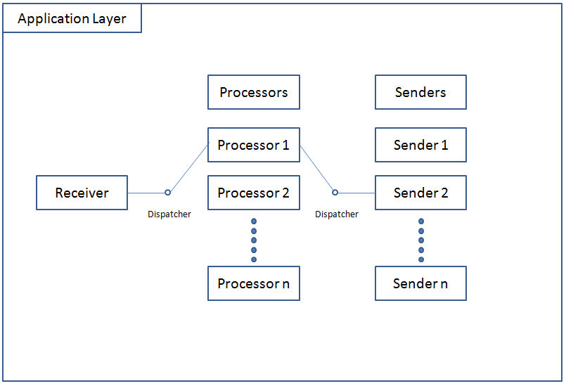

As Shown above, There are three important roles in Application layer. They are Receiver, Processors and Senders

When a receiver get message from lower network layer, It will trigger a callback which may be defined by user or a default one. If it need to process the received message, it will run a dispatcher to decide in which processor to process the data. After process the data, a response may need to send through Senders. Then, the message will be push into a sender thread to send the data.