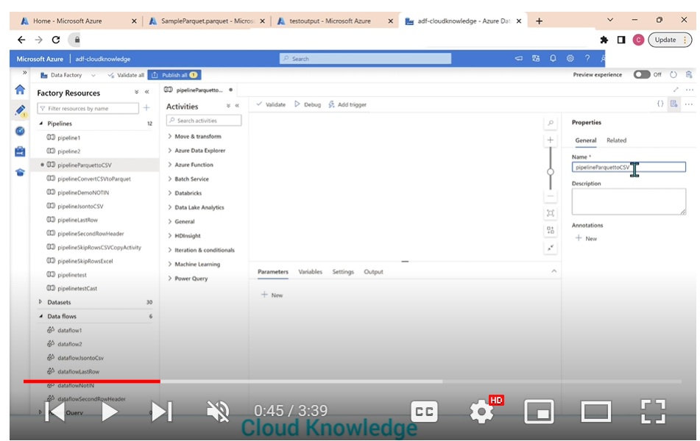

Pipelinename: pipelineparquettocsv

Copy activity🡺

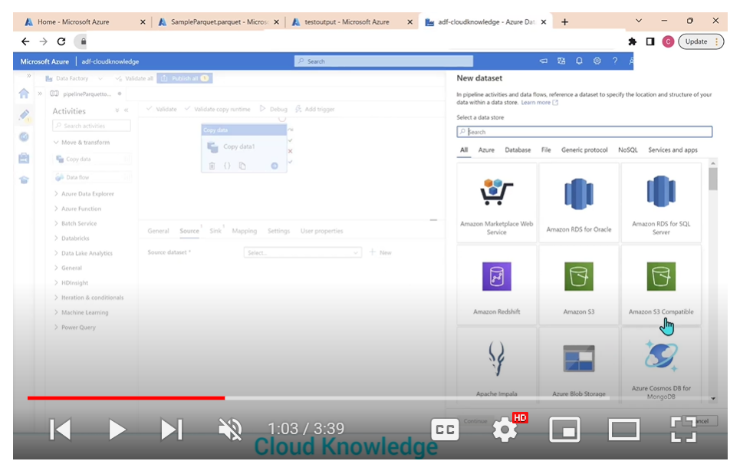

Create new data set=🡺 select adlsgen2

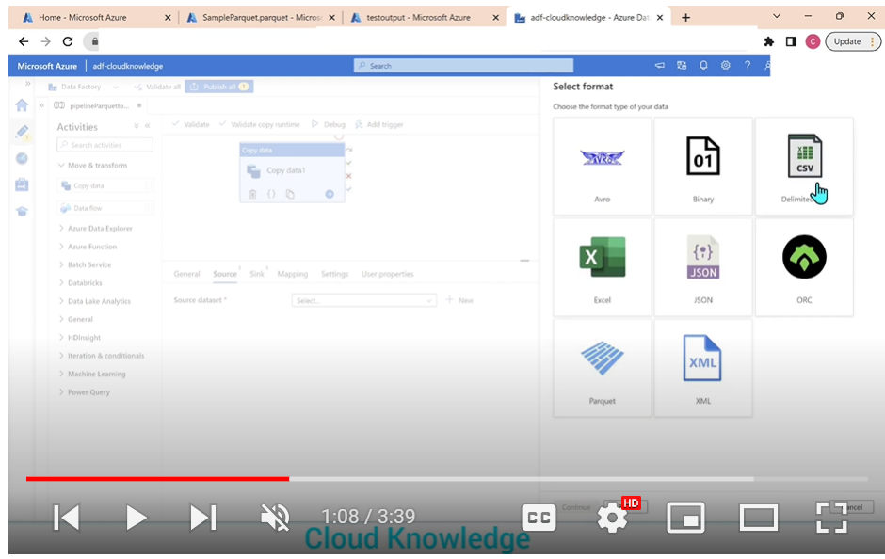

Select parquet

Now create linked sets

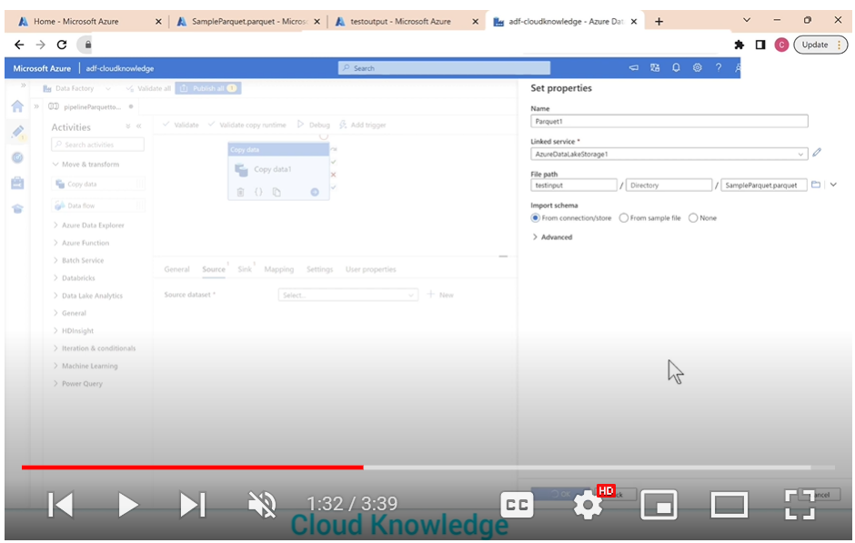

For Target create dataset =🡺 choose adlsgen2

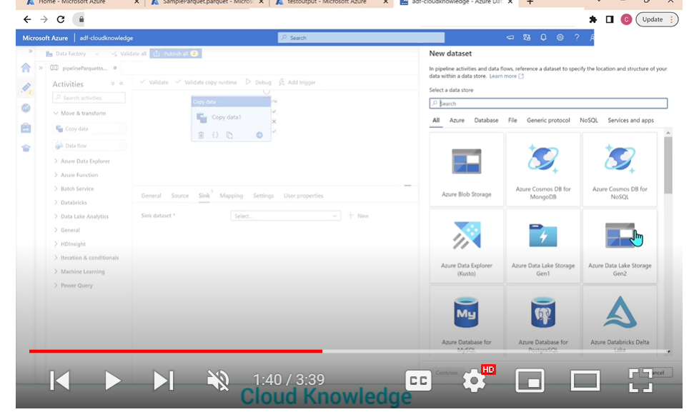

Choose delimiter text

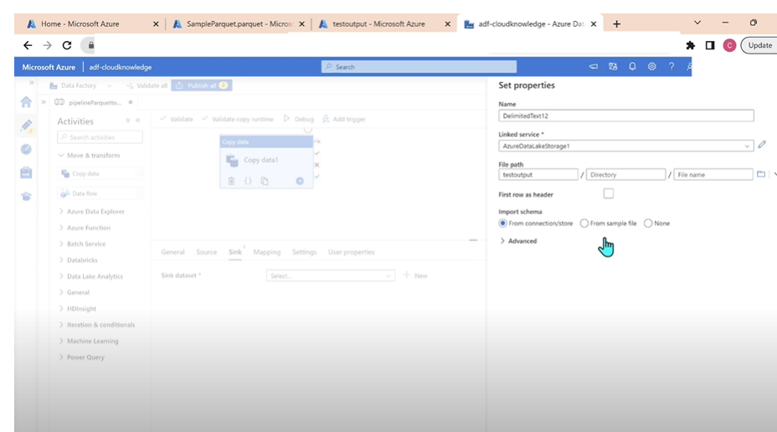

Select row as first header🡺 click on ok

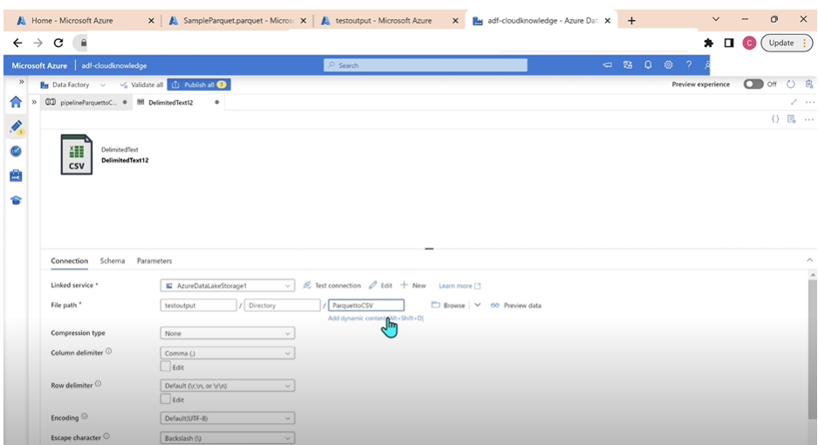

Parquettocsv.csv

Now validate the pipeline and debug it

Once the pipeline successed=🡺 verify now in storage to check whether the parquet converted or not

