Date: 5 September 2026
Author: Shashank Kaveti

Growth Areas

As I outlined in my personal manifesto, the growth areas I have currently identified to make me a better person are:
- Mental
- Physical
- Financial
- Emotional/Spiritual/Relational (we’ll just say “Spiritual”)
- Professional
I’ll use this document to expand on these areas a little bit more and what I can do to grow in said areas, but here’s what I’m envisioning- an app to track the growth. Since I bought this laptop and started this effort to become a better person I also want to make it personalized, technological, and organized in a way that I like. Yes, it is a fresh start, but it feels nice.
Also, here’s a graph that I recently learned about and liked- maybe I will use it to track my growth. Be kind, it is just a draft- but I want to depict growth in each category as an endpoint on the pentagon. I’ll refine it further soon:
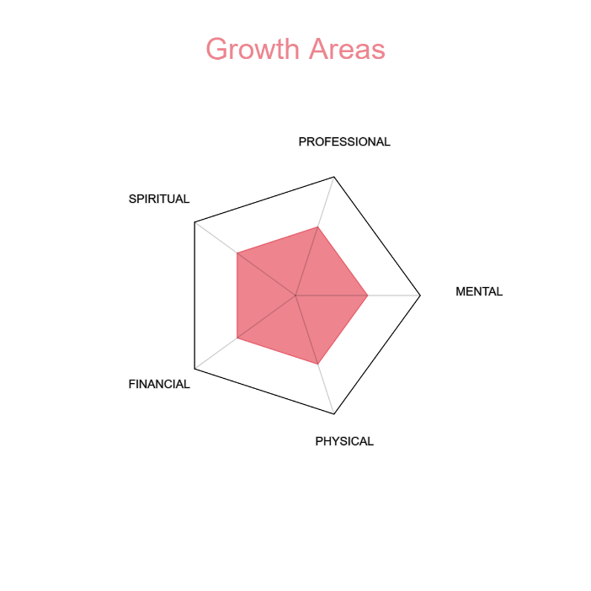

Perhaps I am too trigger-happy, but I want to get building. While this spirit is great- I also want to (and quite honestly need to) learn. If I am to build, I need to understand what I am building. So I’ll start my learning journey as soon as I can.

The Man I Want to Be is…

Mentally:
- In control of his thoughts and emotions
- Focused
- Strong
- Positive
- Hopeful
- Intelligent
- Intuitive
- Sharp
- Witty
- Charming
- Flexible
- Youthful
- Stable- even in the mind’s wildest storms
- Regulated- ice in his veins
- Confident
- Fearless

Physically:
- Very fit
- Slender
- Toned
- Strong
- Glowing
- Beautiful
- Fresh
- Poised- confident
- Well-groomed
- Fragrant
- Young
- Full of vitality
- Energetic
- Agile
- Fast
- Flexible
- Well-rested
- Calm
- Stable

Financially:
- Stable
- Growing
- Wealthy
- Giving
- Rich
- Luxurious, but ethical
- Top-shelf
- Charitable
- Abundant
- Smart
- Resourceful
- Courageous
- Generous
- Providing
- Powerful, but judicious
- Down to Earth
- 1% but humble

Spiritually:
- Benevolent
- Kind
- Well-mannered
- Dharmic above everything else
- Detached from the outcome, but involved in the process
- Meditative
- Powerful
- Energetic
- Mature, but fun-loving
- Intelligent
- Calm
- Caring
- Thoughtful
- Strong
- Fresh
- Authentic
- Expressive- unafraid to be himself
- A refuge for others
- A Guru- a guide for others in need
- Connected- to others, to this planet, and to the divine
- Fatherly
- Big-brotherly
- The X-factor
- A ball of energy
- Aura!
- Family to everyone
- Loving
- Responsible
- Healing

Professionally:
- Successful
- Strong
- Passionate
- Intelligent
- Resourceful
- Helpful
- Collaborative
- Humble
- The best at whatever he does
- Legendary
- Stalwart
- One of a kind
- Irreplaceable
- A leader
- A Lion amongst men!

9/18/2026
I think I have an idea of how to go about this: a mobile app I can use to guide myself to become better in said areas and grow. I’ll hesitate no longer and start the design process of it right away. My hands are itching to plan it all out and have AI build it. I want to make this app and use it by Monday. Here are the action items for me:
- List all requirements of the app
- Design how the app will help me grow in the areas highlighted above
- Buy an Android smartphone (should be very cheap)
- Refine requirements to design MVP
- Build and test MVP until it is stable
- Launch the app and start using it on Monday (9/21/2026)

