PYTHON ACTIVITY-BASED LEARNING
10 Selected Beginner-Friendly Case Studies
Complete Assignment: Problem Statement, Objectives, Assumptions, Algorithm, Flowchart, Pseudocode, Python Code, Test Cases, Sample Output and Conclusion

Student Name | ________________________________
Roll Number | ________________________________
Branch / Section | ________________________________
Subject | Python Programming

Selected question numbers: 12, 13, 16, 18, 27, 29, 35, 51, 53 and 63.
Note: The output images are illustrative sample console outputs created from the sample inputs. If your faculty requires original screenshots, run each program in PyCharm and replace these images with screenshots from your own run.

Question 12 – Attendance Recovery Computation

1. Problem Statement
Calculate a student's attendance percentage from the total classes and attended classes. Check whether the student meets the 75% attendance requirement.

2. Objectives
- Read values using input().
- Calculate a percentage using arithmetic operators.
- Use if-else to decide examination eligibility.

3. Assumptions
- The total number of classes must be greater than zero.
- Attended classes must be between zero and total classes.
- The required attendance threshold is 75%.

4. Algorithm
- Start the program.
- Read total classes and attended classes.
- Validate the entered values.
- Calculate attendance = (attended / total) × 100.
- If attendance is at least 75%, display Eligible; otherwise display Not eligible.
- Stop.

5. Flowchart
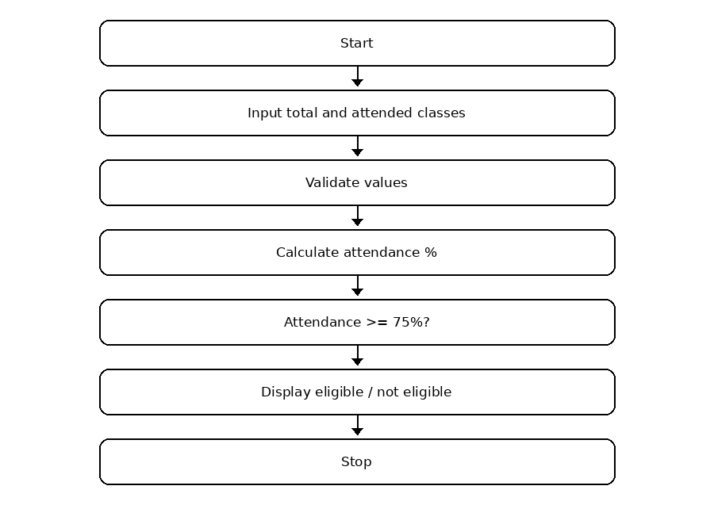

6. Pseudocode
START
INPUT total_classes, attended
IF total_classes <= 0 OR attended < 0 OR attended > total_classes
DISPLAY invalid input
ELSE
percentage = attended / total_classes * 100
DISPLAY percentage
IF percentage >= 75
DISPLAY Eligible
ELSE
DISPLAY Not eligible
ENDIF
ENDIF
STOP

7. Python Source Code
total_classes = int(input("Enter total classes: "))
attended = int(input("Enter attended classes: "))
if total_classes > 0 and 0 <= attended <= total_classes:
percentage = (attended / total_classes) * 100
print("Attendance:", round(percentage, 2), "%")
if percentage >= 75:
print("Eligible for examination")
else:
print("Not eligible for examination")
else:
print("Please enter valid class counts.")

8. Test Cases
Test | Input | Expected result
1 | 40, 32 | Attendance: 80.0 % | Eligible for examination
2 | 40, 20 | Attendance: 50.0 % | Not eligible for examination

9. Sample Output Screenshot
Illustrative console output for the sample test:
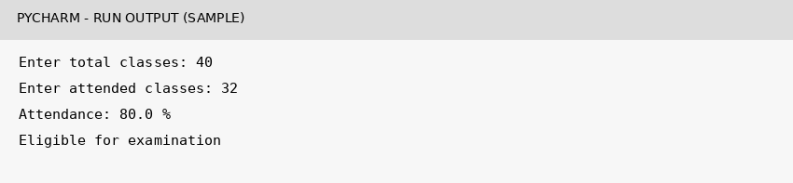

10. Conclusion
Thus, Question 12 was implemented using basic Python concepts. The program accepts input, processes it according to the given conditions, and displays the expected result.

Question 13 – ATM Transaction Simulation

1. Problem Statement
Simulate a simple ATM transaction. Start with a balance of ₹5000, add a deposit, process a withdrawal if sufficient balance is available, and display the final balance.

2. Objectives
- Store and update an account balance.
- Use arithmetic operators for deposit and withdrawal.
- Use conditions to validate transactions.

3. Assumptions
- The starting balance is ₹5000.
- Deposit and withdrawal amounts are whole numbers.
- Negative transaction amounts are invalid.

4. Algorithm
- Start with balance = 5000.
- Read deposit amount and add it if it is non-negative.
- Read withdrawal amount.
- If withdrawal is valid and not greater than balance, subtract it.
- Otherwise display an error message.
- Display final balance and stop.

5. Flowchart
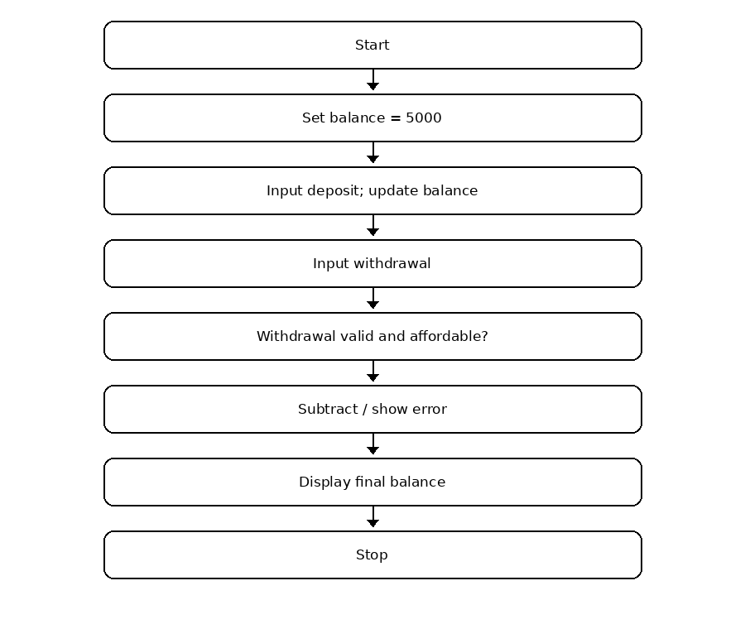

6. Pseudocode
START
balance = 5000
INPUT deposit
IF deposit >= 0: balance = balance + deposit
INPUT withdraw
IF 0 <= withdraw <= balance
balance = balance - withdraw
DISPLAY successful
ELSE
DISPLAY invalid / insufficient balance
ENDIF
DISPLAY balance
STOP

7. Python Source Code
balance = 5000
deposit = int(input("Enter deposit amount: "))
if deposit >= 0:
balance = balance + deposit
else:
print("Invalid deposit amount")
withdraw = int(input("Enter withdrawal amount: "))
if 0 <= withdraw <= balance:
balance = balance - withdraw
print("Withdrawal successful")
else:
print("Invalid amount or insufficient balance")
print("Final balance:", balance)

8. Test Cases
Test | Input | Expected result
1 | 1000, 2000 | Withdrawal successful | Final balance: 4000
2 | 0, 7000 | Invalid amount or insufficient balance | Final balance: 5000

9. Sample Output Screenshot
Illustrative console output for the sample test:
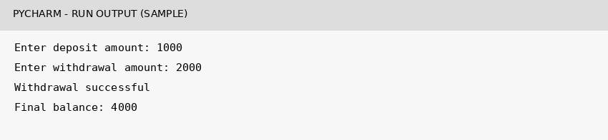

10. Conclusion
Thus, Question 13 was implemented using basic Python concepts. The program accepts input, processes it according to the given conditions, and displays the expected result.

Question 16 – Multi-Day Water Tank Simulation

1. Problem Statement
Calculate the water level in a tank after adding inflow and subtracting outflow. Detect overflow or shortage and display the final level.

2. Objectives
- Update a variable using arithmetic operations.
- Apply if-elif-else conditions.
- Understand capacity limits.

3. Assumptions
- Tank capacity is 1000 litres.
- Initial water level is 500 litres.
- Inflow and outflow are non-negative whole numbers.

4. Algorithm
- Start with capacity = 1000 and water = 500.
- Read inflow and outflow.
- Calculate water = water + inflow - outflow.
- If water exceeds capacity, report overflow and set it to capacity.
- If water is below zero, report shortage and set it to zero.
- Display current water level and stop.

5. Flowchart
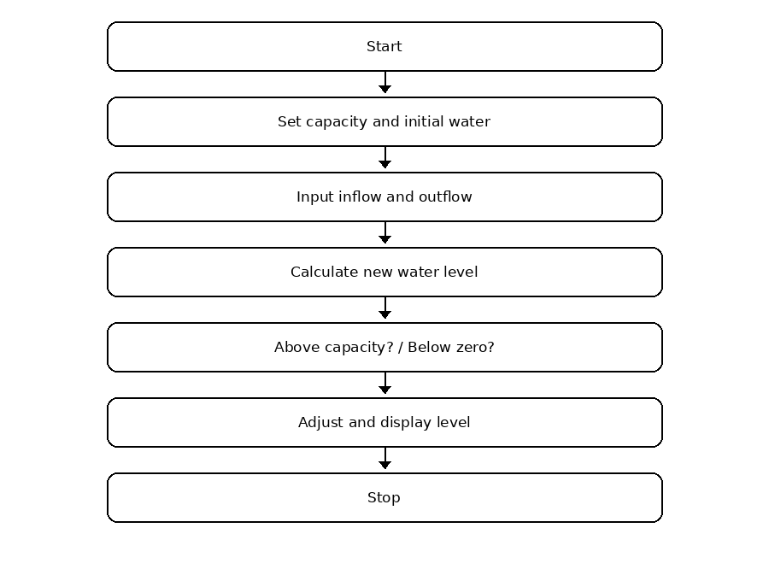

6. Pseudocode
START
capacity = 1000; water = 500
INPUT inflow, outflow
water = water + inflow - outflow
IF water > capacity
DISPLAY overflow; water = capacity
ELSE IF water < 0
DISPLAY shortage; water = 0
ENDIF
DISPLAY water
STOP

7. Python Source Code
capacity = 1000
water = 500
inflow = int(input("Enter water inflow: "))
outflow = int(input("Enter water outflow: "))
if inflow >= 0 and outflow >= 0:
water = water + inflow - outflow
if water > capacity:
print("Water overflow")
water = capacity
elif water < 0:
print("Water shortage")
water = 0
print("Current water level:", water, "litres")
else:
print("Enter non-negative values.")

8. Test Cases
Test | Input | Expected result
1 | 300, 200 | Current water level: 600 litres
2 | 700, 100 | Water overflow | Current water level: 1000 litres

9. Sample Output Screenshot
Illustrative console output for the sample test:
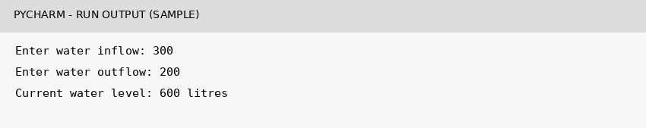

10. Conclusion
Thus, Question 16 was implemented using basic Python concepts. The program accepts input, processes it according to the given conditions, and displays the expected result.

Question 18 – Fuel Consumption and Route Comparison

1. Problem Statement
Calculate the fuel required for a journey and its total fuel cost using distance, vehicle mileage, and fuel price per litre.

2. Objectives
- Use float values for measurements and prices.
- Perform division and multiplication.
- Validate input values.

3. Assumptions
- Distance and fuel price cannot be negative.
- Mileage must be greater than zero.
- Mileage is measured in kilometres per litre.

4. Algorithm
- Start the program.
- Read distance, mileage, and price per litre.
- Check that distance and price are non-negative and mileage is positive.
- Calculate fuel = distance / mileage.
- Calculate cost = fuel × price.
- Display fuel and cost; stop.

5. Flowchart
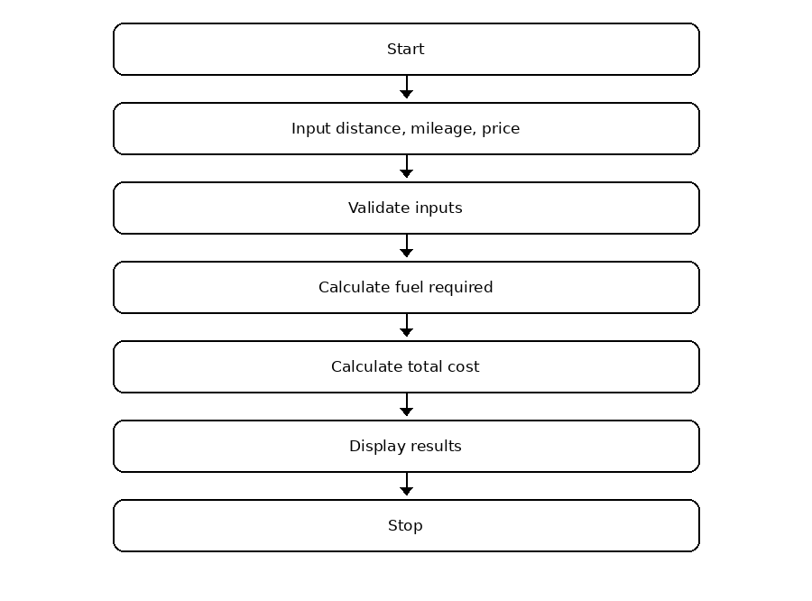

6. Pseudocode
START
INPUT distance, mileage, price
IF distance >= 0 AND mileage > 0 AND price >= 0
fuel = distance / mileage
cost = fuel * price
DISPLAY fuel, cost
ELSE
DISPLAY invalid values
ENDIF
STOP

7. Python Source Code
distance = float(input("Enter distance in km: "))
mileage = float(input("Enter mileage (km per litre): "))
price = float(input("Enter petrol price per litre: "))
if distance >= 0 and mileage > 0 and price >= 0:
fuel = distance / mileage
cost = fuel * price
print("Fuel required:", round(fuel, 2), "litres")
print("Total fuel cost:", round(cost, 2))
else:
print("Please enter valid values.")

8. Test Cases
Test | Input | Expected result
1 | 150, 15, 100 | Fuel required: 10.0 litres | Total fuel cost: 1000.0
2 | 100, 0, 100 | Please enter valid values.

9. Sample Output Screenshot
Illustrative console output for the sample test:
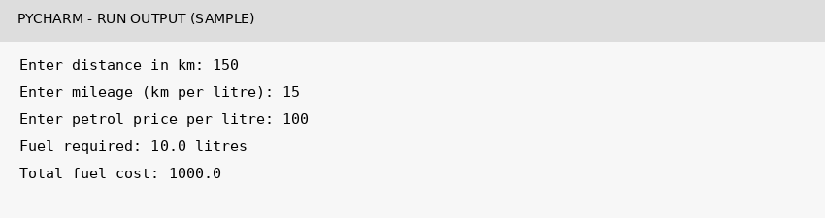

10. Conclusion
Thus, Question 18 was implemented using basic Python concepts. The program accepts input, processes it according to the given conditions, and displays the expected result.

Question 27 – Advanced Numeric Pattern Generator (Simple Number Triangle)

1. Problem Statement
Generate a right-angled number triangle using nested loops. The user enters the number of rows.

2. Objectives
- Use for loops and range().
- Understand nested loops.
- Generate a simple number pattern.

3. Assumptions
- The number of rows must be a positive integer.
- The pattern prints numbers from 1 to the current row number.

4. Algorithm
- Start the program.
- Read the number of rows.
- If rows are positive, run an outer loop from 1 to rows.
- For each row, run an inner loop from 1 to the row number and print each number.
- Move to a new line after each row.
- Otherwise display an error; stop.

5. Flowchart
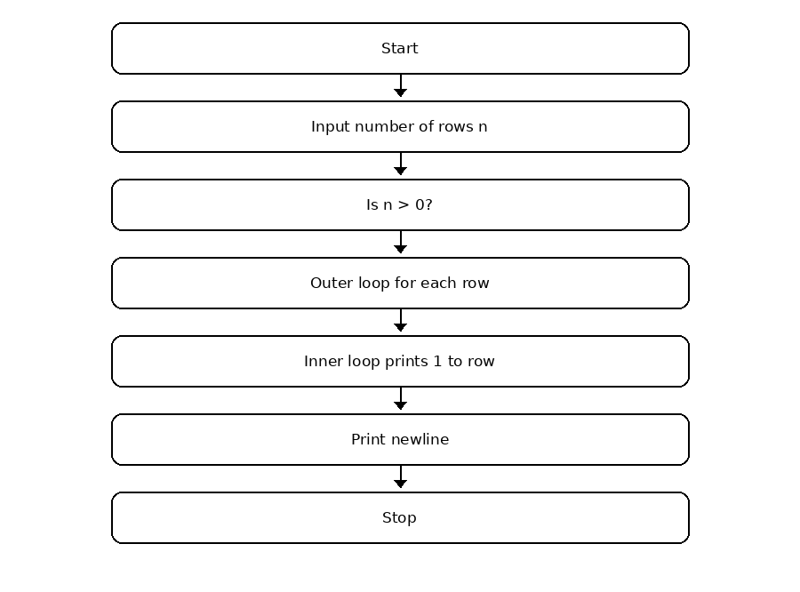

6. Pseudocode
START
INPUT n
IF n > 0
FOR i = 1 TO n
FOR j = 1 TO i
DISPLAY j without newline
ENDFOR
DISPLAY newline
ENDFOR
ELSE
DISPLAY enter positive rows
ENDIF
STOP

7. Python Source Code
n = int(input("Enter number of rows: "))
if n > 0:
for i in range(1, n + 1):
for j in range(1, i + 1):
print(j, end=" ")
print()
else:
print("Enter a positive number of rows.")

8. Test Cases
Test | Input | Expected result
1 | 5 | 1 / 1 2 / 1 2 3 / 1 2 3 4 / 1 2 3 4 5
2 | 0 | Enter a positive number of rows.

9. Sample Output Screenshot
Illustrative console output for the sample test:
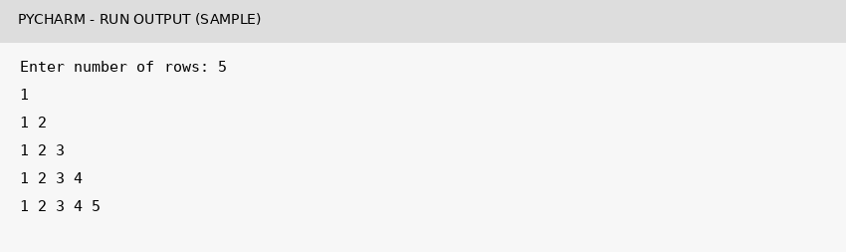

10. Conclusion
Thus, Question 27 was implemented using basic Python concepts. The program accepts input, processes it according to the given conditions, and displays the expected result.

Question 29 – Password Policy Validation Engine (Length Check)

1. Problem Statement
Check whether a sample password contains at least eight characters and display a suitable message.

2. Objectives
- Read and store a string.
- Use len() to find string length.
- Apply a conditional statement.

3. Assumptions
- The minimum required length is 8 characters.
- This simple program checks length only; it does not check uppercase letters, digits, or symbols.

4. Algorithm
- Start the program.
- Read the password.
- Find the number of characters using len().
- If length is at least 8, display Valid password.
- Otherwise display a message requesting at least 8 characters.
- Stop.

5. Flowchart
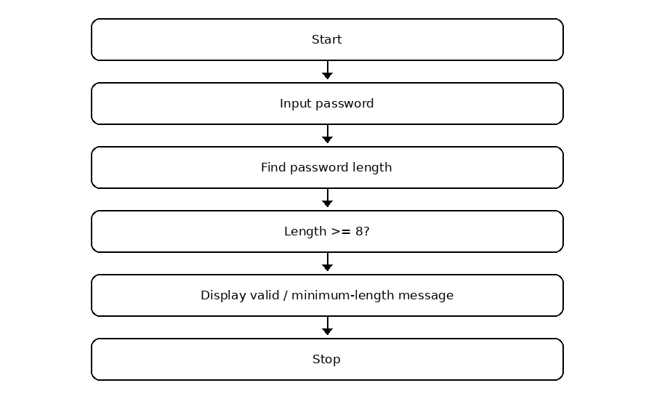

6. Pseudocode
START
INPUT password
length = LENGTH(password)
IF length >= 8
DISPLAY Valid password
ELSE
DISPLAY password must contain at least 8 characters
ENDIF
STOP

7. Python Source Code
password = input("Enter password: ")
if len(password) >= 8:
print("Valid password")
else:
print("Password must contain at least 8 characters")

8. Test Cases
Test | Input | Expected result
1 | python123 | Valid password
2 | abc123 | Password must contain at least 8 characters

9. Sample Output Screenshot
Illustrative console output for the sample test:
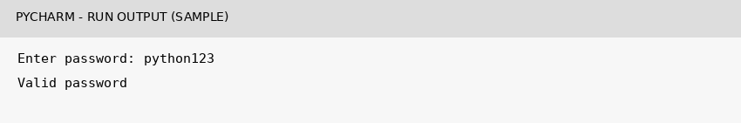

10. Conclusion
Thus, Question 29 was implemented using basic Python concepts. The program accepts input, processes it according to the given conditions, and displays the expected result.

Question 35 – Text Compression Using Character Runs

1. Problem Statement
Compress a string by replacing each group of consecutive repeated characters with the character followed by its count. Example: aaabb becomes a3b2.

2. Objectives
- Use string indexing and len().
- Use a loop and a counter.
- Build a result using string concatenation.

3. Assumptions
- The input is a non-empty string for the main example.
- Characters are compared exactly, including letter case.
- The output format is character followed by repetition count.

4. Algorithm
- Start the program and read a string.
- Set result to an empty string and count to 1.
- Visit each character using its index.
- If the current character equals the next character, increase count.
- Otherwise append the current character and count to result, then reset count to 1.
- Display the compressed string and stop.

5. Flowchart
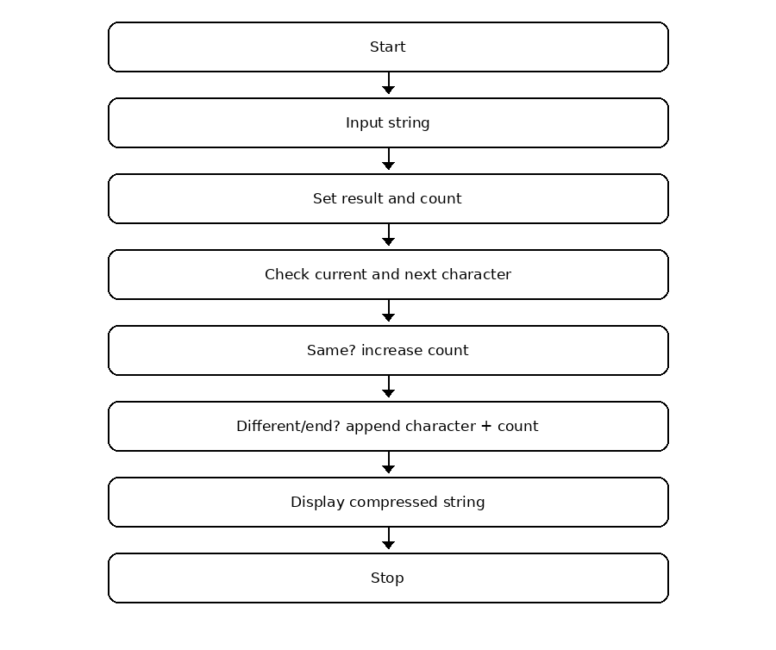

6. Pseudocode
START
INPUT text
result = empty string; count = 1
FOR each index i in text
IF next character exists AND text[i] = text[i+1]
count = count + 1
ELSE
result = result + text[i] + count
count = 1
ENDIF
ENDFOR
DISPLAY result
STOP

7. Python Source Code
text = input("Enter a string: ")
result = ""
count = 1
for i in range(len(text)):
if i < len(text) - 1 and text[i] == text[i + 1]:
count += 1
else:
result = result + text[i] + str(count)
count = 1
print("Compressed string:", result)

8. Test Cases
Test | Input | Expected result
1 | aaabbcccc | Compressed string: a3b2c4
2 | abcd | Compressed string: a1b1c1d1

9. Sample Output Screenshot
Illustrative console output for the sample test:
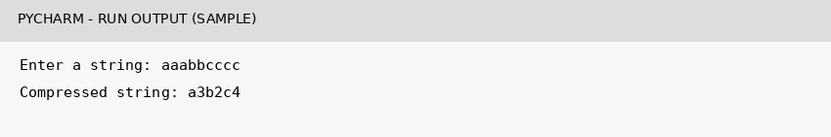

10. Conclusion
Thus, Question 35 was implemented using basic Python concepts. The program accepts input, processes it according to the given conditions, and displays the expected result.

Question 51 – Bus Passenger Occupancy Simulation

1. Problem Statement
Track passengers on a bus over three stops by adding boarding passengers and subtracting passengers who leave. Compare the passenger count with bus capacity.

2. Objectives
- Use a for loop for repeated stops.
- Update passenger count using arithmetic.
- Check capacity and validate passenger counts.

3. Assumptions
- Bus capacity is 50 passengers.
- The bus starts empty.
- Passengers leaving at a stop cannot exceed the passengers currently on the bus.

4. Algorithm
- Set capacity to 50 and passengers to zero.
- Repeat for three stops.
- Read boarding and leaving counts.
- Check that both are non-negative and leaving does not exceed current passengers.
- Update passenger count.
- Display the current count and report if capacity is exceeded.
- Stop after three stops.

5. Flowchart
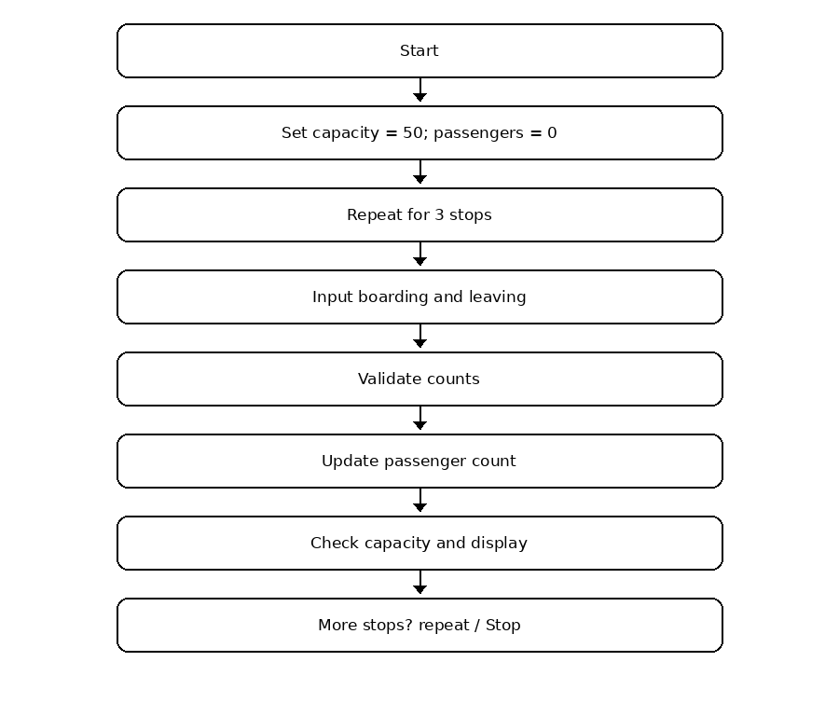

6. Pseudocode
START
capacity = 50; passengers = 0
FOR stop = 1 TO 3
INPUT boarding, leaving
IF boarding >= 0 AND leaving >= 0 AND leaving <= passengers
passengers = passengers + boarding - leaving
DISPLAY passengers
IF passengers > capacity: DISPLAY overloaded
ELSE
DISPLAY invalid passenger count
ENDIF
ENDFOR
STOP

7. Python Source Code
capacity = 50
passengers = 0
for i in range(1, 4):
print("Stop", i)
boarding = int(input("Enter boarding passengers: "))
leaving = int(input("Enter leaving passengers: "))
if boarding >= 0 and leaving >= 0 and leaving <= passengers:
passengers = passengers + boarding - leaving
print("Current passengers:", passengers)
if passengers > capacity:
print("Bus is overloaded")
else:
print("Invalid passenger count")

8. Test Cases
Test | Input | Expected result
1 | Stop 1: board 20, leave 0; Stop 2: board 10, leave 5; Stop 3: board 0, leave 10 | Final passenger count = 15
2 | At stop 1: board -2, leave 0 | Invalid passenger count

9. Sample Output Screenshot
Illustrative console output for the sample test:
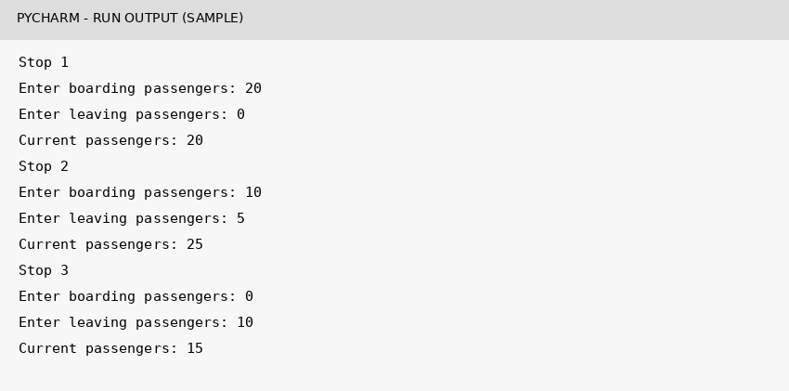

10. Conclusion
Thus, Question 51 was implemented using basic Python concepts. The program accepts input, processes it according to the given conditions, and displays the expected result.

Question 53 – Food Waste Monitoring System

1. Problem Statement
Calculate leftover meals and food-wastage percentage from meals prepared and meals served. Report high wastage if it is above 20%.

2. Objectives
- Calculate a difference and percentage.
- Use if-else to classify wastage.
- Validate meal counts.

3. Assumptions
- Prepared meals must be greater than zero.
- Served meals must be between zero and prepared meals.
- The high-wastage threshold is more than 20%.

4. Algorithm
- Read prepared and served meals.
- Validate prepared > 0 and 0 <= served <= prepared.
- Calculate waste = prepared - served.
- Calculate percentage = waste / prepared × 100.
- If percentage is above 20, display High food wastage; otherwise display acceptable.
- Stop.

5. Flowchart
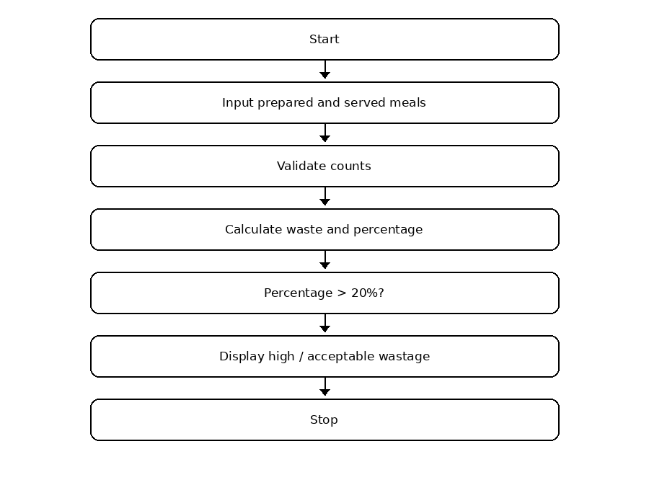

6. Pseudocode
START
INPUT prepared, served
IF prepared > 0 AND 0 <= served <= prepared
waste = prepared - served
percentage = waste / prepared * 100
DISPLAY waste, percentage
IF percentage > 20: DISPLAY High food wastage
ELSE: DISPLAY acceptable
ENDIF
ELSE
DISPLAY invalid meal counts
ENDIF
STOP

7. Python Source Code
prepared = int(input("Enter prepared meals: "))
served = int(input("Enter served meals: "))
if prepared > 0 and 0 <= served <= prepared:
waste = prepared - served
percentage = (waste / prepared) * 100
print("Wasted meals:", waste)
print("Waste percentage:", round(percentage, 2), "%")
if percentage > 20:
print("High food wastage")
else:
print("Food wastage is acceptable")
else:
print("Please enter valid meal counts.")

8. Test Cases
Test | Input | Expected result
1 | 100, 75 | Wasted meals: 25 | Waste percentage: 25.0 % | High food wastage
2 | 100, 90 | Wasted meals: 10 | Waste percentage: 10.0 % | Food wastage is acceptable

9. Sample Output Screenshot
Illustrative console output for the sample test:
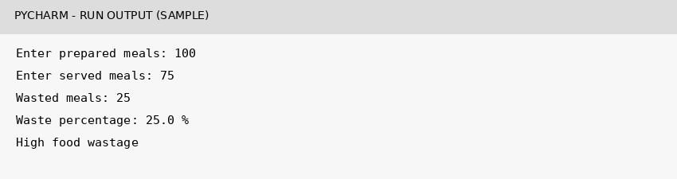

10. Conclusion
Thus, Question 53 was implemented using basic Python concepts. The program accepts input, processes it according to the given conditions, and displays the expected result.

Question 63 – Multi-Product Price Fluctuation Analysis (Single Product Example)

1. Problem Statement
Compare the old and new price of a product, calculate the percentage change, and identify whether the price increased, decreased, or stayed the same.

2. Objectives
- Calculate price difference and percentage change.
- Use if-elif-else to classify the change.
- Display the absolute percentage change.

3. Assumptions
- Old price must be greater than zero.
- New price cannot be negative.
- The percentage is calculated relative to the old price.

4. Algorithm
- Read old price and new price.
- Validate old price > 0 and new price >= 0.
- Calculate change = new price - old price.
- Calculate percentage = change / old price × 100.
- If change is positive, display increased; if negative, display decreased; otherwise display no change.
- Display absolute percentage change and stop.

5. Flowchart
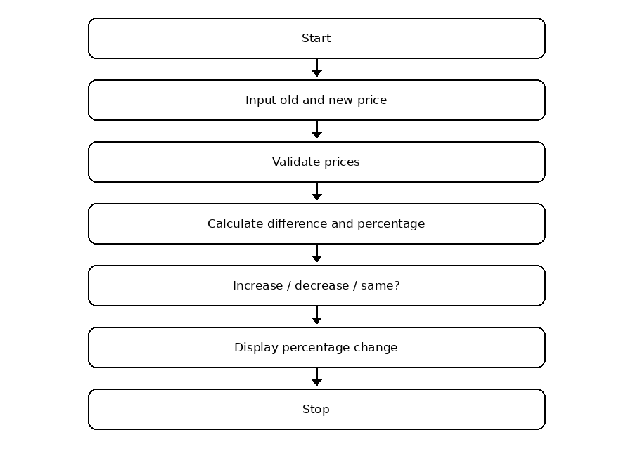

6. Pseudocode
START
INPUT old_price, new_price
IF old_price > 0 AND new_price >= 0
change = new_price - old_price
percentage = change / old_price * 100
IF change > 0: DISPLAY increased
ELSE IF change < 0: DISPLAY decreased
ELSE: DISPLAY no change
ENDIF
DISPLAY ABS(percentage)
ELSE
DISPLAY invalid prices
ENDIF
STOP

7. Python Source Code
old_price = float(input("Enter old price: "))
new_price = float(input("Enter new price: "))
if old_price > 0 and new_price >= 0:
change = new_price - old_price
percentage = (change / old_price) * 100
if change > 0:
print("Price increased")
elif change < 0:
print("Price decreased")
else:
print("No price change")
print("Price change percentage:", round(abs(percentage), 2), "%")
else:
print("Please enter valid prices.")

8. Test Cases
Test | Input | Expected result
1 | 100, 120 | Price increased | Price change percentage: 20.0 %
2 | 100, 80 | Price decreased | Price change percentage: 20.0 %

9. Sample Output Screenshot
Illustrative console output for the sample test:
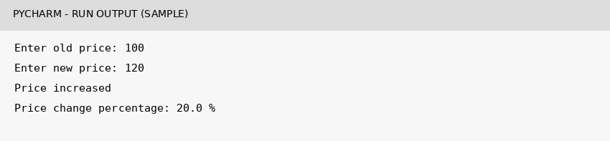

10. Conclusion
Thus, Question 63 was implemented using basic Python concepts. The program accepts input, processes it according to the given conditions, and displays the expected result.

