**MULTIPLE TDN drop condition:**

* **ATS loss train information: ATO.Train.*.Status.id = 0? ATO.Train.*.Status.communication_state = 0?**
* **ATR drop Train Run: ATO.Train.*.Status.dsp_tdn = 000 ?**
* **ATR drop Destination Platform: ATO.Train.*.Status.destination_platform= 0?, ATO.Train.*.Status.route = 0?**

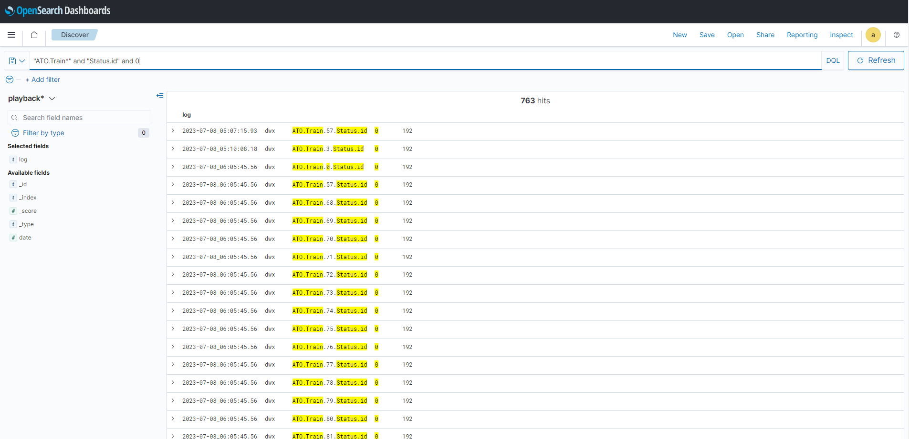

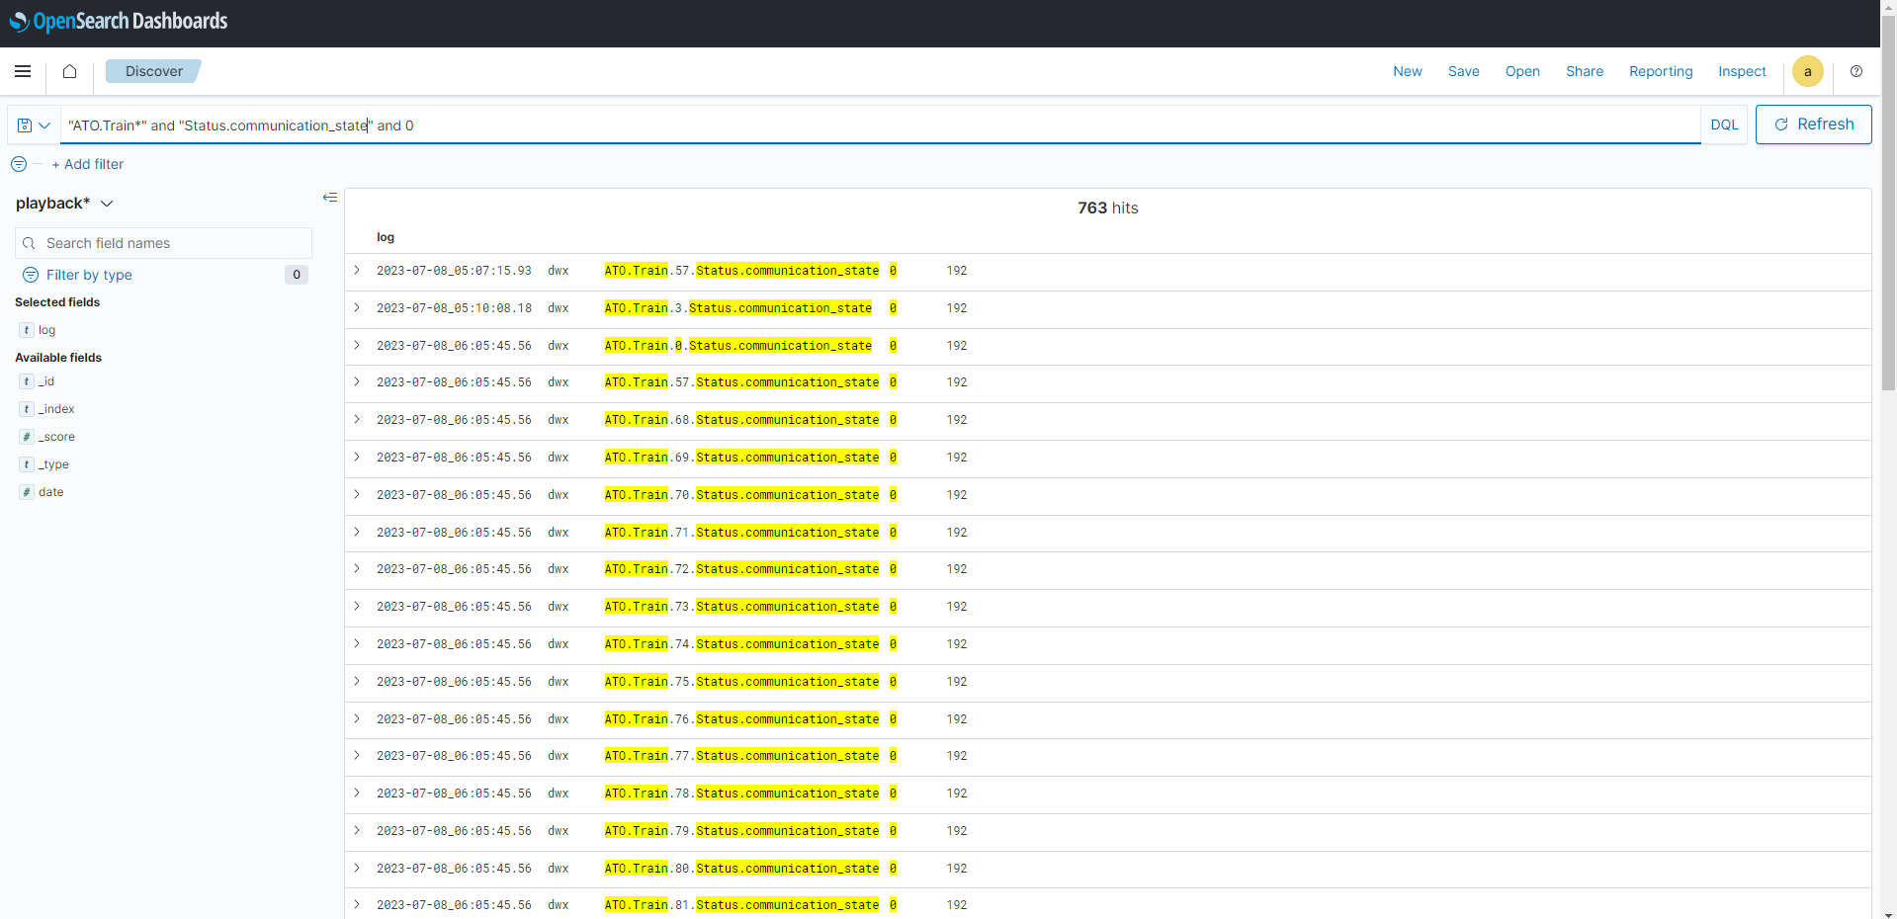

* **ATR drop Train Run: ATO.Train.*.Status.dsp_tdn = 000 ?**

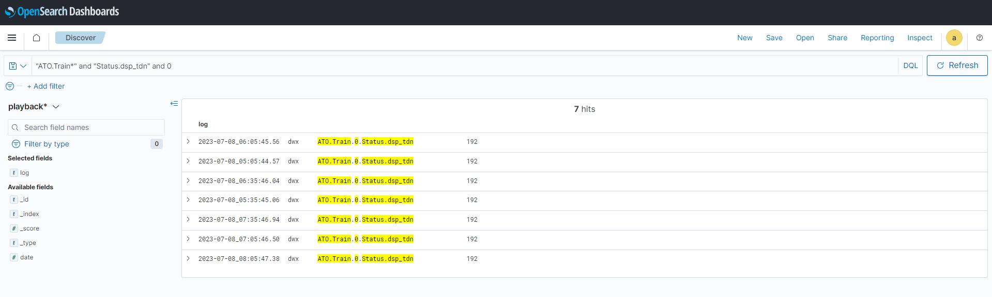

* **ATR drop Destination Platform: ATO.Train.*.Status.destination_platform= 0?, ATO.Train.*.Status.route = 0?**

