Assignment1

**Description:**

On this ecommerce website, toys are mainly sold. Users can check toy’s detail in item page and use the category function in homepage to find the toy they want. Furthermore, hot-selling toys are also provided on homepage to let users know about the current trending toys. In terms of purchase function, users can arbitrarily add toys from the Homepage or ToyDetailpage to the shopping cart. Finally, ContactUs and AboutUs contents are provided on homepage for the user to use.

**User stories:**

1. **Title:** View the hot-sell toys  
   **Story:** As a user, I want to see the hot-selling toys because I want to know what everybody like.  
   **Acceptance criteria:**
2. Toy’s image and name should be provided on Homepage.
3. **Title:** Provide ToyDetail page   
   **Story:** As a user, I want to know the toy’s detail.  
   **Acceptance criteria:**
4. Toy’s detail, such as name, description, category, price should be provided in ToyDetail page.
5. ToyDetail page should also provide add button for user to add toy in the cart.
6. **Title:** Allow user to use category filter  
   **Story:** As a user, I want a filter, so that I can easily find the toy I want.  
   **Acceptance criteria:**
7. Filter with different categories should be provided on Homepage.
8. **Title:** Provide shopping cart function  
   **Story:** As a user, I want to add and remove toy in the shopping cart, so that I can change my order.  
   **Acceptance criteria:**
9. User can add or remove toy in the shopping cart.
10. Provide adding function on home page and ToyDetail page.
11. Purchase list must be provided on ShoppingCart page.
12. Display total price below the purchase list.
13. **Title:** Allow user provide their detail to complete order  
    **Story:** As a user, I need to provide my detail on Order page, so that order can be finished.  
    **Acceptance criteria:**
14. Order popup should be provided.
15. User need to provide their name, email, phone number, and address to complete the order.
16. Order can be cancelled by press cancel button on Order page.
17. **Title:** Provide AboutUs content  
    **Story:** As a user, I want to know more about the website and the vender.  
    **Acceptance criteria:**
18. Provie a button to connect to AboutUs content on homepage.
19. Provide shop information on AboutUs page.
20. **Title:** Provide ContactUs content  
    **Story:** As a user, I want a contact to administer if I occur some problem on the website.

**Acceptance criteria:**

1. Provie a button to connect to ContactUs content on homepage.
2. Users need to provide their first name, last name, email, and content to response problem.
3. Provide a confirm button to let user send this letter.

**Conceptual Model:**

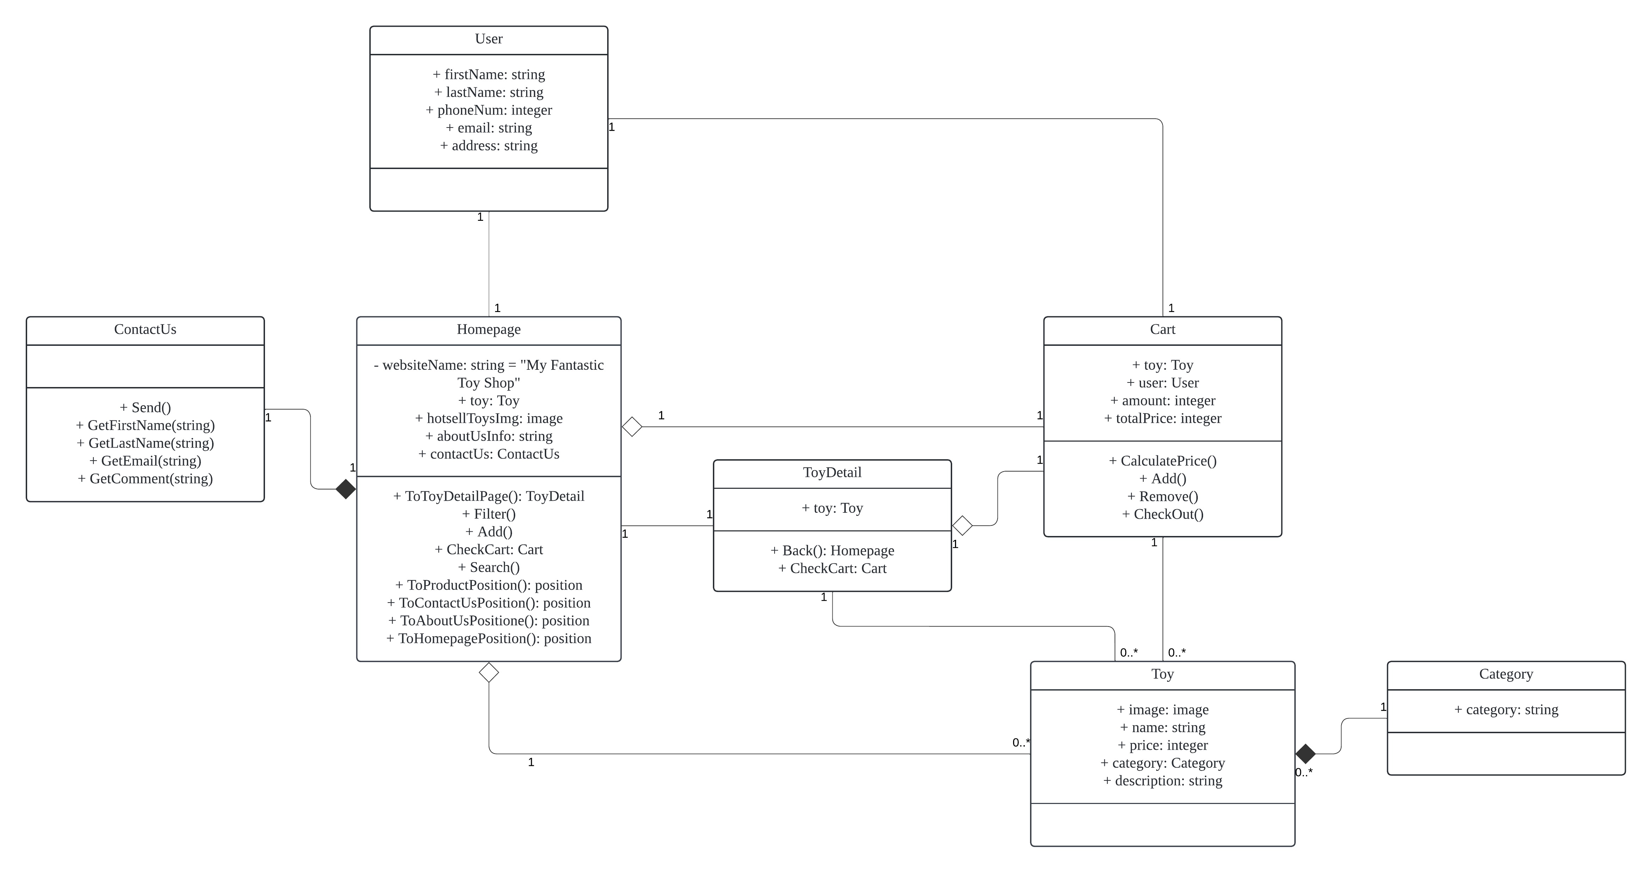

**Database Design:**

