|  |  |  |
| --- | --- | --- |
| **Problem Chosen** B | **2025 MCM/ICM Summary Sheet** | **Team Control Number** 2525796 |

**A study based on the Juneau model of sustainable tourism**

**Summary**

This study proposes and validates a sustainable tourism model for the city of Juneau, Alaska, USA, in response to the environmental and socio-economic challenges posed by the proliferation of tourists. The model takes into account factors such as tourist arrivals, tourism revenues, environmental impacts and infrastructure pressures through a dynamic planning approach to maximize the overall benefits of tourism.

Based on the actual data from 2018 to 2023, we consider the effect of seasonal fluctuations, introduce seasonal impact factors, and divide a year into two phases of off-season and peak season, respectively, to model the equations of the number of tourists, tourism revenue, environmental impact, and pressure on infrastructure, as well as the objective function of the final comprehensive benefits of tourism. And a forward recursive dynamic programming algorithm was used to find the maximum comprehensive benefits of $319 million and $15 million for peak and off-season, respectively, in the city of Juneau. The degree of influence of parameters such as seasonal influencing factors, promotional inputs, and per capita consumption on the model was analyzed through sensitivity analysis. Then the tourism sustainable rating evaluation model was established through AHP. The optimal value was scored on a ten-point scale, and a final composite score of 7.6 and 7.8 was obtained for Juneau City in the high and low seasons, both of which are high sustainable grades. The rationality of the optimal values was verified. We apply this model to Yellowstone National Park and demonstrate its adaptability and adjustment strategies in different tourist destinations by improving the original model appropriately.

With the improved model, we not only provide specific policy recommendations for the city of Juneau, but also a generalizable solution for other tourist cities facing similar problems.

**Keywords: Dynamic programming; AHP; Combined benefits; Sensitivity analysis**

Contents

1 Introduction 3

1.1 Problem Background 3

1.2 Restatement of the Problem 4

1.3 Literature Review 4

1.4 Our Work 5

2 Assumptions and Justifications 5

3 Notations 6

4 Sustainable tourism model 7

4.1 Modeling 7

4.1.1 Tourist arrivals model 7

4.1.2 Tourism revenue model 9

4.1.3 Environmental Stress Model 9

4.1.4 Infrastructure stress model 10

4.2 Establishment of the objective function 11

4.3 Restrictive condition 11

4.4 Final objective function 11

4.5 Dynamic Programming Model Solving 12

4.6 Sensitivity analysis 13

4.7 Optimal value comprehensive evaluation test 16

4.7.1 Defining objectives and hierarchies 17

4.7.2 Constructing a judgment matrix 17

4.7.3 Consistency test and calculation of weights 17

4.7.4 Scoring of sustainable tourism levels for optimal solutions 17

5 Model improvement and application 18

6 Model Evaluation and Further Discussion 20

6.1 Strengths 20

6.2 Weaknesses 21

6.3 Further Discussion 21

7 Conclusion 21

8 MEMO 23

References 24

# Introduction

## Problem Background

Juneau is the capital of the U.S. state of Alaska, located in the southeastern part of the state in the Inland Fjords region, and has a population of about 30,000.The city is an important tourist destination, known for its Mendenhall Glacier, rainforests, and abundant wildlife.20 In 2023, Juneau hosted a record 1.6 million cruise ship tourists, but it has also raised questions about the environmental pressures, infrastructure burdens, and impacts on the quality of life of the local population caused by excessive tourism. Most notable among these is the melting of glaciers in the area.

From 1770 to 1979, the volume loss of Juneau Icefield glaciers was between 0.65-1.01 cubic kilometers per year; from 1979 to 2010, it increased to 3.08-3.72 cubic kilometers per year; from 2010 to 2020, it reached 5.91 cubic kilometers per year. Since 2010, the loss of glaciers in the Juneau Icefield has increased dramatically, and the loss rate has doubled. The glacier area of ​​the entire ice field has shrunk five times faster from 2015 to 2019 than from 1948 to 1979.

The main reason is that due to the rapid development of tourism in Juneau City in recent years, the number of tourists has increased dramatically. On the one hand, a large number of tourists travel to Juneau City by cruise ships, airplanes, automobiles, and other means of transportation, which burn a large amount of fossil fuels and release a large amount of carbon dioxide and other greenhouse gases in the course of operation. On the one hand, in order to meet the demand of a large number of tourists, the city of Juneau needs to build more tourism infrastructure, such as hotels, parking lots, trails and so on. During the construction process, the ecological environment around the glacier will be damaged, changing the surface albedo and heat balance, making the glacier absorb more heat, and at the same time, the heat and waste generated by the construction activities, etc. will also have an impact on the glacier。

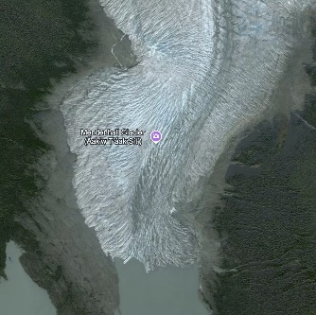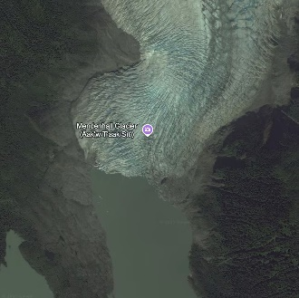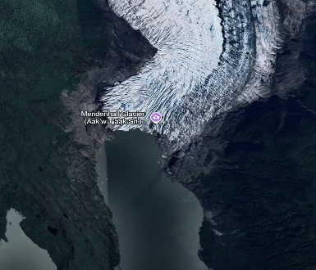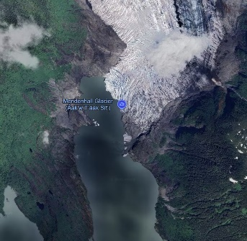

Mendenhall Glacier Map 2010, 2013, 2020, 2023

## Restatement of the Problem

Considering the background information and restricted conditions identified in the problem statement, we need to solve the following problems:

Problem 1: Design a sustainable tourism model for the City of Juneau that optimizes visitor numbers and revenues, considers environmental, social, and economic constraints, develops a spending plan, and performs a sensitivity analysis.

Problem 2: Explore how the model can be applied to other over-touristed areas, analyze key measures in different locations, and examine how the model can be used to promote a more balanced distribution of tourists.

Problem 3: Write a recommendation report for the City of Juneau Department of Tourism that proposes strategies and measures to optimize sustainable tourism development.

## Literature Review

Many scholars or journals have studied this issue. Among them, scholar Wang Jinwei[1], in his study of the problem, concluded that measures such as strengthening tourist education and promoting green travel can help to enhance the public's awareness of environmental protection and reduce the negative impacts of tourism activities on the environment .Rajashree Samaland and Madhusmita Dash[2] proposed ecotourism as a form of sustainable tourism, using an analysis to assess the internal and external factors affecting the ecotourism sector, and found that ecotourism enhances socio-economic well-being in the vicinity of some tourist destinations.。

## Our Work

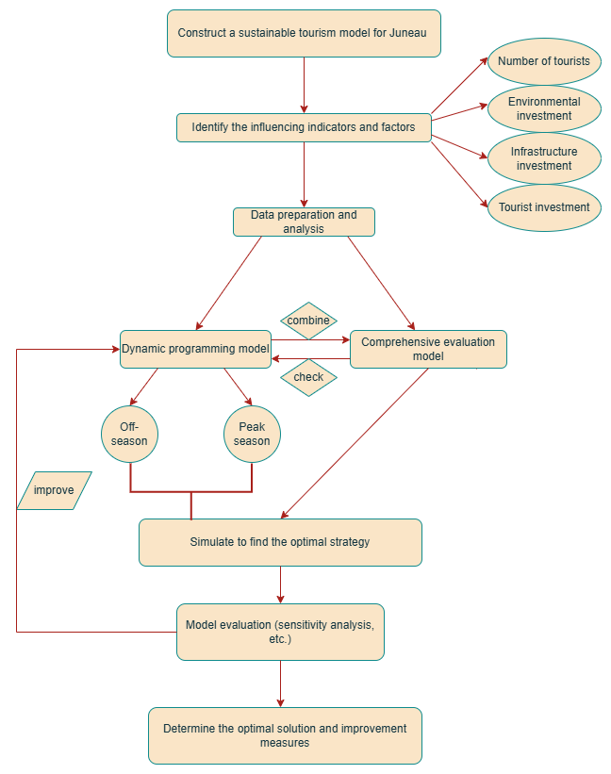

# Assumptions and Justifications

* Assumption: In the tourist quantity model, we give the quantity coefficientsTakes a constant value of 0.05.
* Justification: The determination of this coefficient requires a large number of publicity inputs, seasonal data, word-of-mouth evaluation and the number of tourists and other data, which is difficult to determine, and the value is taken in the range of 0.01 to 0.1, which can avoid too small a value, resulting in the growth of the number of tourists basically has no relationship with these factors, and can also avoid too large a value, resulting in the number of tourists growing too fast. Both are inconsistent with the actual law.
* Assumption: On the basis of the available data, we assume that the maximum capacity of tourists is different in the low and high seasons, which are 80,000 and 1.74 million respectively.
* Justification: The carrying capacity of infrastructure in the off-season and peak season, such as accommodation, transportation, and catering, will be very different. And the threshold is based on the maximum number of passengers in the off-season and peak season from 2018 to 2023, and taking 20% ​​more is relatively reasonable.
* Assumption: Impact factor of word-of-mouth evaluation in low and high seasonsand per capita consumptionare equal and the average tourists' travel time is about one week.
* Justification：Tourists' evaluation of the cultural essence of scenic spots generally does not vary greatly depending on the season, and at the same time, most of the tourists' consumption in the process of tourism is used for the most basic aspects such as lodging, transportation, food and scenic spot tickets, and generally does not generate large additional consumption because of the different seasons.
* Assumption: Local policies were relatively stable during the study period, with no major policy adjustments, no global public health events, and no economic crisis impacts.
* Justification: The occurrence and impact of emergencies are difficult to predict and evaluate artificially, so their occurrence is ignored in this paper.

# Notations

* + - * 1. Notations used in this paper

|  |  |  |
| --- | --- | --- |
| **Symbol** | **Description** | **Unit** |
|  | Number of visitors to Juneau at stage t | Person |
|  | Gross tourism receipts in Juneau at stage t | Dollar |
|  | Total cost of environmental governance in Juneau at stage t | Dollar |
|  | Total cost of infrastructure development in Juneau at stage t | Dollar |
|  | Maximum Passenger Capacity for the City of Juneau | Person |
|  | City of Juneau tourism inputs at phase t | Dollar |
|  | City of Juneau environmental inputs at phase t | Dollar |
|  | City of Juneau infrastructure inputs at phase t | Dollar |
|  | Advocacy input from the City of Juneau at phase t | Dollar |
|  | Peak Season Seasonal Influence Factor for the City of Juneau at Stage t | - |
|  | Off-season seasonal impact factor for the City of Juneau at stage t | - |
|  | Word-of-mouth evaluation coefficient for the City of Juneau at stage t | - |

# Sustainable tourism model

## Modeling

The extent of the city's combined tourism benefits also varies considerably at different times of the year, i.e., it is subject to the effects of different seasons. Therefore, the year can be analyzed by dividing it into two phases: the low season and the high season. That is, each year's peak season is analyzed in comparison with the previous year's peak season, and each year's off-season is analyzed in comparison with the previous year's off-season. T stage is selected from 2018 to 2023.

### Tourist arrivals model

|  |  |
| --- | --- |
|  | () |

|  |  |
| --- | --- |
|  | () |

Among other things, thefor advocacy inputs.is the seasonal impact factor.is the word-of-mouth impact coefficient.is the quantity coefficient.The equation shows that the number of tourists increases when there is more investment in publicity, during the high season, when word of mouth is good and when the tourist ceiling has not been reached.

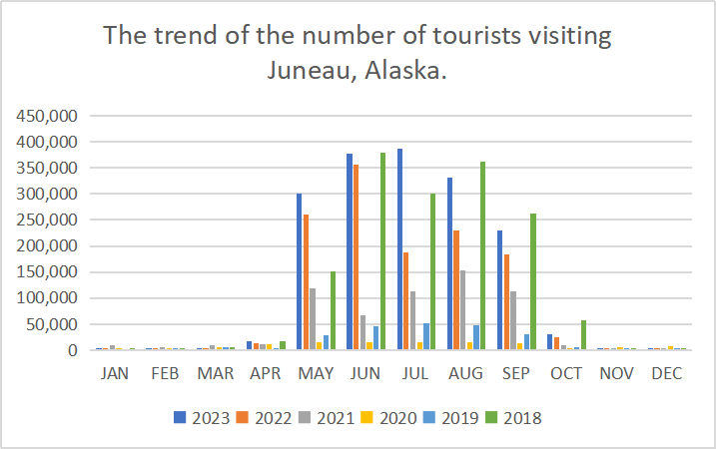

Figure 4.1.1.1

Using the number of visitors per month for the 2022 Mendenhall Glacier Visiting Cruise in Juneau as a reference, there is a chart that shows the City of Juneau is in a high season phase from May to September and a low season phase from October to April.

Seasonal influences during peak seasons*=2.32*

Seasonal influences during the off-season*=0.05*

whereis the monthly average number of tourists during the peak season. is the monthly average number of tourists in the off-season. is the monthly average number of visitors throughout the year.

According to official data from Travel Juneau, the official tourism promotion agency of Juneau, Alaska, in 2018, the total investment of the tourism industry in the local tourism industry was 236 million US dollars, and the publicity investment generally accounted for 3% to 5% of the total investment, that is, the publicity investment was 9.44 million US dollars. According to the hypothesis, the publicity investment in the off-season and the publicity investment in the peak season are both 1/2 of the total investment.

In a McKinley Research Group survey on tourism in Juneau in 2022, travelers' satisfaction with the process was mentioned.

Figure 4.11.2

We use the scoring model to calculate the word-of-mouth evaluation factor, set a full score of 8 points, feel very satisfied with the scenic spot will give full marks, that is, 8 points, and so on, feel satisfied with 6 points, feel the general give 4 points, feel dissatisfied with 2 points. Therefore, the comprehensive score of the scenic spot is 80.04+60.41+40.45 + 2= 4.78 points. Therefore= 4.78/8 = 0.5975.

### Tourism revenue model

|  |  |
| --- | --- |
|  | () |

|  |  |
| --- | --- |
|  | () |

Among them, theis per capita consumption, and the equation shows that tourism inputs affect per capita consumption and income growth, as influenced by the quality of tourism programs and services.

Get $3,798 per person by local stats, combining lodging, meals, transportation, and entrance fees.

### Environmental Stress Model

|  |  |
| --- | --- |
|  | () |

|  |  |
| --- | --- |
|  | () |

where CO2 is the per capita carbon emissions within the natural landscape.is the abiotic carbon emission.is the environmental input and p is the treatment cost per kilogram of carbon emissions. The equation shows that an increase in the number of tourists will increase the environmental impact, and environmental inputs will reduce the level of impact.

Since the treatment cost per kilogram of carbon emissions needs to consider too many factors and is difficult to determine accurately, this paper approximates the U.S. carbon tax as equivalent to its treatment cost, i.e., $0.055 per kilogram. And, from the literature survey, it is known that the per capita carbon emissions in the natural scenic area is 66.3 kilograms per person. Also, abiotic carbon emissions in recent years can be obtained from local statistical agencies. Together, they constitute the total pressure on the environment.

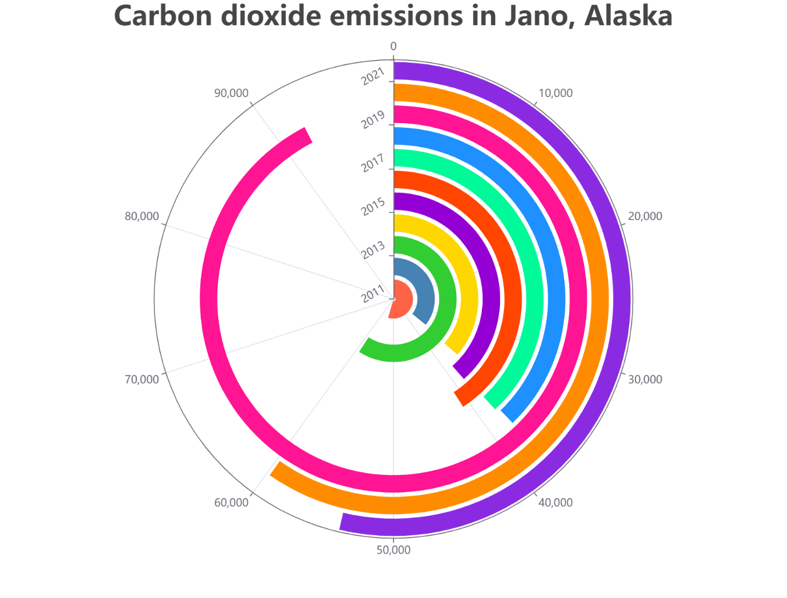

Figure 4.1.3

### Infrastructure stress model

|  |  |
| --- | --- |
|  | () |
|  | () |

where e is the local cost of electricity, s is the local cost of water, q is the local per capita consumption of electricity, w is the local per capita consumption of water, andis the infrastructure construction input, and the equation shows that an increase in tourists increases the pressure on the infrastructure and the construction input relieves the pressure on the infrastructure.

As shown by the statistics, the average cost of electricity in the United States is $0.1373/kWh, and the cost of electricity in Alaska is 1.12 times the average cost of electricity in the United States, which is $0.1538/kWh, and the per capita one-week electricity consumption of local tourists is 86.57 kWh/person. The cost of water in the region is $4.37/kilogallon, and the per capita weekly water use of local tourists is 1.06 kilogallons per person.

## Establishment of the objective function

With the objective of maximizing the sustainable development benefits of tourism in Juneau, an objective function can be obtained

|  |  |
| --- | --- |
|  | () |

Among other things, theis the weighting coefficient, which reflects the importance of environmental impact, infrastructure pressure and tourism income and can be adjusted according to the actual development needs. The weights of tourism income, environmental pressure and infrastructure pressure are 0.5396, 0.1047 and 0.3557, respectively, from the evaluation test model.

## Restrictive condition

|  |  |
| --- | --- |
| Infrastructure carrying constraints |  |
| Budget constraints on tourism inputs |  |
| Limitations on the number of visitors |  |
| Environmental impact threshold constraints |  |

## Final objective function

Peak season objective function

|  |  |
| --- | --- |
|  | () |

|  |  |
| --- | --- |
| Off-season objective function | () |

## Dynamic Programming Model Solving

Tourism inputs, environmental inputs, and infrastructure inputs can be obtained from local statistics for the City of Juneau from 2018 to 2023 for the peak and off-season tourism seasons, respectively. Considering that in 2019, due to the impact of the epidemic, the data of this year is very different from the data of other years. Because this paper removes the impact of epidemics and other emergencies from the assumptions, the data for 2019 are processed so that they conform to the pattern of data over the years.

Figure 4.5.1 Peak Season (Million)

Figure 4.5.2 Off-season (million)

Based on the searched data, the peak season and off-season are found by using the state transfer equations in the tourist model, tourism revenue model, environmental stress model and infrastructure stress model respectively(initial value).A forward recursive dynamic planning algorithm is used to automatically adjust the calculation under the constraints of maximum population capacity, maximum carrying capacity of infrastructure, and environmental impact thresholds, and finally outputs the ideal optimal value of the objective functionand find the corresponding values by backtracking,,,,to provide a specific decision-making basis for tourism planning in the City of Juneau.

After calculations, we finally obtained the optimal values of the combined tourism benefits and their corresponding optimal solutions for the city of Juneau in the off-season and peak season, respectively.

|  |  |  |  |  |  |
| --- | --- | --- | --- | --- | --- |
|  |  |  |  |  |  |
| Peak Season | 319.0776 | 1022680 | 36.7090 | 14.710 | 14.821 |
| Off-season | 15.3979 | 143296 | 0.7911 | 0.322 | 0.320 |

The units of the combined benefits, tourism revenue, environmental pressure, and infrastructure pressure are all in MILLIONS.

## Sensitivity analysis

As we are in the process of modeling and solving, the determination of some parameters is only based on more reasonable assumptions and based on the simple analysis of some actual data, and its true accuracy is still to be proved. Therefore, in this paper, we will analyze the sensitivity of these parameters, and determine the feasibility of the assumption for the model by the degree of influence on the optimal value of the objective function by floating these parameters within a certain range.

Parameters to be analyzed for sensitivity:

|  |  |  |  |
| --- | --- | --- | --- |
|  | volume factor |  | Environmental pressure coefficient |
|  | Infrastructure stress factor |  | Advocacy inputs |
|  | Seasonal impact factor |  | Word-of-mouth evaluation factor |
|  | Per capita consumption level |  | Tourism revenue weighting |
|  | Environmental stress weights |  | Infrastructure stress weights |

Peak Season:

take,,Fluctuations were made within a range of 5% up and down, and a total of 10 sets of data were taken.

Figure 4.6.1

From the figure, it is clear thatThe fluctuation of the fluctuation of the tourism industry has less impact on the comprehensive benefits of tourism, i.e., the model has less impact on the parametermore stable. And for,, due to the increase of the coefficients, the environmental pressure and the pressure of the infrastructure will also increase, making the final comprehensive benefits of tourism lower, and its fluctuation slope is relatively large, so the optimal selection of these two coefficients should be paid attention to.

take,fluctuates within a range of 10% up and down, and a total of 10 sets of data were taken.

Figure 4.6.2

From the figure, it is clear that,The fluctuation of the tourism industry has a small impact on the comprehensive benefits of tourism, mainly reflected in the seasonal impact factor and word-of-mouth evaluation factor in bringing tourists to promote tourism revenue at the same time will also bring due to tourists caused by the pressure on the environment and infrastructure, in a mutually constraining relationship, so that the model for the stability of the parameters of these two is high.

Take,In the range of 10% fluctuation up and down, 10 sets of data were taken.

Figure 4.6.3

From the figure, it can be seen thathas a greater impact on the comprehensive benefits of tourism, which is reflected as a positive effect, implying that the higher the promotional input and per capita consumption brings better tourism benefits. Therefore, for the feasibility of the model, the parameters of these two should be determined based on more accurate statistical data.

For the test of weights, since the change of one weight coefficient causes the change of other weight coefficients, we change the fluctuation value of one weight, the other two weight coefficients we compensate the coefficients according to the mutual occupancy of the two. Here, we take the fluctuation range of weights as 5% up and down.

Figure 4.6.4

From the figure, it can be seen thatThe impact on the comprehensive benefits of tourism is large and positive, because the weight of tourism income increases, and the weight of environmental and infrastructural pressures compensates for the decrease. So the determination of this parameter should be reasonable and accurate. Also, since the environmental and infrastructure pressures are constrained by each other, the model forMore stable.

The above steps were repeated to test the off-season scenario and it was found that the parameter sensitivity in the off-season was similar to that in the peak season.

## Optimal value comprehensive evaluation test

In order to test the reasonableness and feasibility of the optimal solution of the output of the above model, this optimal solution will be tested in this paper using the APH evaluation model.

### Defining objectives and hierarchies

City of Juneau Sustainable Tourism Rating

target layer

目标层

standardized layer

Level of environmental stress

Tourism revenues

Infrastructure stress situation

### Constructing a judgment matrix

Travel industry experts were invited to compare the guideline tiers two by two, using a 1-9 scale.

|  |  |  |  |
| --- | --- | --- | --- |
|  | Degree of tourism income | Degree of tourism income | Infrastructure stress situation |
| Degree of tourism income | 1 | 3 | 2 |
| Degree of tourism income | 1/3 | 1 | 1/2 |
| Infrastructure stress situation | 1/2 | 2 | 1 |

To obtain the judgment matrix A, the denotes the ratio of the relative importance of the ith indicator to the jth indicator.

A=

### Consistency test and calculation of weights

The consistency of the matrix can be judged to be good by CR = CI/RI = 0.0046/0.58 = 0.0079 < 0.1.

From the matrix, the weights of the degree of tourism income, environmental stress situation, and infrastructure stress situation are 0.5396, 0.1047, and 0.3557 in that order.

### Scoring of sustainable tourism levels for optimal solutions

The City of Juneau's tourism sustainability rating is evaluated on a scale of 10. 0 to 2 is very low, 2 to 4 is low, 4 to 6 is moderate, 6 to 8 is high, and 8 to 10 is very high.

Tourism revenues, environmental stresses and infrastructure stresses were quantified as scores F within 0 to 10 for off-season and high season, respectively.

Since tourism revenue is the bigger the better

As environmental stress scenarios and infrastructure stress scenarios are as low as possible

Peak Season:

Degree of tourism income= 8.1 points

Ambient pressure conditions= 6.7 points

Infrastructure stress situation= 7.2 points

The composite score for the peak season S = 8.10.5396+6.70.1047+7.20.3557 = 7.6 points. Tourism sustainability rating is high.

Off-season:

Degree of tourism income= 7.2 points

Ambient pressure conditions= 8.0 points

Infrastructure stress situation= 8.6 points

The composite score for the off-season S = 7.2 × 0.5396+8.0 × 0.1047+8.6 × 0.3557 = 7.8 points. Tourism sustainability rating is high.

|  |  |  |
| --- | --- | --- |
|  | Aggregate score | Sustainability rating |
| Peak Season | 7.6 | 高 |
| Off-season | 7.8 | 高 |

From the above test, it can be known that the optimal solution obtained by the dynamic planning tourism sustainability model is indeed in line with the better comprehensive benefits of urban tourism, but there is still a certain amount of room for improvement, indicating that the model also still exists a certain amount of room for optimization and improvement in order to get a better output variable to provide a more practical policy for the development of the city.

# Model improvement and application

After the establishment of the tourism sustainability modeling system is completed, we should consider its applicability to other similar tourism cities and make certain improvements.

We have analyzed the Yellowstone Park scenic area in the United States, which is also affected by over-tourism, by means of a Geographic Information System (GIS) model. Based on the selection of different locations, we can improve the original tourism sustainability model to some extent. Due to the influence of the epidemic year, we also need to deal with the outliers in the data to make them conform to the general pattern.

The first is the seasonal factor, because the nature of the attractions themselves and the local climate in different places can make the seasonal distribution of travelers vary greatly.Some attractions may have a high number of visitors throughout the year, while others may have a concentration of visitors during only a few months of the year. Determination methodology is the same as for the City of Juneau.

Figure 5.1

Seeking the peak season= 1.89, off-season= 0.11.

This is followed by the word-of-mouth evaluation factor, because different scenic spots will have different audience groups accounted for, therefore, each scenic spot in the evaluation of different travelers are not the same, therefore, different scenic spots tend to have different word-of-mouth evaluation factors. For Yellowstone Park, we still take the traveler satisfaction obtained from data statistics to rate.

Figure 5.2

Deriving the word-of-mouth evaluation factor= 0.675.

And finally, per capita consumptionBecause per capita consumption in different regions within a country often varies greatly due to the level of local economic development, price level, policy and market environment, etc., the value of per capita consumption often has a significant impact on the final output of the model. Therefore, the value of per capita consumption often has a great impact on the final target output of the model. Therefore, the per capita consumption in Yellowstone National Park is $4,052 based on local data.

After the parameters were improved, the Yellowstone data was substituted into the improved model. The final value of the output is obtained:

|  |  |  |  |  |  |
| --- | --- | --- | --- | --- | --- |
|  |  |  |  |  |  |
| Peak Season | 983.4512 | 3204865 | 101.1623 | 30.3235 | 35.1123 |
| Off-season | 50.4874 | 656523 | 23.1658 | 7.9874 | 6.3214 |

Substitute it into our evaluation and testing system.

|  |  |  |
| --- | --- | --- |
|  | 综合得分 | 旅游可持续等级 |
| 旺季 | 8.2 | 很高 |
| 淡季 | 7.7 | 高 |

From the results it is shown that our improved model outputs better values and it also shows that our model possesses better applicability.

Finally, we will build a simple scenic spot promotion model, if we are given a region, we calculate the number of tourists who will realize the optimal comprehensive benefits of tourism in that place after improving the seasonal factor, the word-of-mouth evaluation factor and the per capita consumption and other parameters through its relevant data. If>1, so do not publicize it at this time.On the contrary, if<1, it means that there are too few tourists at this time, and the attraction can be strongly promoted.Taking Yellowstone Park as an example, in 2023, the number of tourists in the peak season reaches 4.3 million, at this time>1, the number of people in the off-season is only 230,000, at this time<1.

# Model Evaluation and Further Discussion

## Strengths

Strength1: The model takes into account the number of tourists, tourism revenues, environmental pressures, and infrastructure pressures, and provides a more comprehensive picture of the complex system of tourism in Juneau, which contributes to the goal of sustainable development.

Strength2: Dividing the year into off-season and peak season for modeling separately, fully taking into account the differences in tourism patterns in different time periods, makes the modeling closer to the actual situation and improves the accuracy of the model.

Strength3: The model can dynamically optimize the development of the tourism industry through the comprehensive consideration of the dynamic planning objective function, and this dynamic planning method can better adapt to the dynamic changes in the development of the tourism industry and improve the scientific and applicability of the model.

Strength4： The setting of most of the parameters of the model is based on actual data. For example, the seasonal influence factor of the tourist model and the determination of the word-of-mouth evaluation coefficient all refer to the actual tourism data and related research in Juneau City, and this data-driven approach based on data can improve the scientificity and credibility of the model.

Strength5: Some assumptions in the model, such as the maximum capacity of tourists in low and high seasons, the proportion of publicity inputs, etc. are based on the actual data reasonably presumed, these assumptions not only simplify the complexity of the model, but also better reflect the actual situation, so that the model in the theory and practice to achieve a better balance between the

## Weaknesses

Weakness1: Some of the parameter assumptions are highly subjective, such as the quantity coefficientassumptions, which are not supported by sufficient data, may deviate significantly from reality and affect the accuracy of the model.

Weakness2: Some of the parameter assumptions are highly subjective, such as the quantity coefficientassumptions, which are not supported by sufficient data, may deviate significantly from reality and affect the accuracy of the model.

## Further Discussion

Improvement of the model: To address the subjectivity of the parameter assumptions, data should be further collected, and statistical analysis or machine learning algorithms should be used to determine more reasonable parameter values, at the same time, optimize the data acquisition channels, establish a more complete database, and improve the accuracy of the data, and finally, the structure of the model can be appropriately simplified, and the variables and equations can be reasonably integrated, so as to reduce the difficulty of solving the problem.

Expansion of the model: the model can be applied to different sizes and types of tourist cities to test its versatility, and on this basis, it can appropriately change the desired parameters, such as seasonal influence factor, word-of-mouth coefficient and so on. At the same time, new variables are introduced, such as the cultural value of tourism resources, the distribution of tourists' stay time, etc., to improve the comprehensiveness of the model, and combined with big data and real-time detection technology, to realize the dynamic updating of the model, and to reflect the changes in the tourism industry in a timely manner.

# Conclusion

By analyzing the actual data from 2018 to 2023, we constructed a complex model that includes several factors such as the number of tourists, tourism revenue, environmental management costs and infrastructure construction investment. The model was modeled and solved in detail according to the different characteristics of off-season and peak season.

The sensitivity analysis further validates the stability and applicability of the model, revealing the important influence of per capita consumption and promotional inputs on the overall tourism benefits. At the same time, we also emphasize the importance of reasonably setting the seasonal impact factor and word-of-mouth evaluation coefficient to ensure that the model can accurately reflect the actual situation and provide effective policy guidance. In addition, by extending the application to Yellowstone National Park, we demonstrate the model's adaptability in different geographic and cultural contexts, proving its broad generalizability.

This study not only suggests specific sustainable development strategies for the city of Juneau, such as increasing promotional investment, optimizing per capita consumption levels, and promoting a balanced distribution of tourists, but also provides lessons for other tourism cities around the world. We found that balancing economic efficiency and environmental protection is the key to achieving sustainable tourism development. Through rational resource allocation and scientific decision-making, the pressure on the natural environment can be reduced while boosting tourism revenue, ensuring the long-term healthy development of tourism.

# MEMO

Date: January 27, 2025

To: City of Juneau Tourism Commission

From: Team #2525796

Topic: Sustainable Tourism Strategies for the City of Juneau

Honorable members of the City of Juneau Tourism Commission,

We are honored to present our strategic recommendations aimed at enhancing the sustainability of Juneau's tourism industry. Our comprehensive model utilizes dynamic planning and sensitivity analysis to optimize the balance between visitor numbers, revenue expenditures, environmental protection, and infrastructure sustainability.

Our studies indicate that during peak season, Juneau could welcome approximately 1,022,680 visitors, generating about $319.08 million in tourism revenue, all while maintaining a sustainable carrying capacity for both environment and infrastructure. In contrast, during the low season, an optimal number of visitors is estimated at around 143,296, with projected revenues of $15.4 million. We recommend allocating $790,000 towards environmental protection measures and $320,000 for ongoing infrastructure improvements from these funds.

For long-term sustainable development, we propose strategically reinvesting additional revenues: $36.71 million to support environmental protection projects and $14.71 million for infrastructure development. During off-seasons, focus should be placed on maintenance and upgrading of existing facilities to ensure high-quality tourist services year-round.

Sensitivity analysis highlights the significant impact of per capita consumption levels and promotional efforts on tourism revenue. Thus, we advise implementing targeted promotional strategies during the off-season and educational programs promoting responsible tourism behaviors among visitors.

To distribute visitor traffic more evenly and reduce pressure on popular attractions, we suggest highlighting lesser-known sites within Juneau and developing new tours or enhancing existing ones to offer diverse experiences.

In terms of infrastructure and environmental protection, we propose using tourism tax funds to improve local waste management systems, public transportation, and support conservation projects.

Implementing these strategies will help Juneau maintain its status as a premier tourist destination while addressing environmental and social challenges, harmonizing economic growth with sustainable development.

We look forward to collaborating closely with the Juneau Tourism Commission to refine and implement these strategies for a prosperous and sustainable future for the City of Juneau.

# References

1. Wang Jinwei, Lu Guangjuan, Zhang Liyan ,et al.Mechanisms of climate change perception on the environmental responsibility behavior of urban residents in ice and snow tourism - A case study of Beijing[J].Geography Research,2023,42(02):440-457.
2. Samal R ,Dash M .From strengths to strategies: Mapping the sustainable path for ecotourism in Chilika wetland through SWOT-QSPM analysis[J].Journal for Nature Conservation,2025,84126817-126817.