**Purpose**

Hotpot is becoming more and more popular in Shenzhen nowadays. This case tries to give some advice to those people who still want to open a hotpot restaurant in Shenzhen recently.

There are two main points this case tries to figure out for them: 1) which kind of hotpot the mass like most about its taste, that means they can choose a similar flavor for their own restaurant to ensure a good reputation; 2) what areas include the most hotpot restaurants, that means they should be careful with these competitive areas.

**Scraping Process**

In order to achieve this goal, I scraped one of the website at the Dianping.com, containing the complete information of all the hotpot restaurants in Shenzhen.

* URL: <http://www.dianping.com/shenzhen/ch10/g110p49>
* Parameters: the restaurants’1)name, 2)score of taste, 3)address

**Problem**

The data preview in Jupyter Notebook is perfect but after outputting them in a csv file, they become a set of messy codes.

I used “utf8”to encode the data but it didn’t work.

In Jupyter Notebook:

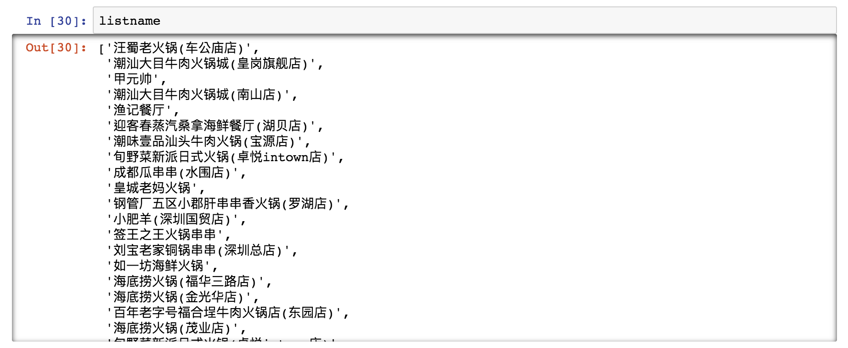

In csv file:

