Distributed Location-Assisted Multiple Access Scheme for Vehicular Ad Hoc Networks
Huimin Wu, Student Member, IEEE, Rong Yu, Member, IEEE, Shengli Xie, Senior Member, IEEE

I. Introduction
Mobile ad hoc network (MANET) is a type of self-organized wireless networks which is dynamically formed by a group of cooperative mobile nodes. Vehicular ad hoc network (VANET) is an important branch of MANET that consists of moving vehicles[1]. VANET is studied as a major part of the intelligent transport system (ITS) and is likely to become one of the most promising applications of MANET [2]. A VANET consists of a set of vehicles equipped with communication device, called on-board unit (OBU) , and a set of stationary units deployed along roads, called roadside unit (RSU). The main objective of a VANET is to allow a group of communication vehicles to set up and maintain a network among themselves, without the support of a base station or a centralized node; to provide reliable and efficient vehicle to vehicle (V2V) and vehicle to RSU (V2R) communications. Based on these two kinds of communications, VANETs can support many kinds of applications in safety, entertainment, and vehicle traffic optimization [1].
As a special type of MANET, VANETs have some distinct characteristics, such as: 1) the highly dynamic network topology; 2) instantaneity of the safety message; 3) predictable and regular movement trajectory of vehicles; 4) various qualities of service (QoS) requirements of potential application. These special characteristics result in significant challenges in the design of an efficient medium access control (MAC) protocol. Diverse MAC protocols have been proposed for VANETs based either on carrier sense multiple access (CSMA) or on channelization such as time division multiple access (TDMA). IEEE 802.11p is a recently proposed MAC standard for VANETs, which is based on CSMA. This protocol is based on the legacy IEEE 802.11 standard which is widely implemented. So, the most of the MAC protocol which is widely used in VANETs is based on CSMA [4][5]. The Carrier Sense Multiple Access (CSMA) based MAC protocol adopted in IEEE 802.11p has some inherent disadvantages because it cannot avoid collisions effectively and the channel switching scheme defined in IEEE 1609.4 might result in inefficient use of wireless resources [6]. In addition, the MAC protocol based on CSMA also suffers from serious problems such as low efficiency when the network has larger amount of nodes and the unreliable broadcast service which is subject to the hidden terminal problem [3]. ADHOC MAC is based on TDMA and is proposed for inter-vehicle communication networks [6]. Distinguishing form IEEE 802.11p, ADHOC MAC can support reliable broadcast service without the hidden terminal problem, and can cover the whole network using a significantly a smaller number of relaying nodes than that using a flooding procedure [3]. Moreover, ADHOC MAC can guarantee every node to access the channel at least once in every frame, which is adequate for the timeliness applications. The protocols in [7, 8, 9, 10, 11] are based on the TDMA mechanisms, in which TDMA slots are selected by the nodes themselves in a distributed manner. However, the TDMA slot allocation process is based on completely random contention. This means will result in a large overhead of time, which is not suitable for safety application which require fast reconfiguration and low message delivery latency.
Through the above analysis, we can summarize some difficult issues to design a MAC scheme to support non-delay-tolerant applications in VANET. First, there are no central entities like base stations can be used by the MAC layer in VANET to coordinate the allocation of TDMA slot. Second, the topology of VANETs is highly dynamic change caused by vehicle mobility because any vehicle may join and leave VANETs in an uncertain manner. Finally, real-time applications often have some requirements on quality of service (QoS) such as delay bound from the MAC layer [12]. Consequently, in order to address these difficulties, we should make full use of the characteristics of VANETs such as the information of vehicular location. However, along with the rapid advance of the global positioning system (GPS) technology and its applications, getting the information of vehicular location in VANET environments becomes feasible. In this paper, we proposed a novel decentralized location-based Randomized MAC protocol to cope with the delay bound problem in VANET. By the theoretical analysis and simulation , the proposed MAC protocol has reached an outstanding performance.
The rest of this paper is organized as follows. Section II describes the system model and the problem formulation is presented in Section III. The solution of this research is analyzed in Section IV. Section V presents the simulation results and explains some limitations of the novel MAC protocol. Finally, Section VI concludes this research and suggests some future works.

II. System model
A highway under consideration is regarded as the object of this study. And the highway is divided into several areas. In order to simplify the complexity of system model, we consider a one-way traffic road as an object of the research. The scenario of VANET consists of some vehicles distributing randomly in these areas and a set of RSUs distributing along the side of the road. The length of the area L is depended on the effective distance which can guarantee vehicles in this area to communicate with each other normally. In this study, the area is divided into N locations, and the probability P which any vehicles exist in each location is equivalent. Moreover, in order to make vehicles in the area access the channel in order, M time slots are allocated for the area, i.e., the vehicle in the area can communicate with each other by using the M time slots. We provide that P_{nm} expresses the probability which the vehicle in the N-th location occupies the M- th time slot. As shown in Fig.1.
1
M
2
3
……
M-3
M-2
M-1
p: the probability of the vehicle appears
P₁₁
P₄₁
Fig.1 Illustration of Location-based Randomized Channel Access scheme
1
2
4
3
……
N-3
N-2
N-1
N

Based on the above assumption, N*M unknown parameters can be obtained, such as P_{ij} (i = 1, 2, …, N; j = 1, 2, …, M). In this paper, we employ the genetic algorithm (GA) optimize the N*M unknown parameters. The objective of the optimization is to decrease the average collision probability (ACP) among the vehicles in the studied area. The optimum values of the probability accessing the time slot will be regarded as the basis of the vehicles access time slot. When the vehicle wants to choose a time slot to transmit information, it will occupy the corresponding time slots according to the probability distribution relating to location information that is P_{ij}. By using this incomplete random method to access the time slot is a method proposed by this paper. However, accessing the time slot by complete random way is another method that has already existed. Computing the average collision probability with these two methods respectively, we can found the expression of the average collision probability under the two different ways.

A. Average Collision Probability in Location-assisted Random Access Scheme
Under this method, we calculate the collision probability of the vehicle appears in every location to access the time slot. Then we add all the collision probabilities up to get the total collision probability. Let the total collision probability divide by the location number N, the average collision probability will be obtained. In order to introduce the computing process of the collision probability, we assume that a vehicle has existed in the first location and requested the time slot, which may be occupied by the vehicle on other locations. In the circumstances, the collision is appeared, and the collision probability model of the vehicle in the first location can be founded as:
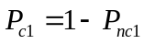 (1)
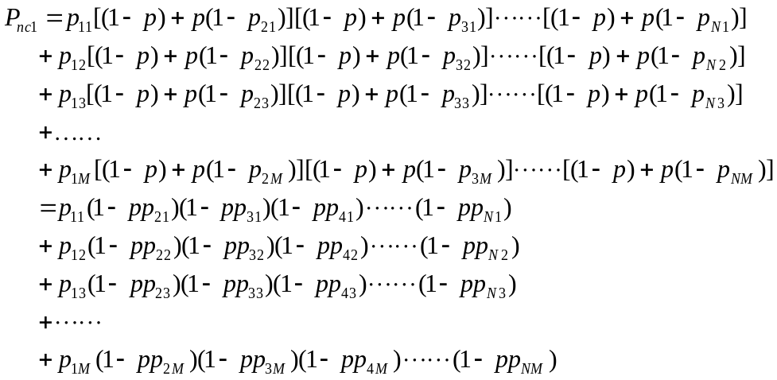 (2)
Where, the P_{c1} means the collision probability of the vehicle in the first location accessing time slot; the P_{nc1} means the non-collision probability of the vehicle in the first location accessing time slot.
Based on the above derivation, the expression of total collision probability of the vehicle in all locations accessing time slot can be founded as:
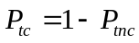 (3)
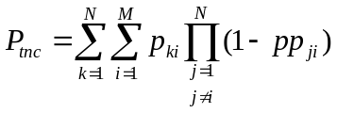 (4)
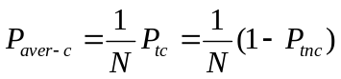 (5)
Where, the P_{tc} means the total collision probability of the vehicle in the studied area accessing time slot; the P_{tnc} means the total non-collision probability of the vehicle in the studied area accessing time slot; the P_{aver-c} means the average collision probability of the vehicle in the studied area accessing time slot.

B. Average Collision Probability in general Random Access scheme
Under the circumstance of xxx, all vehicles access the time slot with an equal probability, so the average collision probability of the vehicle accessing time slot by this method is equal to the collision probability of the vehicle in any locations accessing any time slots. Consequently, the average collision probability model is founded as:
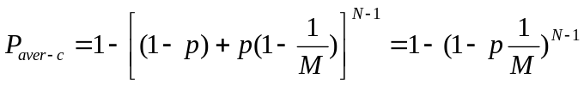 (6)

III. Problem formulation and solution
In VANET, the MAC protocol design faces severe challenge, due to the network structure of VANET changes so fast, caused by the situation which the vehicle may join and leave the network frequently and randomly. Meanwhile, the scheme of how to allocate slot to the vehicles in a distributed means is a focal point. In order to obtain an efficient method to allocate slot to the vehicle, we should make full use of information in VANET as much as possible. In [14], a decentralized direction-based TDMA scheduling strategy is proposed for VANET. This strategy is exploited to cope with the problem of slot allocation to a certain extent. However, with the rapid development of global positioning system (GPS) technology，the locational information of the vehicle on the road is a significant one that we can use to help to allocate time slot to vehicles. Taking this property in the VANET circumstance into consideration, we propose a decentralized location-based TDMA scheduling strategy for VANET. However, there are two forms of method to assign time slot to vehicle based on the locational information. The first one is complete random access method and the second one is incomplete random access method. In the first method, the vehicle in any location access the assigned time slot with an equal probability. Nevertheless, in the second method, the vehicle in different locations accesses the same time slot with different probability. In this paper, under complete random access method and incomplete random access method, two mathematic models are built for the process of time slot assignment, respectively. Meanwhile, we analyze the performance index which includes the collision probability and throughput capacity under the two methods.

IV. Solution
In section II of this paper, the model of collision probability on the condition of incomplete random access method is founded. According to the expression (1) and (2), we can see there are many parameters in the expression of the average collision probability. Different value of the average collision probability can be acquired when the parameters take different values. Therefore, we should optimize all the unknown parameters in order to get a minimum of the average collision probability. In accordance with the model, the objective function and the constraint condition of the optimization problem can be written as:
(1) Objective Function
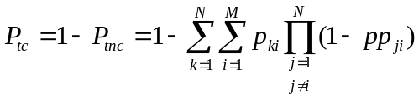
(2) Constraint Condition
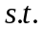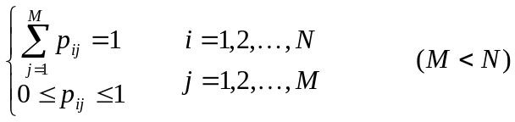
By analyzing the model, we draw a conclusion that the model of the total collision probability on the condition of incomplete random access method has multivariable, high-ordered, non-linear characteristic. These characteristics make the optimizing process become difficult. Meanwhile, common method used to solve the optimization problem did not accomplish the optimization of this model. However, Genetic Algorithm (GA) optimizer is an adaptive heuristic search algorithm premised on the evolutionary theories of natural selection and genetic, which is an intelligent exploitation of a random search within a defined search space to solve the optimization problem and can search for approximate global optimum solution. The basic concept of GA is based on the principle of survival of the fittest by Charles Darwin. According to this principle, GA must perform the following five steps: 1) encode all the parameters in the objective function and construct the individual chromosome; 2) establish and initialize the initial population; 3) assign fitness values to individuals according to the objective function value; 4) duplicate the individuals of high fitness values from the population; 5) achieve the operation of crossover, mutation and recombination among the population to produce individuals of the next generation. Through the reiteration of above genetic operation, a group of individuals will be acquired to make the function of the collision probability get the minimum. By the decoding operation the real values of all the parameters in the function of the collision probability can be obtained. These real values make the objective function get the approximate global optimum solution.
In the process of the GA optimization, Gray code coding method is used to achieve the parametric coding and 20 binary bits represent a parameter. In addition, we select the function of the total collision probability as the fitness function and assign fitness values based on the ranking method.

V. Simulation
In this section, we present the process that using the Genetic Algorithm optimizes all the parameters in the expression of the total collision probability on the condition of incomplete random access method. Meanwhile, the Matlab simulation results of the performance comparison between the two kinds of channel access method are presented.
The scenario under consideration is a segment of a one-way traffic highway. In this segment, the highway is divided into N locations, and the vehicle appears in these locations can communicate with each other normally. Each vehicle has unique information of location at any time, i.e. no location overlap, and the probability of a vehicle appears in a location is constant and equal during the simulation time. In order to improve the utilization factor of the wireless channel, we set the slot number M less than the location number N. Due to the situation that the vehicles should keep a safety distance between each other when they travel on the highway. Consequently, we set the length of every location as 10 meters. In order to guarantee vehicles in the studied area can communicate with each other effectively, we set the length of the area as 500 meters. Then we can get that the location number N is equal to 50. According to the value of N, the value range of M can be determined. To guarantee the efficiency of the channel, we set the value of M range from 1 to 20. Along with all the simulation parameters determined, the simulation program of MATLAB can be run and the simulation result can be obtained.

A. Simulation of parameters’ optimization by using GA

VI. Conclusion

ACKNOWLEDGMENTS

REFERENCES
[1] Omar, H.; Zhuang, W.; Li, L, “VeMAC: A TDMA-based MAC Protocol for Reliable Broadcast in VANETs,” Mobile Computing, IEEE Transactions on Mobile Computing, 1536-1233, 2012
[2] A-ADHOC: an Adaptive Real-time Distributed MAC Protocol for Vehicular Ad Hoc Networks. (Digital Object Identifier: 10.1109/CHINACOM.2009.5339734 Publication Year: 2009, Page(s): 1 – 6)
[3] VeMAC: A Novel Multichannel MAC Protocol for Vehicular Ad Hoc Networks.
[4] Q Chen, D Jiang, V Taliwal, L Delgrossi, “IEEE 802.11 based vehicular communication simulation design for NS-2,” the 3rd international workshop on Vehicular ad hoc networks, 2006.
[5] Z Niu, W Yao, Q Ni, Y Song, “Study on QoS Support in 802.11e-based Multi-hop Vehicular Wireless Ad Hoc Networks,”Networking, Sensing and Control, 2007 IEEE International Conference on (ICNSC), 2007.
[6] F. Borgonovo, A. Capone, M. Cesana, and L. Fratta, “ADHOC MAC: new MAC architecture for ad hoc networks providing efficient and reliable point-to-point and broadcast services,” Wireless Networks, vol.10, no. 4, pp. 359-366, 2004.
[7] A distributed bandwidth reservation algorithm for QoS routing in TDMA-based mobile ad hoc networks
[8] Distributed and adaptive TDMA algorithms for multiple-hop mobile networks
[9] DRAND Distributed randomized TDMA scheduling for wireless ad-hoc networks
[10]Adaptive Distributed Randomized TDMA Scheduling For Clustered Wireless Sensor Networks
[11] A simple distributed PRMA for MANETs
[12] Self-Configuring TDMA Protocols for Enhancing Vehicle Safety With DSRC Based Vehicle-to-Vehicle Communications
[13] TDMA-based multi-hop resource reservation protocol for real-time applications in tactical mobile ad hoc network
[14] Direction Matters: A Decentralized Direction-based TDMA Scheduling Strategy for VANET.

