**Homework**

**[qinlianc@buffalo.edu](mailto:qinlianc@buffalo.edu)**

**Qinlian Chen 50208157**

**Question1**

**Assumption**

Assume , accordingly 

**State Space**

d range from 0 to 0.5m, divided in to 200 units

Theta range from 0 to 360 degree, divided into 180 units

The State space have grids

**Initial Value**



**Prediction step**





,where andis 360*1 matrix

remain the same after curve





**Update Step**



,where 

,among which 

Beam function reference: *ProbabilisticRobotics* Page 125-126, (a)Gaussian distribution related

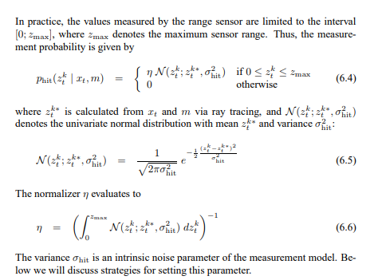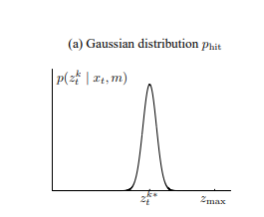

**Result**

• Plot the estimate at those 6 time-steps

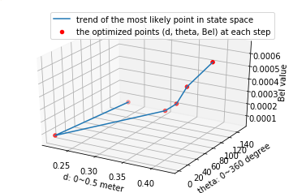

Fig1 3d plot of each optimized point at each step

Axis-x represents for the distance from the point to the wall. (unit: meter)

Axis-y represents for the angle.(unit: degree)

Axis-z represents for the distance from the point to the wall. (unit: meter)

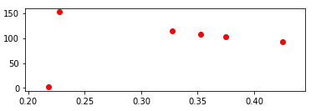

Fig2 2d plot of each optimized point at each step

Step1 distance = 0.2275 degree = 152. Bel_value = 5.5408650043099036e-05

Step2 distance = 0.2175 degree = 2. Bel_value = 8.339012147323719e-05

Step3 distance = 0.3275 degree = 114. Bel_value = 0.0001458040047563614

Step4 distance = 0.3525 degree = 108. Bel_value = 0.00023685848635039

Step5 distance = 0.375 degree = 102. Bel_value = 0.00040340493973957907

Step6 distance = 0.425 degree = 92. Bel_value = 0.0006512483741328149

• What is the most likely states at time =1

Time=1 means the 5th step above.

Underlined stuff demonstrate the state of optimized point at time=0

After

The most likely states is:

d = 0.0776m

Theta = 216.60 degree

**Question2**

Beam function change