Warm-up exercise:

The default “shared_buffers” value given in the postgresql.conf file is 128MB. Given that each buffer is 8KB long. The quantity of shared buffers is 128 * 1024 * 1024/8 * 1024 = 16,384

Ex1: Devise some Queries on the Test DB

what is the largest staff/student id? (People.id)

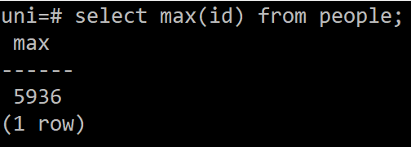

what is the earliest birthday of any person in the database? (People.birthday)

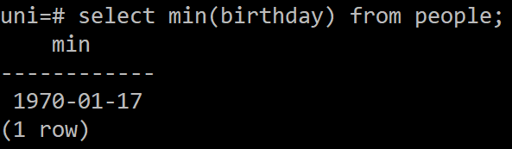

what is the maximum mark available for any assessment item? (Items.maxmark)

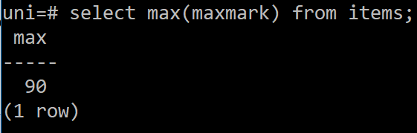

what assessment items are in each course and how many marks does each have?

(Courses.code,Items.name,Items.maxmarks))

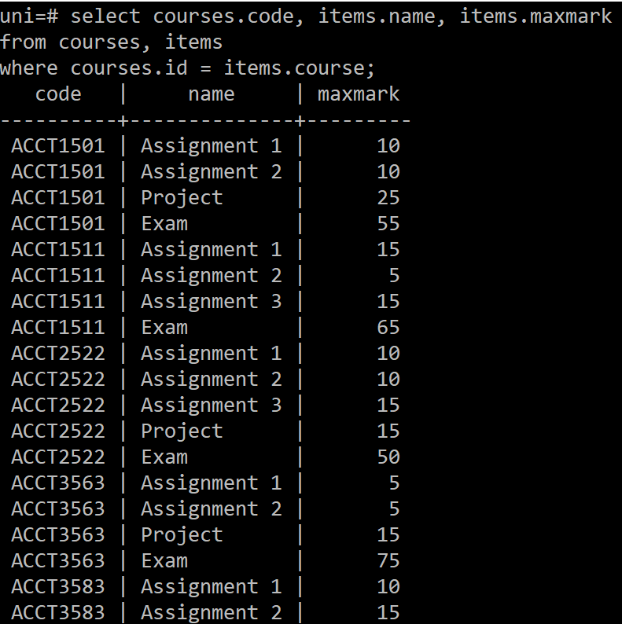

how many students are enrolled in each course? (Courses.code,count(Enrolments.student))

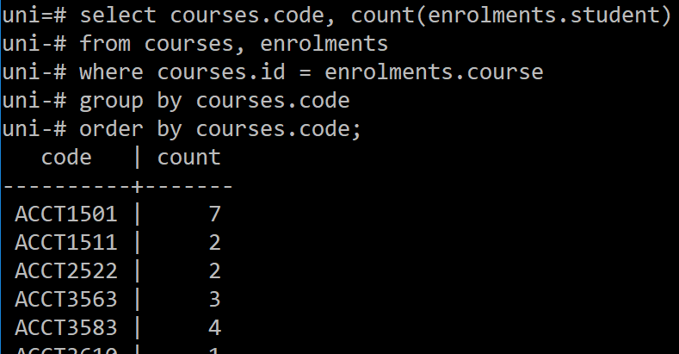

check that each student's assessment marks add up to the final mark for each course

(Course.code,People.name,Enrolments.mark,sum(Assessment.marks))

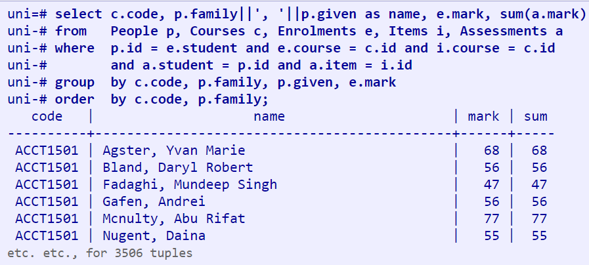

Ex2: Explore the Files of the Test DB

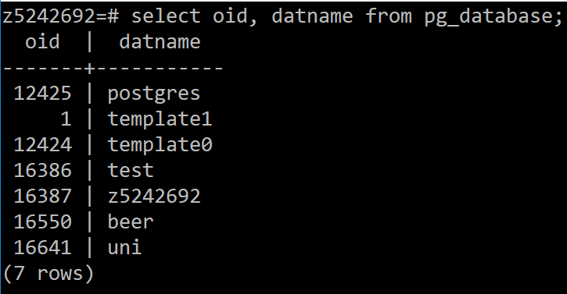

This will give you a list of databases, including template1, template0 and postgres, each with an associated OID. There should also be a tuple for your **uni** database; the OID value should also appear as the name of a directory in **pgsql/data/base/**.

2.

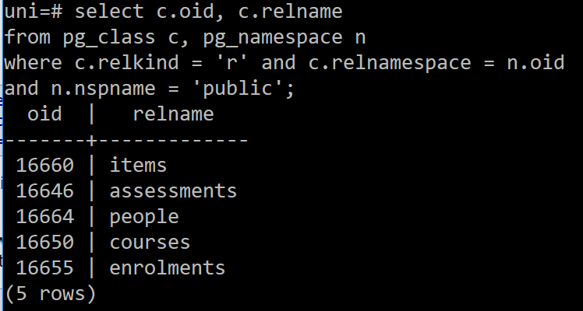

Show data files associated with a table are named after the OID of that table.

3. While you're examining the data files, return to psql and write a query to print the number of data pages in each relation.

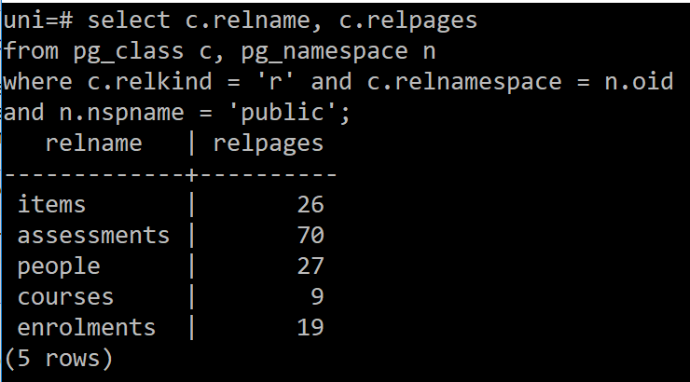

4. Once you've got the page counts in the catalog, check that they're consistent with the file sizes in the directory for the uni database (assuming an 8KB page size).

