# High efficient deposition of 2-in. double-sided YBCO thin films in batch with pulsed inject MOCVD

R Chen1, B W Tao1, *, R P Zhao1, G Y He1, C Zeng2 and X Y Lu2

1 State Key Lab of Electronic Thin Films and Integrated Devices, University of Electronic Science and Technology of China, Chengdu, 610054, People’s Republic of China

2 School of Opto-Electronic Information, University of Electronic Science and Technology of China Chengdu 610054

E-mail: taobw@uestc.edu.cn

## Abstract

A special substrate turnplate disk and a U-type nozzle were designed for efficient producing double-sided YBCO thin films in batch with pulsed inject MOCVD. Multi-pieces of double-sided YBCO thin films could be prepared in one run. In this paper,12 pieces of 500 nm thick YBCO thin films could simultaneously deposited on both sides of 2-in. LaAlO3 single crystalline wafers in less than 4 hours, at an average preparation rate of 16 min per piece. The double-side YBCO thin films in one turn and different turns with same condition have good consistency. And the YBCO thin films maintained good homogeneity in-plane and consistency for both sides. Meanwhile, the critical current density is mainly distributed between 2.2 and 2.4 MA·cm-2 (77 K, 0 T), and the microwave surface resistance is only 0.323 mΩ (77 K, 10 GHz). The film properties could meet the commercial demand of microwave filters.

Keywords: MOCVD YBCO double-sided efficient

## 1.Introduction

YBa2Cu3O7-delta (YBCO) high temperature superconductor (HTS) thin films deposited on single crystal have been widely used for microwave filters, because of its excellent property of high critical current density (*Jc*) and low microwave losses [1-10]. The microwave filters with double-sided YBCO thin films have much lower insertion loss and stronger anti-interference capability compared to ordinary filters [11-14]. Generally， double-sided YBCO thin films prepared by depositing the second side after the first side being finished [15-17], which had negative impacts on the double-sided consistency, made the deposition process complicated and take more time owing to extra vacuuming, cooling-down, and heating-up. Gradually, simultaneous deposition route to prepare double-sided YBCO thin films has been developed and made progress [18-20].

With great effort, double-sided YBCO thin films with good performance had been prepared successfully with different deposition methods all over the world[18-22], but the price is still too high due not only to the high cost of preparation, but also to the low preparation efficiency. Nowadays, the main preparation methods of YBCO thin films for microwave usage on single crystal include co-evaporation [16, 21], sputtering [18, 19], pulsed laser deposition (PLD) [9, 20] and metal organic deposition (MOD) [22-24]. Co-evaporation method can be used to deposit single-sided YBCO thin films in batch rapidly, but it is difficult to simultaneously deposit double-sided thin films due to the raw material melting. Usually, co-evaporation method takes about 10 hours to make one run for double-sided films. With PLD, the films are still deposited one side after the other and it takes more than 6 hours to make a double-sided sample. The traditional sputtering method, of which the depositing rate is only about several nanometers per minute, usually takes time longer than normal working hours to prepare a piece of 500 nm thick double-sided YBCO thin films. As for MOD method, just the decomposition process takes approximately 10 hours.

In recent years, metal organic chemical vapor deposition (MOCVD) method has been improved and makes a quick progress in the preparation of YBCO HTS tapes as a low cost large-scale production method [25, 26]. As reported, the deposition rate of YBCO thin films on tapes could reach up to about 1 μm·min-1 [25]. And YBCO thin films prepared in this way also could have good high frequency properties. This fast deposition method for HTS tapes should be also suitable for YBCO thin films on single crystals only if it could deposit on the both sides of the substrates. So we transplanted our MOCVD equipment into the preparation of double-sided YBCO thin films on single crystal.

Besides, in order to further improve the efficiency of production, the pre-preparation that cost hours such as vacuuming, heating-up, preparation of the precursor solution, and post-annealing should be considered. The efficiency of the preparation of YBCO thin films would greatly enhanced if multi-pieces of double-sided YBCO thin films rather than only one piece were deposited in one run.

In the paper, a special substrate turnplate disk and a U-type nozzle were designed to prepare multi-pieces of double-sided YBCO thin films simultaneously and efficiently with pulsed inject MOCVD.

## 2.Experiment

A planetary turnplate disk made of stainless steel and a U-type nozzle made of copper, were designed to prepare 12 pieces of double-sided YBCO thin films simultaneously as shown in Figure 1. As shown in Figure 1(a), the turnplate disk has 12 circumferentially shaped openings, in which wafers were maintained. With it, at most 12 pieces of YBCO thin films could be deposited in one turn, significantly shortening the production progress of each YBCO thin films. Meanwhile, the diameter of the openings was a little larger than of substrate, such as 53 mm vs 50.8mm. Upon the rotation of the planetary turnplate disk, the wafers “walk” within each opening due to the force of friction between the substrates and the openings and its weight. In order to avoid that the centripetal force is too large that the wafer cannot “walk” normally, the rotating rate cannot be too large. Here, the rotating rate of the turnplate is set to be 12 turn per minute. The U-type nozzle contains two opposite symmetrical linear slits, with 1mm in width and 110 mm in length (covered the 2-in. substrates in the middle) and 45 mm in distance each other. It was used to deposit double-sided YBCO thin films simultaneously as shown in Figure 1(b). The position relationship of the turnplate disk and the nozzle is shown in Figure 1(c).

In our experiment, 2-in. double-sided LaAlO3 (LAO) single crystal wafers were used as substrates for YBCO thin films. The deposition chamber was heated to 845 ℃, while the evaporation chamber and transport pipeline were heated to 300 ℃. Y(tmhd)3, Ba(tmhd)2·(1,10-heptanedionate), Cu(tmhd)2 were dissolved into tetrahydrofuran solution in a proper proportion, where ‘tmhd’ is the abbreviation of 2,2,6,6, -tetramethy-3,5-heptanedioline. During depositing, the precursor solution was pulsed injected into the evaporation chamber as floss and evaporated immediately. And the precursor vapor was mixed up with the nitrous oxide, oxygen, argon in a proper gas flow ratio, and was transferred into the depositing area from the nozzle continuously and reacted on the substrate surfaces. After deposition, the temperature of the deposition chamber was decreased down to 500 ℃ gradually by adjusting heating current manually. After annealing for 20 minutes in pure oxygen, the YBCO thin films were cooled down to room temperature slowly.

The thin films thickness was measured by a step profiler (Veeco Dektak 150). The *Jc* was measured through the Leipzig *Jc*-scan system and the microwave surface resistance (*Rs*) was measured through a sapphire resonator [27]. The texture was characterized by an x-ray diffraction system (XRD, DanDong DX-2700) with *θ*-2*θ* scan for crystal phase and orientation and *ω*-scan for out-of-plane orientation.

## 3.Results and discussion

### 3.1 The preparation efficiency of double-sided YBCO thin films on LAO wafers

Using our pulsed inject MOCVD, at most 12 pieces of 2-in. YBCO thin films could be prepared in one turn. Thus, the average preparation rate of pre piece of double-sided 500 nm thick YBCO thin films in one run is only about 16 min per piece as shown in table 1. Co-evaporation is the only method which was applied in commercial production of YBCO thin films currently. With co-evaporation, in order to deposit double sides, the vacuum is broken and the wafer turn to the other side after one side is deposited. Co-evaporation takes time longer than normal working hours to make a run for double-sided YBCO thin films. In contrast, our pulsed inject MOCVD method reported in this paper could deposit double-sided YBCO thin films simultaneously and is faster than co-evaporation in batched production.

The innovation of multi-pieces double-sided deposition aside, our pulsed inject MOCVD method take the advantage of deposition rate. The commercial co-evaporation method usually takes about 15 minutes to deposit a piece of 500 nm thick YBCO thin films. Our MOCVD method could deposit 12 pieces of 500 nm thick YBCO thin films in 75 minutes as shown in Table 1, which is one-third slower than the deposition rate of HTS tap because of a farer substrate-to-slit distance. Thus, the deposition time of a piece of 500nm thick YBCO thin films is only 6.25 minutes, which is smaller than co-evaporation method.

**Table 1.** The average preparation time of pre piece of double-sided 500 nm thick YBCO thin films in one turn

|  |  |  |  |  |
| --- | --- | --- | --- | --- |
| Pre-preparation time (min) | Deposition time for 12 pieces of 500 nm thick double-sided YBCO thin films (min) | Post preparation time (min) | Total time in one turn (min) | Average preparation rate (min pre piece) |
| 60 | 75 | 60 | 195 | 16 |

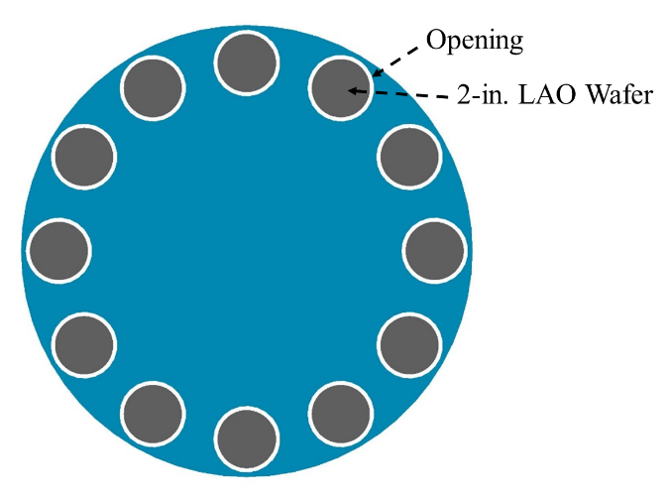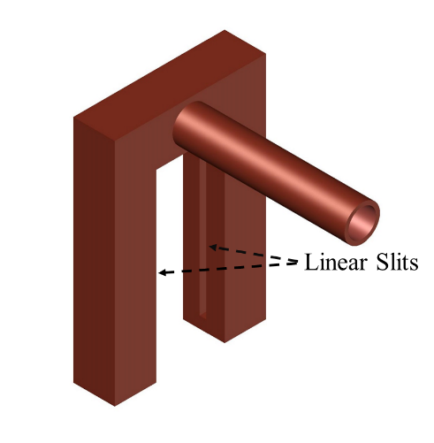

(a) (b)

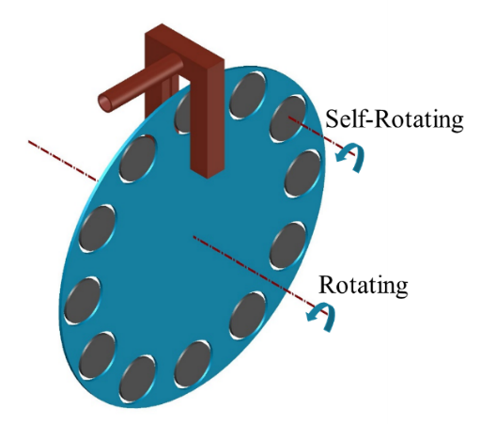 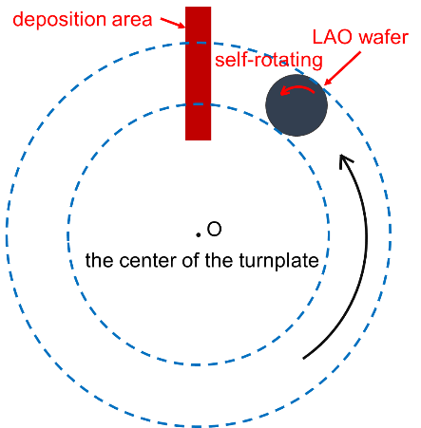

(c) (d)

**Figure 1.** The planetary turnplate disk and the U-type nozzle: (a) the turnplate disk; (b) the nozzle; (c) the position relationship of the turnplate disk and the nozzle;(d) the rotating deposition model



**Figure 2.** The thickness distribution of 2-in. YBCO thin films under different condition: one self-rotated and the other fixed

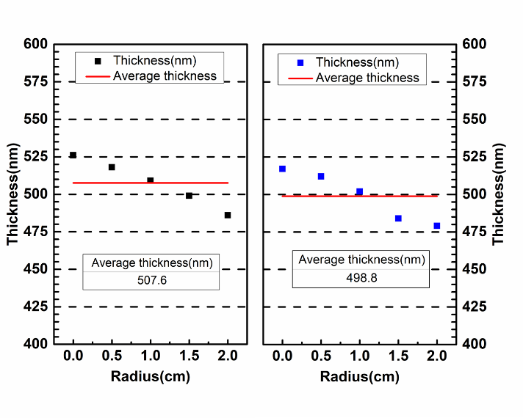

**Figure 3.** The thickness distribution of both sides of 2-in. double-sided YBCO thin films

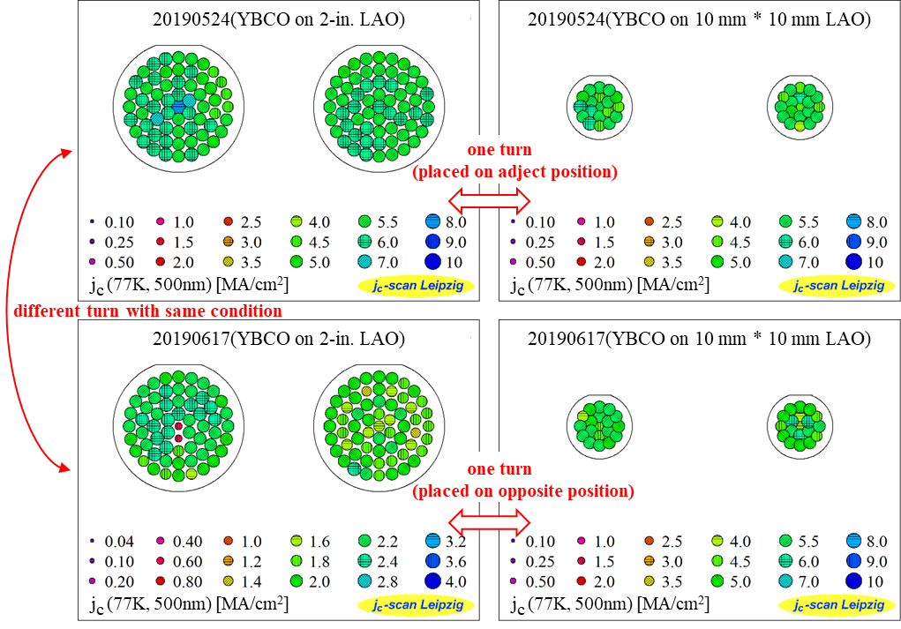

**Figure 4.** *Jc* (77 K, 0 T) of 2-in. double-sided YBCO thin films in one turn and different turn



**Figure 5.** Transformation of *Jc* (77 K, 0 T) on both sides of 2-in. YBCO thin films

## 

**Figure 6.** The measurement of *Q* of the 2-in. 500nm thick double-sided YBCO thin films



**Figure 7.** The XRD *θ*-2*θ* scanning patterns of double-sided YBCO thin films at radii of 0, 1, 2 cm of side A and B



**Figure 8.** The XRD *ω*-scanning patterns of double-side YBCO thin films

### 3.2 The measurement of double-sided YBCO thin films

The self-rotating rate of the LAO wafer is related to the rotating rate and the diffidence of circumference between the opening and the wafer. Here, the self-rotating rate is about 217°/min as measured. As for 500nm YBCO thin films, the deposition time is 75 min as shown in table 1. Thus, the 2-in. LAO wafer rotated about 45 turns during deposition. The rotating deposition model of our pulsed inject MOCVD is shown in Figure1(d). Although the width of the linear slit is only 1 mm, the width of the uniform deposition area which is decided by the width of the heat shield placed around the slit, is about 21 mm.

In order to identify the self-rotating behavior’s effect on the thickness distribution, YBCO films was deposited on two 2-in. LAO wafers of which one LAO wafer was fixed and the other self-rotated. The thickness of the two pieces of YBCO thin films were measured along the diameter. As shown in Figure 2, the thickness distribution curve of the YBCO thin films which self-rotated during deposition is centered on 0. It indicates that the thickness of the films is distributed along the radius. And the thickness distribution curve of the YBCO thin films which was fixed kept going up along the diameter. Obviously, the homogeneity of in-plane thickness is improved with the wafer’s self-rotating behavior.

The thickness distribution along the radius of both two sides of 2-in. YBCO thin films was shown in Figure 3. The average thickness of the two sides are approximately 507.6 nm and 498.8 nm, respectively. This deviation is mainly caused by the slight offset between the planetary turnplate disk and the nozzle. Meanwhile, the in-plane deviation of thickness of each side is around ±5 %, and it is obvious that the thickness decreases as the radius increases. This in-plane thickness deviation, which could be derived from the turnplate thickness-effect (the turnplate is much thicker than the substrate and interfere the vapor flowing), is larger than expected results for a linear slit MOCVD and self-rotation substrate.

Figure 4 shows the measured results of *Jc* (77 K, 0 T) of double-sided YBCO thin films on LAO substrate in one turn and different turn at the same condition. The *Jc* of YBCO thin films in one turn and different turns are much the same which indicates our pulsed inject MOCVD has good consistency and repetition in batch production of double-sided YBCO thin films. Meanwhile, the *Jc* (77 K, 0 T) at every point measured on specimen 20190524(YBCO on 2-in. LAO) is mainly distributed between 2.2 and 2.4 MA·cm-2 as shown in Figure 5. And the variation of the Jc along the radius of each side is small and the distinction between the two sides is not obvious.

In order to obtain Rs, a sapphire resonator was used to measure the quality factor (*Q*) of the YBCO thin films [27]. As shown in Figure 6, the measured Q of 500nm YBCO films is 87524 at 31.506 GHz. The Rs is as low as 0.323mΩ (77 K, 10 GHz) which indicates that the YBCO thin films prepared has met the commercial demand of surface resistant of microwave filters.

The XRD *θ*-2*θ* scan patterns of double-sided YBCO thin films, which were measured at radii of 0, 1, 2 cm are shown in Figure 7. Except the peaks of LAO at 23.4° and 47.9°, there are only YBCO (*00l*) peaks other than (*h00*) peaks in the *θ*-2*θ* curve, which indicates that almost all YBCO grains are c-axis-oriented as expected.

The XRD *ω*-scanning of the double-sided YBCO thin films, which were used to characterize the out-of-plane texture, were performed at the equivalent position of each side. As shown in Figure 8, the full width of half maximum (FWHM) of each side is 0.498° and 0.507° respectively, which shows little difference between the two sides. Although these FWHM data is bigger that of YBCO thin films prepared by other methods, our YBCO thin films perform well in *Jc* and *Rs* as mentioned above. It probably because that in-plane angles within certain range between YBCO grains are allowed, which have no significant effect on the performance.

## 4.Conclusion

In this paper, we presented a special substrate turnplate and a U-type nozzle that used for the efficient production of double-sided YBCO thin films in batch with pulsed inject MOCVD. Experiment results indicated that the average preparation rate of 2-in. double-sided 500 nm thick YBCO thin films was only about 16 minutes per piece. The double-side YBCO thin films in one turn and different turns with same condition have good consistency, which indicates our pulsed inject MOCVD is suitable for batch production of double-sided YBCO thin films. Meanwhile, the YBCO thin films maintained good homogeneity in-plane and consistency for both sides. And the Jc of prepared YBCO thin films with good biaxial texture is 2.2-2.4 MA·cm-2 (77 K, 0 T). Moreover, the Rs was as low as 0.323 mΩ (77 K, 10 GHz). It illuminated that the prepared double-sided YBCO thin films have met the demand of microwave filters (Jc≥2.0 MA·cm-2 (77 K, 0 T), Rs≤0.5 mΩ (77 K, 10 GHz)) and this design to efficiently produce double-sided YBCO thin films in batch is feasible.

## Acknowledgment

We gratefully acknowledge the support of the National Natural Science Foundation of China (No.51872040).

## Reference

[1] S.I. Bondarenko, V.P. Koverya, A.V. Krevsun, S.I. Link, High-temperature superconductors of the family (RE)Ba2Cu3O7-δ and their application (Review Article), in: Low Temperature Physics, 2017, pp. 1125-1151, doi:10.1063/1.5008405.

[2] L. Guo-Chun, Z. Dawei, S. Chien-Fu, M.E. Johansson, R.S. Withers, D.E. Oates, A.C. Anderson, P. Polakos, P. Mankiewich, E.d. Obaldia, R.E. Miller, High-power HTS microstrip filters for wireless communication, IEEE Transactions on Microwave Theory and Techniques, 43 (1995) 3020-3029, doi:10.1109/22.475668.

[3] A. Fathy, D. Kalokitis, V. Pendrick, E. Balohoubek, A. Pique, M. Mathur, Superconducting narrow band pass filters for advanced multiplexers, in: 1993 IEEE MTT-S International Microwave Symposium Digest, 1993, pp. 1277-1280 vol.1273, doi:10.1109/MWSYM.1993.277107.

[4] H. Jia-Sheng, M.J. Lancaster, D. Jedamzik, R.B. Greed, On the development of superconducting microstrip filters for mobile communications applications, IEEE Transactions on Microwave Theory and Techniques, 47 (1999) 1656-1663, doi:10.1109/22.788606.

[5] J.X. Jin, X. Ying, Q.L. Wang, Y.S. He, C.B. Cai, Y.S. Wang, Z.M. Wang, Enabling High-Temperature Superconducting Technologies Toward Practical Applications, IEEE Transactions on Applied Superconductivity, 24 (2014) 1-12, doi:10.1109/tasc.2014.2346496.

[6] J. Qiao, C.Y. Yang, High-Tc superconductors on buffered silicon: materials properties and device applications, Materials Science and Engineering: R: Reports, 14 (1995) 157-201, doi:<https://doi.org/10.1016/0927-796X(94)00172-3>.

[7] D.E. Oates, G.F. Dionne, Magnetically tunable superconducting resonators and filters, IEEE Transactions on Applied Superconductivity, 9 (1999) 4170-4175, doi:10.1109/77.783944.

[8] S.H. Talisa, M.A. Janocko, C. Moskowitz, J. Talvacchio, J.F. Billing, R. Brown, D.C. Buck, C.K. Jones, B.R. McAvoy, G.R. Wagner, D.H. Watt, Low- and high-temperature superconducting microwave filters, IEEE Transactions on Microwave Theory and Techniques, 39 (1991) 1448-1454, doi:10.1109/22.83816.

[9] M. Lorenz, H. Hochmuth, D. Matusch, M. Kusunoki, V.L. Svetchnikov, V. Riede, I. Stanca, G. Kastner, D. Hesse, High-quality Y-Ba-Cu-O thin films by PLD-ready for market applications, IEEE Transactions on Applied Superconductivity, 11 (2001) 3209-3212, doi:10.1109/77.919747.

[10] Y. He, Y. Wang, Y. Hu, W. Chen, Z. Yan, Superconducting electrode capacitor based on double-sided YBCO thin film for wireless power transfer applications, Superconductor Science and Technology, 32 (2019), doi:10.1088/1361-6668/aaebd8.

[11] T. Zhang, Z. Long, L. Zhou, M. Qiao, F. Hou, M. Tian, Realization of Even Transmission Zeros for Filter Without Cross-Couplings, IEEE Transactions on Microwave Theory and Techniques, 66 (2018) 5248-5259, doi:10.1109/tmtt.2018.2871140.

[12] L.-M. Wang, W.-C. Lin, M.-L. Chang, C.-Y. Shiau, C.-T. Wu, Characteristics of Ultra-Wideband Bandpass YBCO Filter With Impendence Stub, IEEE Transactions on Applied Superconductivity, 21 (2011) 551-554, doi:10.1109/tasc.2010.2091231.

[13] S. Kolesov, H. Chaloupka, A. Baumfalk, T. Kaiser, Planar HTS structures for high-power applications in communication systems, Journal of Superconductivity, 10 (1997) 179-187, doi:10.1007/bf02770548.

[14] L. Gao, L. Sun, F. Li, Q. Zhang, Y. Wang, T. Yu, J. Guo, Y. Bian, C. Li, X. Zhang, H. Li, J. Meng, Y. He, 8-GHz Narrowband High-Temperature Superconducting Filter With High Selectivity and Flat Group Delay, IEEE Transactions on Microwave Theory and Techniques, 57 (2009) 1767-1773, doi:10.1109/TMTT.2009.2022813.

[15] G. Muller, B. Aschermann, H. Chaloupka, W. Diete, M. Getta, B. Gurzinski, M. Hein, M. Jeck, T. Kaiser, S. Kolesov, H. Piel, H. Schlick, R. Theisejans, Double-sided YBa/sub 2/Cu/sub 3/O/sub 7-/spl part// films for planar high-power filters, IEEE Transactions on Applied Superconductivity, 7 (1997) 1287-1290, doi:10.1109/77.620754.

[16] H. Kinder, P. Berberich, B. Utz, W. Prusseit, Double sided YBCO films on 4" substrates by thermal reactive evaporation, IEEE Transactions on Applied Superconductivity, 5 (1995) 1575-1580, doi:10.1109/77.402874.

[17] Y. Ito, Y. Yoshida, M. Iwata, Y. Takai, I. Hirabayashi, Preparation of double-sided YBa2Cu3O7−δ film by hot-wall type MOCVD, Physica C: Superconductivity, 288 (1997) 178-184, doi:[10.1016/S0921-4534(97)01573-6](https://doi.org/10.1016/S0921-4534(97)01573-6).

[18] X.Z. Liu, B.W. Tao, X.W. Deng, Y. Zhang, Y.R. Li, The preparation of two inch double-sided YBCO thin films, Superconductor Science and Technology, 15 (2002) 1698-1700, doi:10.1088/0953-2048/15/12/313.

[19] F. Ding, H. Gu, T. Li, J. Cao, X. Lv, Y. Lei, Batch production of large-area double-sided YBa2Cu3O7−δthin films by DC magnetron sputtering, Superconductor Science and Technology, 22 (2009), doi:10.1088/0953-2048/22/5/055019.

[20] M. Lorenz, H. Hochmuth, D. Natusch, K. Kreher, Highly reproducible large-area and double-sided pulsed laser deposition of HTSC YBCO:Ag thin films for microwave applications, Applied Physics A, 69 (1999) S905-S911, doi:10.1007/s003390051556.

[21] W. Prusseit, R. Semerad, K. Irgmaier, G. Sigl, Optimized double sided DyBa2Cu3O7-thin films for RF applications, Physica C: Superconductivity, 392-396 (2003) 1225-1228, doi:[10.1016/S0921-4534(03)01028-1](https://doi.org/10.1016/S0921-4534(03)01028-1).

[22] T. Manabe, M. Sohma, I. Yamaguchi, K. Tsukada, W. Kondo, K. Kamiya, T. Tsuchiya, S. Mizuta, T. Kumagai, Surface resistances of 5-cm-diameter YBCO films prepared by MOD for microwave applications, Physica C: Superconductivity and its Applications, 445-448 (2006) 823-827, doi:[10.1016/j.physc.2006.04.042](https://doi.org/10.1016/j.physc.2006.04.042).

[23] S.S. Wang, Z.L. Zhang, L. Wang, L.K. Gao, J. Liu, High quality uniform YBCO film growth by the metalorganic deposition using trifluoroacetates, Physica C: Superconductivity and its Applications, 534 (2017) 68-72, doi:[10.1016/j.physc.2017.02.001](https://doi.org/10.1016/j.physc.2017.02.001).

[24] M. Sohma, K. Tsukada, I. Yamaguchi, K. Kamiya, W. Kondo, T. Kumagai, T. Manabe, Cerium Oxide Buffer Layers on Perovskite-Type Substrates for Preparation of c-Axis-Oriented YBa2Cu3O7 Films by Fluorine-Free Metalorganic Deposition, IEEE Transactions on Applied Superconductivity, 19 (2009) 3463-3466, doi:10.1109/TASC.2009.2018822.

[25] R. Zhao, Q. Liu, F. Zhang, Y. Xia, H. Tang, Y. Lu, C. Cai, B. Tao, Y. Li, High Rate Growth of MOCVD-Derived GdYBCO Films Based on a Simple Self-Heating Method, Journal of Electronic Materials, 47 (2018) 7062-7068, doi:10.1007/s11664-018-6632-8.

[26] S. Miyata, K. Matsuse, A. Ibi, T. Izumi, Y. Shiohara, T. Goto, High-rate deposition of YBa2Cu3O7−δ high-temperature superconducting films by IR-laser-assisted chemical vapor deposition, Superconductor Science and Technology, 26 (2013) 045020, doi:10.1088/0953-2048/26/4/045020.

[27] C. Zeng, Z. Luo, S. Bu, K. Yang, Q. Zhang, A novel method for the measurement of frequency-character of surface resistance of HTS thin film, Chinese Science Bulletin, 55 (2010) 1088-1091, doi:10.1007/s11434-009-0639-8.